The Children Mission Hope of Majose International Home/School Construction Proposal

Chidren Having a lesson
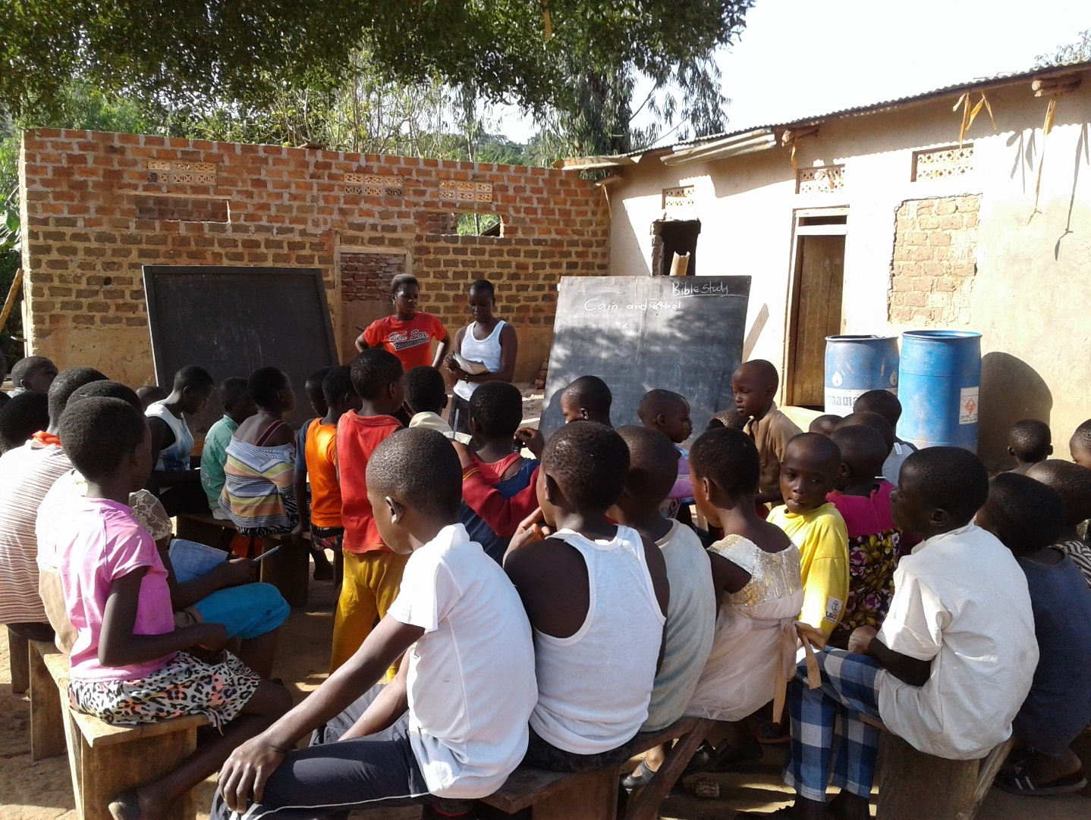
Ensuring that each of our children goes on to school, is an important part of our mission at The Children Mission Hope of Majose
International with over 20 percent of the children being HIV positive and neglected by their available relatives, the remaining children who are not HIV positive whose parents died also need a place where they can call home. We want to provide the children with the same basic education and support we would provide to our own children. A strong education with christian values based on biblical teachings. Our desire is to keep them together with the love of Jesus Christ. A primary, secondary and vocational education model is our greatest hope for eliminating extreme poverty for our orphans to begin envisioning a life beyond the lack of hope. Therefore, we would like to offer a secure home and school model that combines both formal primary and secondary school together with special vocational technical skills. A model that provides a stronger foundation for future employment opportunities especially self-employment in a country where only roughly 20 percent of the graduates from tertiary educational institutions obtain formal employment.

The fundamental benefit of having a home and school buildings for our primary and secondary school is that it will enable our children to be nurtured in a well-organized and secure
Environment. Especially the girl child, where rape and gender violence against women is high in our society. It undertakes their education within the social and cultural environment, where the fear of God and trusting in Him for their future is part of them. We will provide strong support structures for discipline and good behavior, compared to placing them in other schools where they are subjected to social pressures at an early age. The new home and school would prevent such consequences that often include dropping out of school and teenage pregnancies.

The structural requirements will include: dormitories/accommodations, classrooms, an administration block, main hall/chapel, kitchen, laboratories for science subjects, workshops for vocational subjects, library and other facilities like bathrooms, toilets, water and electricity and equipping those facilities with furniture, books and equipment, are estimated to cost a total of UGX 6,157,483,613 (US$ 1,759,281).​

Why Construction of a home, school and vocational buildings now?
The Children Mission hope of Majose International provides accommodation, food, tuition fees, uniforms, and school expenses for all of our current 110 children that are school going. We provide children education from nursery to tertiary education. The children's education is key in guaranteeing them a bright future as education is the best asset one can give his children and is owned personally by the child where no one can take it away. We envision seeing these children grow in the ways of the Lord, joining university level or vocational schools if more appropriate and becoming better and responsible citizens in future with a humanitarian spirit of making the world a better place for everyone to live in and achieving their dreams.
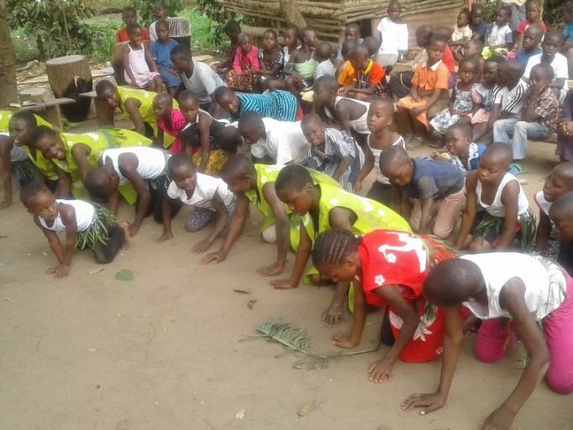
Children Mission Hope of Majose International is currently operating from a volunteer’s home squatter’s land on some other person’s property. Only 56 children reside presently on the property. The other 54 children live with others throughout the area. However with the help of a good Samaritan Sister Patricia Plump Babetto, Children Mission was able to acquire its own land, and it is important that Children’s Mission construct’s its own home that guarantees all​ the orphaned children a permanent home and will reduce costs and also gain independence in operations meant to benefit the children resulting in cost cutting that will lead to sustainability of the project. This will also result in proper organization of resources for the children to give them a permanent place where children will display their potential to the fullest by having more space to play and exercise their talents which would result in opening doors for them. 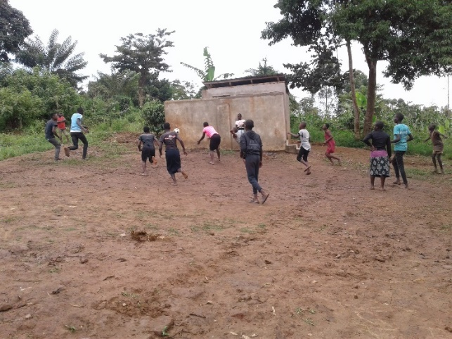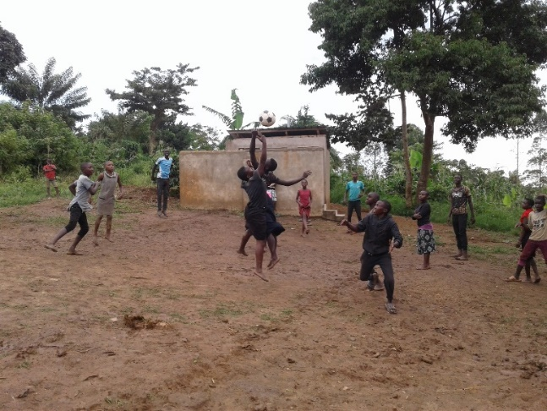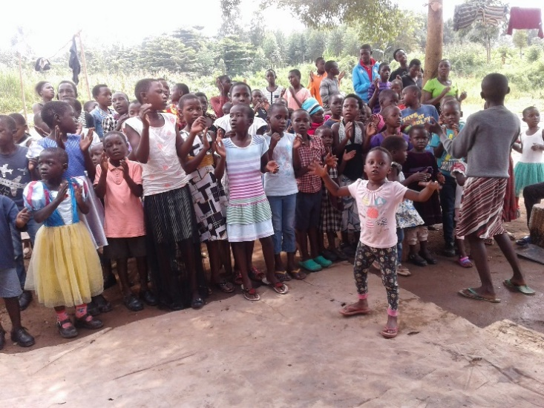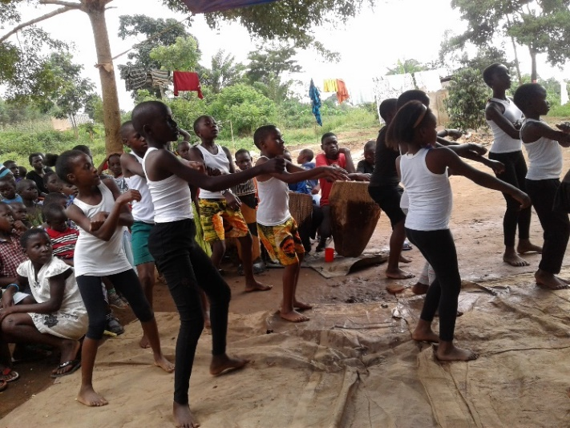
Without a secure home and school, our girls will more than likely marry while very young, run away to the city to get low wage jobs, or become sex workers. Our boys will also end up doing low paying jobs in the village or city and never escape the cycle of poverty. The overwhelming benefit of having our own home and school for all 110 children would enable them to undertake their education within the social, cultural community of Wakiso Bembe. Children Mission Hope desires to provide support structures for discipline and good behavior compared to other schools where our children are subjected to social pressures at an early age, resulting in high drop-out rates and teenage pregnancies.
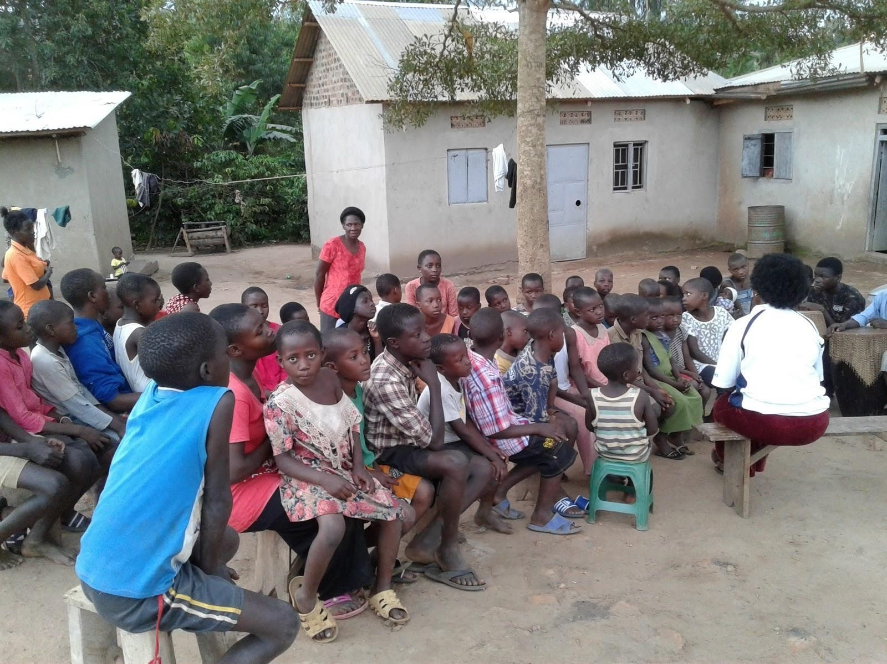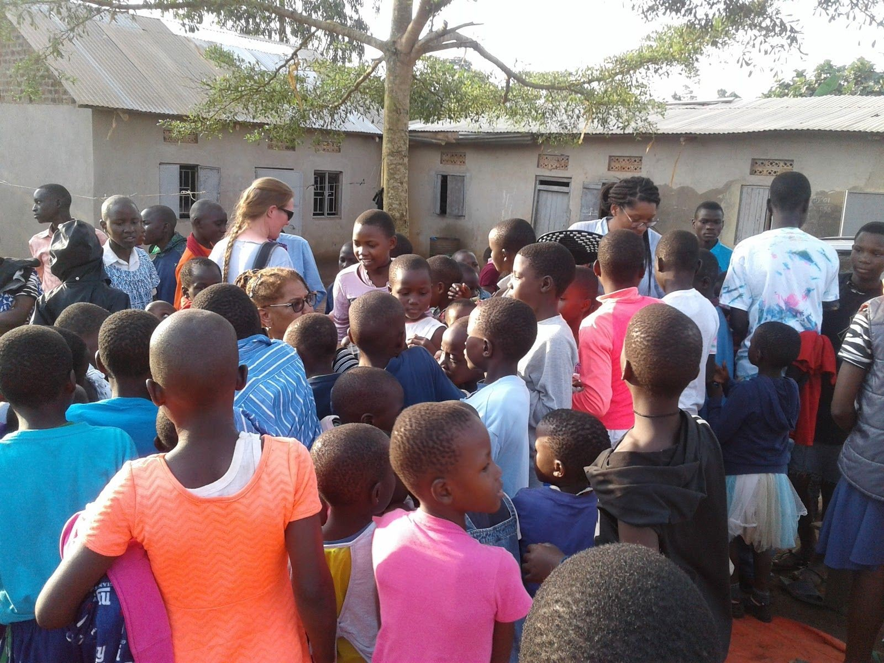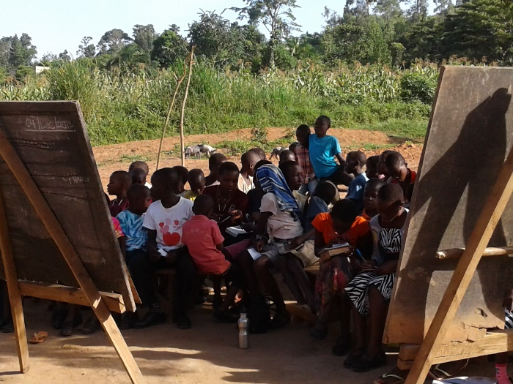
Above is the current children home on someone else’s property.

Construction of Orphaned Children home and school Project

Project description
The home and school initially will offer a combination of life skills, vocational and formal school studies from nursery to primary seven and ordinary level i.e. (senior one to four) leading to attainment of Uganda Certificate of Education. On completion of ordinary level, students who will opt to continue with vocational studies at further levels will have been equipped with practical knowledge and skills to make their further studies easier and at the same time are able to earn a living from the skills obtained. Children especially the best performers who will opt for the advanced level (senior five to six) leading to attainment of Uganda Advanced Certificate of Education will be sponsored in other schools till a later date when CMHMI will consider introducing this level within the project.
The Children Mission Hope of Marjose International home and school will consist of two dormitories for girls and boys, classroom block , a dining hall/Chapel, a library, computer lab, 3 science labs, Kitchen, administration block, toilets, workshops specifically for the vocational studies planned to be incorporated in the ordinary level education.
This project on the start will provide accommodation to 110 Orphaned, and vulnerable children, Chapel/Multipurpose hall where they can praise and worship God receive biblical teachings and Christian values, have meals and class rooms for their formal education.

Land & Structures
Children mission hope of Majose International already has acquired approximately 4.2 acres of land on plot 70 in Namayumba Sub-County, Wakiso District. This land is considered sufficient for the above mentioned structures and other amenities the home and school will require. It is also envisaged that the Home and school will acquire more landphotos of the new acquired land: at a later stage in case of expansion of the program.​Below are the

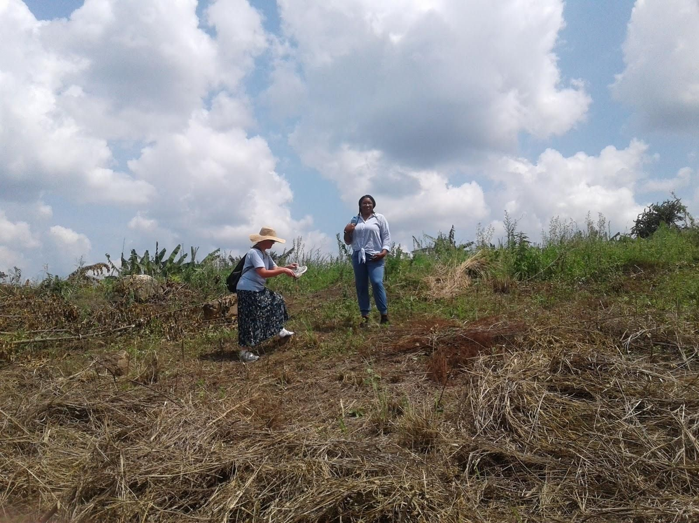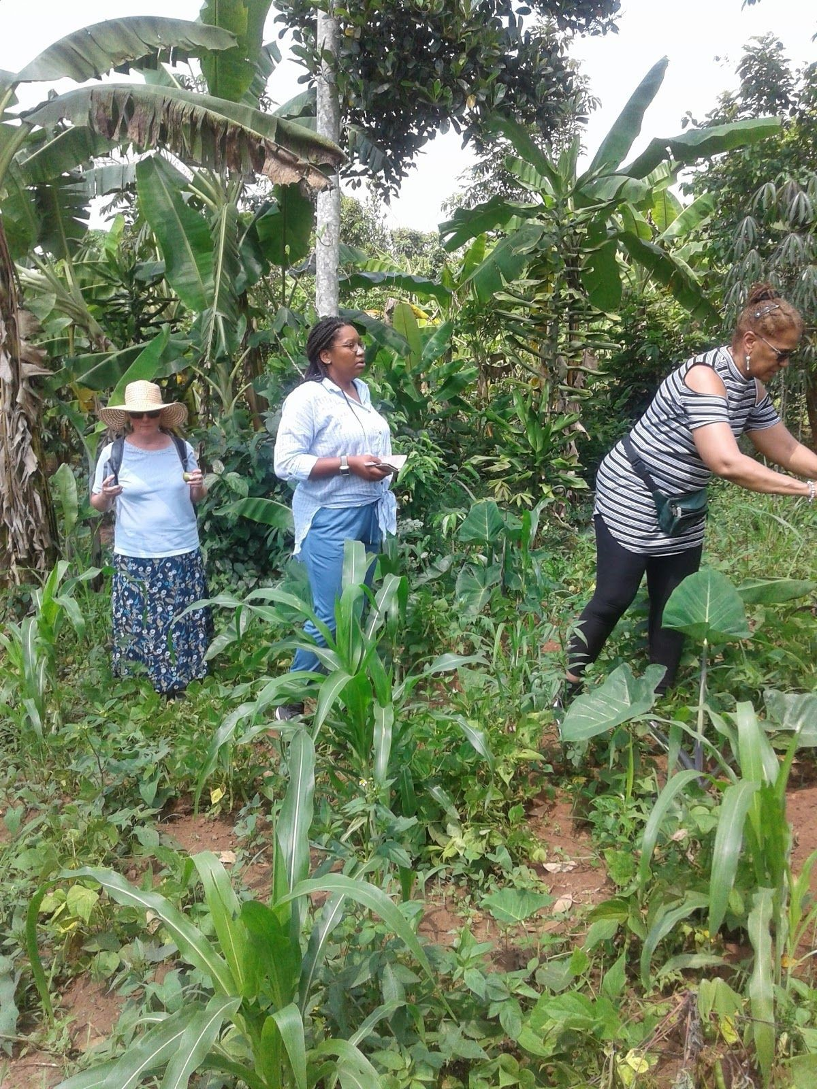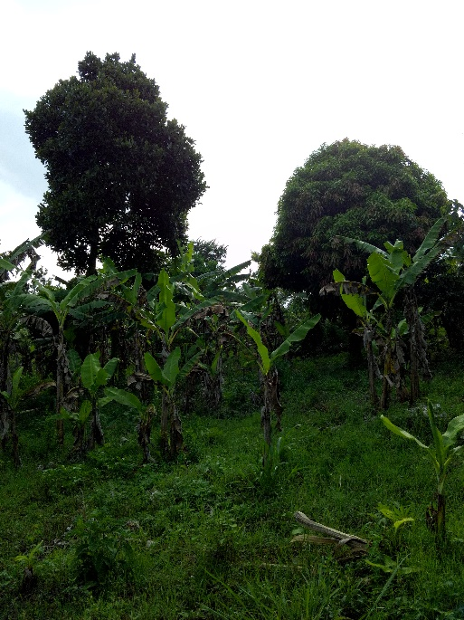

Sports and extra-curricular facilities
The home and school will require a football pitch and a basketball court which will also serve for net-ball and football at the start. Other sports facilities will be addressed in later years of operation.

Children maintenance
Children Mission Hope of Majose International home will require to provide a secure and conducive environment for the children as envisioned. The home will contribute to discipline with love and care as management will be in a better position to monitor all the children in an organized setting. This will also further improve their livelihood as they will participate in their food production i.e. in agriculture which will improve their life skills, since agriculture is the backbone of Uganda’s economy, they can be absorbed in the sector for employment.
Children maintenance will be in form of providing enough water, electricity, accommodation, meals, medical, education needs and other general operational costs as computed in the following tables below after
the last paragraph.
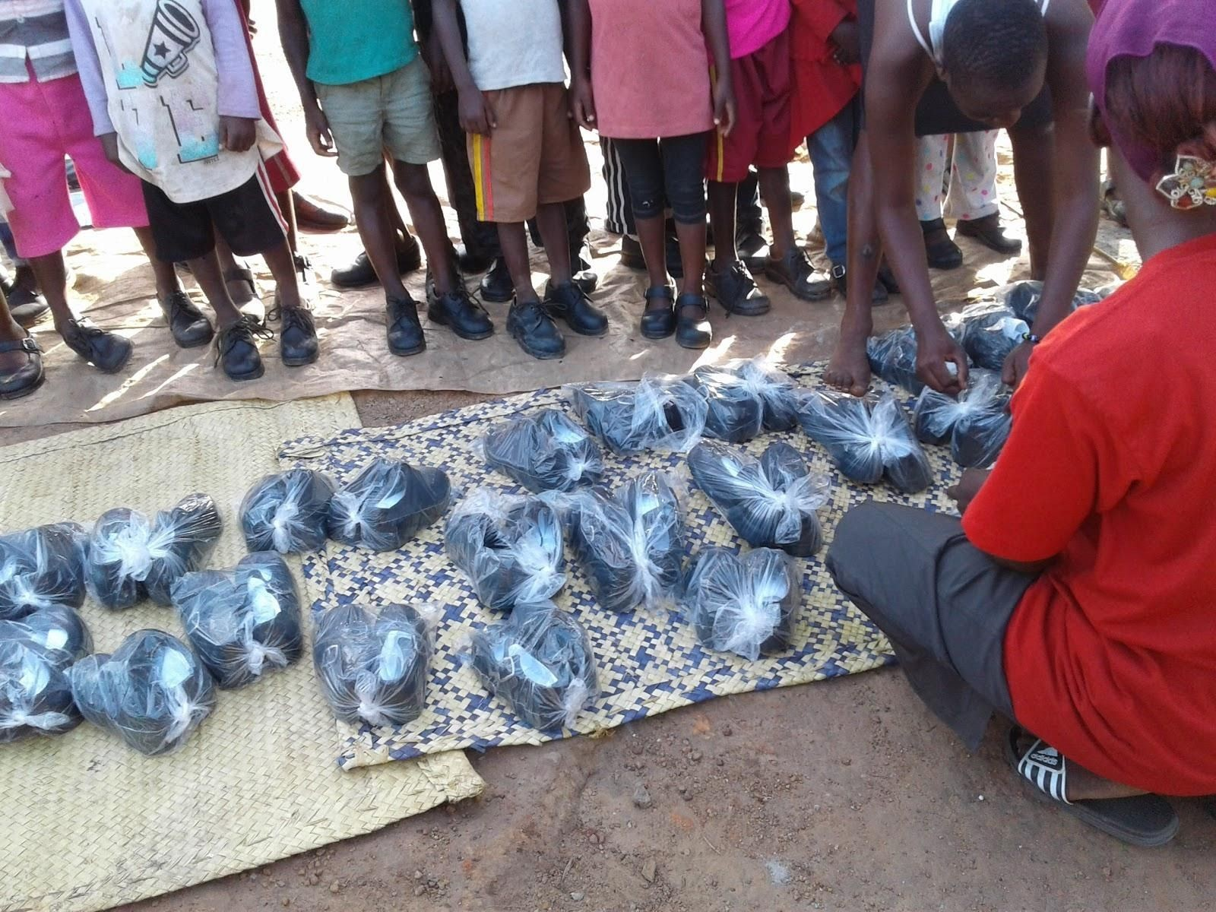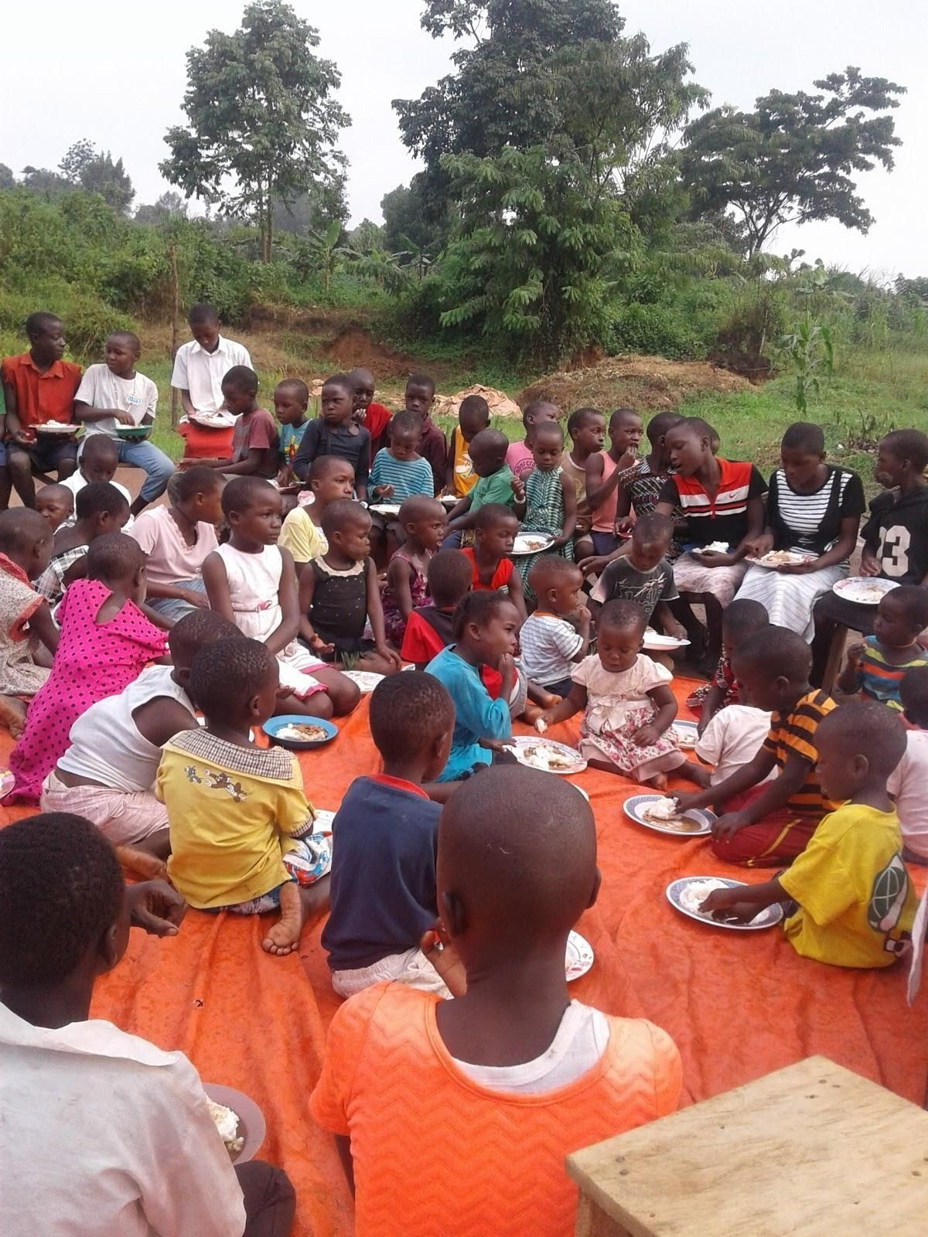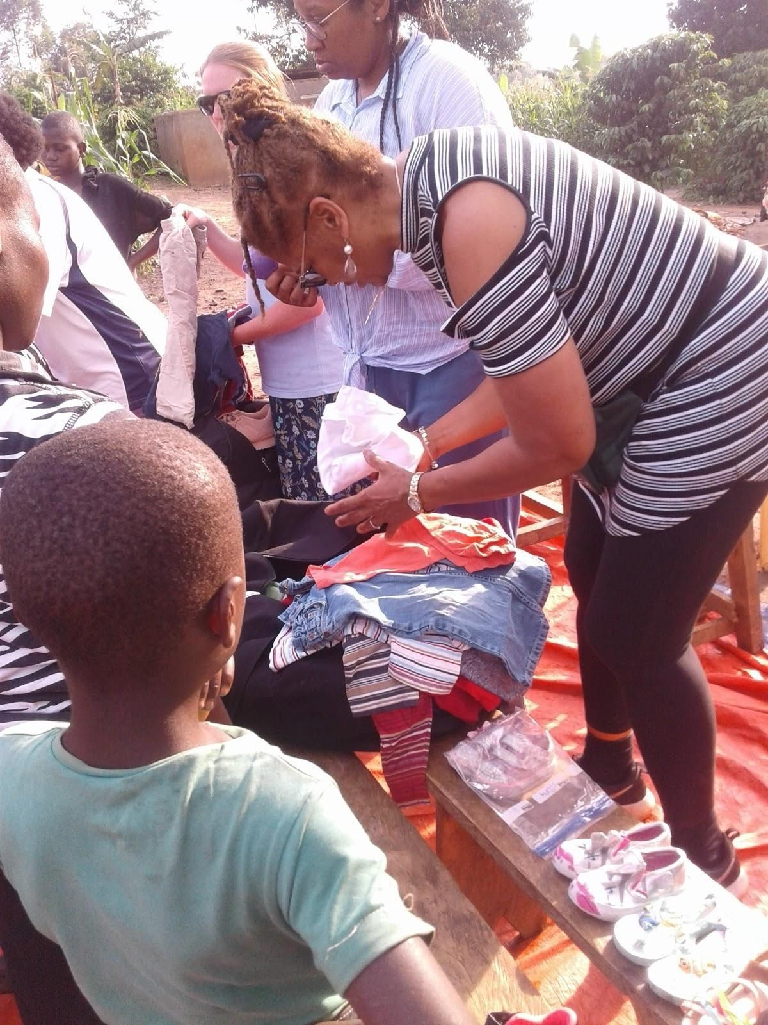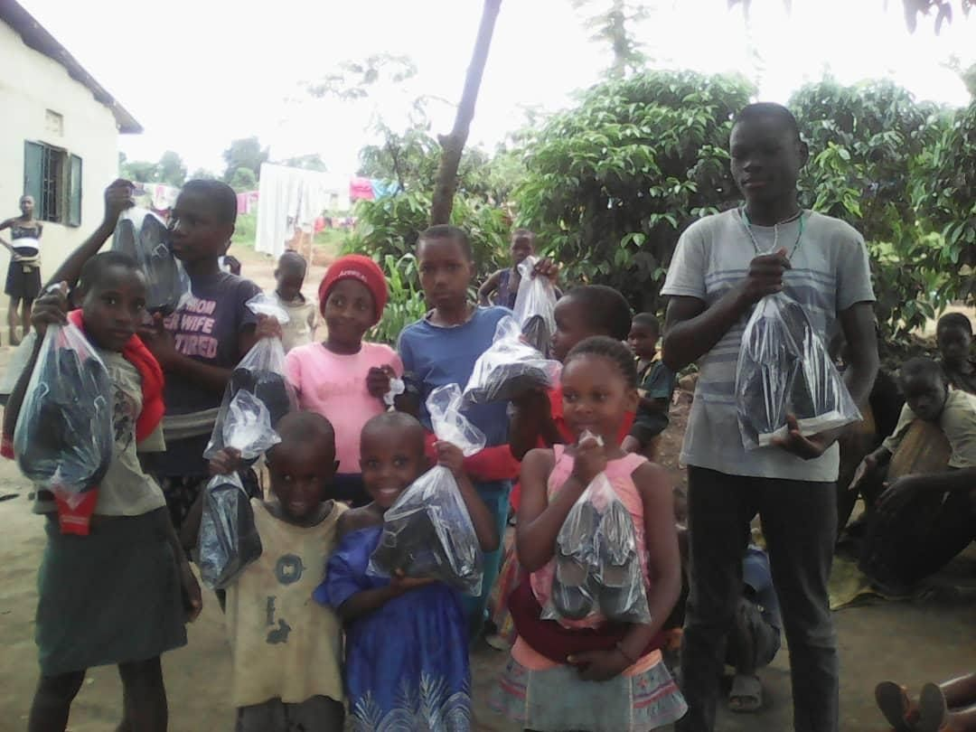

The above photos of children receiving shoes, clothing and having lunch as some of the basic necessities

Total Project Capital Requirements
Includes 8% contingency annually 2021 to 2023 Phase 1: Ugx 4,235,083,613 $ 1,210,023 2023 Phase 2: Ugx 1,922,400,000 $ 549,256 Total: Ugx 6,157,483,613 $1,759,281

Phase 1 Capital Requirements to be completed in two years (2021 to 2023)

Structure | Description and purpose | Cost
 |  | UGX | US$
2.Dormitor y blocks | Two blocks will be required; one for boys and the other for girls, each estimated to accommodate 110 children to provide room for future expansion of the program. | 1,500,000,000 | 428,571

Dining  Hall &  Kitchen | A dining hall is another important facility the Home and school will have. It will be designed to accommodate the entire school population of 220 students considering the future plan. | 650,662,193 | 185,903
Class  Rooms &  Administra  tion  blocks  (PHASE I CLASS  ROOMS &  OFFICES): | 12 classrooms will be built in Phase 1 to be able to cater for the needs of the current children we have. The  Admin Block connected with classrooms will have 3 Offices and a Staff Room. Each class will be accommodating a maximum of 40 students per guidelines from the Ministry of Education forecasting the future plans. | 1,604,061,523 | 458,303
3 Lined 4-  Stance  Latrines | There will be 3 Pit  Latrines well  distributed on the home school Campus to serve the home during shortage of water supply and for | 66,650,000 | 19,042
 | effective and efficient sanitary material/waste disposal.
External  Works | Drive ways linking the structures & Retaining walls including the water well. | 100,000,000 | 28,571

Contingenc y 8% | This includes consultancy services, solar and hydroelectricity connections. | 313,709,897= | 89,631
GRAND  TOTAL |  | 4,235,083,613/= | 1,210,023

Phases 2 Capital Requirements (2023 to 2024)

Structure |  | Description and purpose | Cost Ugx | Cost USD
2 Laboratory block (Two  Laboratories) – PHASE 2 |  | Two structures of two rooms each will be required to house the four Laboratories for | 930,000.000 | 265,714
 |  | physics, chemistry, biology & a computer laboratory. Under phase 2, two blocks will be constructed,
2 Workshop  blocks vocational studies  PHASE 2 | for  – | Two structure’s to accommodate four workshops for vocational studies will be required. 4 workshops (one for each of the vocational subjects) equipped with necessary tools will be required.  Under phase 2, | 850,000,000 | 242,857
 |  | Sub-total | 1,780,000,000 | 508,571
 |  | 8% contingency | 142,400,000 | 40,685
 |  | GRAND TOTAL  PHASE 1 AND 2 | 6,157,483,613 | 1,759,281

Due to a lack of proper accommodation and school facilities, the need for a genuine home and school buildings are a great necessity now and greater than ever. Sending a student to boarding school costs over $1,500 a year plus an additional $450 in transportation costs, welfare costs and staff time. This figure is only expected to increase in the years to come.

The Home presently accommodates 56 orphans on squatter’s land whereas the other 54 are living throughout the area. Currently the orphanage needs assistance right now. It is dependent on donations that at times are not consistent. The distribution of food, medical care and education also fluctuates and our desire is to provide stability in our children’s lives.

The current cost 2020-2023 for the maintenance of a child and the orphanage is as follows: (Before the completion of the Project)

Description and  Purpose | Cost Ugx | Cost USD
Feed a child for a month  -56 children a month.  -110 children a month | 125,000  7,000,000  13,750,000 | $ 36  $2,000  $3,928
Primary  Send a child to school for a quarter -5 children for a quarter  -10 children for a quarter  Secondary  Send a child to school for a quarter -5 children for a quarter  -10 children for a quarter | 130,000/=  650,000/=  1,300,000/=  270,000/=  1,350,000/=  2,700,000/= | $37  $186  $371  77  385  771
Cloth a child for a year (including uniform)  -10 children for a year  -20 children for a year | 237,000/=  2,370,000/=  4,740,000/= | $ 68  $ 677  $ 1,354
Medical for a child for six months -56 children six months  -110 children for six months | 330,000/=  18,480,000/=  36.300,000/= | $ 94  $ 5,280  $ 10,371
Maintenance of the orphanage for a month | 2,230,000/= | $ 637
Utilities of the orphanage for a month | 250,000/= | $ 71
Cost for seeds and planting of food for six months. | 2,700,000/= | $ 771

Provide a child with personal supplies i.e toothpaste, sanitary pads etc for  a month  -5 children supplies per month | 36,500/=  182,500/= | $ 10  $ 52
-10 children supplies per month | 365,000/= | $ 104
Primary  Provide scholastic materials a child for a term. -5 children scholastic materials for a term -10 children scholastic materials for a term  Secondary  Provide scholastic materials a child for a term -5 children scholastic materials for a term 10- children scholastic materials | 70,900/=  354,500/=  709,000/=  98,700=  493,500/=  987,000/= | $ 20  $ 101  $ 202  $ 28  $ 141  $ 282

The projected cost 2023 and beyond for the maintenance of a child and the orphanage is as follows:

Description and  Purpose | Cost Ugx | Cost USD
Feed a child for a month.  -110 children a month | 137,500  15,125,000/= | $ 39  $ 4,321
Primary  Send a child to school for a quarter -5 children for a quarter  -10 children for a quarter  Secondary  Send a child to school for a quarter -5 children for a quarter  10 children for a quarter | 180,000/=  900,000/=  1,800,000/=  351000/=  1,755,000/=  3,510,000/= | $ 51  $ 257  $ 514  $ 100  $ 501  $ 1002
Cloth a child for a year(including  Uniform)  -10 children for a year  -20 children for a year | 310,000/=  3,100,000/=  6,200,000/= | $ 86  $ 886  $ 1772
Medical for a child for six months | 71,500/= | $ 20
110 children for six months | 7,865,000/= | $ 2,247
Maintenance of the orphanage for a month | 2,899,000/= | $ 828
Utilities of the orphanage for a month | 325,000/= | $ 93

Cost for seeds and planting of food for six month | 3,510,000/= | $1,003

