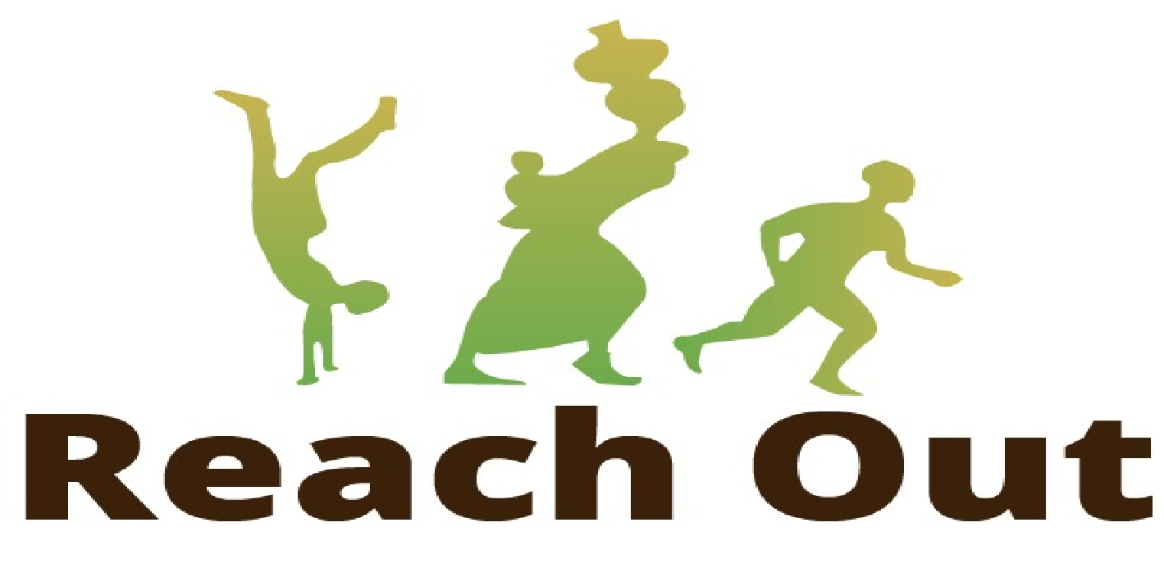

GLOBAL GIVING
JANUARY 2022 REPORT.

- BACKGROUND
In the last quarter of 2021, the humanitarian needs of the South-West region of Cameroon increased due to a Cholera outbreak in Bamusso amidst the ongoing humanitarian crisis. Reach Out swiftly acted as first-responders to the outbreak with funds from Global Giving. A mobile clinic was dispatched to the endemic area comprising of a Medical Doctor, Laboratory Scientist, two Nurses, and a WASH officer to provide emergency healthcare assistance to the affected population.
Meanwhile, in January 2022, activities of the Community Health Workers (CHWs) in Ekondo Titi continued. A summary of their activities is included in this report.
- Project Goal
To provide free primary healthcare services to people in vulnerable communities affected by the ongoing humanitarian crisis in the North-West and South-West regions of Cameroon.
Project Objectives
- To support two (2) CHWs in Kitta, Ekondo-Titi Health District to provide free primary healthcare services to those in need.
- To perform surveillance on diseases prone to outbreaks in Kitta and Tole.
- Results
The Community Health workers in Ekondo Titi provided primary health care services to 117 vulnerable persons in Kitta. These services included the treatment of uncomplicated common infections/diseases through the provision of essential drugs, referral of complicated cases, immunization of children, proper nutrition for children <5 years, maternal and child health and education about common diseases with guidelines for prevention and control. Results from activities carried out are grouped under Health, Sensitization and Nutrition.

3.1 Health Data
In Kitta, CHWs received 117 persons (58 males, 59 females) who had health challenges in January 2022 with 59 children <5 years (29 males, 30 females) being the majority. CHWs provided essential drugs to treat 29 persons for uncomplicated malaria,15 persons for acute respiratory tract infections and 33 persons for acute diarrhea. Vitamin A and Albendazole was administered to 32 children (19 males,13 females). CHW also assisted in 1 delivery within the community and distributed 3 maternal kits to pregnant women and lactating mothers. A summary of Health data is presented in Table 1 found in the attached document.

Table 1: Health Data from CHWs in Ekondo Titi
Indicators | < 5years |  | 5 – 17 years |  | 18 – 59 years |  | > 59 years |  | Total
Indicators | Males | Females | Males | Females | Males | Females | Males | Females | Total
# People received for health problems by the CHW | 29 | 30 | 24 | 24 | 5 | 5 | 0 | 0 | 117
# People with health problems referred to the health facility by CHW | 0 | 0 | 0 | 0 | 0 | 1 | 0 | 0 | 1
# of malaria suspected cases received by CHW in the community | 17 | 18 | 17 | 17 | 0 | 1 | 0 | 0 | 70
# of suspected malaria cases who benefited from an RDT in the community | 11 | 13 | 8 | 10 | 0 | 0 | 0 | 0 | 42
# of suspected malaria cases who who tested positive with RDT in the community | 8 | 10 | 5 | 6 | 0 | 0 | 0 | 0 | 29
# of uncomplicated malaria cases confirmed and properly treated in the community | 5 | 7 | 2 | 4 | 0 | 0 | 0 | 0 | 18
# of complicated malaria cases referred to a health facility by CHW | 0 | 1 | 0 | 0 | 0 | 0 | 0 | 0 | 1
# pregnant women referred to health facility | 0 | 0 | 0 | 0 | 0 | 1 | 0 | 0 | 1
# Number of deliveries within community | 0 | 1 | 0 | 0 | 0 | 0 | 0 | 0 | 1
# Children provided E. drugs for ARI | 6 | 4 | 3 | 2 | 0 | 0 | 0 | 0 | 15
#people with drugs for acute diarrhea | 6 | 8 | 5 | 5 | 5 | 4 | 0 | 0 | 33
# People provided anti-malaria | 8 | 10 | 5 | 6 | 0 | 0 | 0 | 0 | 29
# Children 6 months – 15 months of age provided vitamin A and worm therapy | 19 | 13 | 0 | 0 | 0 | 0 | 0 | 0 | 32
# PLWs provided with maternal care kits | 0 | 0 | 0 | 0 | 0 | 3 | 0 | 0 | 3

3.2. Sensitization Data
CHWs in Kitta provided health sensitization to their host communities on proper health-seeking practices vital to prevent diseases common in their communities. A summary of the attendance of these educational talks in Kitta from the month of December 2021 to January 2022 is summarized in Table 2 of the attached report. Educational talks were given on topics like proper handwashing water, purification and preservation, and proper waste disposal.

Table 2: Number of people sensitized by CHWs in Ekondo Titi
Indicators | < 5years |  | 5 – 17 years |  | 18 – 59 years |  | > 59 years |  | Total
Indicators | Males | Females | Males | Females | Males | Females | Males | Females | Total
# People provided with education on handwashing | 14 | 17 | 57 | 53 | 21 | 27 | 0 | 0 | 189
# People provided with education on water purification and preservation | 0 | 0 | 57 | 64 | 19 | 24 | 0 | 0 | 164
# People provided with education on waste disposal | 15 | 9 | 66 | 56 | 17 | 22 | 0 | 0 | 185
# People provided with education on proper latrine use | 17 | 6 | 63 | 51 | 18 | 20 | 0 | 0 | 175
# People provided with education on malaria and the use of LLNS | 0 | 0 | 74 | 55 | 18 | 21 | 0 | 0 | 168
# People provided with education on diarrhea prevention | 0 | 0 | 72 | 53 | 19 | 20 | 0 | 0 | 164
# People provided with education on A.R.I prevention | 22 | 0 | 65 | 50 | 20 | 22 | 0 | 0 | 179
# of girls provided with menstrual hygiene education | 0 | 0 | 0 | 3 | 0 | 2 | 0 | 0 | 5

3.3. Nutrition Data
The CHWs performed routine mid-upper arm circumference (MUAC) screening for 32 children (19 males, 13 females) between the ages of 0-5 years during routine home visits in Kitta. No cases of Severe Acute Malnutrition were identified with or without complications. However, 3 caregivers of infants and young children were sensitized on proper feeding for these groups.

- STORY OF GLOBAL GIVING IMPACT IN BAMUSSO
How My Canoe Boy Didn't Die Of Cholera
“Good day, my name is E.A. I am a canoe master and a fisherman. I am from Akwa-Ibom state in Nigeria. I have been fishing in Cameroon for over 25 years. When I heard about this disease called cholera, I thought as everyone that it was caused by evil spirits. After fishing, I and my canoe boy will pray to God to protect us from the evil spirit. I finally understood the importance and severity of the disease when it affected my canoe boy. In a few hours, I could not recognize him. He had lost a considerable amount of weight; one could literally count his bones. Fortunately, the Reach Out Mobile clinic team sponsored by the Global Giving crowdfunding platform, had engaged in an emergency cholera response in Bamuso. They were the first to respond by providing medical care to persons who are infected with cholera.
So, I boarded my canoe and rushed him there. I had just Three Thousand Naira (approximately 8 USD) on me and was ready to borrow more to keep my canoe boy alive. When I arrived at the health center, the treatment provided was free. This was unbelievable! I have always known for every disease; a charge is required considering the cost of education for medical doctors. They immediately took him in, provided all the necessary care, and within eight hours, he could eat and sit by himself. I am so grateful to the Reach Out mobile clinic Team and the Global Giving crowd-funding platform for coming to our aid.
“I pledged to use my canoe to bring anyone who is infected with this deadly disease to the hospital as my appreciation for your generosity while following guidelines for prevention recommended by the mobile clinic team.”
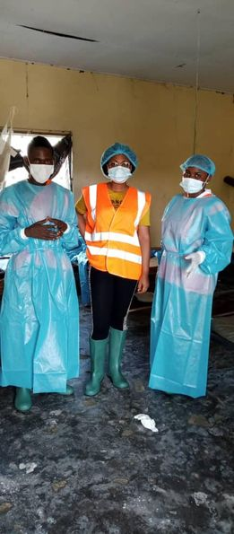
Mobile Clinic team
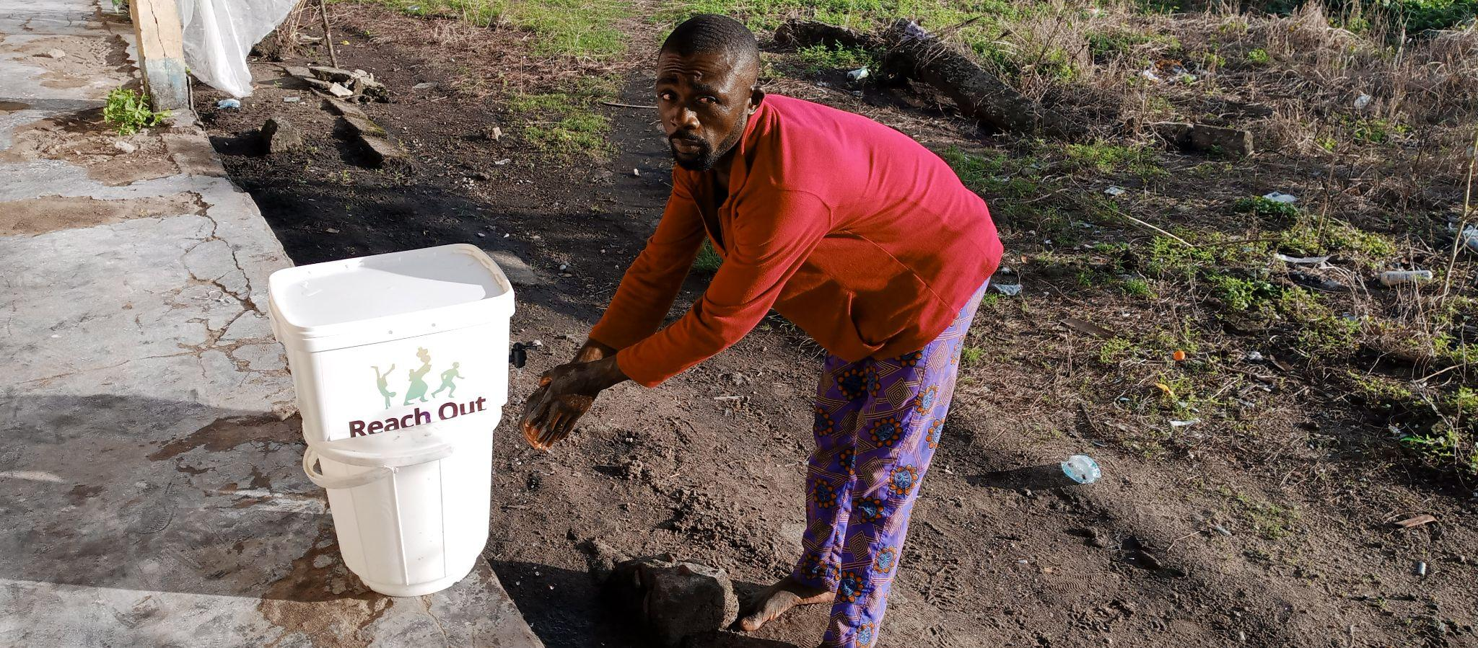
E.A complying to Cholera prevention techniques after being sensitized by the REO mobile clinic team using a Washstation provided by team’s sponsors.

- Challenges
- Insecurity from the NSAGs group in Kitta.
- Mobile Communication challenges between CHWs and project managers leading to delayed submission of reports.
- CHW has no mobile phone to provide JPEG image reports of activities in the Kitta.
- Recommendations
- A mobile phone should be purchased for the CHWs to send JPEG image reports of field activities.
- Allocate a monthly budget of 5000 frs to CHW to make 2 trips to field office to avoid late submission of reports
- Conclusion
The people of Bamuso and Ekondo titi extend their heartfelt appreciation to the sponsors of the activities of REO mobile clinic team and CHW.

