SUMMARY NEWS PIECE FROM FOCAGIFO HOPE INSTITUTE (JAN –FEB 2021)

Introduction
This is a summary of what has happened at the FOCAGIFO Hope Institute since January 2021. This summary news Piece includes activities that have taken place, challenges encountered, Plans for this term and our Plea.
Acknowledgement
I would like to acknowledge the support received from USA friends towards the establishment of a temporary Library space for the youths and the Education of Nakato Aisha- a vulnerable girl child with a strong vision impairment who is being supported by FOCAGIFO to attain Formal education. I would also like to appreciate the support from Friends in UK (Wales and Oxford) towards the sponsorship of the Youths at FOCAGIFO Hope Institute. I appreciate the FOCAGIFO Parents who have struggled to send back their children to us amidst very serious Covid19 effects. I appreciate the Staff who have also chosen to return to FOCAGIFO in the new year to continue serving the young People. Last but not least, I appreciate the FOCAGIFO Executive Board for the continued guidance to the Management.

Accomplishments
In this short period, we have accomplished the following:

- Received FOCAGIFO Finalists back from their holidays
Due to the Corona Virus pandemic, the academic year 2020 was interrupted right from March when the President pronounced a lockdown on all almost all Institutions including Educational Institutions to which we belong as an Institute. Consequently all the youths were sent home until October 2020 when only finalists were allowed to return for their second term. This term run from October to December 2020. This year, we are excited that these finalists have returned for their third (final) term in which they will do their National Examinations to end the Course. A Total of 27 (13 Male and 14 Female) students will finalise their courses this term.

- Registration of new Students
At the Start of this year, the Ministry of Education and Sports gave guidance on this academic year’s calendar and Vocational Institutions were allowed to open for new students on 1st March 2021. FOCAGIFO is therefore registering new students who will enroll and study with those students who had just joined in FEB/March 2020 before they were sent back on a lock down. So far, a total number of 27 (7 male and 20 female) have registered and are confirmed. We will continue to receive applications for this year up to 31st March 2021.

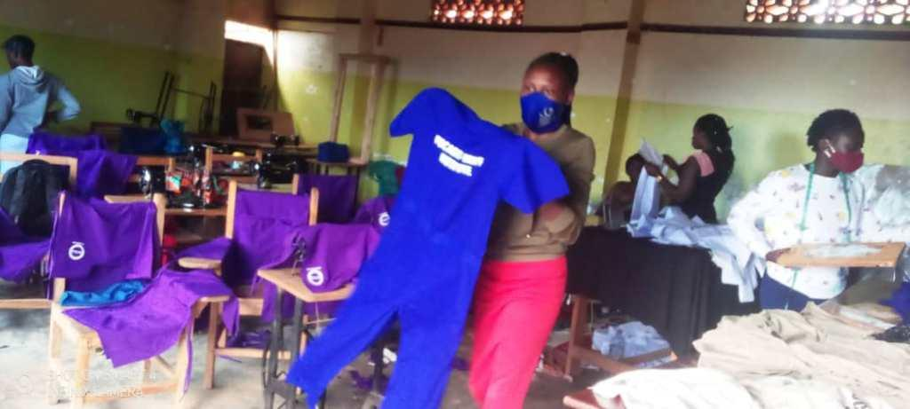
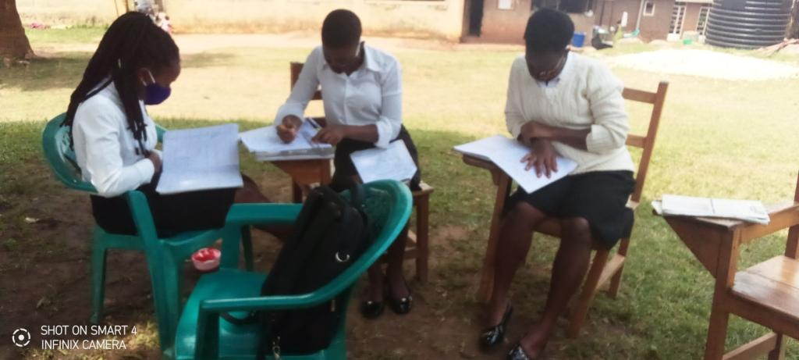
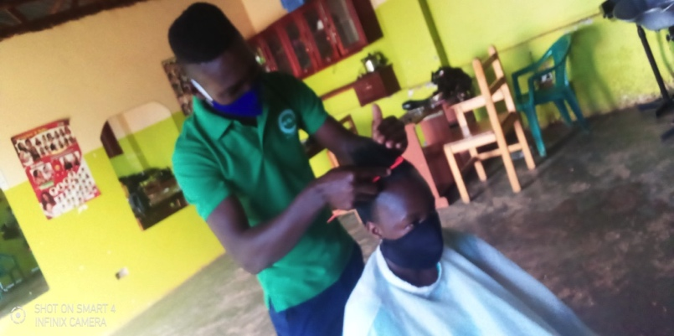
Some of the Catering Students doing personal reading under a tree shade
A Hair dressing Student working on his Client
The Fashion & Design Class working on Students’ Overalls

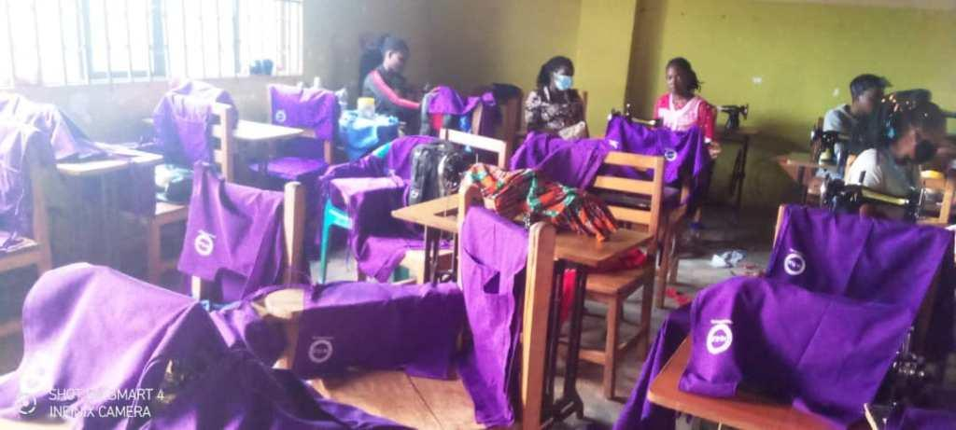

The Fashion & Design working on Students’ Aprons

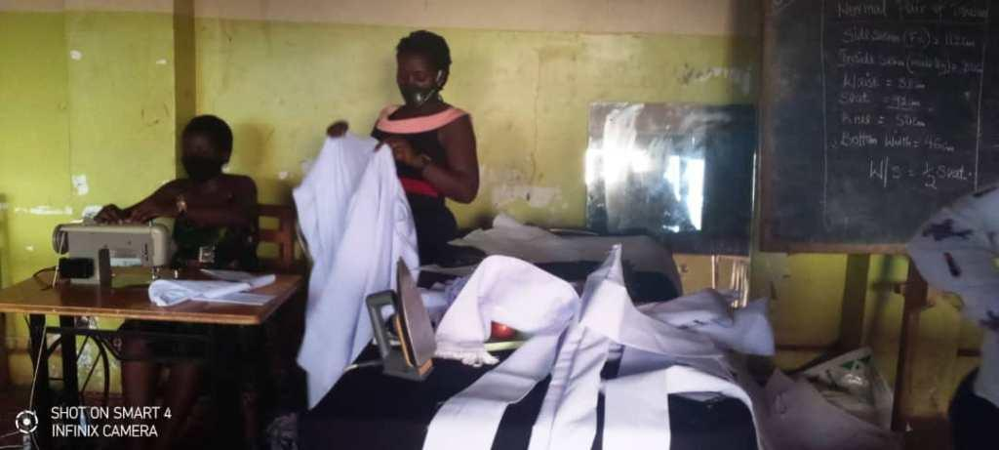

The Fashion and Design Class designing
Clerical Robes

Harvest of Maize from the FOCAGIFO land in Semuto
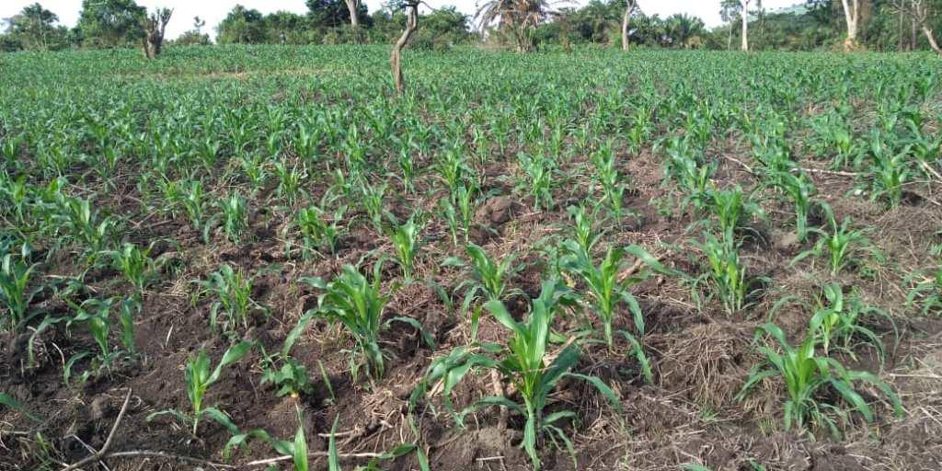
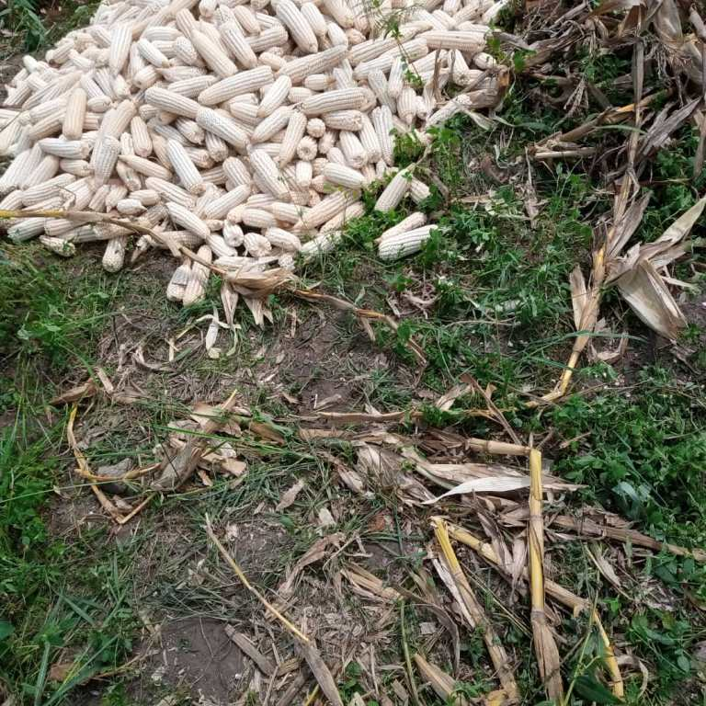
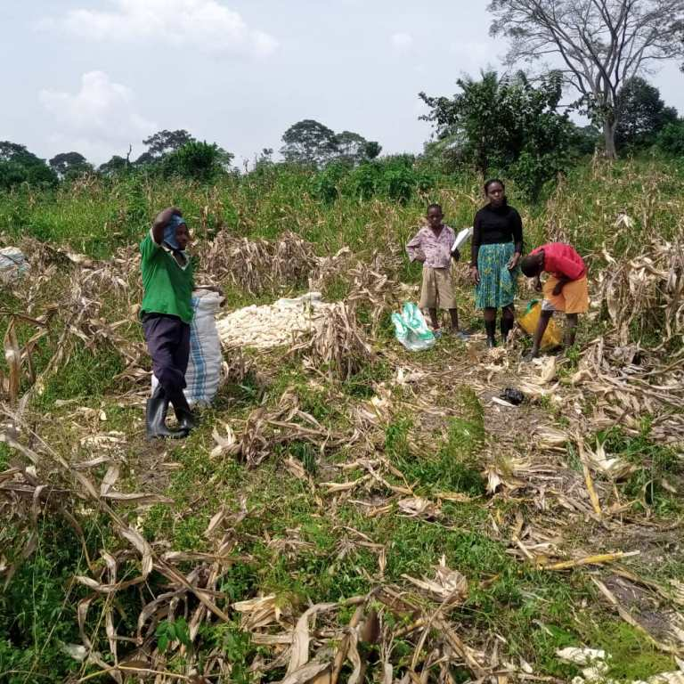
Around August 2020, I informed you that FOCAGIFO had tilled part of her land at Semuto to grow maize and Cassava to supplement on the Institute food. I am very excited to share that we harvested our first season which did fairly well with the products. After all the processing, we now have 25 bags of ready maize flour available for Students consumption. This food will cover both this term and the next term.
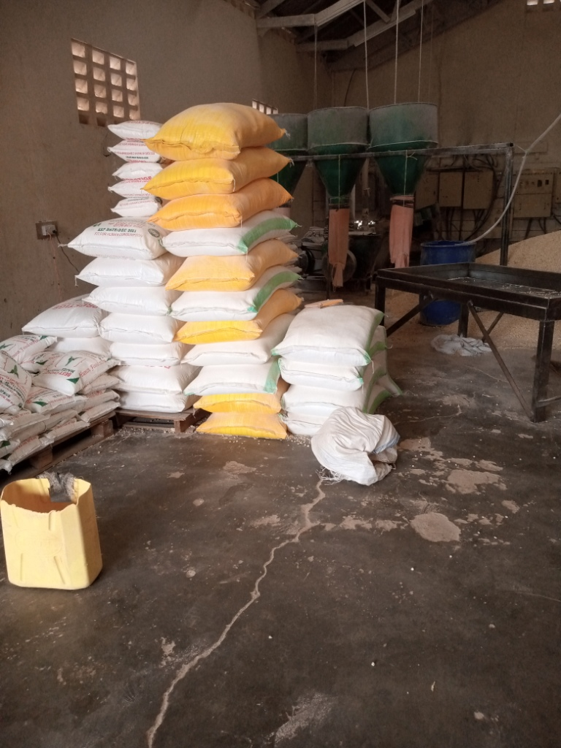
Some Maize after harvest
Part of the maize being harvested
Our maize at an early stage

Part of our Maize Flour after processing at the Maize Mill

- Establishment of the Library Space
Since our big plan to construct a very good library for the Institute is not yet resourced, FOCAGIFO decided to create a temporary reading space. We are humbled by Dr Karin’s efforts in raising resources that have supported this work. We turned our reception/lounge to a Library. We have had to block the entry door through the reception to other offices and instead created totally a new entry through the parking area. We repainted the reception and re arranged it to suit the reading purpose. We have also got some copies of text books to Start on the equipping of the Library and are now working on new Chairs for this purpose also. Although it is not yet complete, the place is now comfortable for use and Students have started using the establishment.
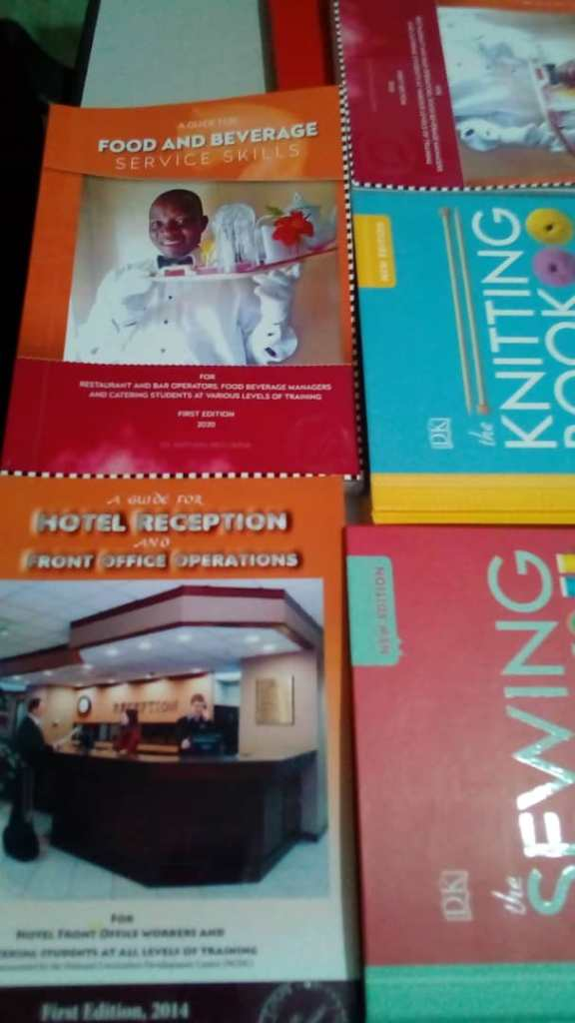
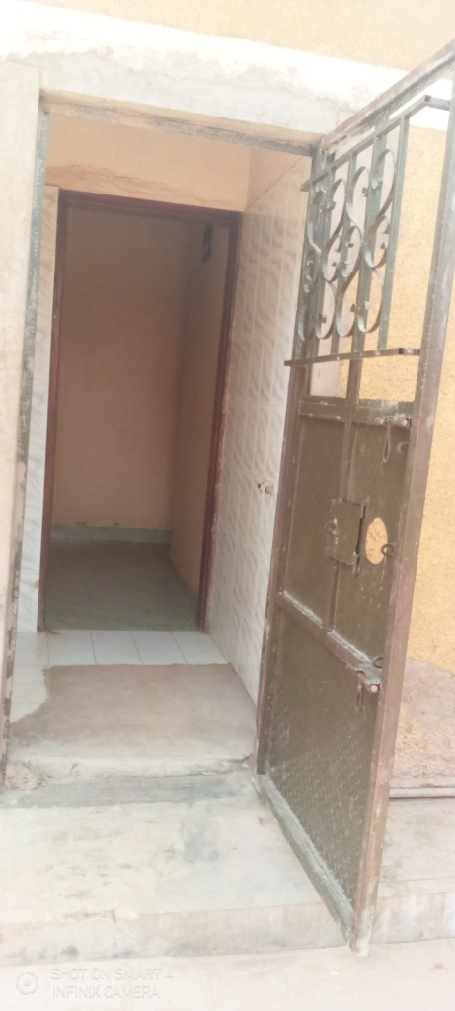
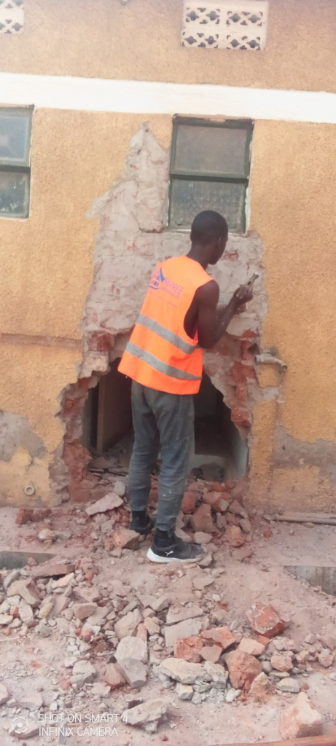
Some of the text books purchased in this phase
The newly created entry ready for use
A builder creating an alternative entry into the Offices
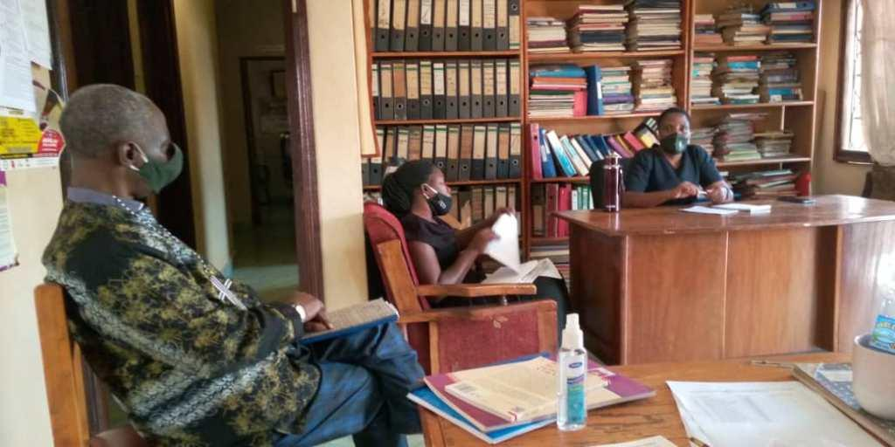

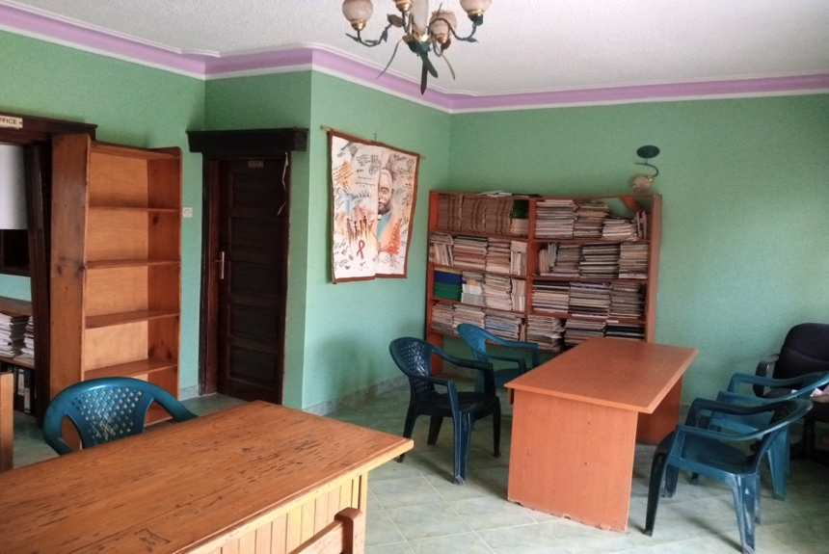

The Reception area before renovation and re-arrangement

The newly painted reception area which will serve as students and Staff Library

Challenges
Lots of issues are still challenging and these include but are not limited to the following:
- The Corona Virus Pandemic and its effects have heavily affected the Institute Operations. This is clearly evidenced in the numbers of the Students who have dropped off the Training Programme. Where as we had 50 finalists at the onset of lockdown last year, only 27 have been able to return to complete their respective courses. In addition, FOCAGIFO had registered a total number of 60 New students in March 2020 when lockdown set in but up to now only 27 have returned.

- Inadequate Library Equipment: The Text books for technical education are exorbitantly expensive and we have only been able to get 12 copies of new text books to add on what we previously had. Having a functional standard Library requires lots of books, journals, magazines and the like. Although FOCAGIFO has a big stock of books and such materials, most of them are related toHIV & AIDS, Theology, Sociology and Political Education. We therefore need to do more stocking of the Technical/Vocational Education books.

- Need to update the Vehicle for Automotive Technology Practice: For about 3 years now, the Automotive Department has presented the need for a better motor vehicle which they can use for Practice and exams. This is because the existing vehicle is so old and outdated and most times lacks the relevant components for Practice and Assessment.

- Low numbers of students: Due to the effects of Covid19, our enrollment is still low and yet this affects the Institute Operations whose operational costs are usually very high. We are grateful to Ms. Sally Hubbard who mobilized resources part of which has helped us to advertise the Institute. We have brought in more fees subsidies and we will continue to do more publicity to attract more students into the Institute.

Plans for the Term
- We will have Guild Campaigns and Elections soon
- We will start the 2nd set of National Examinations in March 2021. The first set was concluded last Friday and these were exams from Makerere University for the Finalists in the Early Childhood Development
- We plan to Plant food again at Semuto in the coming Season
- We Plan to do more publicity for the Institute to raise a minimum of 200 students for this year
- We are scheduled to implement a 3months’ training of Women and Youths (30 in Number) with support from the Government of Uganda – Ministry of Education and Sports

CONCLUSION:
We remain indebted to you our friends for all the support towards the running of FOCAGIFO Hope Institute! It is a tough period for the globe but we are grateful that you have not abandoned the Youths at FOCAGIFO. We remain committed to transparency and empowerment of the Young People with Skills relevant to their living and thriving!

Ruth Ninsiima Mbalinda
PRINCIPAL

