PROJECT REPORT FOR 3RD AND 4TH QUARTERS 2023

Ibadan Grammar School is a scarcely funded government high school which is situated in a catchment area where family resources are poor, and the economic landscape is highly deficient. In spite of this severe economic background, parents are adamant about sending their children to school and their wards are equally determined to acquire education and take advantage of the opportunities given to them. Sometimes, the students appear in school without the mandated school uniforms and other paraphernalia. At other times, they refuse to show up in school either because their parents could not afford the school fees or are unable to provide the necessary tools such as books, stationery and unforms.

Ibadan Grammar School Old Students Association NA, Inc (IGSOSANA) continues to actively engage with the school in respect of the academic performance of the students, development of badly needed physical structures, upgrading the quality of faculty as well as the welfare of indigent students whose parents can barely support their wards in school.

In the past 6 months, we have executed the following programs with the support of our donors: -

- BOOK DRIVE & E-LEARNING: Mathematics and English textbooks were given to over 100 Senior Secondary School students so that they can have references to help them in and outside the classroom. We were also able to support computer workshops for some of the students.

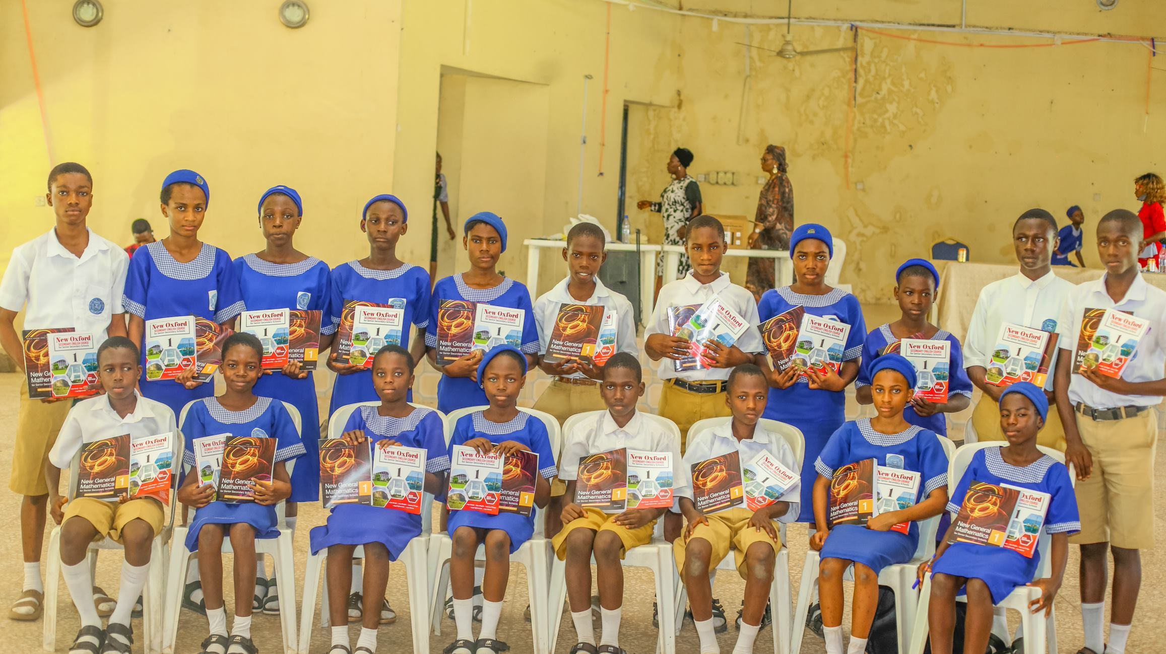

↑↑ Some of the above students would have had difficulties coping with their schoolwork without these textbooks. With more donor support, we are hoping to be able to extend this program to other subjects and to more students. Our ultimate objective is to provide necessary infrastructure which will give the students access to virtual textbooks and on-line education.

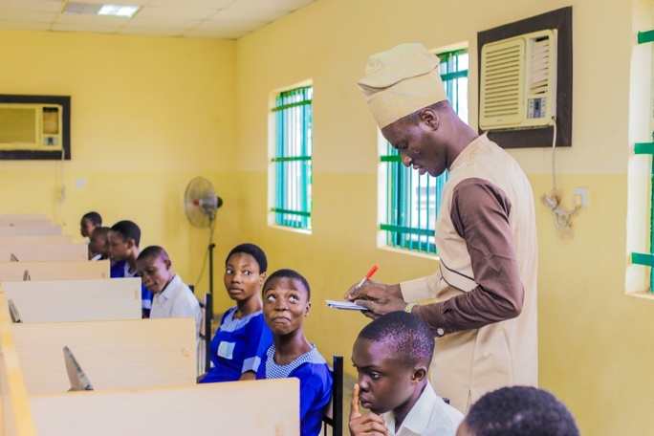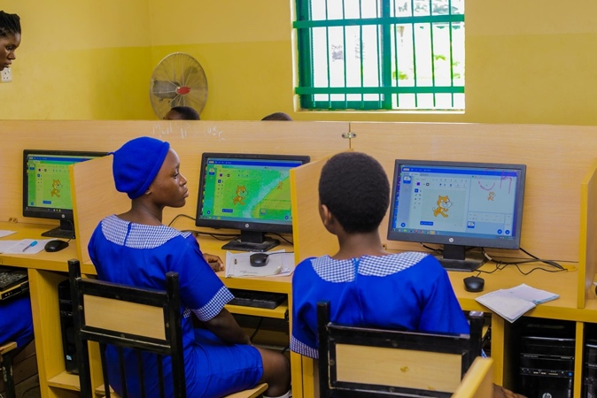
↑↑Students in the Computer Laboratory

- PRIZE GIVING EVENT 2023: This event, which was held in November was a huge success. The Association disbursed over $4000 worth of prizes for deserving students. Thanks to all our Donors who made this possible.

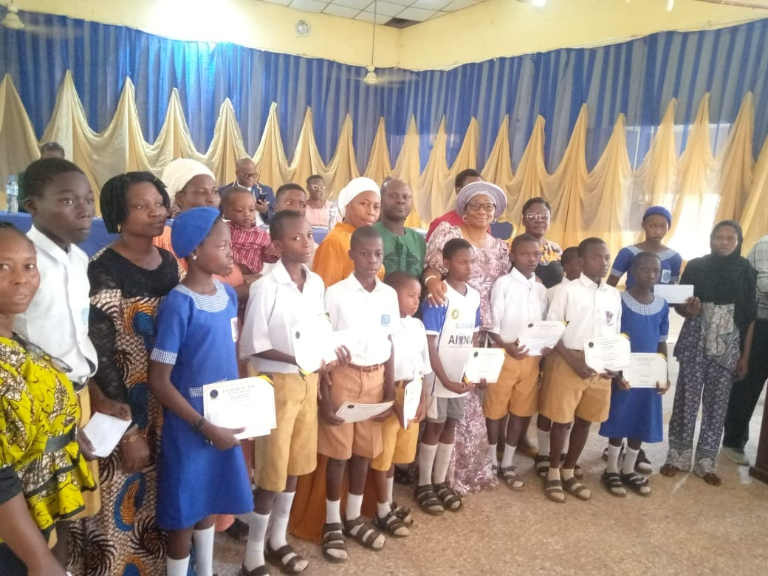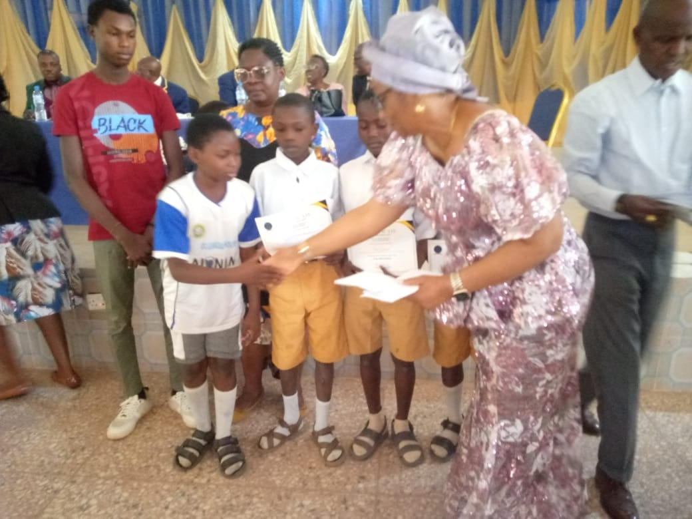

↑↑ Prize Giving 2023

- UNITED NATIONS INTERNATIONAL GIRL CHILD DAY: IgsosaNA made adequate provision for this day to be celebrated by the female students. A presentation on Digital Safety in Girls’ World was delivered. The problems encountered with Phishing in the digital environment was highlighted and the girls were taught how to prevent and deal with phishing scam. This program was hosted by Ibadan Grammar School, but other schools joined virtually.

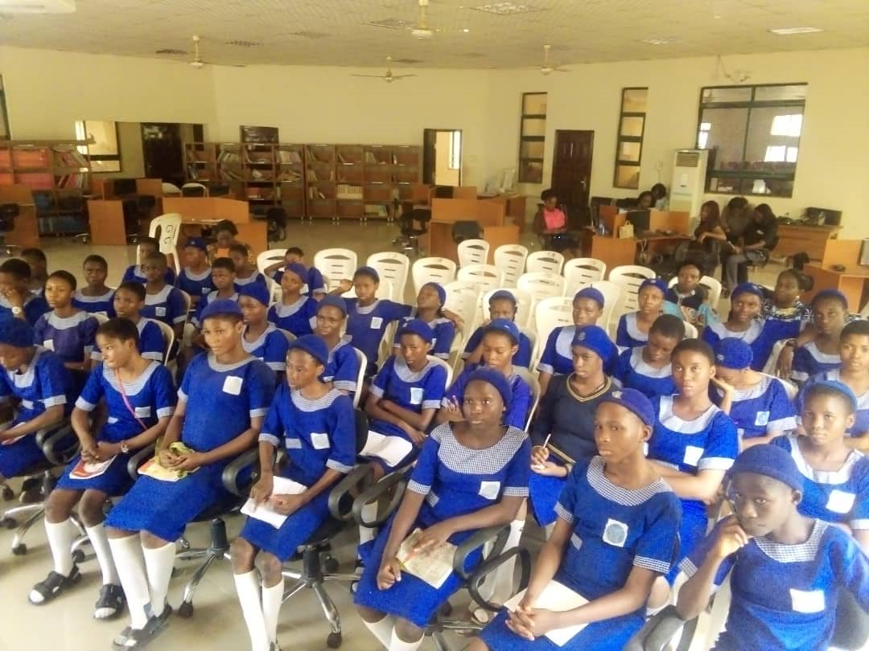

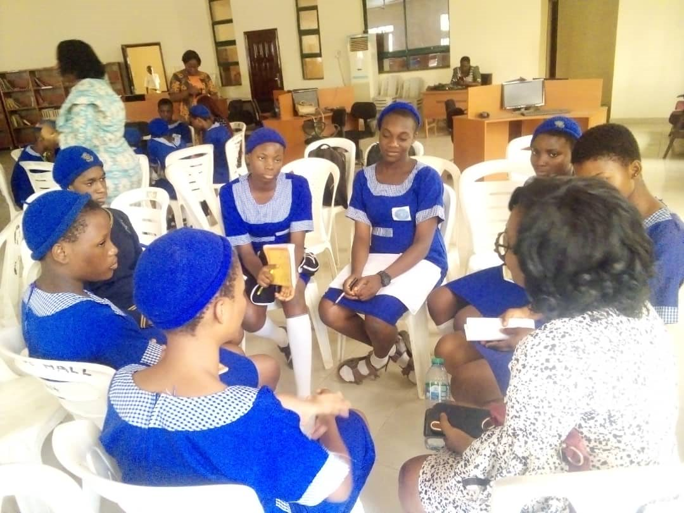
↑↑Some of the participants at the United Nations International Girl Child Day

- ACADEMIC STAFF: Owing to the huge support provided by our Donors, IgsosaNA continues to be responsible for the employment and payment of salaries for six additional teachers in specialized subjects such as Mathematics, Further Mathematics, Chemistry, English/Literature, Physics, History, ICT, and Technical Drawing to supplement the pool of teachers hired by the government. A special development programme is being designed for 2024 and we are hoping to get the full support of our Donors for this important initiative.

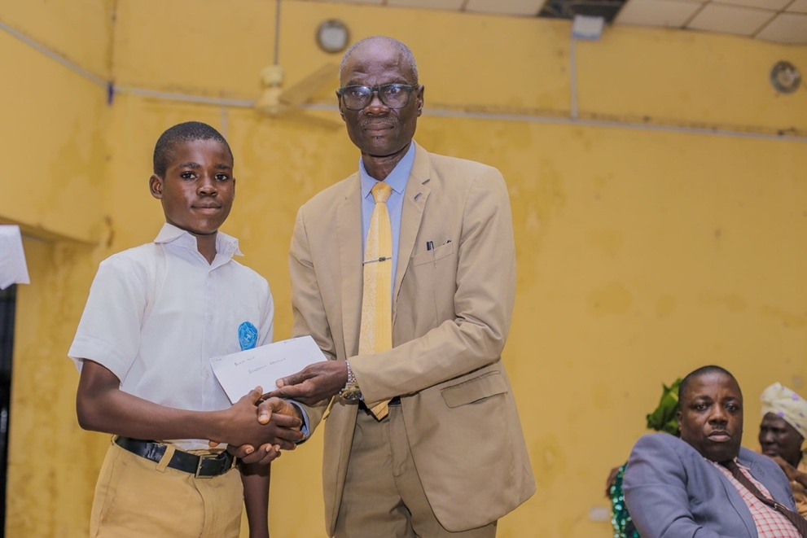
↑↑ The School Principal with one his students and another Teacher seated.

