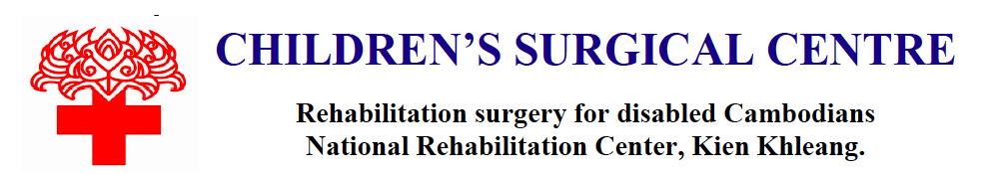
Quarterly Report January 2022
WHO WE ARE
CSC aims to improve the quality of life for disabled poor people by providing free rehabilitation surgery. Integral to CSC’s mission is a program of training local surgeons and hospital staff by international experts – focusing on the development of sustainable surgical services.

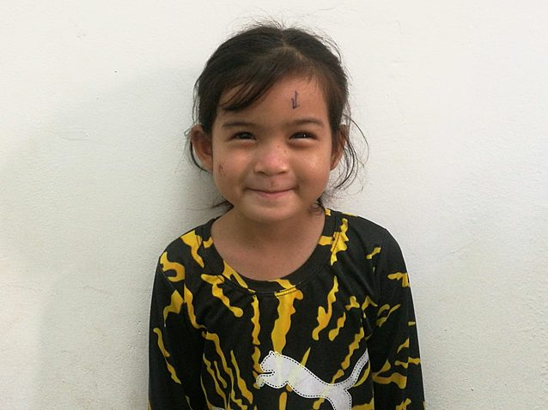  Her mother said: I feel very happy that my daughter's eyes can see everything clear so she can go to school, study hard and feel good about how her eye looks. I am relieved to no longer worry about damage to her eye. Thank you to everyone who took care of Vanny. | Meet Vanny  Vanny is a 5-year-old girl in the first grade. She lives with her parents in Svay Rieng Province, Cambodia. Her father is a taxi driver, and her mother is a garment factory worker. Vanny is an only child. Outside of school, she likes to play with her friends and draw.  One year ago, Vanny developed an entropion of the eyelids. This means that her eyelids turn inward, causing her eyelashes to scrape the surface of her eyes. It is difficult for her to open her eyes, and the condition causing tearing and irritation.  Vanny and her parents traveled four hours over rough roads to Children’s Surgical Centre to receive treatment. On November 9th, surgeons performed a corrective procedure to repair her eyelids. The surgery should permanently correct her condition so that she will no longer have her symptoms.

CHALLENGES
The COVID-19 pandemic hit Cambodia in early 2021; CSC activity continues to be lower than pre-pandemic because many patients are afraid or cannot travel to Phnom Penh, which was under lockdown much of the year 2021. Donations have fallen dramatically with many large donors ceasing support. As we continue our mission of training local surgeons and improving the quality of life for disabled Cambodians, every donation helps to pay for staff and supplies.

Our mission is to directly connect people through technology to access life-changing surgery. We are guided by the needs of our patients and strive to help them achieve health and meaningful change in their lives. CSC aims to improve the quality of life for disabled poor people by providing rehabilitation surgery.  THE ASK  Whatever you can give, please know we are grateful to receive it! Little acts of kindness can collectively make a big difference. Thank you for your continued support and for helping us through what continues to be several challenging years. | 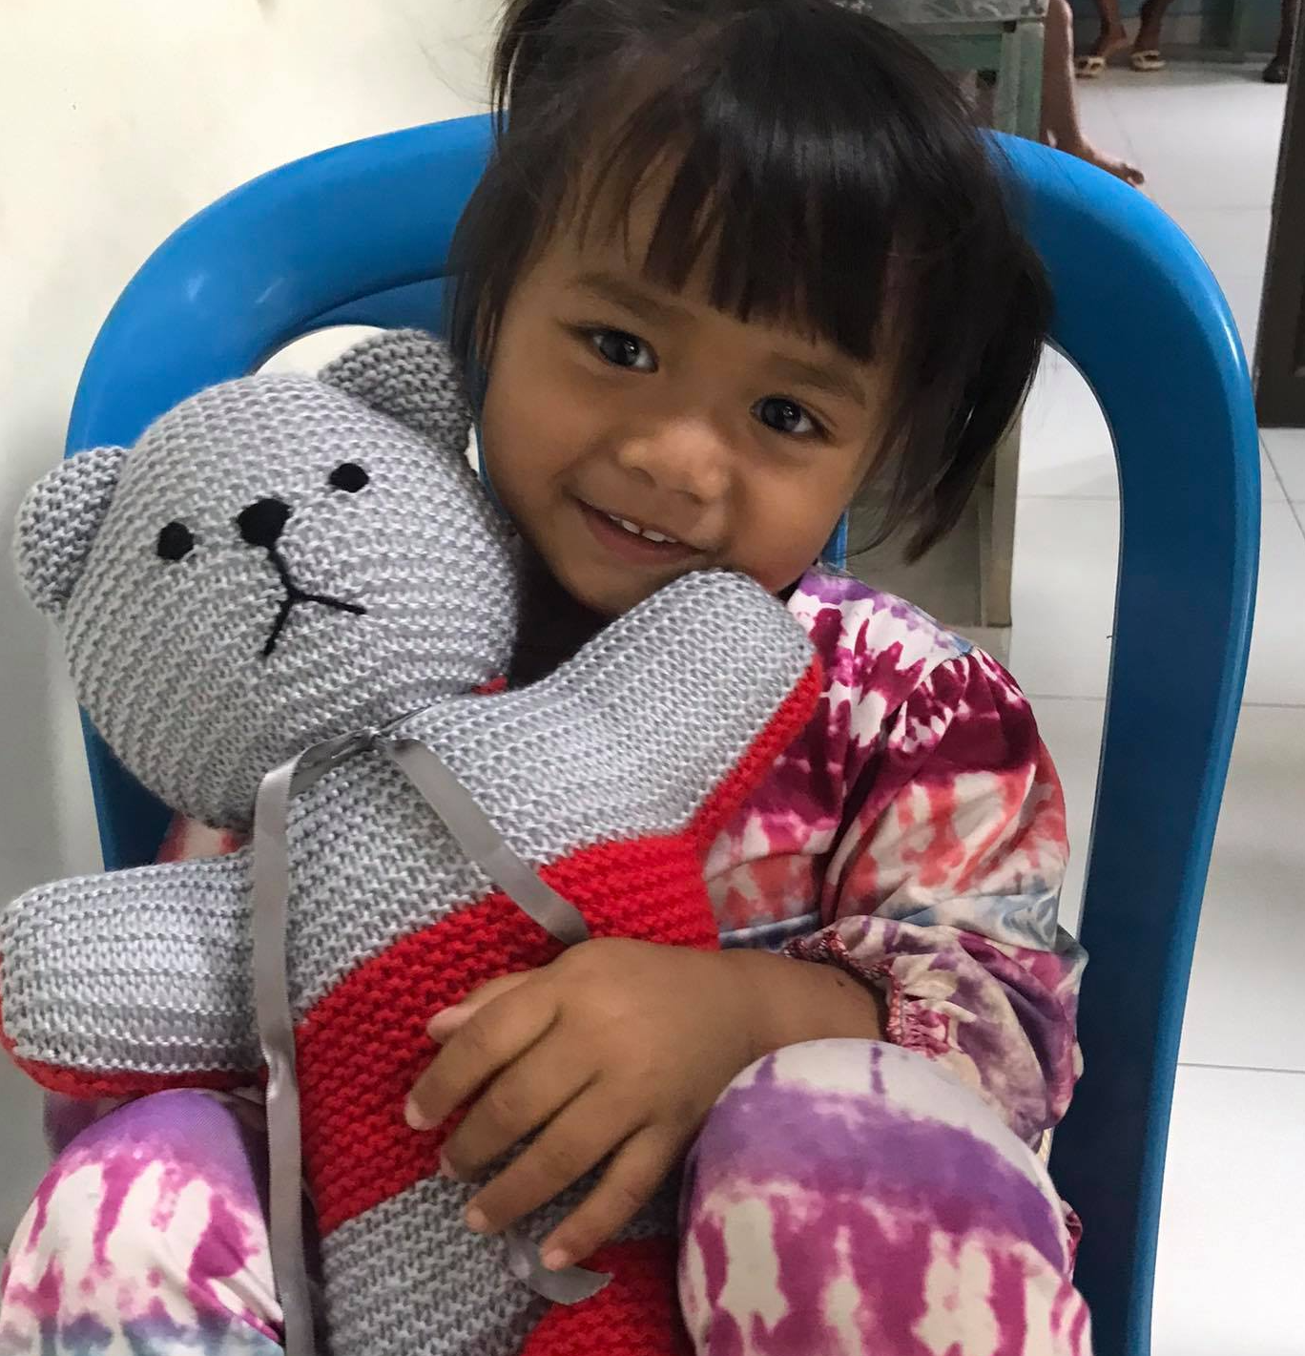

Please visit https://www.globalgiving.org/projects/build-hospital-wing-for-25000-disabled-cambodians/
to learn more about how you can help change the lives of thousands of Cambodians each year.
Children’s Surgical Centre (INGO), P.O. Box 1060, Phnom Penh, Cambodia (National Rehabilitation Centre, Kien Khleang, Route 6A, Chroy Changvar, Phnom Penh, Cambodia)
Tel/Fax: +855 23 430 202 – Email: info@csc.org – Website: https://www.csc.org/

