Play. Invest. Rebuild Childhoods.
Toybank’s Play2Learn Program Update Report
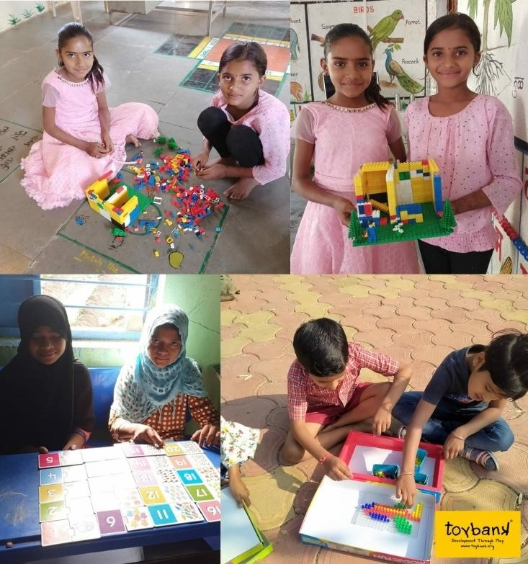
Children engaged in Play2Learn Sessions at Toybank Play2Learn Centers
in Zilla Parishad schools in Beed district of Maharashtra.
The new year brings us immense hope and energy. We take this opportunity to express our gratitude for the faith and backing our supporters have had in our work. With 2022 here and our rejuvenated spirit to continue our efforts towards making play a reality in the lives of our children, we wish you a safe and resilient 2022!

The pandemic has and continues to deprive 188 million at-risk Indian children’s happy and safe spaces of learning and play. We are humbled, yet take immense pride in our team who have ensured that the progress we have made for our children won’t reverse. Throughout 2021, we’ve seen noteworthy resilience in the ways our children tackled hardships and roadblocks to learn and play.

Toybank has been delivering its hybrid Play2Learn program to 60,000+ children across 12 districts in Maharashtra and 4 states and 1 Union Territory in India. The program guides and supports 13,695 caregivers through 581 support groups. (as of 31st December 2021).

Although 2021 was a challenging year, it was also a testament to the Power of Play in our children’s lives. As we ring in the new year, here’s a quick update of the work brought together over the last few months and a hope for the same to empower our children in the coming year.
We Played!
- We disseminated 1009 Play2Learn activities where children from various age groups and learning levels learned holistically with our curriculum-aligned activities. Our Play2Learn activities helped children work on their anxieties due to distressing news and online learning during the pandemic, helped rebuild healthy routines and recognise emotions
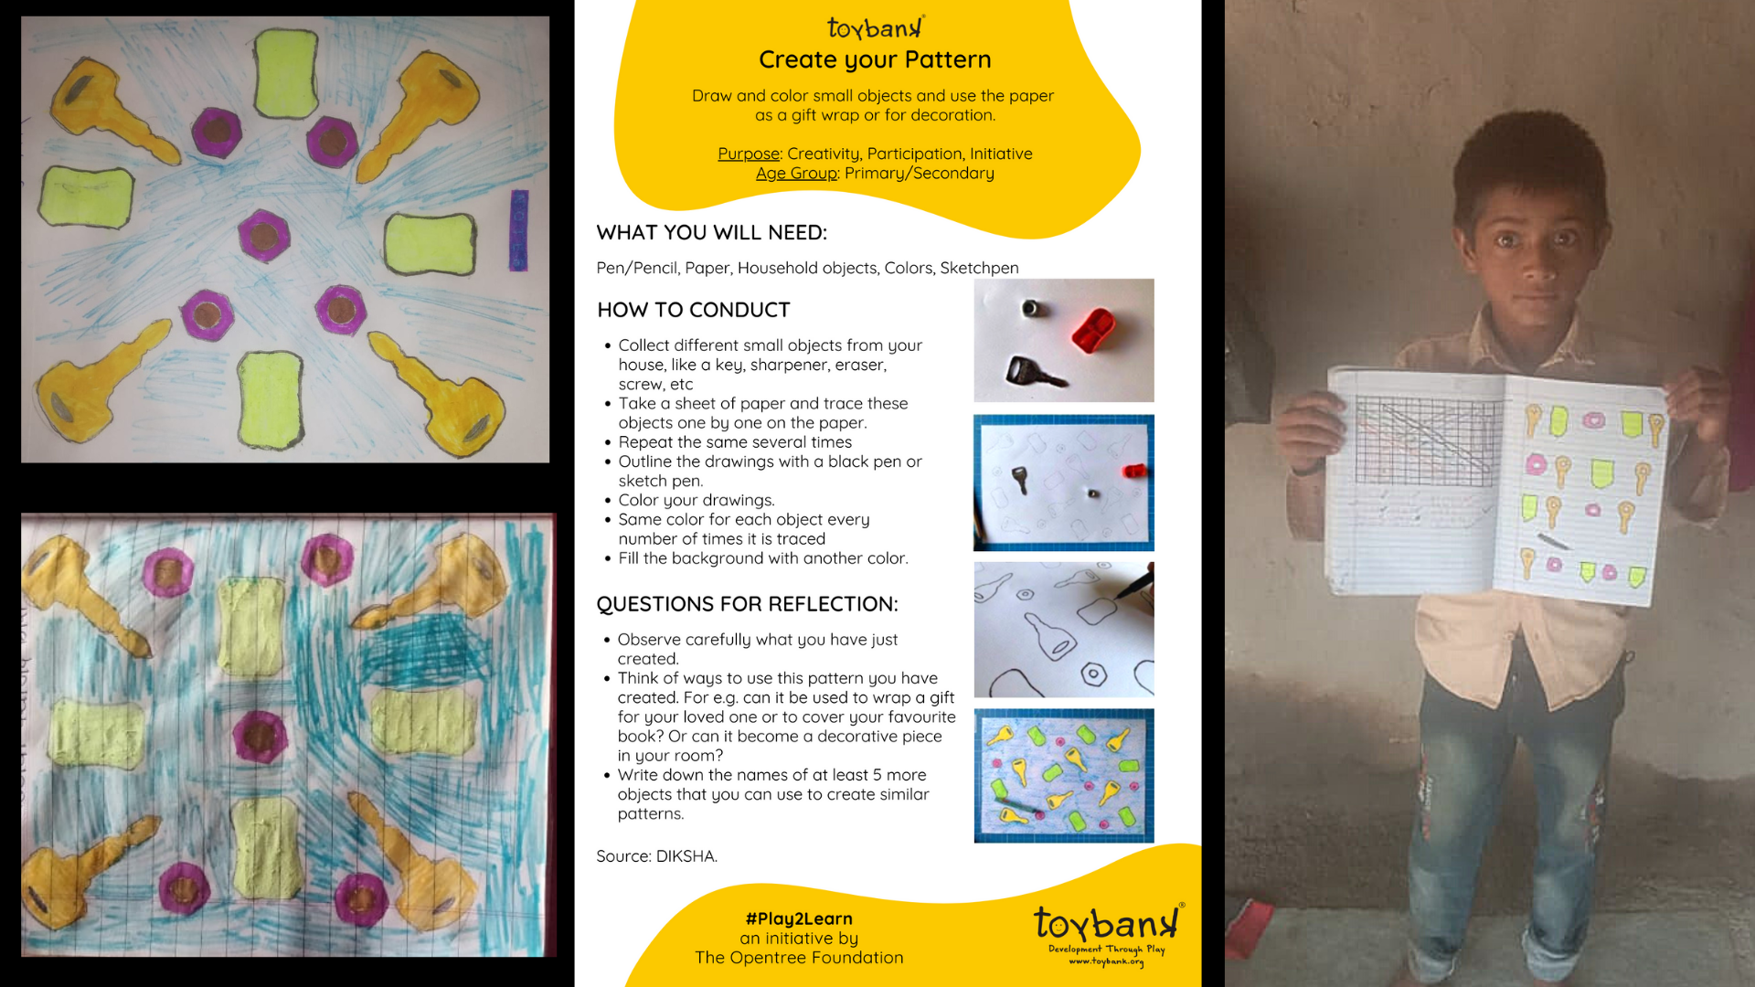
Children develop their creative skills through Playsheet Create Your Pattern
- Physical Play2Learn Sessions were conducted by partner-teachers while following social distancing rules. Children played board games in groups of two or three under teachers’ supervision to ensure their safety.
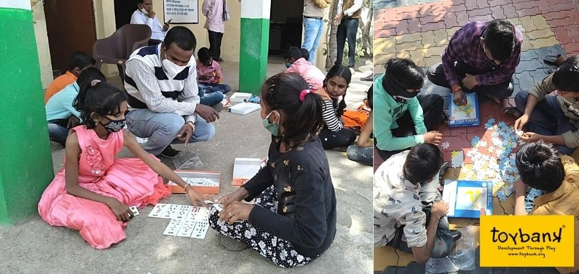
Partner-teachers guide children during play sessions
- 85 Digital Play2Learn Sessions were conducted by our Program Officers. These are curated with a sequential session plan by the team to encourage peer learning, boost children’s learning with the Play2Learn Kit and break the ice among classmates through group activities. These sessions gave the children the opportunity to become more curious and build on life skills.
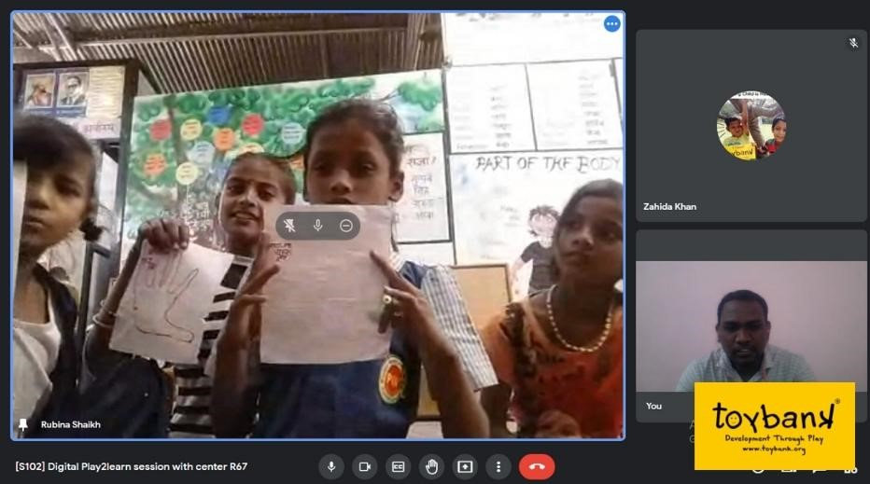
Children make animals with hand-outlines and share it with Toybank’s program officer during a digital Play2Learn Session
- 28 student volunteers facilitated 22 buddy sessions as part of The Buddy program. These sessions included getting to know and building a bond with the child, discussions around aspirations and about emotions, strengths, routine and habit building. The Buddies give the children a platform to have social interactions which have been drastically hit due to the pandemic.
- Across 4 states and 1 Union Territory in India, the digital Toybank Play2Learn Kit has made Play adaptable and accessible to children. In collaboration with these organizations, we ensured the continuity of learning for children in disadvantaged neighborhoods who do not have the luxury of online schooling. In order to mitigate these situations and make the home environment safe, healthy, and stress-free for children we are engaging these kids digitally with creative, educational and fun activities.

We invested!
We are invested in children’s Right to Play. We have been continually tracking on-ground issues that our children have been facing through fortnightly calls with partners, virtual focus group discussions, and in-person meetings and rural visits with education and block officers, headmasters and principals to ensure Play was a part of their virtual learning and back-to-school plans.
- We visited our rural districts of Beed, Latur & Osmanabad in October to give key partner-stakeholders a refresher on our program, check the program’s progress, plan for teacher training and physical Play2Learn sessions as schools were in the process of reopening. These visits enabled us to strengthen our partnerships, thus ensuring the program’s smooth delivery
“Everything related to education collapsed during the pandemic. But Toybank's continued efforts ensured children had some form of knowledge,” shared Dr. Vinayak, Toybank’s program incharge of our partner in Beed.
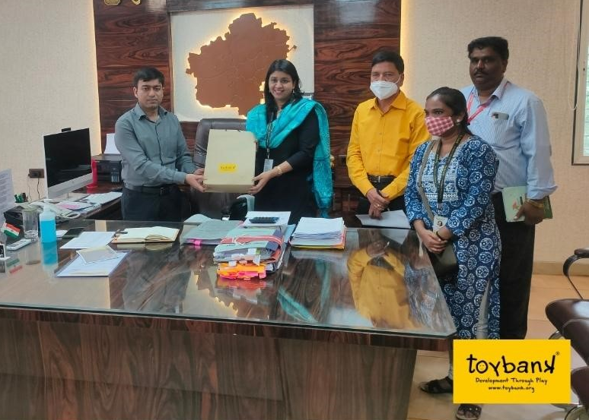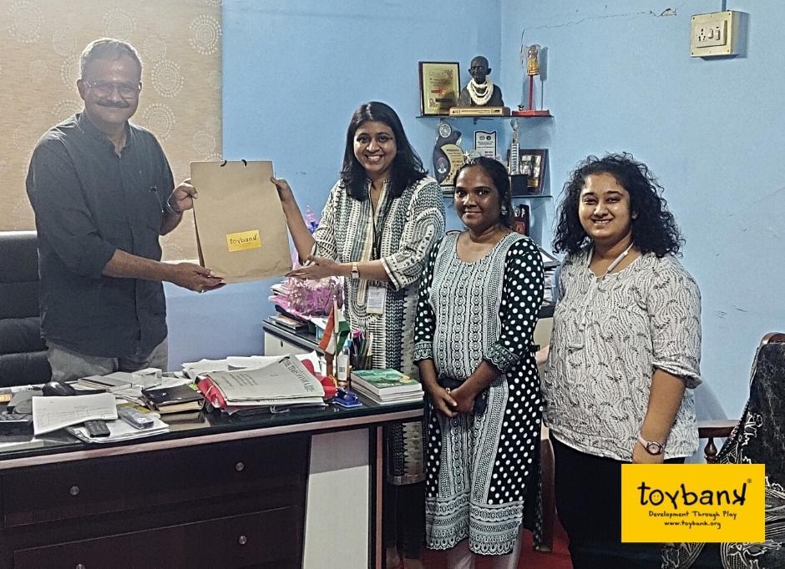
Meeting with Abhinav Goel, Latur Zilla Parishad CEO, and Bhagwan Phulari, Primary School Education Officer
Meeting with Partner-Head at Beed district

- In December, over a course of 6 days, 500+ teachers were trained in Latur district of Maharashtra. The training was a platform for the Toybank team to not only re-connect with the teachers, but to also hear first hand some of the challenges they faced in the pandemic. The training was interactive and designed to motivate the teachers to ask questions on Play, and take them through our Play2Learn program (Physical and Digital). The teachers first hand played with the games and understood their objectives and skills they cater to.
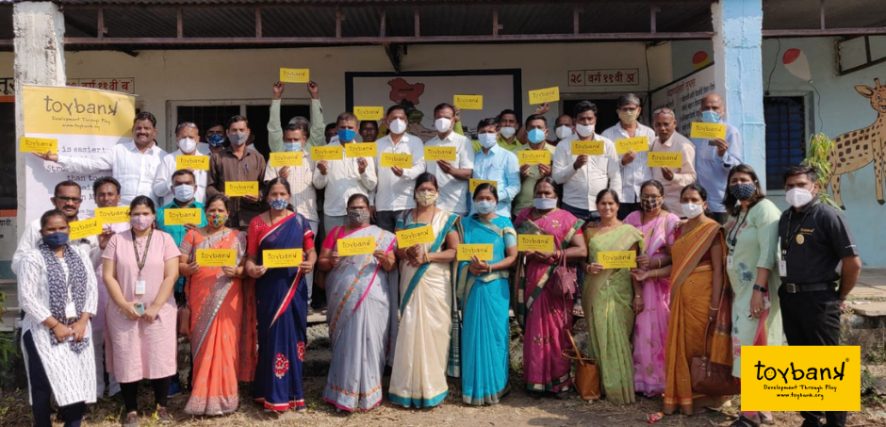
“I enjoyed playing Reversi. It's a very interesting game. 6 of us played chinese checkers and we learnt unity and teamwork,” Teacher from Ausa block, Latur, Maharashtra.
“The concepts that you have shared today are very good. This is one of the best trainings that I have attended in a while,” shares Navnath Bharat Mende, Teacher from Renapur block, Latur, Maharashtra
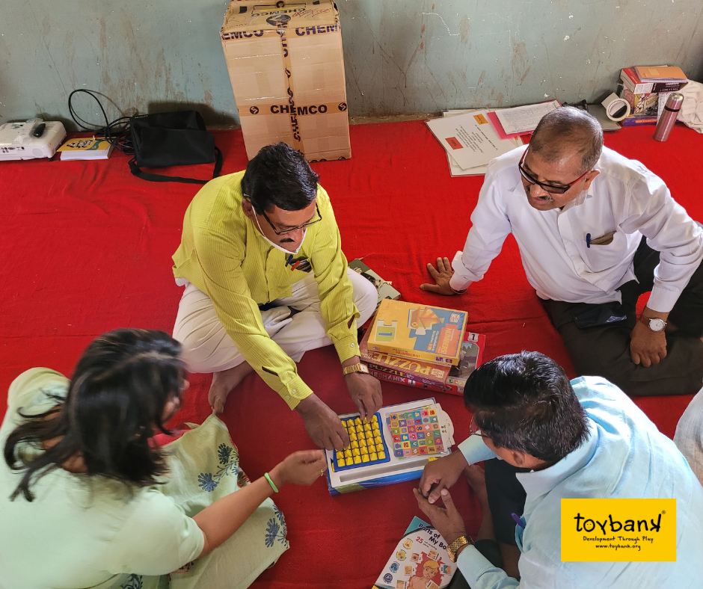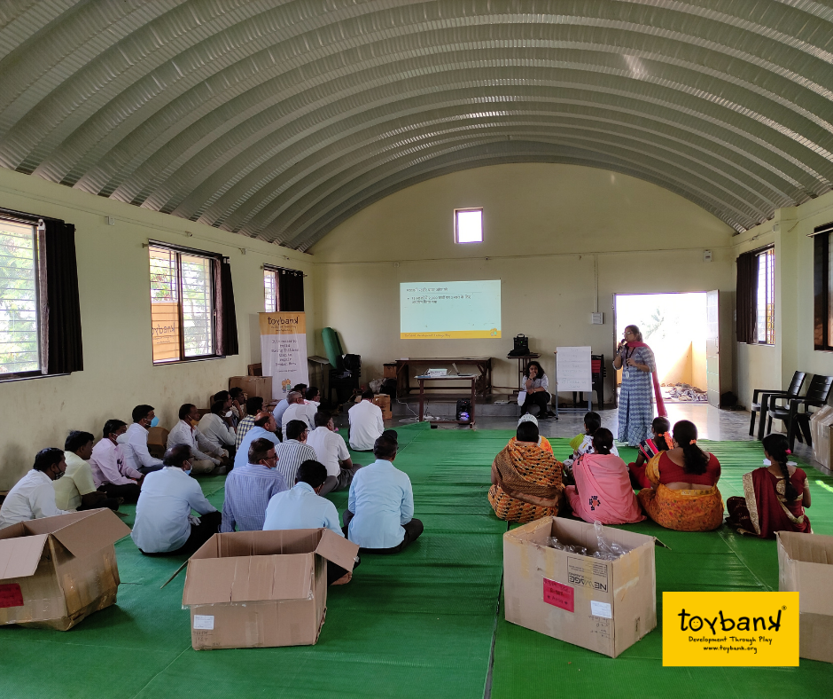
- Parents supported their children's academics as well as mental wellbeing by taking time out and playing with our Play2Learn activities.
Vasantrao Patil, a parent whose child is part of our Play2Learn Center in Latur district, said to our PO, “I’ve never met anyone from Toybank in person at our school, but these playsheets are really good for our children. My child completed the Positive Self-Talk Flower playsheet and I displayed it at home so that my child always remembers his positive qualities.”
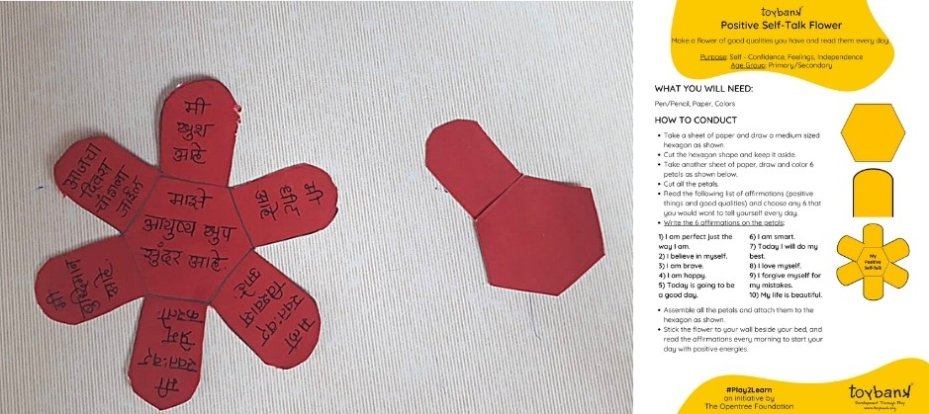
Child creates her flower of positive affirmations
- 34 Virtual Focus Group Discussions with 330 teachers and decision-makers gauged the effect of lockdown on our children. They shared feedback and suggestions on our Digital Toybank Play2Learn Program helping us to strengthen and support our partners effectively.
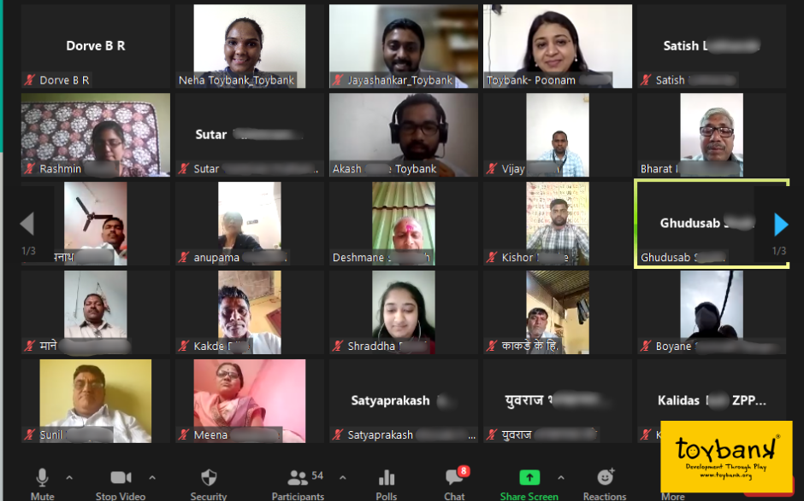
Screenshot of teachers in conversation with Team Toybank on Zoom
Leena Kamble, teacher from ZPPS Lokhandisawargaon, Play2Learn Center in Beed district shared what she benefited from the program, “It has helped me bond with them, overcome language difficulties, teach them despite their restlessness, inattentiveness or disinterest in studies. Children may not do something from textbooks but if I ask them to do the same thing through an activity, they readily do it.”
We’re rebuilding childhoods!
Story of Resilience: Behavioral change witnessed through Play
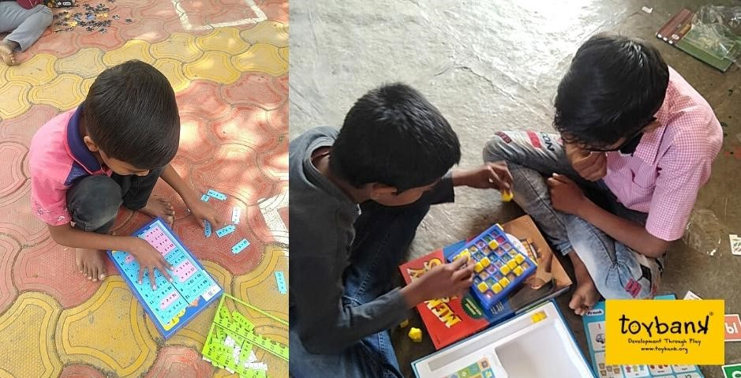
“Since 2017, Toybank has been giving us quality games. I am very happy to be working with the organization as it has also played a very crucial role in my teaching profession. The playsheets sent during the pandemic have been very useful for the overall development of my students. The WhatsApp group benefited me as I stayed connected with all the students. Their confidence has been boosted and also helped them overcome the socio-emotional fear caused by the pandemic.
One of my students, Paresh (name changed) who is very mischievous, was struggling to focus in class and disturbed other students. So one day I requested him not to bring his bag to school for some time. For about 2 months I only gave him toys and games to play with. Slowly his level of concentration started increasing, because he found joy and happiness in those games. This also resulted in increasing his patience and I could see a change in his behaviour."
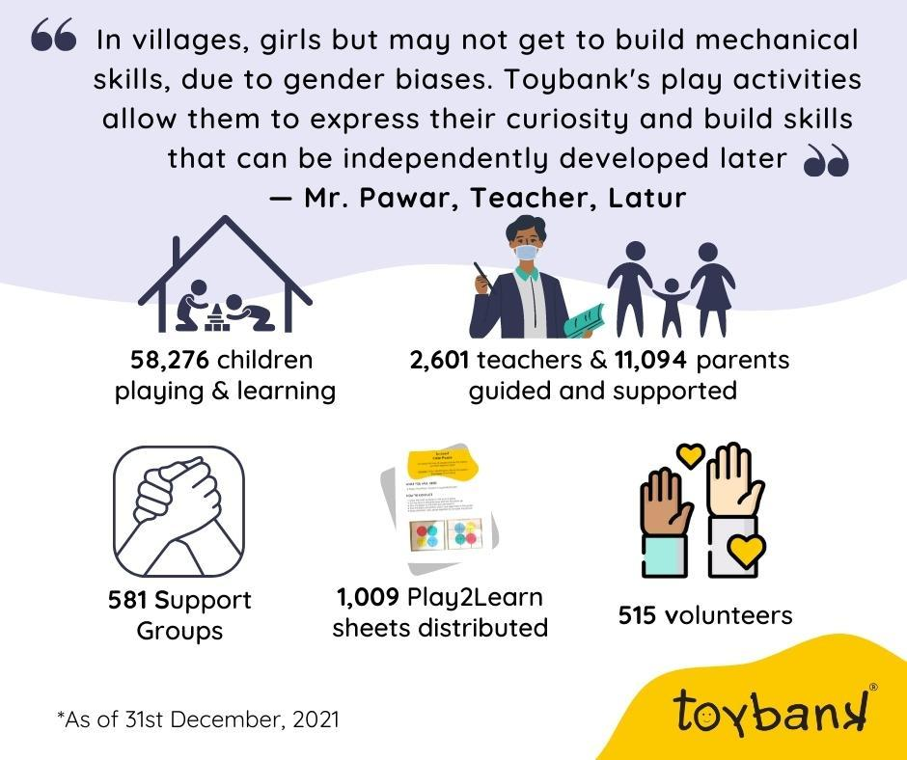
—Story shared by Leena Kamble, Teacher from ZPPS in Beed District, Maharashtra, India
Invest to Rebuild Childhoods through Play

Investing in Play to make mental well-being and learning accessible is the need of the hour. We must come together as a society to rebuild children’s childhoods and their future outcomes. Your support will ensure 60,000+ children continue to Play, learn and become resilient!

Thank you and Happy Toybanking!

