Celebrating 17 years of access to quality Play and learning for at-risk children,
through Toybank’s Play2Learn Program
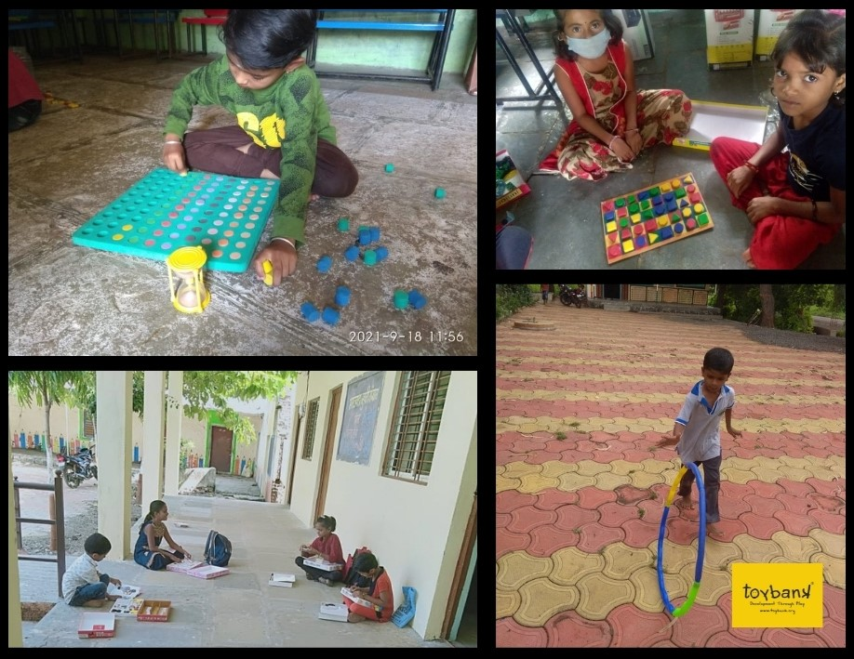
Children engaged in play as Zilla Parishad schools and
Toybank Play2Learn Centers reopen in Beed district of Maharashtra.

Children in India have been away from blackboards, playing, eating together and chattering during recess, and attending physical education in playgrounds for more than a year-and-a-half—the seventh-longest school closure in the world. Since December 2020, barely six months into the lockdown, educationists and experts have been urging to resend kids back to school. At the moment, more than 300 million students in India continue to learn virtually. At-risk children have contended with lack of access to quality play experiences, and thus mental and emotional well-being. It has rightly been said that if children do not go back to school soon, we will have a lost generation of kids, with UNESCO calling ‘Interrupted learning’ among the top adversities of COVID-19 on children.
Toybank-Development through Play has continually recognized these losses long before the outbreak of the pandemic. From providing games to a couple of thousands of street kids to setting up Play2Learn Centers impacting over 57,000 kids, we have consistently responded to our children’s evolving needs for the past 17 years, even during COVID-19 as our program went digital.

Supporting children and caregivers to face the limits of digital divide and virtual learning fatigue
A July 2021 Harvard report, ‘Persevering through the Pandemic,’ states that 58 percent of parents have witnessed COVID-19 harm their children’s academic development. Just over half of the parents saw a negative impact on their child’s social-emotional development, which can affect the ability to learn, build relationships and manage emotions.
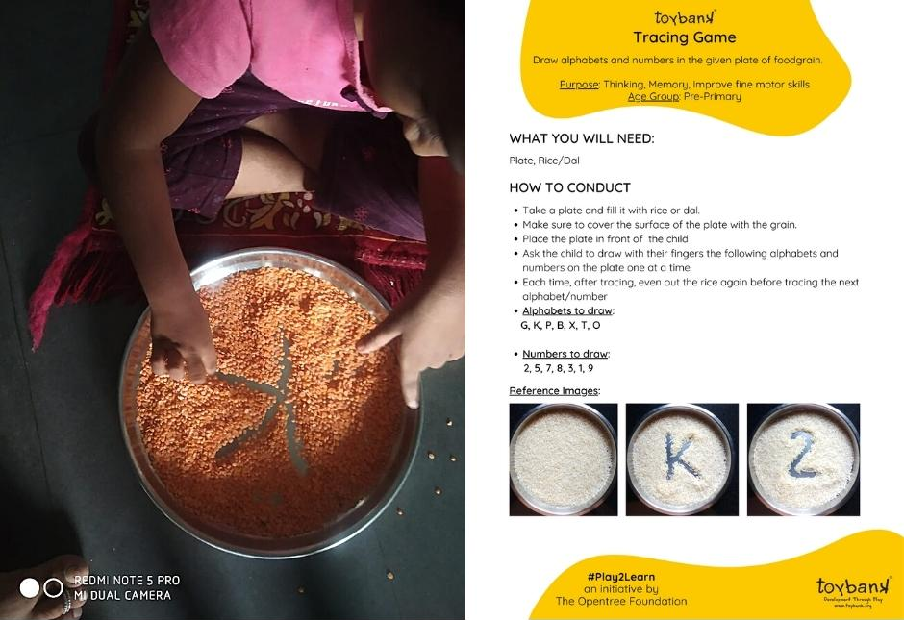
Primary children practiced the forms of alphabets by tracing them in a plate of dal, rice or pulses sourced from their kitchen (ZPPS Malnathpur, Play2Learn Center in Beed district of Maharashtra)
Toybank, too, has been continually tracking on-ground issues that our children have been facing through telephonic surveys, virtual focus group discussions, and whenever restrictions were eased we had in-person meetings with education and block officers, headmasters and principals to ensure Play was a part of their virtual learning and back-to-school plans.
We curated our digital program to address and bridge various gaps such as—school dropouts, social distress due to the virus, digital fatigue, learning loss, etc. We had a blend of various play activities, sessions and offline activities such as:
- 150 Physical Play2Learn Sessions conducted by teachers trained by Toybank in areas with minimal COVID cases

- 1,492 games distributed to approx. 800 tribal children in remote areas of Mulshi and Matheran in Maharashtra, where they have no access to schools or learning materials
- 3000+ replenished games at our Play2Learn Centers in Ahmednagar, Beed, Latur & Mumbai districts of Maharashtra
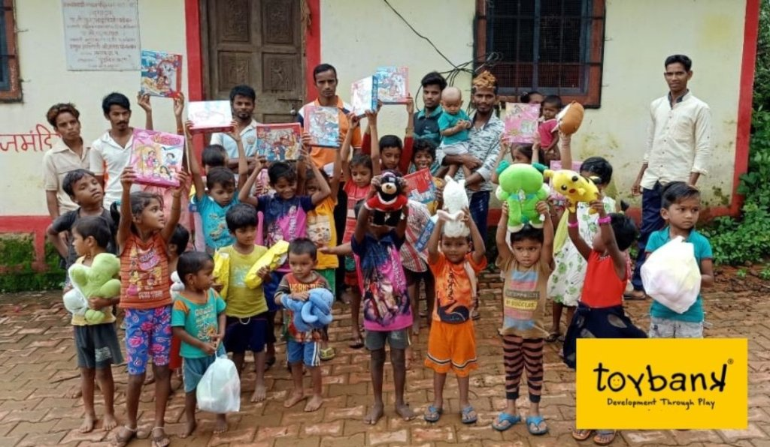
Tribal children in Mulshi-Tamhini village in Maharashtra access quality games to play with at home
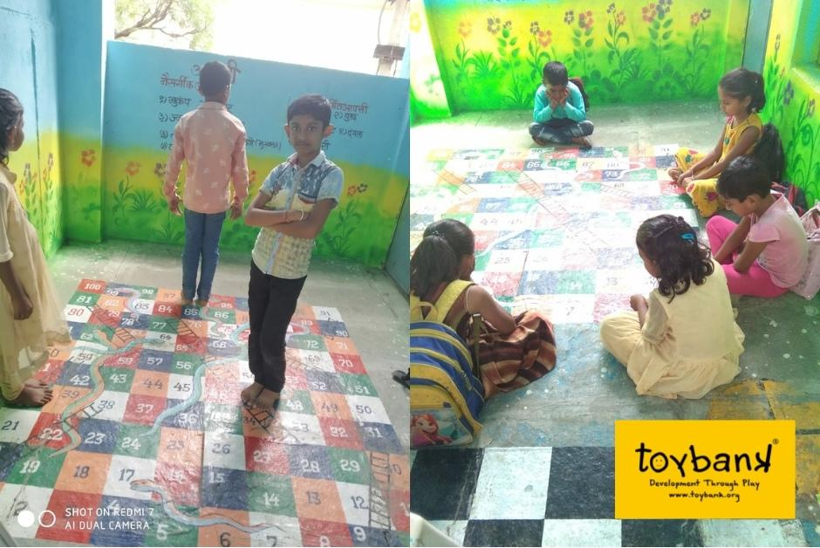Children move about the life-sized Snakes & Ladders while learning about healthy habits (ZPPS School in Singhgaon, Play2Learn Center in Latur district of Maharashtra)

“The Toybank Play2Learn Kit provides quality activities that meet various learning levels of children and skills that will make them resilient to get ahead in life,” said Miss Anju, Teacher, partner-school Rani Sati English School, Mumbai.

- 55 Virtual Play2Learn Sessions conducted by Toybank Program Officers and 58 Virtual Play2Learn Sessions conducted by Toybank-trained corporate volunteers
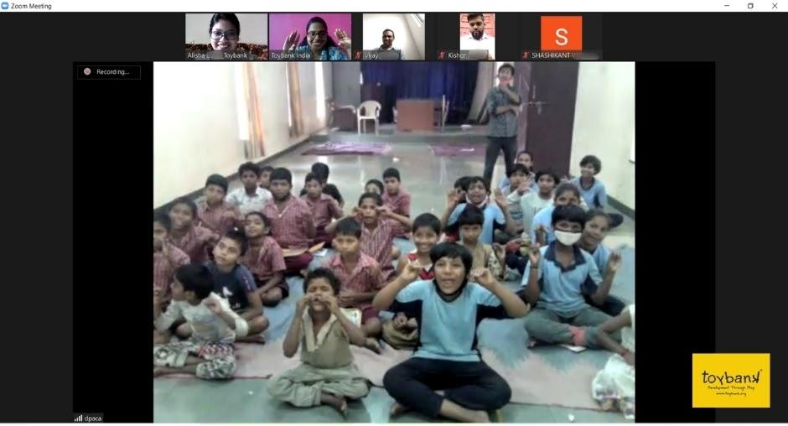
Children learn an action song on how to listening attentively during a digital session at (MNP School, Play2Learn Center in Ahmednagar district of Maharashtra)

- 8 Focus Group Discussions with 146 teachers and decision-makers gauged the effect of lockdown on our children, feedback and suggestions on our Digital Toybank Play2Learn Program and ways to strengthen and support our partners effectively.
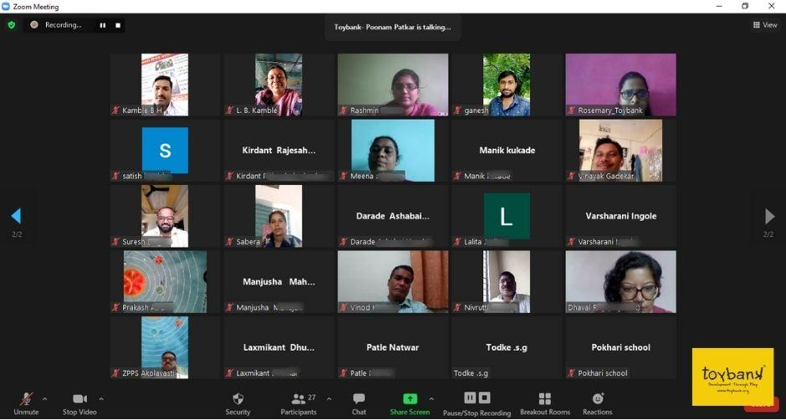
In conversation with partners in Beed district during an FGD
Leena Kamble, teacher from ZPPS Lokhandisawargaon, Play2Learn Center in Beed district shared what she benefited from the program, “It has helped me bond with them, overcome language difficulties, teach them despite their restlessness, inattentiveness or disinterest in studies. Children may not do something from textbooks but if I ask them to do the same thing through an activity, they readily do it.”

Benefits of the Toybank Play2Learn program
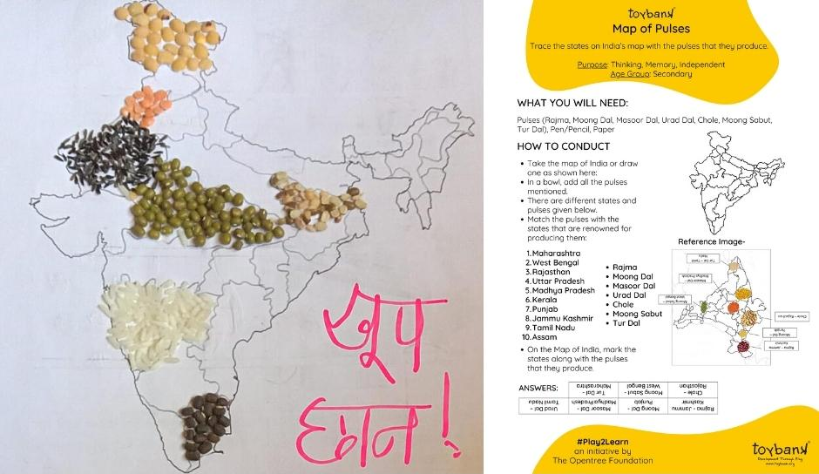
- Meaningful engagement at home
- Accessible & self-directed learning
- Safe spaces at home
- Stimulating learning environment
- Opportunity for normal development, building autonomy and exploration
- Reducing the severity of potential trauma caused by fear and uncertainty
- Enabling caregivers to focus on their responsibilities
- Promoting opportunities for early learning and responsive caregiving
Children learn different types of pulses and the states they are produced in through activity Map of Pulses (ZPPS Bhavthana, Play2Learn Center in Beed district of Maharashtra)
Story of Resilience: Bridging learning gaps with the game Abacus
“Sameer was in Class 2 and at the end of the academic year when schools closed down due to COVID-19. He could recognise single to two-digit numbers easily. By the time he was in Class 3 in June 2020, his school had just begun remote learning. This not only negatively impacted what he had learnt but we also failed to track how much our students were grasping.
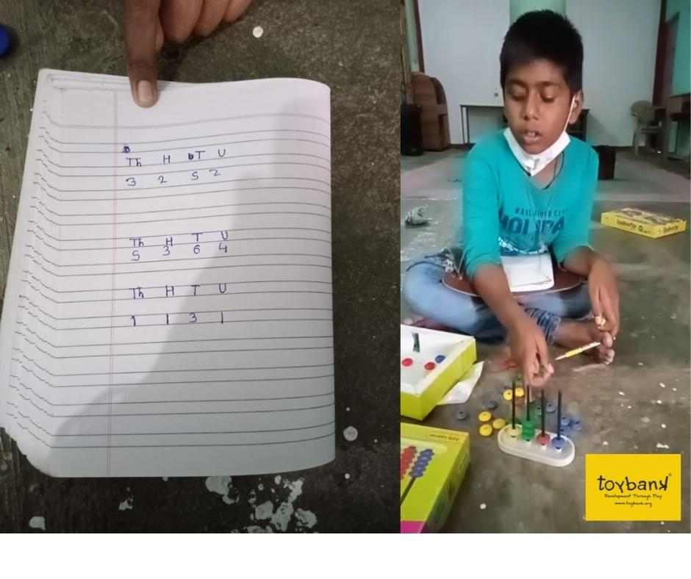
Sameer was in Class 4 by June 2021, with schools yet to reopen. With the introduction of three-digit and bigger numbers, he was off his learning track once again. When children could attend school physically, I noticed that Sameer struggled with number recognition. Toybank had restocked Abacus, so I decided to creatively bring him up to speed with digits. I visually associated the colorful beads with units, tens and hundreds, which made counting easy and quick for Sameer. This excited him to keep coming and learning more. With this realistic learning experience, he eventually took his notebook along and started writing down all the numbers he learned.”
—Story shared by Shubhangi Kulkarni, Teacher from ZPPS Bansorala School in Beed District, Maharashtra, India
Sameer practicing counting of numbers with Abacus at ZPPS Bansorala School,
(Play2Learn Center in Beed)
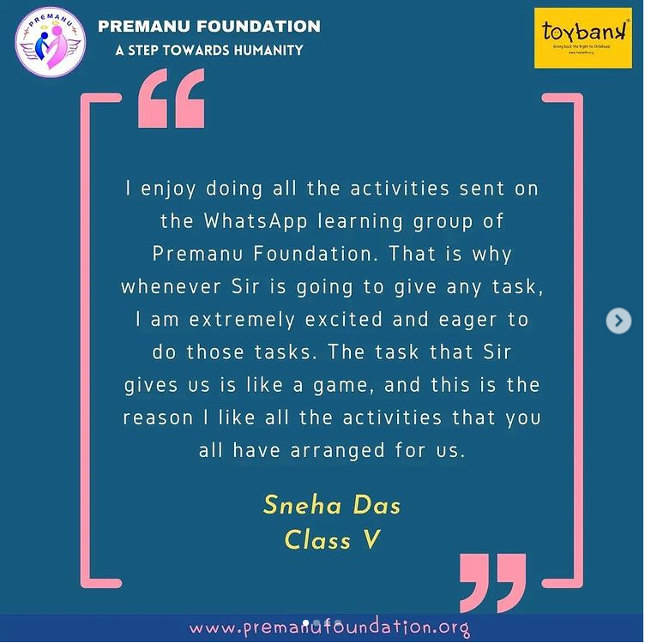
Our work across India
The digital and translations feature of Toybank Play2Learn Kit has made it adaptable in different rural and urban communities of Maharashtra, Andhra Pradesh, Tamil Nadu, Karnataka and West Bengal. We have and continue to ensure that language is the last barrier preventing children from playing.
We have witnessed the power of play adopted within different contexts and backgrounds and our activities include resources that are easily obtainable locally. We supported our partner facilitators, teachers and caregivers to fit the Play2Learn sheets into their local lexicon.
Partner Premanu Foundation shares children’s testimonials on social media (West Bengal)
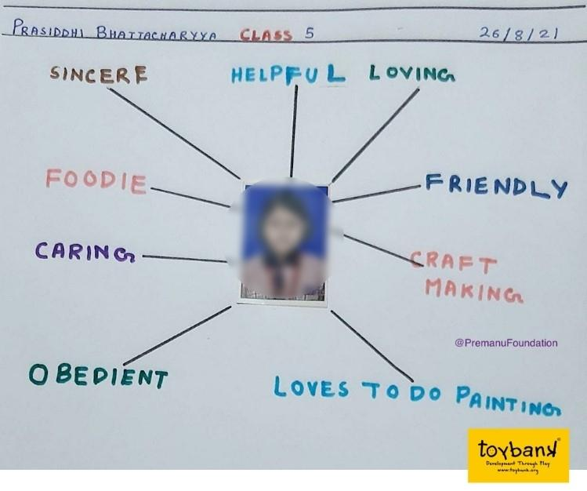
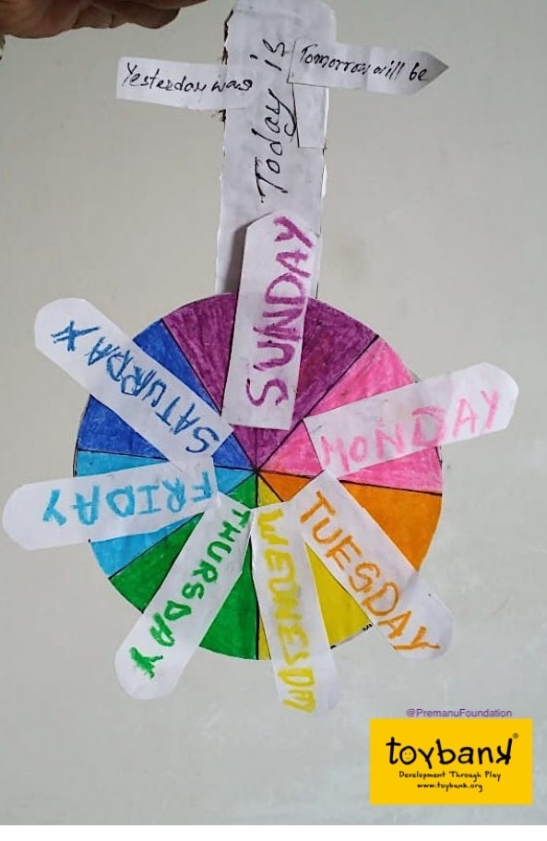
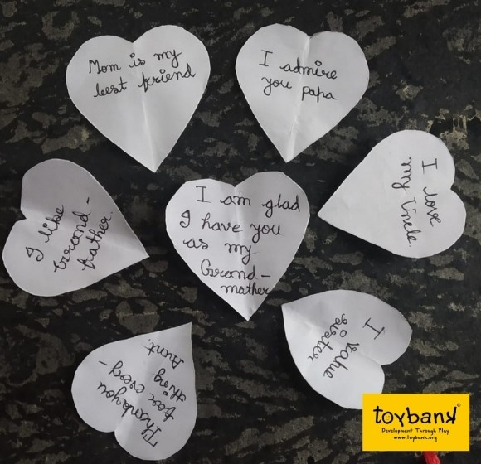

Children from Premanu Foundation solved activities such as Days of the Week, These are my Qualities and Hidden Hearts (West Bengal)

Championing play during the toughest time in the world
Toybank won the 2021 Global Good Awards—COVID Crisis Champions Category. They bagged the ‘Gold’ position and were rewarded for their agility in responding to the impact of Covid-19. We are ever grateful for the solid support of Toybankers like you who support us in building a better, stronger and kinder generation.

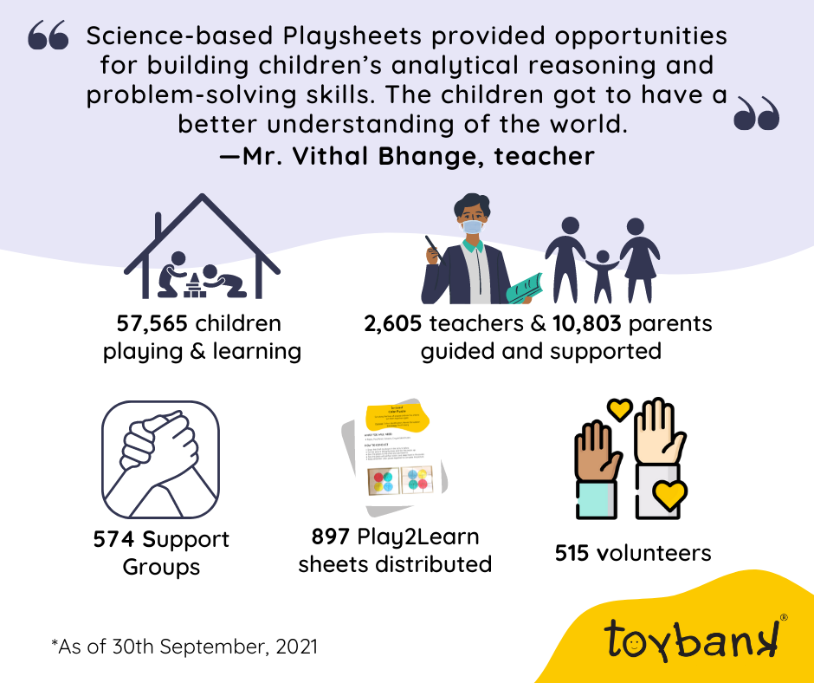
Outreach figures as of the 30th of September 2021
Supporting Toybank for enriched learning and equitable childhoods
We are paving the way for at-risk children to negotiate their way around learning losses, digital divide and gaps in social-emotional development. Toybank is determined to help children transition from this period of uncertainty back to normalcy and on the path to a bright future with the firm backing of Play. As Toybank bolsters its efforts to rebuild childhoods with equity, your support will go a long way in backing us up.
Thank you and Happy Toybanking!

