DOOR STEP SCHOOL, MUMBAI

School on Wheel Project
Supported by Child Action & Hemraj Goyal Foundation Progress Report for the period of July 2021 to December 2021
Project title- School on wheels-
Non formal education for street children and pavement dwellers

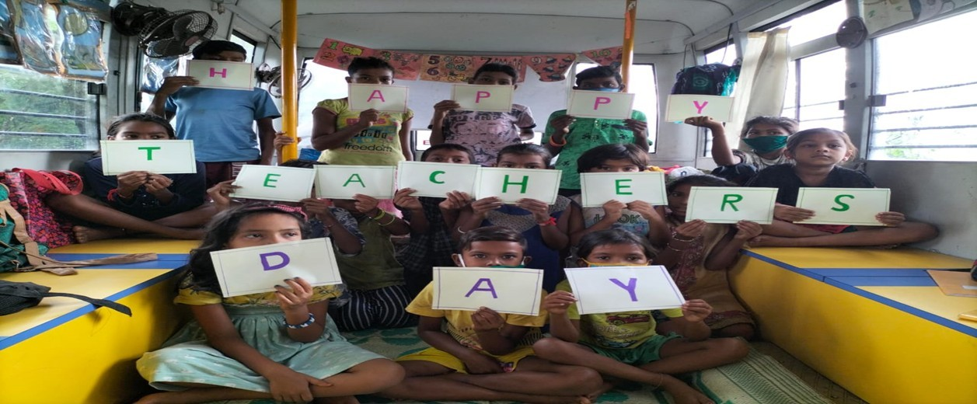

“Because of Door Step School our children are most discipline and discouraged to begging” Parents expression.

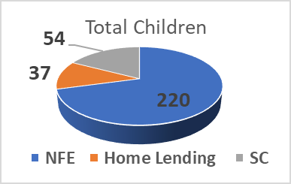
Number of beneficiaries location wise
Sr. No. | Location | No of Beneficiaries
Sow I | Obraoi Mall & Film City, Kandivali - Raghulila Mall, Boriwali -Indira Nagar | 150
SOW II | Boriwali East -Flower  Market, MTNL, Poisar & Tumnipada | 222
 | Total Beneficiaries | 372

Page 1 of 11

Rational:
Endlessly, even this year too COVID-19 epidemic continued to interrupt children’s education around the world. Children from deprived background were severely disturbed economically and emotionally. Not even only children were affected but at the same time parents were truly strained for their children for their academic development. Most of the beneficiaries of the project and their families have taken major heat due to the lockdown. Many of our children’s parent come from the weaker section of the society with limited livelihood opportunities hence were not able to serve the family due to uncertain extensions of lock down.

Post some relaxation in COVID 19 our primary approach has been community-based activities along with online sessions in certain cases wherein offline activities were not possible. We have adopted many of new implantation strategies to support children to bring them back into the main streamline of education. Even though it was quite challenging to connect with children and parents directly in an effective way, we were able to reach out to the maximum beneficiaries in both the ways online and offline.

The entire universe experienced stress, anxiety, fear, sadness and loneliness during the pandemic and still it’s not getting over and we are almost on the verge of getting into third wave experience. We tried to provide Mental Health management solutions to our beneficiaries (both children and parents) during the pandemic at some extend. Our online Mental Health sessions has been one of the key effective interventions that we have initiated to support children and parents to deal with the consequences of this global pandemic situation of COVID 19. Children and parents were educated on how to manage their stress and cope up with this epidemic condition. Children and parents’ response to this program was outstanding and the maximum active participation was observed.

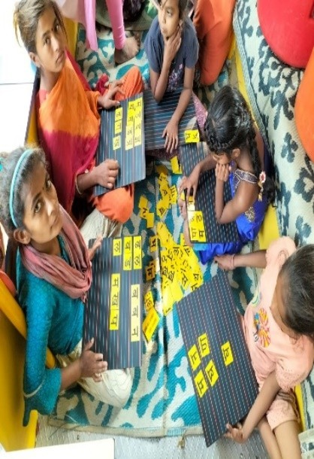
Impact story

Child Name: Manisha Raskotiya Age: 13 Years
Geographical Location: Flower Market, Borivali Station Program: Non-Formal Education (SOW)

13 years old Manisha lost her parents both and father at the phase of early life. She was left with the responsibility of her other 3 siblings post her parents exit from their life. She is staying with her grandmother at present and looking after for
her siblings. Despite of having strong wish to learn and attend school she unbale as she has more household responsibilities on her shoulder to be performed in absence of her parents. In short, she is playing a role of both mother and father for her siblings simultaneously at the age of just 13 yrs., where she supposed to avail educational benefits, develop mental and physical health extra.
Despite of many constrains, Manisha was the regular student of our NFE classes, however all of sudden her attendance was recorded poor and she used to bunk the classes and later she completely stopped to coming.
Our teacher realized her absence and decided to make a home visit to address her issue and the root cause for her absence. When interacted with her grandmother it was found that Manisha is getting marry at the of just 13 (against the Indian marriage law). Our team was shocked to know on this, her grandmother wanted to get Manisha marry early so that her grandmother can be free from her duties and responsibilities. She uttered that we are the street dwellers and live openly on the streets and Manisha is getting younger, so I am bit worried about her safety.
Our teacher made her aware on being literate, and how can Manisha her life and have a better future ahead if she continues with her studies, and she can even have a better life partner and married life ahead is she complete her education and become empowered women.
It was also made very clear to her grandmother that if Manisha gets marry at this age, you all will be fined including her in-laws and even jailed also as per on account of legal violation of the Indian marriage act.
In result to this, her grandmother cancelled her marriage proposal and started sending her to our classes regularly.
Now, Manisha seems to be very happy and looks more focused on her studies. Her performance in our mid test is recorded satisfactory and Teacher is working closely with her to take it to the next level

Key achievements / Highlights:

- 1892 classroom session were conducted although it was quite challenging due to lockdown protocol, all the safety precautions / measure were ensured 100% during the sessions.
- Combination of offline and online sessions was the most effective channels to provide qualitative education as well as quantitative.
- 223 direct and 43 indirect beneficiaries benefited off our Mid-day meal initiatives
- Mid -Day Program has helped to improve in children attendance and regularity in regards to ensure their retention.
- 372 children were directly benefited by two school on wheel buses on the streets of Mumbai Sub- urban.
- Home Lending is emerging as another flagship program in order to build linguistic skills of the neo literate children.
- We have been able to retain 60% of children from last year to this year.
- 56% girls are enrolled into the programs across
- Over 1500 indirect beneficiaries were reached out in the form of parents, sibling and other stakeholders.
- 99.7 % of the children were found sustained across all the programs till the end of first half of the year.
- 138 children were given an exposure to digital learning on a daily basis, they were delighted to be aware on current affairs, social values, their mathematical and scientific concept were cleared.
- Digital learning has been the key intervention to benefit children, they were delighted to be aware on current affairs, social values and even it has help them to clear their mathematical and scientific concept with the uses of various apps and information sources available on digital devices
- Children have been able to adopt health and hygiene practices during the pandemic with and now regularly following the same under the guidance of teachers
- Girls were made aware on “good touch and bad touch” in regard to keep themselves safe and empowered.
- Reading and writings workshops, Literacy rally on world literacy day, Girl Child Day, events and celebrations were the key activities performed during the reporting period.
- During the lockdown parents were supportive to send their children to the NFE classes and even they helped us to get place to conduct the classes in the community.
- 50% of the children are able to identify letter and numbers in their day to routine and it has help them to improve in their practical knowledge. They were able to identify Bus numbers and routes in their vicinity for travel and could save their money which was being spend on autorickshaw originally.
- 150+ parents were made aware on Covid 19 vaccination and 79 parents were facilitated to avail second dose of vaccination.
- 79 parents’ meetings were conducted to ensure their participation in their children’s academic development.
- Online 3 Mental Health Awareness session were organized for 55 children on general Awareness.

Attendance – Study class and NFE

 |  |  |  |  | 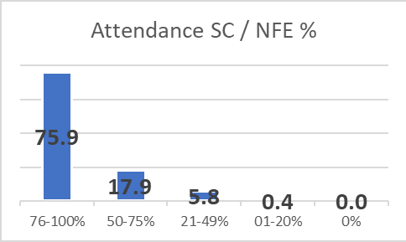
Category | Total | M | F
76-100% | 208 | 95 | 113
50-75% | 49 | 26 | 23
21-49% | 16 | 8 | 8
01-20% | 1 | 0 | 1
0% | 0 | 0 | 0
Total | 274 | 129 | 145

- Around 76% of children attended more than 76% of planned classes
- Not any children found any 0% category of attendance
- Only around 6% of children attendance has been recorded average
- 0.4 % of children attendance recorded poor

Performance
- NFE- Language
- 63% of children in NFE program can recognize and identify 21 alphabets and 3 matra’s in in Hindi Language against 70 % were not able to recognize at the beginning of the year
- 55 % of enrolled children are comfortable in making sentences and on their grammatical concept are still required inputs against 75 % of them were not able to make sentences during pre-test.
- 71 % of enrolled children can recognize minimum 75 - (2 and 3 Letter) sight words.

- 82 % of children were able to express themselves in their language.

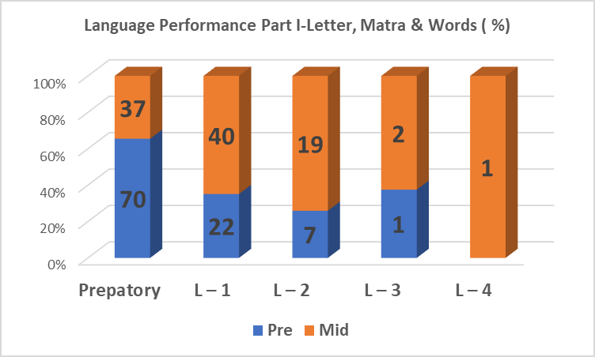 | 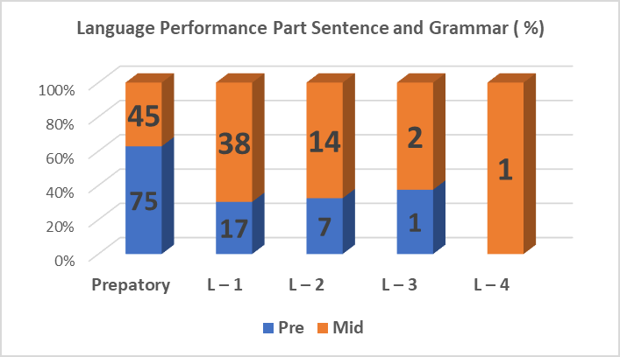
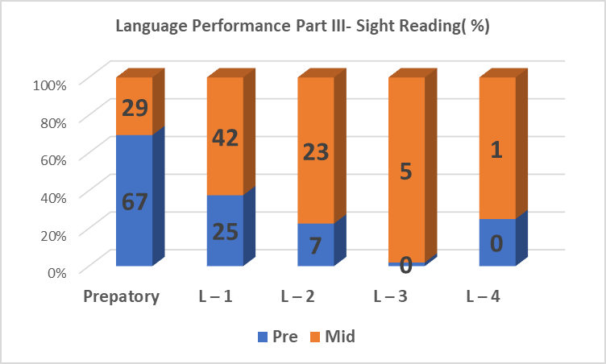 | 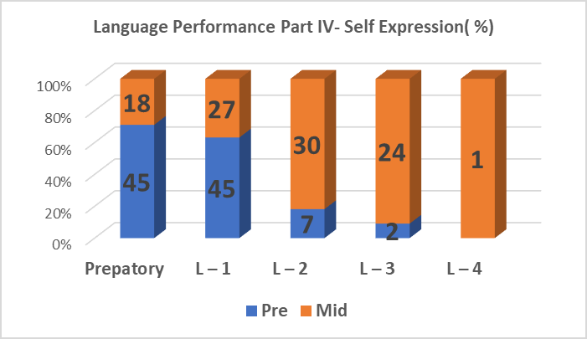

Maths

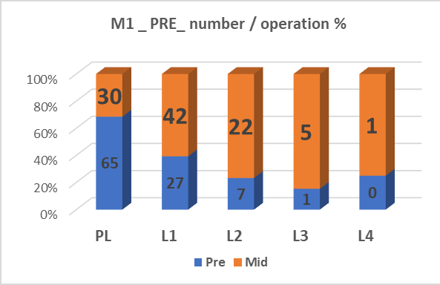 | 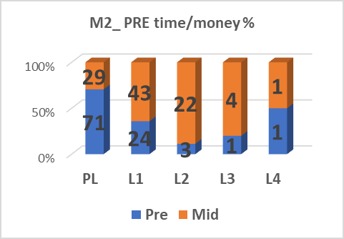
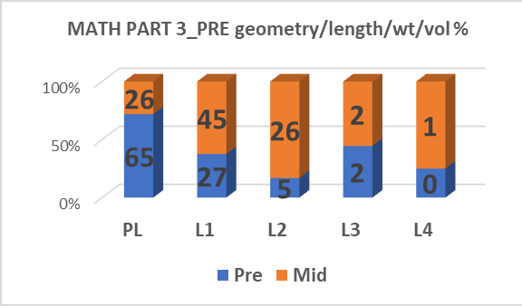 | - 65 % of the children can recognize 1-5 numbers, counting of coins and do 1-digit operations as well plus -Minus etc, where  65 % of children were not able to recognize in the beginning of the year.  - 71% of the children can recognize 1-10 numbers and 2-digit operations. Also are able to identify currency and read the watch.  - Geometric concepts of 76% children were cleared by the midst of the year.

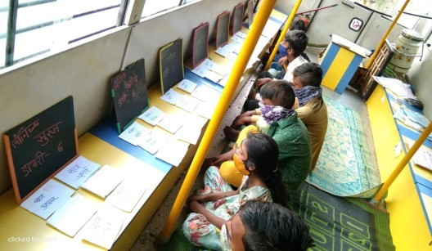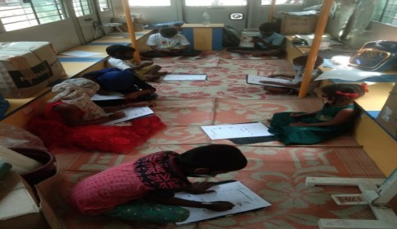Best activity 1:

Best activity has been performed by the teacher for NFE class children on bus of film city and Oberoi Mall, Goregaon.
Activity Theme: Reading and writing
Objectives: To improve in reading and writing skills of each child
Methodology used:
- Regular monitoring and checking of daily based homework given by the teacher.
- An exposure to review classmate’s homework ( exchanged) and provide feedback – positive and improvable
- Maintaining of daily dairy on a regular basis
- Daily dairy exhibition was conducted to know on the amount of dairies were maintained by each child.
- Those who were found with more dairies, were applauded and appreciated by the teacher
Outcomes:
- The change is children handwriting was noticed
- Reading and writing skills were found improved

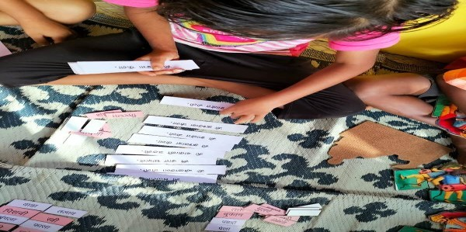Best activity 2:

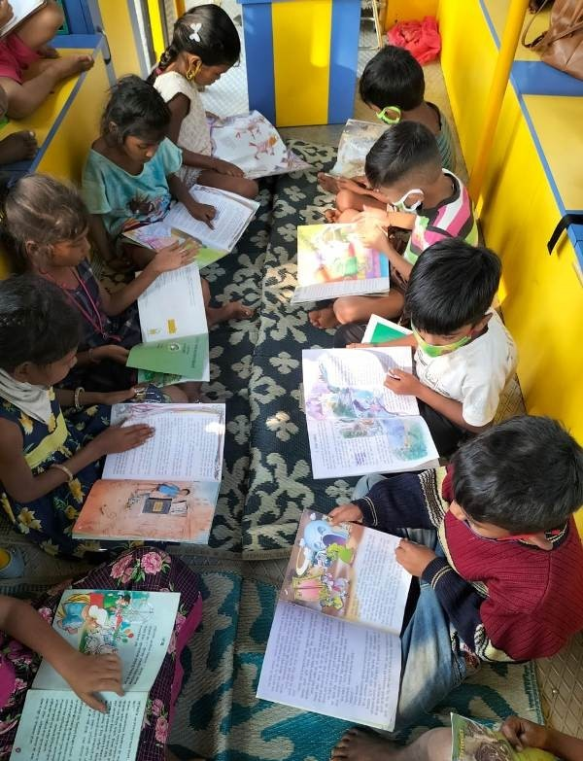Activity Theme - Lets Read
Objective: - To improvise in children's reading competencies
Location: -MTNL, Borivali

Methodology used:
- Children were oriented on the handling ways of the books
- Children were given a choice to choose the story books as per their interest to read once in every fortnightly
- All were asked to create their own story form the picture observations.
- Children were divided into groups in order to clear their concept

and understanding thorough group discussion
- All children were provided with equal opportunity to express their thoughts
- The letters which were thought in the regular classes were related to the words in the story by the teachers.

Outcome: -
- Reading skills of the children were found improved
- Phonic connects were cleared
- Children were given an exposure to enhance in communication skills and team work
Children Feedback: We like to look at the picture and make our own story from it and we also like to hear different stories with the uses of puppets.

Challenges

  - Some of the children has household responsibilities on their shoulder, hence they are unable to give their fulltime in the sessions.

  - Parents alcohol addiction, does affect on children’s overall devolvement, hence their active participations in the education process lagging behind

  - Most of the parent want their children to earn rather focus on studies, hence we face lots of challenges to mobilize children and keep them sustained in the program

  - Some of the communities are occupied with drug business in a latent way, they also force their children to be in this business, we have to take legal advice and actions many times in regards to keep children into the main streamline of education.

  - Devastation of illegal structures has been one of the permanents constrain, children are always under this pressure of being roofless.

  - Children are more focused on livelihood generation rather than availing educational benefits, hence it becomes difficult to keep them engaged with educational activities all the time.

  - Children from the diverse background get enrolled into NFE program, it is quite challenging to plan the session in the beginning as per their level of understanding.

Photo Gallery

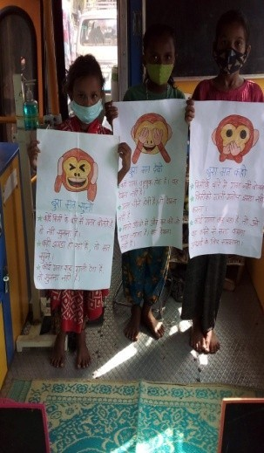 | 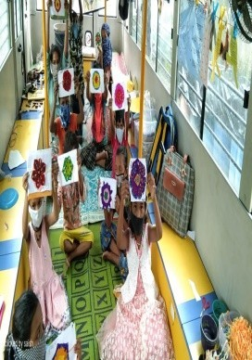
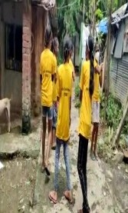 | 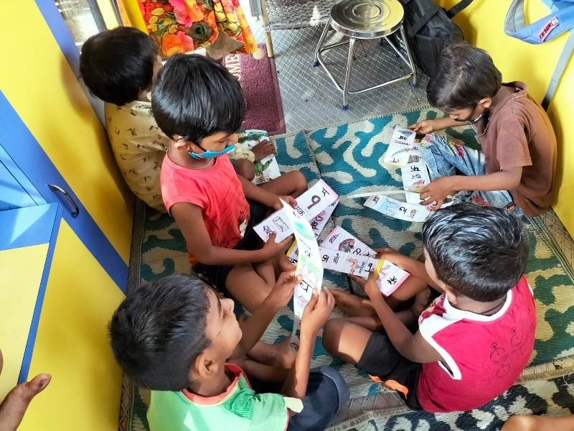
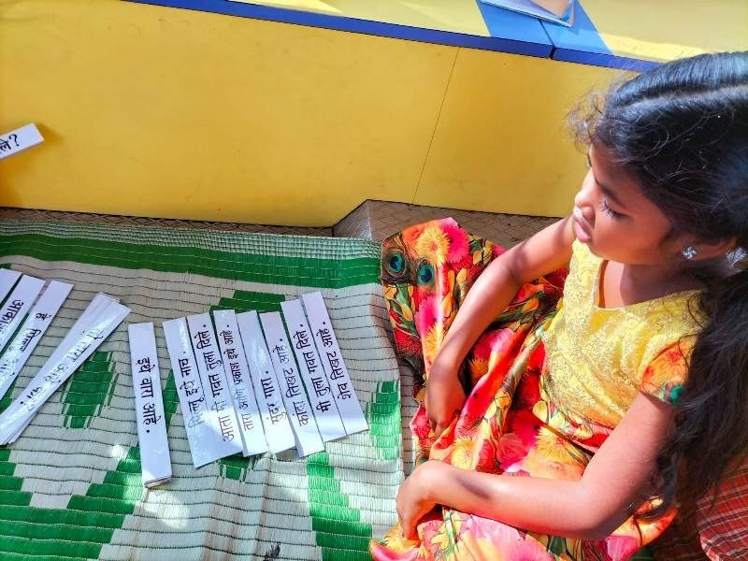 | 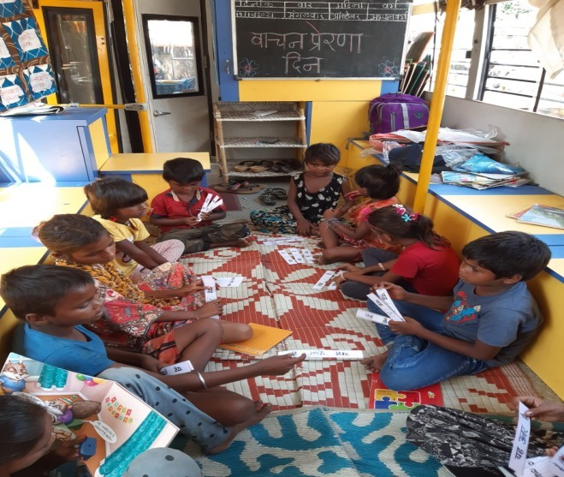

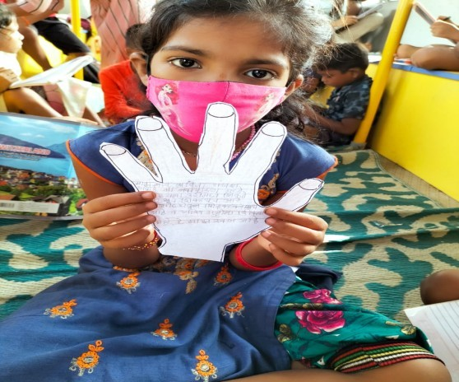 | 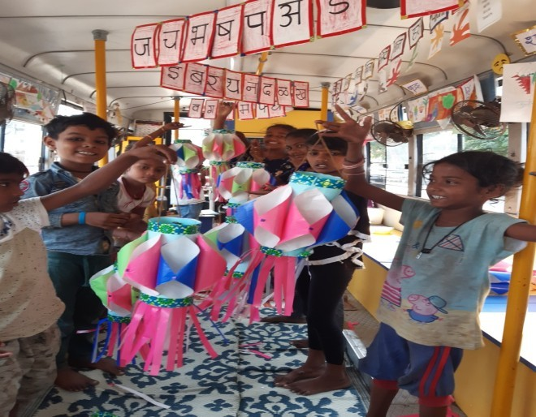
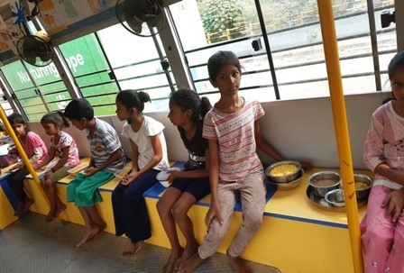  Mid Day Meal | 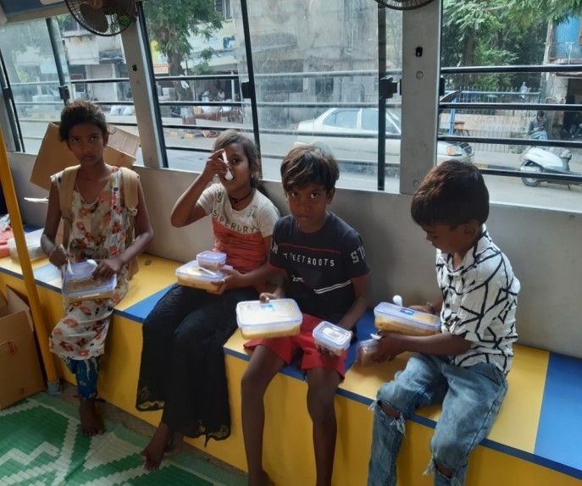  Mid Day Meal

