Annual report
Thanks!

We wish you a happy year 2022.
Thank you for helping us make the dream of a new world come true. May we, like Mary, continue to protect the fragility of many people, encouraging them to be the protagonists of their lives..

Education
Children in the early childhood space
33
Students attending school classes,
physical education, vegetable garden classes
81
Students received from secondary level
02
University students
03
Orchestra Students
150
Adults who finished their secondary studies with jobs in Gastronomy and Computer Science in La Nazarena
28
Adults who attended primary school in La Nazarena
10
CANTIDAD
100
% of families enrolled in the school
2021

School classes: In September 2020 we began face-to-face classes with primary and secondary students. As of September 2021, with the majority of families vaccinated, we achieved full assistance.
Primary school for adults: The agreement was held throughout the year, and in this context of a pandemic, face-to-face classes were given once a week to accompany adults in their learning. Food assistance continues to be provided once a month to enrolled students. In the month of December, two graduated.
Adult High School: 28 students were received. A great event, for being the first promotion based in La Nazarena. 13 of them finished with a trade in Gastronomy and 15 in Computer Science.

Orchestra students Student graduated
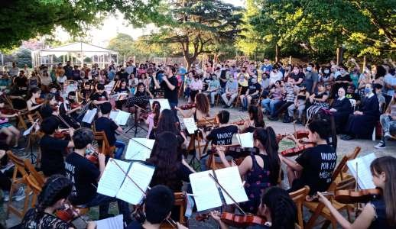
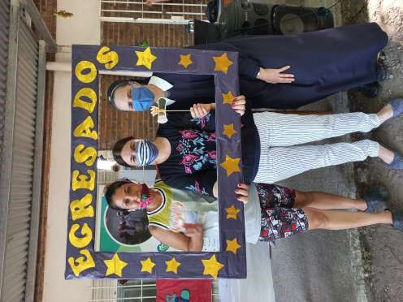
Sacraments and formation in values
Preparation for First Communion
25
Mothers who participated in training talks
10
Mothers who prepared to be Missionaries of the Pilgrim Virgin of Schoenstatt
03
People who prepared the Stations of the Cross in the New Schoenstatt Shrine for the pilgrims during Holy Week
15
Children and adolescents who received Baptism
17
CANTIDAD
19
Adolescents who participated in neighborhood missions

Teachers who received spiritual training

09
Missions carried out by the Schoenstatt Youth with the participation of our adolescents and youth

02
2021

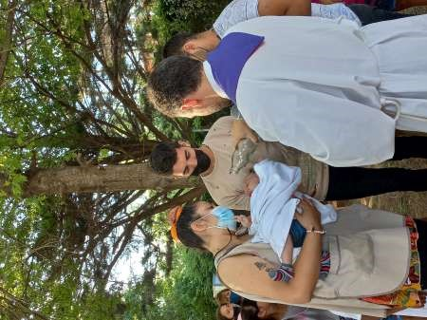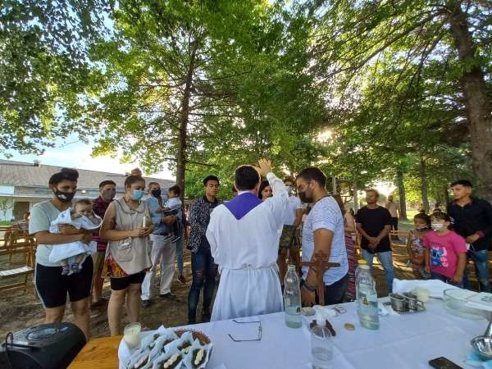
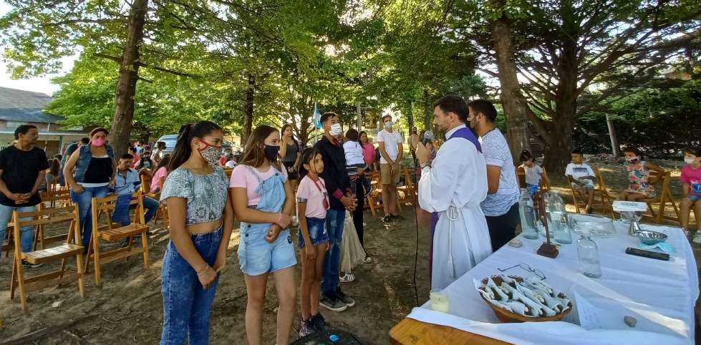
*Baptisms

Health

Psychological and psychiatric care (virtual and face-to-face)
Children and adults participated in the flu vaccine campaign in La Nazarena.
47
Children and adults who were accompanied in the vaccination process against covid-19
54
Children accompanied weekly from our psychopedagogical office
04
Accompanied families in matters of health and paperwork.
40
People who use community showers
100
Caring for the environment through plastic storage
650
Harvests from the community garden
12
CANTIDAD
kg
2021
Adults accompanied from our psychiatric cabinet
08
People treated in our medical office
100

Primary health care: We accompany the 40 families who attend the La Nazarena human development center and their family group in matters inherent to the health area (including some families who do not attend daily). Showers are used by families throughout the week.
Plastic filled bottles: We continue to raise awareness about recycling and a more sustainable environment, that is why we collect bottles and transfer them to an eco point.
Students who carried out in our center the sowing, care and harvest of the crops of: bell pepper, celery, onion, chard, lettuce, broccoli, tomato, beet and many more. They made scent plant boxes out of repurposed wood, which were used with scent plants..
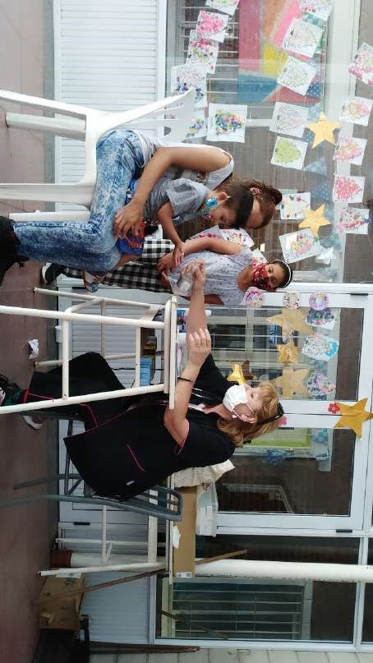
* Families from the center attending the periodic medical check-up
Accompaniment

2021
Families who are financially helped to make trips by public transport to carry out health procedures | 30
Delivery of food bags and cleaning kits | 175
Families attend the dining room and the activities proposed by the center every day | 32
Subjects taught in person under strict protocol | 11
Families benefited by La Nazarena in social programs | 02
Enrollment in programs: the companions help families in the process of enrollment in provincial programs. Thanks to this, two families from La Nazarena managed to expand their house.

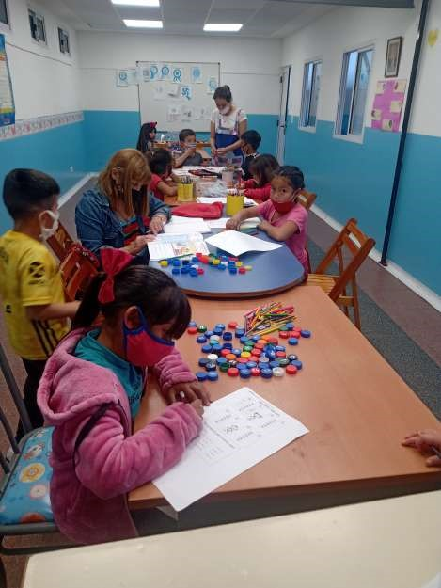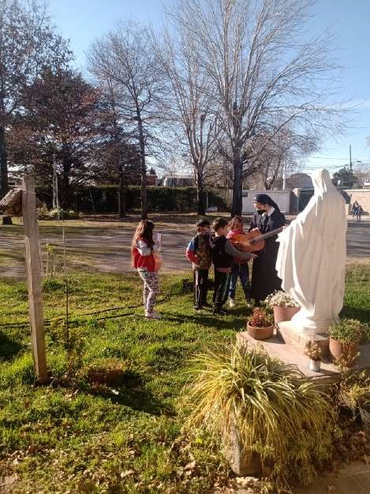
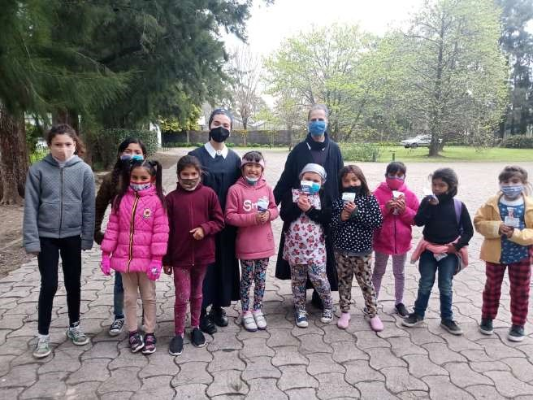
*Asignaturas que se dictan en forma presencial con estricto protocolo

Workshops

(Participants) 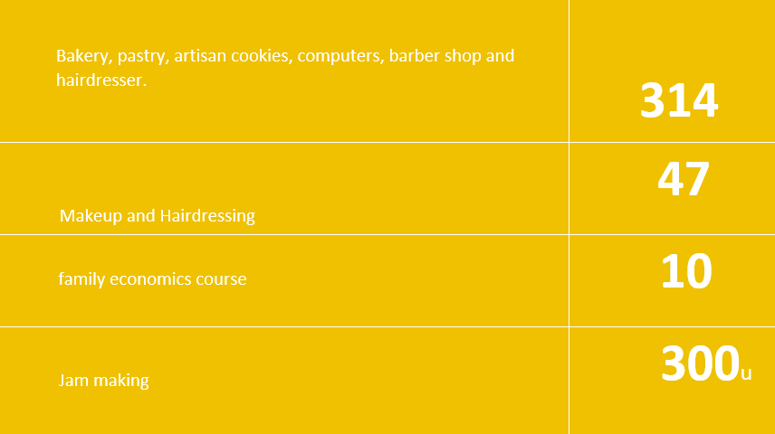

Educating Foundation: 314 students were trained during the year and received their diplomas .
Beauty for a future (L’Oréal y Pescar foundation):
Between 2019 and 2020, 88 people graduated from La Nazarena.
From this number, currently:
67.4% are employed.
47.67% work in the beauty industry.
Micro-enterprises:
Catering for 140 people.
Preparation of 300 jams.

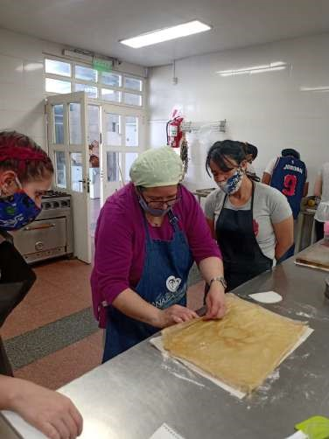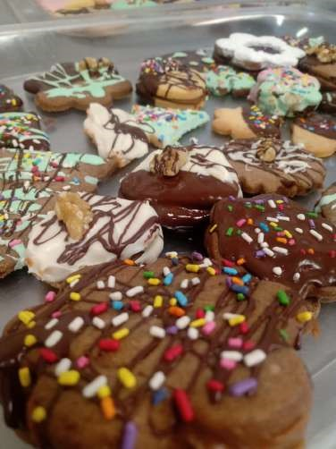
*Pastry course
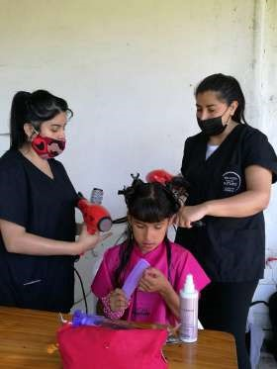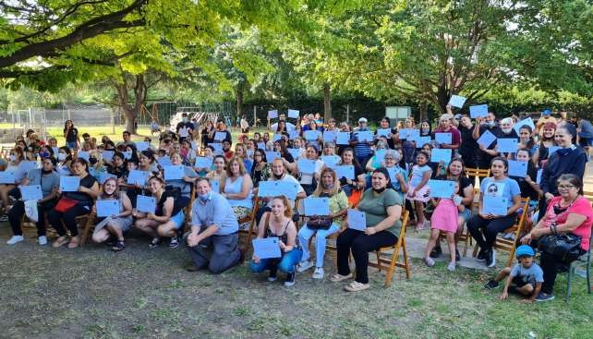
*Delivery of diplomas from Fundación Educando courses

Our Allies
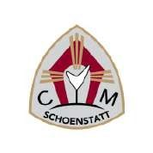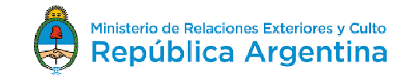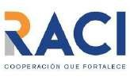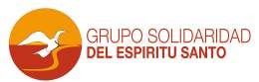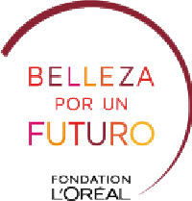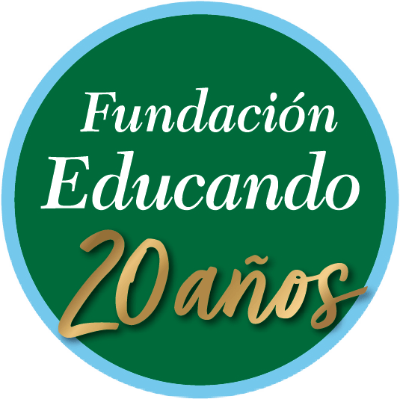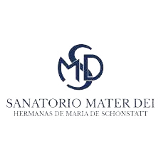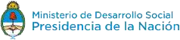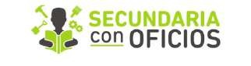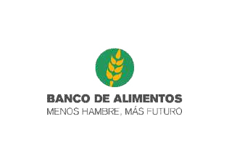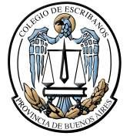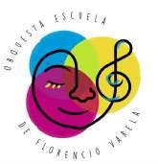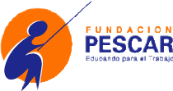
MEMBRESÍA
La Nazarena Team
Legal representative: Sister María Paz Baltar Rodríguez
Director: Sister María Del Carmen Sörös
Coordinator: Sonia Mabel Rivero
Volunteer advisor committee: Analía Bestani, Mabel Cedro,
Isabel Bestani, Silvana Frías, Taira Peña, Claudio Nicolini
LaNazarenaSchoenstatt centrolanazarena +54 9 11 6467-4222 www.lanazarena.org.ar

