A PROPOSAL FOR FUNDING TO SUPPORT MOTHERS SKILLS TRAINING AN INITIATIVE BY BELIEVE MENTAL HEALTH CARE ORGANIZATION

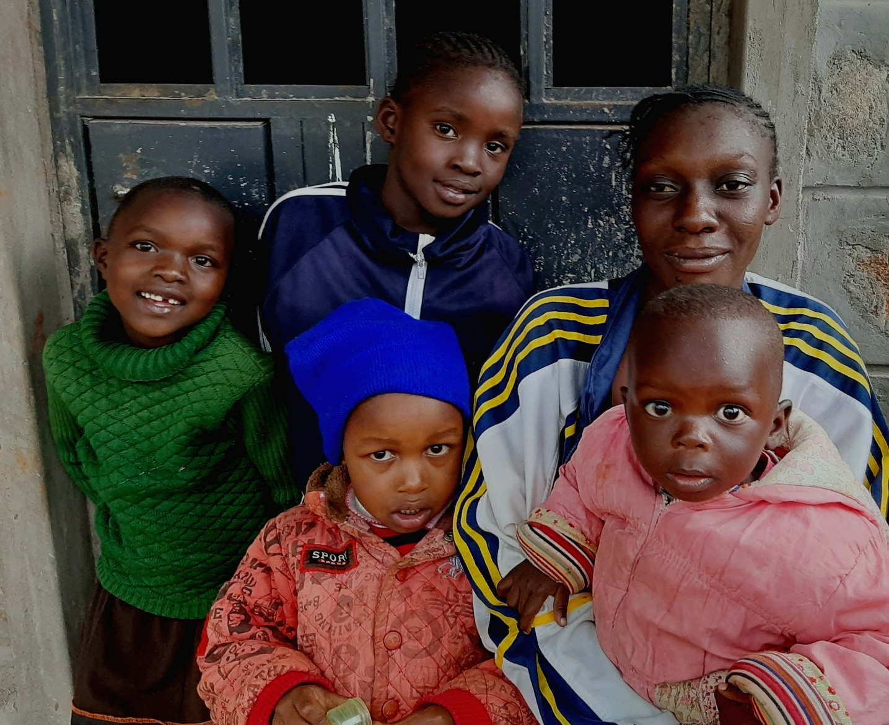

PROJECT; TRAIN 500 MOTHERS ON CHILDREN MENTAL HEALTH IN 5 WARDS IN UASIN-GISHU COUNTY, KENYA.

ORGANIZATIONAL BACKGROUND
Believe Mental Health Care Organization is a registered community based organization with the department of social development in April 2019.BMHC Org was founded with the aim of promoting education and culture. Believe Mental Health Care Organization is committed to the mental health and psychological wellbeing of young people in Kenya, Uasin-Gishu County in particular in pursuit of its vision, mission and objectives of providing creating awareness and sensitization, education and development programs to Kenyan children, youth and women through community engagements. we are a youth and women led organization working on better mental health care and empowerment of the society. We are implementing intervention and preventive programs, exercises, talks, campaigns and social studies on sound education and provision of psychosocial support.

BMHC organizational structure takes cognizance of principles whose aim will be to facilitate efficiency and effectiveness in our operations by having a clear span of control and the need for unity of command to enhance speedy decision making while retaining accountability at every stage. BMHC Org is a multi-layered organization which is guided by a board of directors. The second layer of command is the executive which is led by the CEO and has various departments lead by their respective heads. The members (form committees) and volunteers come at the last tier.

As a community organization our programs and exercises are focused on diversity and inclusion, empowerment and education at all levels of the society.
With the rising concerns around mental health BMHC Org has had significant growth since its inception. We have achieved establishment of safe spaces within associations in university of Eldoret; Nijali talk space, we have solicited 13 secondary schools in Uasin-Gishu to participate in our Ongea-Uliza exercise (talking boxes) and we have established a strong working relationship with Kimumu and G.K Prison primary schools.

PROBLEM STATEMENT
The Kenya government has been at the forefront in addressing issues on mental health by being a signatory to various international and regional rights declarations and treaties; Universal Declaration on Human Rights, the International Covenant on Economic, Social and Cultural Rights (ICESCR), the Convention on the Rights of Persons with Disabilities (CRPD), the Convention on the Rights of the Child (CRC), the African Charter on Human and Peoples’ Rights (ACPHR), the Protocol to the African Charter on the Rights of Persons with Disabilities and the African Charter on the Rights and Welfare of the Child. At the local level, the Constitution of Kenya (2010), The Mental Health Act (cap 248) focuses on in-patient admission and provides for prohibition of ill-treatment in hospital including how to examine females. Despite having a broad legal and policy context Kenyans still grapple with challenges in getting mental health services and information.
The World Health Organization (WHO) Annual Report (2017), ranks Kenya as sixth among African countries with highest rates of depression (at 1.9 million cases). It is estimated that six million Kenyans suffer from common mental conditions such as depression, dementia, and substance induced disorders due to abuse, schizophrenia, delusional disorders as well as stress and anxiety. According to the Kenya Mental Health Policy (2015-2030), mental disorder cases in Kenya continue to rise rapidly. Statistics indicate that at least one in every four {1:4} Kenyans suffers from a mental illness at one point in their lives. Despite the state of mental health disturbing, Kenya has only 88 psychiatrists,427 psychiatrist nurses who are trained to handle mental illness, about 10 medical social workers and a few mental psychologists and counselors who are competent to handle mental issues, budgetary allocation for mental health is only 0.5% of health budget thus leaving the mental equation completely overstretched
Incidences that explain rise in mental illness include cases such as a man hacking his wife and children to death, a woman killing her husband, children barely 10 years of age committing suicide or homicides; or a university student swallowing a handful of pills only to sleep herself to death. And while no one is safe from mental health, the most affected is the current generation-a big portion of them being millennia’s and kids.
Mental Health impedes the achievement of other health and development outcomes and contributes to poverty and vulnerability. The Kenya Mental Health Policy (2015-2030) states “Mental health is a key determinant of overall health and socio-economic development. In this project we are seeking to combat stigma and raise awareness on mental disorders so as to enable mothers to seek mental health services for themselves and their children. We also intend to gather and document cases of violations of the rights of people with mental disorder that will be crucial for the government in policy formulation.
In view of the above, it is important for us to take up mental health as a serious health issue. Childhood mental and developmental disorders are an emerging challenge to health care systems both nationally and globally. The lack of attention to the mental health of children may lead to mental disorders with lifelong consequences, undermines compliance with health regimens, and reduces the capacity of societies to be safe and productive. Children with mental and developmental disorders are at higher risk of mental and physical health problems in adulthood, as well as increased likelihood of unemployment, contact with law enforcement agencies, and need for disability support. The recent suicide crisis in Kenyan children especially those from low-middle income households is alarming. We as an organization we intend to intensify awareness campaigns on the condition, demystifying stigma, prevention, early symptoms, management and treatment services through training of mothers to know about their children’s mental health and behavioral pattern to curb mental disorders in children. Through a series of advocacy at the community level, we will beseech the Kenyan Government to allocate more funding to mental health services and train health workers at all levels to manage and treat mental health challenges.
.
PROJECT JUSTIFICATION
Childhood mental and developmental disorders have serious adverse impacts on the psychological and social well-being of children and their families. Despite the burden that mental health problems impose on children and adolescents, our country health system and community do not provide satisfactory care to those in need. The widespread implementation and evaluation of parenting skills training in all countries is recommended to achieve a meaningful reduction in the global prevalence and burden of childhood and developmental disorders.

The health of children is highly dependent on the health and well-being of their caregivers; the environments in which the children live, both home and school; and, as they transition into adolescence, the influence of their peers. Using these criteria, efforts to address children’s mental health problems or improve parenting skills may improve the mental health and development of many children.
Several systematic reviews have demonstrated the effectiveness of parenting skills training in reducing both internalizing and externalizing problems in children (Furlong and others, 2013, Kaminski and others, 2008), as well as in reducing the risk of unintentional childhood injuries (Kendrick and others, 2007) and improving the mental health of parents (Barlow and others, 2014). A meta-analysis of group-based parental skills training for parents of children with conduct problems showed moderate effect sizes with a standardized mean difference (SMD) in conduct problems of -0.53 (95% confidence interval (CI) -0.72 to - 0.34) as assessed by parents (Furlong and others, 2013). Therefore, parenting skills interventions can reduce or prevent both the onset of childhood mental disorders and subsequent adverse health and social outcomes.

PROJECT GOALS
-to equip mothers with maternal understanding and attitude about child development.
-to reduce, prevent child abuse and maltreatment
-to help mothers raise their children with a higher value of life, know how to manage their emotions and with empathy.
PROJECT ACTIVITIES
ACTIVITY | TIMELINE | MATERIALS
Prepare training sessions plans ,questionnaires and visual aids | 4 weeks | -IEC materials  -printing papers  -laptop  -printer
Recruit mothers age 18-30,100 each from kimumu ward,langas ward,huruma ward,kapsoya ward and kapseret ward | 4 weeks | -volunteers and partner organizations  -schools  -forms  -IEC materials
Group mothers depending on their locations (groups of 20) | 1 week in each ward | -wards maps  -printing papers  -printer
Arrange for training space  Conduct the training sessions; pre survey and teaching | 2 weeks in each ward  2-3 days in each ward | -facilitators and volunteers  -visual aids and videos  -brochures  -writing materials  -Flipcharts and makers  -portable boards  -field hire  -facilitation fees  -marketing; shirts  -snacks  -projector and projection screen  -camera  -banner
Conduct post survey; evaluation | 6weeks | -laptops  -camera  -printing papers  -printer
Report writing | 1 week | -laptops  -printer  -printing papers

PROJECT RESULTS
Short term
-better mother –child interactions
-reduced child abuse and maltreatment
-reduce conflicts in the family
Long term
-increased sense of well-being in children and reduced negative effects of conflict that can lead to mental health illness.
-reduction in child behavioral problems
-increased stability; child attachment
- the recognition of children in need of formal diagnosis and treatment
-improved physical health

-enhanced productivity

CONCLUSION
Childhood mental and developmental disorders globally account for a significant health and societal burden. As the evidence presented in this proposal indicates, key interventions that have the potential to reduce mental and developmental disorders in childhood are parenting skills training and maternal mental health interventions. A widespread implementation and evaluation of parenting skills training and maternal mental health interventions in all countries is recommended to achieve a meaningful reduction in the global prevalence and burden of childhood and developmental disorders. (Barlow et al,2014)

REFERENCES

Barlow, J., Smailagic, N., Huband, N., Roloff, V. & Bennett, C. (2014). Group-based parent training programmes for improving parental psychosocial health. The Cochrane database of systematic reviews 5, CD002020.

Furlong, M., McGilloway, S., Bywater, T., Hutchings, J., Smith, S. M. & Donnelly, M. (2013).

Cochrane review: Behavioural and cognitive-behavioural group-based parenting programmes for early-onset conduct problems in children aged 3 to 12 years (Review). Evidence Based Child Health 8, 318-692
Kaminski, J. W., Valle, L. A., Filene, J. H. & Boyle, C. L. (2008). A meta-analytic review of components associated with parent training program effectiveness. Journal of Abnormal Child Psychology 36, 567-89.

Kendrick, D., Barlow, J., Hampshire, A., Polnay, L. & Stewart-Brown, S. (2007). Parenting

interventions for the prevention of unintentional injuries in childhood. The Cochrane database

of systematic reviews, CD006020.

https://www.nation.co.ke/lifestyle/lifestyle/Why-modern-day-parenting-is-in-crisis/1214-5239072-o0leu9/index.html

https://www.nation.co.ke/news/Why-suicide-murder-cases-are-on-the-rise-at-colleges/1056-5027620-qm2hp3/index.html

WORKPLAN

TRAIN 500 MOTHERS ON CHILDREN MENTAL HEALTH IN 5 WARDS IN UASIN-GISHU COUNTY,KENYA
BMHC Org; Promoting Parents skills training and mental health awareness in Uasin Gishu County
ACTIVITY
OBJECTIVE 1;TO FACILITATE COMMUNICATION AND AWARENESS OF SOCIAL,CULTURAL AND MENTAL ISSUES
ACTIVITY 1: SELECTION AND TRAINING OF MOTHERS IN 5 WARDS IN UASIN-GISHU COUNTY, KENYA.
Sub-activity 1.1: SELECTION OF 1OO MOTHERS IN EACH WARD
Sub-activity 1.2 : GROUPING OF MOTHERS IN 5 GROUPS DEPENDING ON LOCATIONS PER WARD
Sub-activity 1.3 ; 3 DAY TRAINING
Activity 2: PROJECT INCEPTION MEETING WITH FACILIITATORS,VOLUNTEERS AND STATEHOLDERS IN EACH WARD.
Sub-activity 2.1: INCEPTION METING IN HURUMA WARD TARGETING 100 MOTHERS
Sub-activity 2.2: INCEPTION METING IN LANGAS WARD TARGETING 100 MOTHERS
Sub-activity 2.3: INCEPTION METING IN KAPSERET WARD TARGETING 1OO MOTHERS
Sub-activity 2.4: INCEPTION METING IN KAPSOYA WARD TARGETING 100 MOTHERS
Sub-activity 2.5:INCEPTION METING IN KIMUMU WARD TARGETING 100 MOTHERS
Activity 3: DEVELOPMENT OF CHILDREN MENTAL HEALTH MESSAGING TOOLS AND KIT
Sub-activity 3.1 : DEVELOP AND DESIGN IEC MATERIALS AND MANUALS
Sub-activity 3.2;PRINTING OF IEC MATERIAL TO BE USED IN TRIANING OG YOUTH SRHR CHAMPIONS
OJECTIVE 2: TO PROMOTE SELF AND EMOTIONAL AWARENESS AND ADVOCATE AGAINST SHAMING AND BULLYING
Activity 5: MAPPING OF CHILDREN COUNSELORS,PSYCHOLOGISTS IN UASIN-GISHU COUNTY
Sub-activity 5.1: IDENTICATION OF COUNSELORS AND PSYCHOLOGIST WITHIN UASIN GISHU COUNTY
Sub-activity 5.2: COURTESY VISITS TO VARIOUS COUNSELORS AND PSYCHOLOGISTS
Sub-activity 5.3: ANALYSIS AND SELECTION OF COUNSELORS AND PSYCHOLOGISTS TO WORK WITH WITHIN UASIN-GISHU COUNTY
Activity 6: ESTABLISH A REFERRAL SYSTEM WITH SELECTED COUNSELORS AND PSYCHOLOGISTS
Sub-activity 6.1: DEVELOP A REFERRAL PROCESS TO LINK MOTHERS TO COUNSELORS AND PSYCHOLOGISTS
Sub-activity 6.2: MONITOR REFERRED CASES
Sub-activity 6.3
Activity 7; CONDUCT PRE AND POST SURVEY TESTS
Sub-activity 7.1 CONDUCT PRE-SURVEY TEST ON PARENTAL STYLES AND SELF AWARENESS
Sub-activity 7.2 CONDUCT POST SURVEY TEST
OBJECTIVE 3: TO INVEST IN PEOPLE TO FORM HEALTHY RELATIONSHIPS AND BETTER GENDER INTERACTIONS
Activity 8: GIRLS AND WOMEN WORKSHOPS ON BEING AWARE
Sub-activity 8.1 : THREE DAY WORKSHOP TO ENGAGE GIRLS AND WOMEN ON THEIR PERSONAL DEVELOPMENT
Sub-Activity 8.3;MEETING WITH KEY STAKEHOLDERS TO PLAN FOR KEY CALENDER DAYS
Activity 9:LEARNING, MONITORING AND EVALUATION
Sub-activity 9.1 PROGRAM STAFF MONTHLY REVIEW MEETING
sub-activity 9.2 WARD MONITORING VISITS WITH GROUP LEADERS
sub-activity 9.3 MONTHLY CONFIRMATION ON REFERALS AND FOLLOW-UP
sub activity 9.4: STAFF INTERNAL MONTHLY REPORTING ON PROGRESS
Sub-activity 9.5: 4 BOARD MEETINGS TO REPORT ON PROGRESS
sub-activity 9.6: QUARTERLY REVIEW AND FEEDBACK A30SESSIONS BETWEEN MOTHERS /COUNSELLORS AND PSYCHOLOGISTS
sub-activity9.7; CONDUCT ORGANIZATION CAPACITY ASSESSMENT
Activity 10; CREATE A SUPPORT SYSTEM
Sub-activity10.1;FACILITATE FORMATION OF SAFE SPACES WITHIN THE MOTHERS GROUPS
Sub-activity 10.2; INFORM ,ENGAGE AND MONITOR THE MOTHER GROUPS
Sub-activity 10.2; MONITOR MOTHER-CHILD INTERACTIONS

