Youth Farming and Leadership Report #5
November 10, 2021
The Sojourner Foundation continues our Youth Farming and Leadership Programme with our second group of young people, aged 17 to 21, 11 trainees from the Barbados Youth ADVANCE Corps as well as 2 other students. We are in the fifth week of the first of two terms of training, introducing our 13 students to the principles of organic farming, culinary arts and the concepts of sustainability and sustainable living. Each day starts with a check in with students, a mindfulness practice and a brief physical activity in which we encourage the trainees to take the lead.
Our facilitators this term are:
- Aldair Sobers – sustainable development, agriculture, coordination and oversight
- Leah Clarke – sustainable living, health and wellness, coordination and oversight
- Bernice Chase – culinary arts, including health and safety and nutrition
- Tempu Nefertari – personal and cultural development
- John Hunte – principles of organic farming
- Erskine Proverbs – building with natural materials

Our team also includes assistance from a student counsellor trained in psychology, an elder with over 30 years of experience in organic farming and healing herbs and specialists in alternative energy forms.

The First Four Weeks of Training
Orientation, which was conducted during our first week, focused on getting to know each other, protocols, expectations and creating community agreements around respect, behaviour, participation and safety. We also conducted virtual tours of our two main farm spaces and discussed food security. Activities included a food audit, reviewing the sources of the foods the trainees had in their kitchens.
During the second week, we discussed sustainable development and sustainability in agriculture, reinforcing these concepts with practical examples, case studies and exercises for the trainees to do. We also discussed systems, including food systems and economic systems, considering how we can reverse some of the negative, systemic challenges we face. We introduced permaculture as a regenerative system that can help to sustain our communities.
The trainees were also introduced to health and safety in the kitchen with Bernice Chase, an award-winning culinary artist/chef of many years, and we reviewed Ministry of Health requirements and HACCP guidelines. We also looked at nutritious meals and the importance of good nutrition as well as healthy habits that we can implement.
We started the third week with an introduction to the general principles of organic farming with John Hunte, an organic farmer of over 20 years and Secretary of the Organic Growers and Consumers Association. We discussed soil regeneration; natural control of pests, weeds and diseases; water conservation and animal welfare. The trainees learned about the benefits of organic farming and how healthy crops are cultivated. Activities included looking at the trainees’ backyard spaces and drawing a farm map.
We commenced on the ground training during this week so that we could apply what the trainees were learning online and get away from some of the frustrations of the online classes. We first conducted a tour of Kamp Deed, our farm space in Turners Hall, St. Andrew, building teamwork skills, confidence and trust with a hike. The trainees had their first personal development session with Tempu Nefertari and they also planted some saplings.
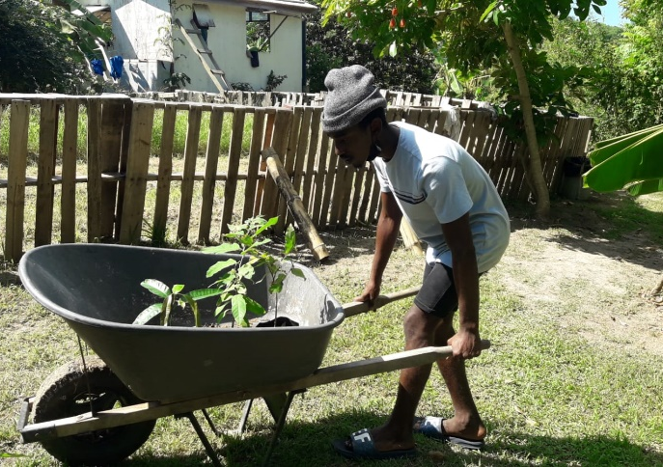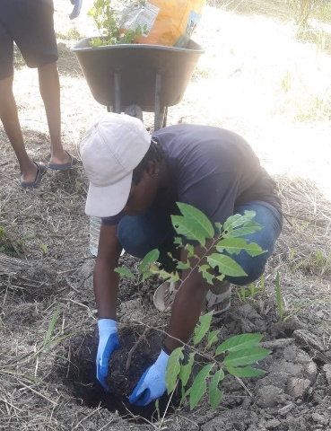
Trainees planting lime trees and soursop trees, applying mulch and watering the trees
In our online organic farming session with John in the fourth week, the trainees learned how to plant and care for organic seedlings. This included how to manage the exposure to sunlight and water and how to amend the soil with compost.
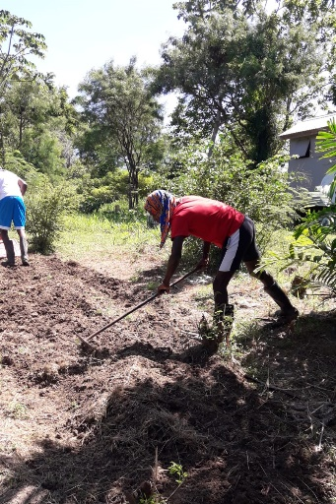
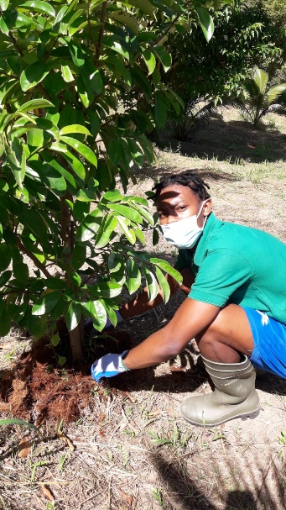
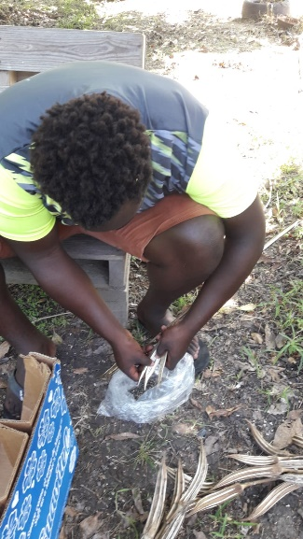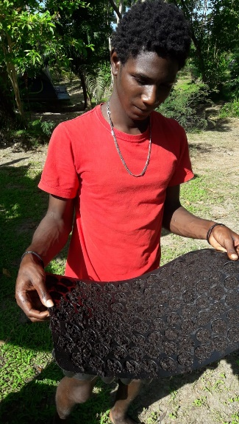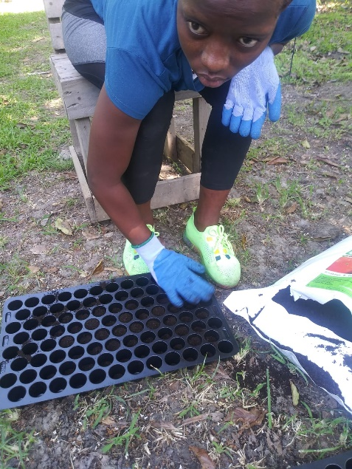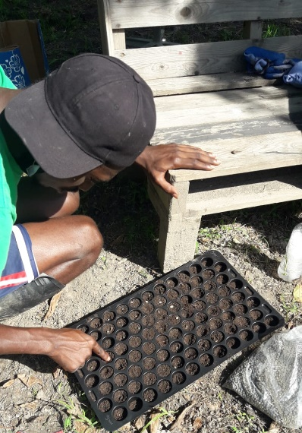
Face to face classes continued with trainees filling seedling trays with various types of seeds, including watermelon, okra, squash and pumpkin. They also started preparing beds for transplanting the seedlings and looked after the saplings they planted the week before as well as other fruit trees in our orchard.
The trainees continued to discuss nutrition with Bernice during the fourth week, learning about the nutritional benefits of specific foods, including sweet potato, breadfruit and carrots. Culinary arts activities included another food audit that reviewed the nutritional content of the foods we eat. Our personal development session focused on knowledge of self and helped us to look more closely at our personalities and areas that we can improve.
Overall Assessment
The trainees have generally shown a high level of interest in the programme, with strong engagement, both online and face to face. However, there have been challenges with online attendance and participation is sporadic as trainees have indicated unreliable internet service and most lack access to appropriate devices to access the online classes. They have mainly been using cell phones, which is not ideal for our classes. Some of the trainees do not have any devices at all and are using borrowed devices, but this is only a temporary solution. One trainee only showed up to three classes with a borrowed device, but it seemed that he had difficulty participating each time.
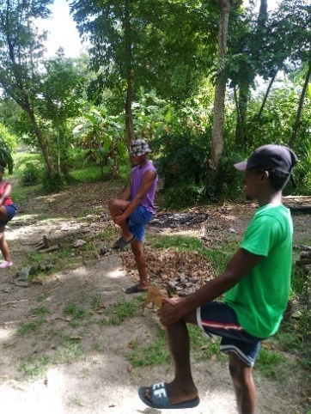
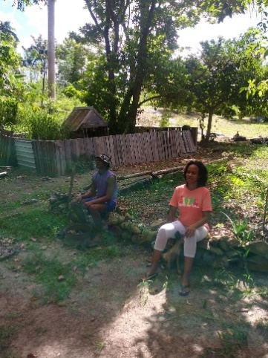
The trainees noted that online fatigue was an additional source of frustration, which led us to start on the ground training twice a week, which they thoroughly enjoy and are eager to attend and participate. Given the significantly increased participation during face to face training, in which the trainees are very engaged, we have started the fifth week on the farm every day.
Trainees start each day with a meditation and a stretch
To date, transportation for the trainees has mainly been provided by the facilitators, which is not a sustainable practice. However, we recognise that bus fare is likely to be another challenge for the trainees and we are seeking to acquire a coach for the use of trainees, which will be particularly useful when we are going on tours. We are also seeking to raise funding for appropriate devices for the trainees in the likely event that we need to return to online classes.
We believe the challenges with the devices and transportation could lead to disenchantment and disappointment and a possible early exit from the programme, so we are hoping that they can be resolved as soon as possible.
We thank you immensely for the support you have provided over the past year and a half and we look forward to continuing to share our progress with you.

