
Opportunity International
Support Branch Expansion in Arusha
OVERVIEW: Opportunity Tanzania
Opportunity International carefully monitored Tanzania over the last few years and in December 2007 acquired the microfinance institution, Faulu Tanzania, in order to begin serving Tanzania’s poor. Now known as Opportunity Tanzania, the institution has come a long way since our acquisition and we are hopeful that with support it will become a successful bank for the poor.

Currently, Opportunity Tanzania has one office in Dar es Salaam that is the home office for loan officers that work in three area-teams around the capital (Illala, Temeke and Kinondoni). Opportunity Tanzania’s goal is to grow client outreach, while also converting to an institution capable of accepting savings deposits and offering the poor insurance policies. These steps together should allow Opportunity Tanzania to become a more sustainable institution truly capable of transforming poverty for many years to come. Opportunity needs $150,000 to expand its outreach to Arusha, a major northern Tanzanian city in great need of support.
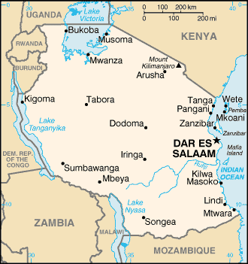
- Opportunity currently serves 3,625 active loan clients through the Dar es Salaam region.
- The average client loan size is $320, where clients use this money to start or expand their businesses.
- Opportunity Tanzania plans to reach 65,000 active loan clients and provide saving services to 227,000 people by 2013 and hopes to increase lending products to include school fee loans and agricultural loans, to meet the needs of poor families.

Why Arusha?
Opportunity is looking to open a new branch in Arusha because of its large population and tremendous poverty. Hardworking entrepreneurs in rural areas need microfinance. Arusha is the fourth largest city in the country, and just over 1.3 million people live in the region, making it a perfect place for investing in a substantial financial institution dedicated to the needs of the poor.


Located in the northern highland of Tanzania, Arusha is home to Mount Kilimanjaro, the highest peak in Africa, and is famous for its many national parks with native wildlife, providing an unforgettable safari ride through the trails of the animal’s natural habitat.
Mt. Kilimanjaro is the highest point in Africa, attracting many visitors to its location in Arusha.

What many don’t know is that beyond the city and the tourist resorts, families – hardworking men and women, and young teenagers – struggle against generational poverty. Opportunity International wants to expand to the most rural parts of Tanzania, because about 78% of the population live in rural areas, while 22% live in the urban areas.

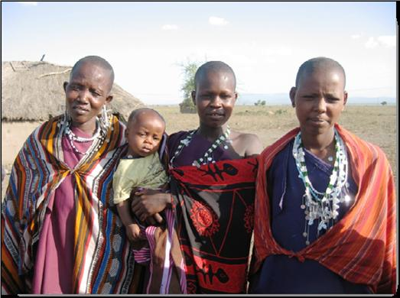
How Can We Help?
Tanzanians are desperate to find a way to escape the constant battle against debilitating poverty and it is essential that opportunity is given to those entrepreneurs who have ideas, but no funds to help realize their vision. Further, it is necessary to build a deposit-taking institution for those who have never had access to a bank, usually storing their meager cash and change under a bed mattress or in the ground behind their home.

Opportunity Tanzania’s success in bringing transformation to clients in Dar es Salaam shows the vital need for our services around Tanzania. A branch in Arusha will help reach into rural Tanzania, expanding to meet those most in need. With the introduction of loans, Trust Groups providing a supportive network, savings accounts, and trainings, Opportunity can help Tanzanians help themselves.

Join Us!
We ask for your help in supporting branch expansion to Arusha. We hope to raise $150,000 to build an Opportunity Tanzania branch, which will not only be a physical structure, but will bring a symbol of support and a realization that people do care and want to help fight against the poverty cycle in Tanzania.

Your funding will provide for infrastructure costs, information technology, office equipment, security, loan officer training and transportation, and personnel costs.

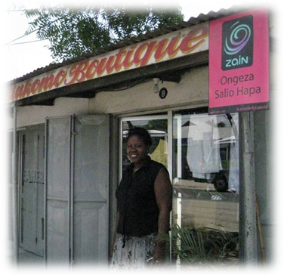
Developing another branch in Arusha will give more people access to Opportunity’s financial services and transformation. Help us reach out to the rural poor and transform a people, a region, and a country.

APPENDIX: Phases of a Branch Expansion
Success from Dar es Salaam: Meet Lisa Msuya
Lisa Msuya is a model of transformation in her community. She came to Opportunity Tanzania with a dream of opening a women’s clothing store. With her first loan of $115 and valuable business skills training, she opened a small boutique. But, Lisa didn’t stop there. Her boutique has been well received by the community and she has taken out additional loans to start a men’s clothing shop, a barber shop and a dry cleaners.

Today, Lisa is the successful operator of four businesses in Dar es Salaam and she employs three workers from her community, where work is not easy to find. She not only has the funds to send her son to school and provide for her family, but sheds hope on other people who are looking for the chance to become an entrepreneur.

Phase One: New Unit Set-up
- Rent and equip a small, storefront office in the service region. A local presence is necessary for the program to become an integral part of the community. Computers will connect the branch with the main office for daily reporting of financial transactions and services.
- Hire and train a new unit manager. Opportunity usually promotes an experienced, high-performing loan officer to the new loan officer supervisor position. S/he will require extensive and on-going training to manage, mentor, and motivate staff and to integrate the new unit into the overall operations.
- Recruit and train new, indigenous loan officers to expand into rural areas. Because the distances are generally great—even from the branch office—the loan officers need to figure out transportation. An Opportunity car or motorbike is ideal, but public transportation is the norm. The branch will need to invest in loan officer training to build an efficient high performing team.
- Investigate villages for their group-lending needs and potential. The loan officers will focus on the poorest for whom a small loan can make a major life-style difference.
- Hold informational sessions in the village(s) so loan candidates can self-select into Trust Groups of 15-30 members who will guarantee each other’s loans and commit to working together so that all may succeed.
- Meet with new Trust Groups weekly for six weeks of group formation and pre-loan training so that when the loan is issued, the borrowers are prepared to put the funds to the best use and have developed a friendship and support network.

Phase Two: Increasing Outreach
- Disburse loan funds to new Trust Groups. Most borrowers will engage in food growing, processing, and vending; sewing and weaving; and straw and woodcrafts. Their businesses will generate the cash flow necessary to service short-term credit.
- Loan officers will continue to attend the weekly meetings of their Trust Groups to provide training, on-going support, and timely collection of savings and loan payments. The loan officer will facilitate group-selected trainings in basic business practices, health education (including AIDS prevention in Africa), personal empowerment, and community development.
- After four months, initial loans will be repaid. Loan officers will qualify successful Trust Groups for larger loans and business expansion and continue to attend the weekly meetings to provide more advanced training.
- Provide savings accounts for borrowers so that they can accumulate useful sums of money for their children’s education, business expansion, and unexpected expenses. By making savings collection a component of the weekly meetings, the members have a convenient way to make savings deposits and develop the habit of saving. Their savings are secure, not hidden in their homes at risk of theft and appropriation by family members who wield more power.
- Monitor impact. Opportunity uses eMerge, an integrated loan portfolio management and accounting system to provide management and accounting reports and to provide close-of-business day reports. Through consistent and detailed monitoring, services and policies can be quickly modified based on relevant, measurable data, to meet the unique needs of people served by a particular branch or by the program as a whole.

