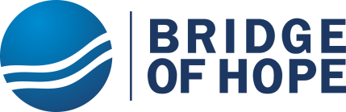

Enable 360 children with disabilities in Armenia.
Progress Report October- December, 2021

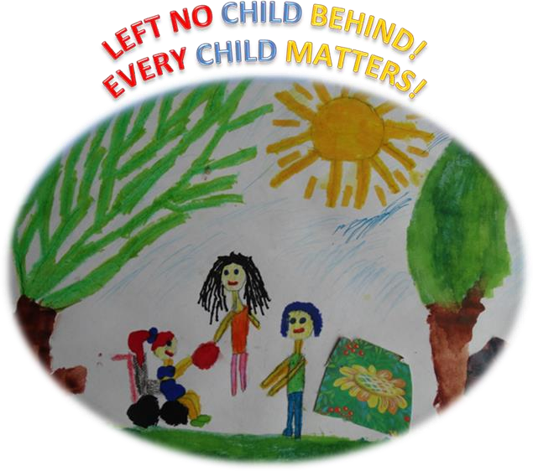

EVERY CONTRIBUTED PENNY HAS MADE CHANGE!

Highlights
Staring from March 2020 up to date 12,189.82 USD is raised for the project.
The current progress report covers the period 01.10.2021-31.12.2021. Within this period 1741.90 USD have been donated by our benevolent benefactors that makes around 3% of overall budget allocated to the project for this period.
The report is a kind of a gratitude to all of our individual donors, who have had their valuable contribution into the collective efforts towards better quality of life for 360 children with disabilities through the services supporting their inclusion and participation at school and in their respective community.
Summary of progress Community based centers in Dilijan, Ijevan and Berd and Noyemberyan cities of Tavush Marz have become welcoming doorways for 360 children with disabilities enabling them to access education and community life. The services have covered an incredibly wide range of activities and approaches ranging from very rights-based and radical community initiatives, to rather narrow service delivery of certain aspects of rehabilitation.

Activities
- Life skills
- Art Therapy – drawing, sculpturing, music and singing.
- Occupational therapy
- Speech development – individual and group.
- Physical therapy.
Outcomes 360 children have developed their essential social skills helping them to succeed in learning and social interrelations: focus and self-control, perspective-taking, communication, making relations, critical thinking, taking on challenges, self-confidence, engaged learning.
310 children are successfully enrolled at inclusive secondary and VET schools. 50 kids enjoy their early childhood development at kindergartens.

Success story
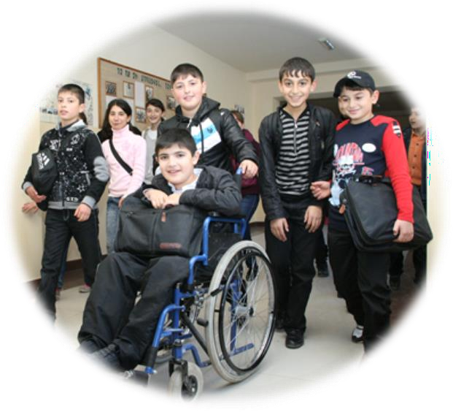
The most important thing for me is the relationship with my peers and their friendship I enjoy. I learn a lot of things from my friends that you cannot find in any of textbooks.
I live in the small village of Azatamut in Tavush Marz where I go to school and study at the 9th grade. Twice per week I visit the Bridge of Hope center in Ijevan where I get my services and spend really nice time with my peers, make new relationships with volunteers from Ijevan University. The mutual trust, respect and support of my friends have reinforced my confidence and already I do not speak of my dreams, but my goals and plans. I have decided to continue my education at the university and obtain full competencies of computer programming.
I am grateful to Bridge of Hope and to all of donors who inspired me confidence and became the constructors of my life path towards dignified and independent leaving.

