No | Name of Schools | Address | Beneficiaries | Contact Person | Recyclables Collected (kg)
1. | My Dream Stead School | 52, Babatunde Street, Wilmer, Ajegunle, Lagos. | 22 | Founder | 47kg
2 | LA Pry School, Layeni | Ojo Road, Ajegunle | School Donation | Head Teacher | 94kg
3 | Primegold College | 10/12, jejelaye street, Olodi Apapa | School Donation | Head Teacher | 145.3kg
4 | Aunty Wura School | No. 293 bale Str. Aga-Hausa | School Donation | Head Teacher | 49.5kg
5. | Gaskiya Secondary School | Gaskiya Road, Off Ijora Badia, Lagos | School Donation | Head Teacher | 230kg
6. | Kings Child Academy | 2, Odudu lane, Banana Busstop, Ajegunle | School Donation | Head Teacher | 50kg
7 | Rose Emmanuel | 38, Layi-Oyekanmi Street, Off Isolo Road, Mushin, Lagos. | School Donation | Propritress | 54.1kg
8 | Kingston High School | 28/30, Aminu Ishola Alaba –Oro, Lagos | School Donation | Principal | 256kg
9 | Mary Kelv School | 140 Ojo Road, Ajegunle | School Donation | Proprietors | 40kg
10 | Ajegunle Nur & Pry School | 293 Baale Str, Ago Hausa, Boundary, Ajegunle | School Donation | Head Teacher | 65kg
11 | Olugbenga School | Ojo Road, Ajegunle | School Donation | Head Teacher | 10kg
12 | Isrina School | 16, Barrister Ahmed Street, Mechanic Bustop, Ajegunle , Lagos | School Donation | Admin | 25kg

Schools/Beneficiaries of the Recyclespay Educational Project

MARCH 2025 –SEPTEMBER 2025

Beneficiaries Data
JUNE 2025
1. | 16//06//2025 | Goriola Primary School | 25kg
2 | 6//06//2025 | Glorious Bequest School | 35kg
3 | 6//06//2025 | Kingston High School | 70kg
SEPTEMBER 2025
1 | 26//09/2025 | Righteous View School | 45kg
2 | 26/09/2025 | Karmel School
 |  |  | 35kg

Aggregated Records from March 2020 – September 2025
No | Name of Schools | Address | Beneficiaries | Contact Person | Recyclables Collected (kg)
1 | Isrina School | 16, Barrister Ahmed Street, Mechanic Bus-Stop, Ajegunle, Lagos. | 39 | Admin | 10,733.5kg
2 | My Dream Stead School | 52, Babatunde Street, Wilmer, Ajegunle, Lagos. | 22 | Founder | 1353.3kg
3 | The Great Ecstasy Private School | Plot 2b Gbadamosi street Alagbaa iyana lpaja Lagos | 19 | Owner | 264.61kg
4 | The Great Children Joy school | 16, Adegboyega Street, Ilupeju | 3 | Proprietress | 175.1kg
5 | Zion Bells School | 75b. Harrison Street, Century Bus stop, Ago Palace Way, Lagos | School Donation | Principal | 352.4kg
6 | Kingston High school | 28/30, Aminu Ishola Alaba –Oro, Lagos | School Donation | Principal | 1679.3kg
7 | Phillamville school | 12, Awoyokun Street, Onipanu | 4 | Proprietress | 1521.4kg
8 | Kings child Academy | 2, Odudu lane, Banana Busstop, Ajegunle | 9 | Proprietress | 903.3g
9 | YPO Shodeinde Memorial Islamic school | 5, Akanbi Street, Ladi-lak, Bariga. | 5 | Proprietress | 224.6kg
10 | Rose Emmanuel school | 38, Layi-Oyekanmi Street, Off Isolo Road, Mushin, Lagos. | 5 | Proprietress | 619.3kg
11 | Prosperity Schools | 5, Untufam Ekpe Street, Ojokoro (Behind Holy Ghost Bible College, Agric, Ikorodu, Lagos. | 5 | Proprietress | 32.2kg
12 | Fadek school | 40 Shoga Street, Off Fatoki Isuti Road, Egan, Igando, Lagos | 11 | Fadek school | 98.3kg
13 | EBS School | 10, Nosamu Street, Boundary, Ajegunle, Lagos. | 10 | Proprietress | 73kg
14 | Emakreva Nur and Pry School | 10, Nosamu Street, Boundary, Ajegunle, Lagos. | 10 | Proprietress | 52.8kg
15. | A-Z All Phase Academy | 13, Mutairu Street, Itire, Off Ijesha Road, Lagos | 7 | Proprietress | 24.1kg
16. | Owu African Church Central Primary School | Owu, Abeokuta, Ogun State | School Donation | Proprietress | 306.6kg
17. | Salvation and Praise School | 59, Peter Agah Street, Oke Afa, Isolo, Lagos | School Donation | Headmistress | 190.7kg
18 | Vivaville International School | 1, Hossana Church Close, Off Alhaja Alake Street, Isale-Akoka, Akoka, Yaba, Lagos. | School Donation | Head Teacher | 25kg
19 | Izharul Haq Nursery and Primary School. | 7, Ijikoyejo Street, Baruwa Bus Stop, Ijeshatedo, Lagos | 17 | Proprietress | 685.8kg
20 | Royal Heirs Imperial School | 5, Adebayo Odueko Street, Off Lanre Bus-Stop, Odo-Eran, Governor's Road, Lagos. | 5 | Proprietress | 15kg
21 | The difference School | 15/17, Rafiu Adebanjo Street, Beside Elemoro Street, Eputu Bus-Stop, Ibeju-Lekki, Lagos. | 10 | Proprietress | 56.1kg
22 | Absolute Footprint School | 12 Ayeni Street, Akesan , Lagos | School donation | Proprietress | 1100.4kg
23 | Glory Access School | 6,Oyeniyi Crescent, Oladapo Bus stop, Isuti Road, Igando, Lagos | School donation | Proprietress | 42kg
24 | Badia Nur. & Pry School | 33/34, Ireti Owoseni Street, Badia Ijora, Lagos. | School Donation | Head Teacher | 70kg
25 | Ireti Nur. & Pry School | 33/34, Ireti Owoseni Street, Badia Ijora, Lagos. | School Donation | Head Teacher | 70kg
26 | Olojowon Demonstration Nur. & Pry School | 33/34, Ireti Owoseni Street, Badia Ijora, Lagos. | School Donation | Head Teacher | 47kg
27 | Kusoru Nur. & Pry School | Ilasa, Isolo, Lagos | School Donation | Head Teacher | 51.3kg
28 | Ire-Akari Pry School | Ilasa, Isolo, Lagos | School Donation | Head Teacher | 23kg
29 | Metropolitan Nur. & Pry School | Orile Iganmu, Lagos | School Donation | Head Teacher | 105kg
30 | Ishaga Close Primary School | 112/114 Itire Road, Mushin | School Donation | Head Teacher | 82.3kg
31 | Olokun Pry School | Ilasa, Isolo, Lagos | School Donation | Head Teacher | 42kg
32 | Olisa Primary School | Alh. Abass Olisa Street, Off Dada Street, Mushin, Lagos. | School Donation | Head Teacher | 19.1kg
33 | Ire-Akari Baptist School | Ilasa, Isolo, Lagos | School Donation | Head Teacher | 27kg
34 | United Patec School | 73, Adedirun Street, Amukoko, Ajegunle | School Donation | Head Teacher | 151.6kg
35 | Maryola School | 76 Ojo Road, Ajegunle | School Donation | Head Teacher | 36.3kg
36 | Ire Akari Estate Model School | 8/14 Ugali Street, Ire Akari Estate, Isolo | School Donation | Head Teacher | 142.4kg
37 | Mary Kelv School | 140 Ojo Road, Ajegunle | School Donation | Proprietress | 246.6kg
38 | LA Pry School 1A | Ojo Road | School Donation | Head Teacher | 232kg
39 | LA Pry School 1B | Ojo Road | School Donation | Head Teacher | 195kg
40 | Ajegunle Primary School | 293 Baale Str, Ago Hausa, Boundary, Ajegunle | School Donation | Head Teacher | 333kg
41 | Primegold College | 10/12, jejelaye street, Olodi Apapa | School Donation | Head Teacher | 304.5kg
42 | Tolu Nur/Pry School | Tolu Complex, Olodi Apapa | School Donation | Head Teacher | 230kg
43 | Alaba Primary school 1 | Ojo Alaba Road | School Donation | Head Teacher | 72kg
44 | LA Pry School 2A | No. 293 bale Str. Aga-Hausa | School Donation | Head Teacher | 125kg
45 | Ikotun Senior High School | College busstop, Ikotun, Lagos | School Donation | Head Teacher | 496kg
46 | Gaskiya Secondary School | Gaskiya Road, Off Ijora Badia, Lagos | School Donation | Head Teacher | 521.2kg
47 | Victorious King School | 108 Ojo Road, Ajegunle, Apapa | School Donation | Head Teacher | 23kg
48 | Reservation School | 1, Tolu Complex, Temi Dire, Olodi Apapa | School Donation | Head Teacher | 51kg
49 | Chuzza School | 18, Okito Street, Oreghe, Lagos | School Donation | Head Teacher | 100.5kg
50 | Aunty Wura School | No. 293 bale Str. Aga-Hausa | School Donation | Head Teacher | 49.5kg
51 | Olugbenga School | 18,Lagida Street, Olodi Apapa, Lagos | School Donation | Head Teacher | 45.4kg
52 | Christ Assembly School | Rasaki Street, Alakoto, Ajegunle | School Donation | Head Teacher | 117.8kg
53 | El Nenora School | 20, Akpiri Street, Olodi Apapa | School Donation | Head Teacher | 7.5kg
54 | Bequest School | 15, Orodu Street, Ajegunle | School Donation | Head Teacher | 55.5kg
55 | Ayodele School | 12, Ayodele Street, Ojo Road | School Donation | Head Teacher | 48.3kg
56 | Kadoso School | 45, Orege Street, Olodi Apapa, Lagos | School Donation | Head Teacher | 70kg
57 | Goriola Primary School |  | School Donation | Head Teacher | 25kg
58 | Righteous View School |  | School Donation | Head Teacher | 45kg

Activity Pictures:

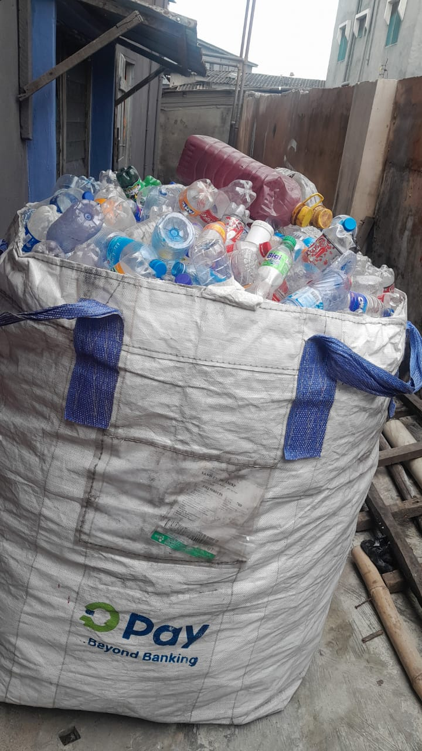Image 1

Image 2(Pick up at Karmel School)

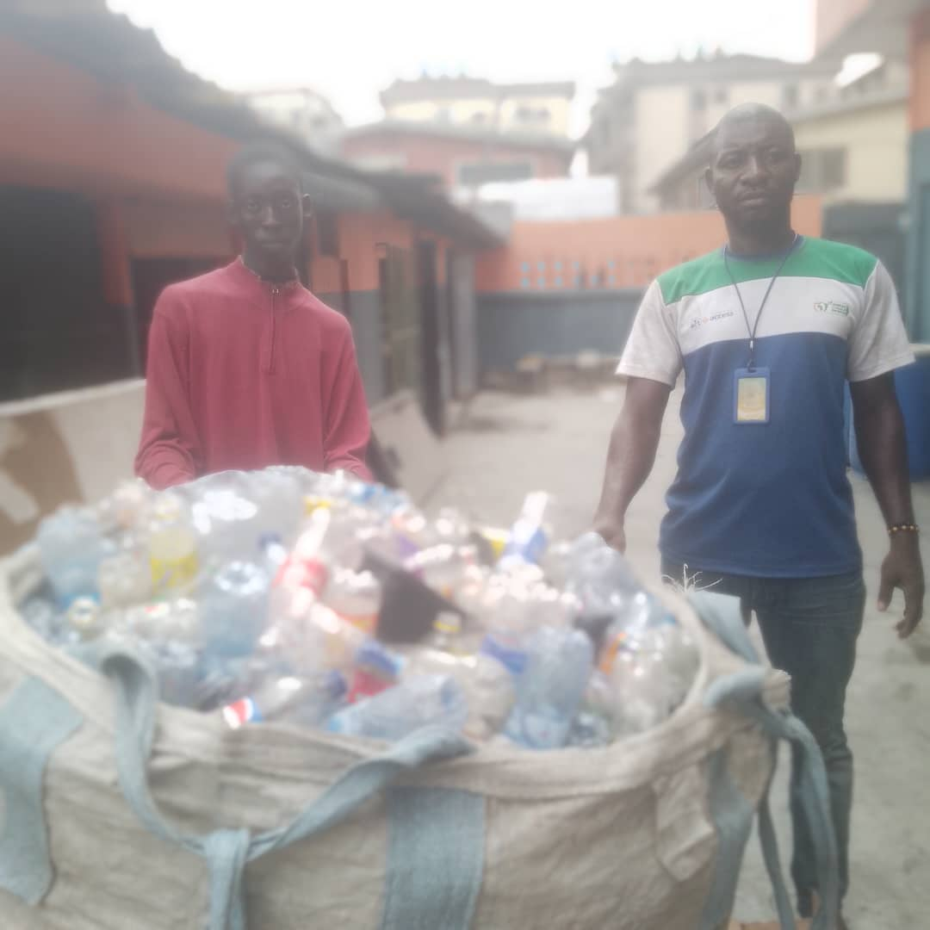
Image 1(Pick up Kingston School)
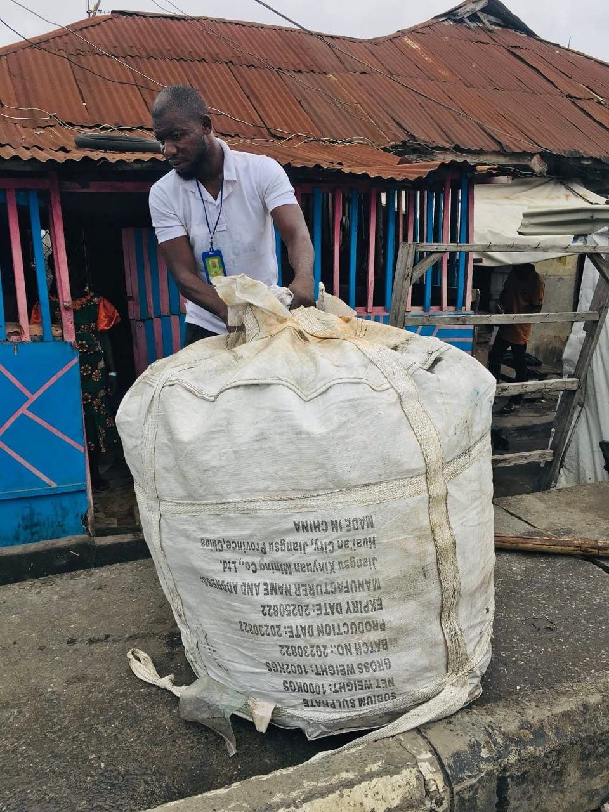

Image 3 (Pick up at Glorious Bequest School)

