GLOBALGIVING REPORT
Title: PROGRESS REPORT ON THE RE-BUILT BLOCK OF SIX (6) CLASSROOMS IN ENUGU STATE.
Great News! On 30th March, 2022; the organization successfully handed over a renovated block of six classrooms over to the Enugu State Universal Basic Education Board (ESUBEB); which is the operational policy of the Nigerian Educational system as the project beneficial Umuolo Community Primary School, Idi-opi is under the control of the Enugu state Universal Primary Education board.
Furthermore, Julie Helping Hands Foundation Team on 25th June, 2022 paid a visit to the school which showed that the completed project has inspired a more efficient learning environment for the teachers and pupils who were once exposed to unfavourable weather and learning conditions. More so, Parents have found hope and are now eager to send their children to school as the safe, efficient and renovated classrooms remains a thing of joy to them; The Traditional Leader further told us that the rate of “Child Hawking” in the village has reduced drastically. The school recorded their highest admission intake this year.
This project has helped us achieve one of our thematic goals, which is Quality Education especially; and also the Sustainable Development Goal 4 (QUALITY EDUCATION) for the disadvantaged and less privileged children within rural communities.
Thank you for promoting access to quality education for vulnerable children.
We have come this far with your support.
CHALLENGES
During the Monitoring and Evaluation, the organization realized that there is a need for learning aids/facilities as most of the classrooms had pupils learning on the bare floor and to that we are working towards equipping the classrooms with teaching and learning facilities such as; desks, tables, white marker boards and chairs. Our initial target was to set this up by September so that pupils can resume the next session in a favourable learning environment. This would also help the school conduct its affairs efficiently and effectively. But we are yet to meet up due to a lack of resources. We believe that by December, the classrooms would be fully equipped with the learning facilities for the pupils to receive a more efficient tuition. This will make learning more attractive for the pupils while the teachers will also be motivated to teach better.
Thank you for promoting access to quality education for vulnerable children.
We have come this far with your support.

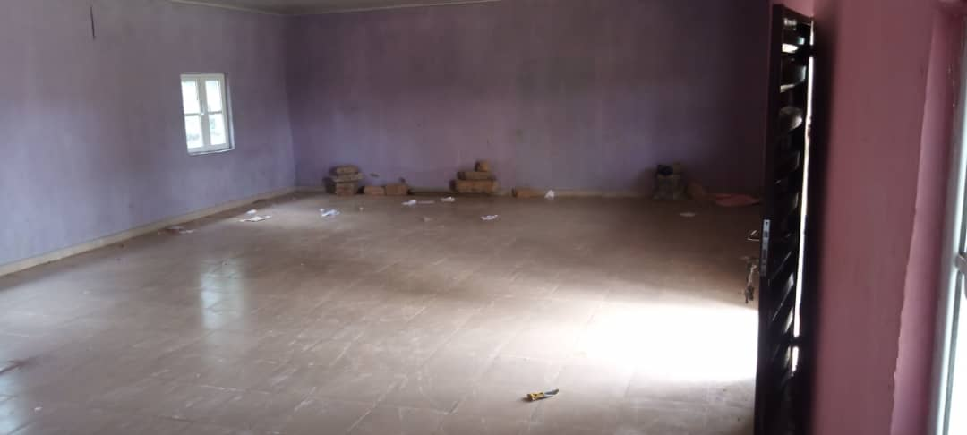
INSIDE VIEW OF THE ONE OF THE CLASSROMS.

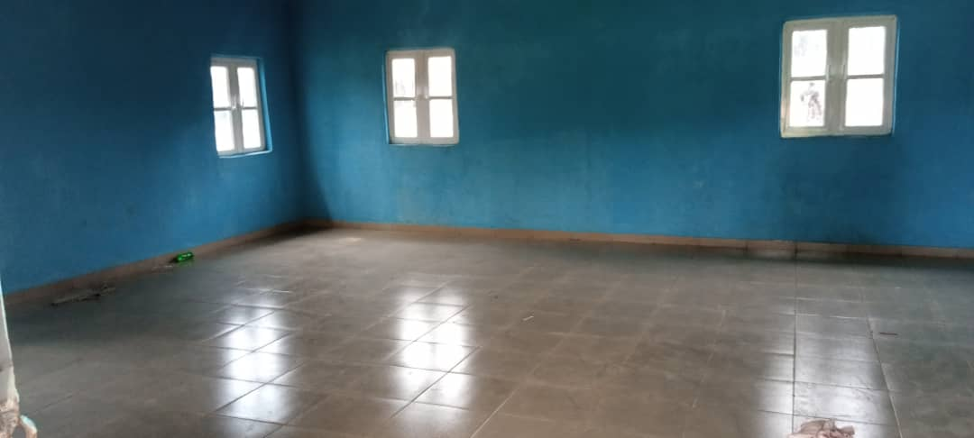
ANOTHER PICTURE OF ONE OF THE UNEQUIPPED CLASSROOMS.

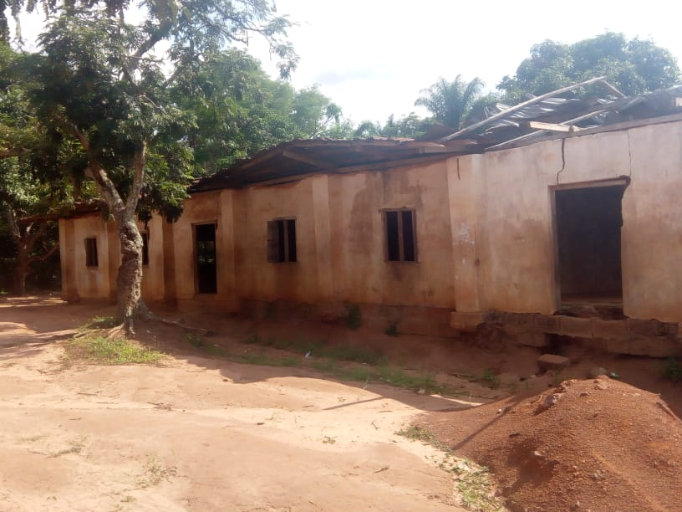
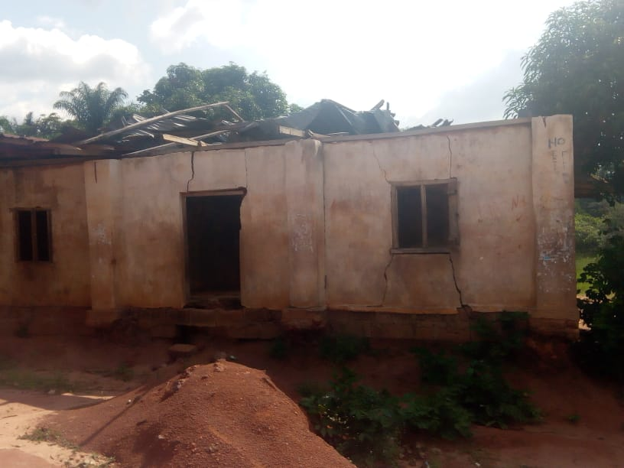
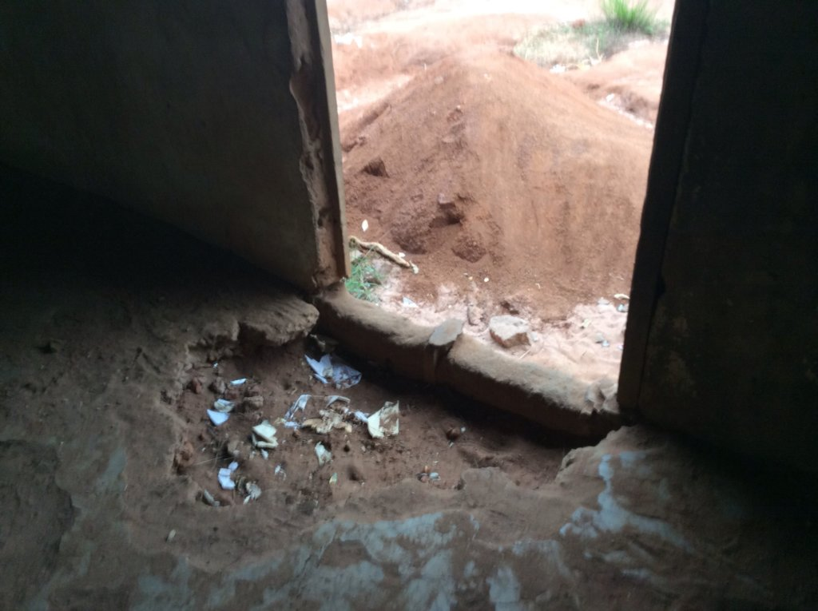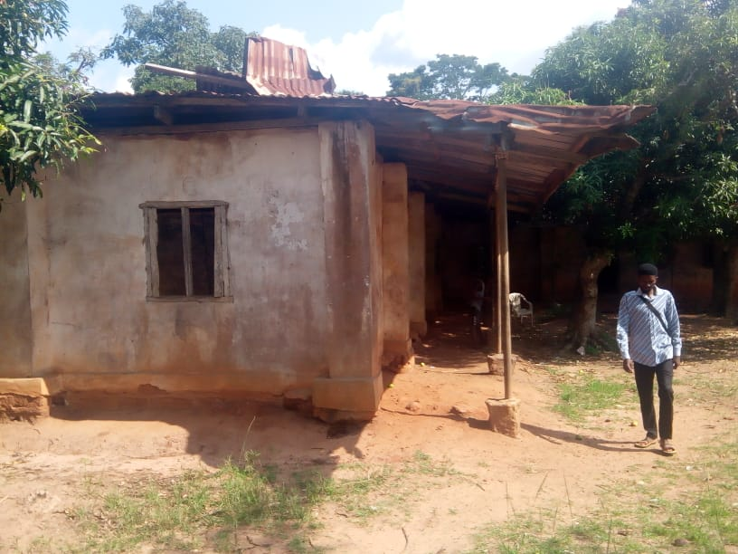
PREVIOUS STATE OF THE SCHOOL BUILDING

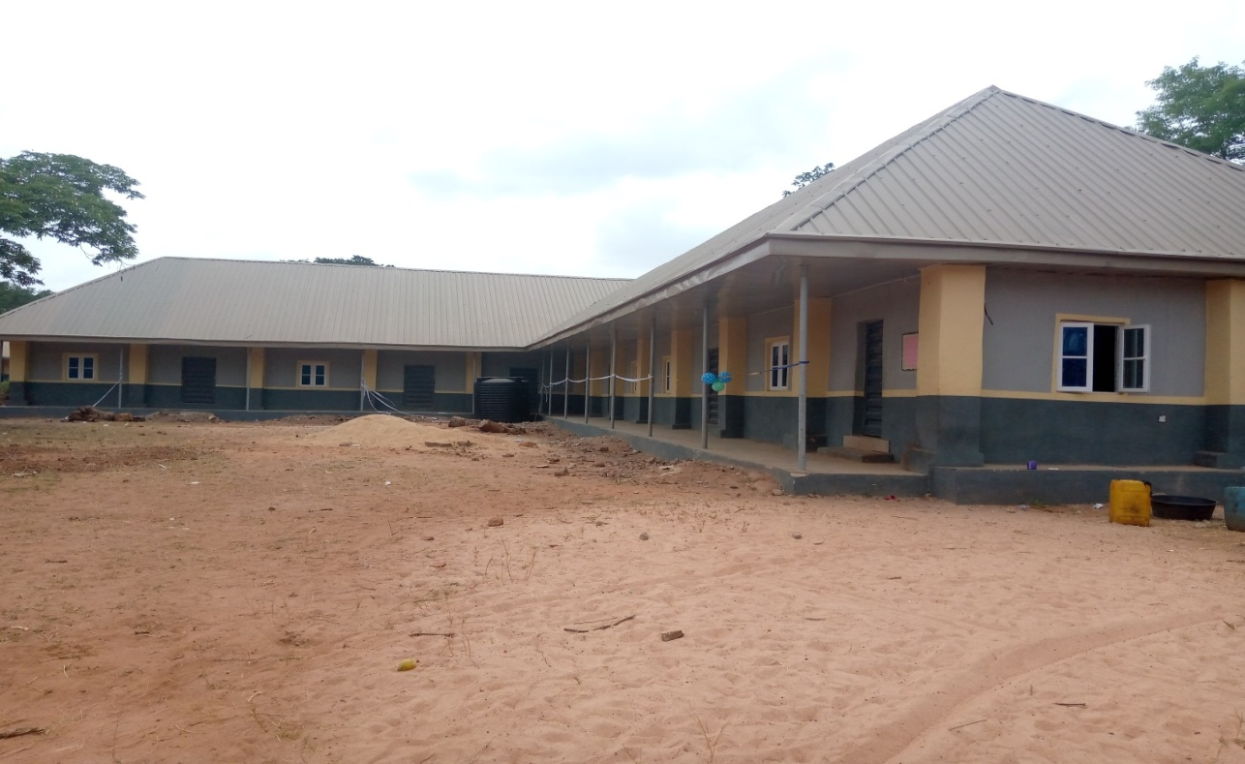
REBUILT BLOCK OF CLASSROOMS

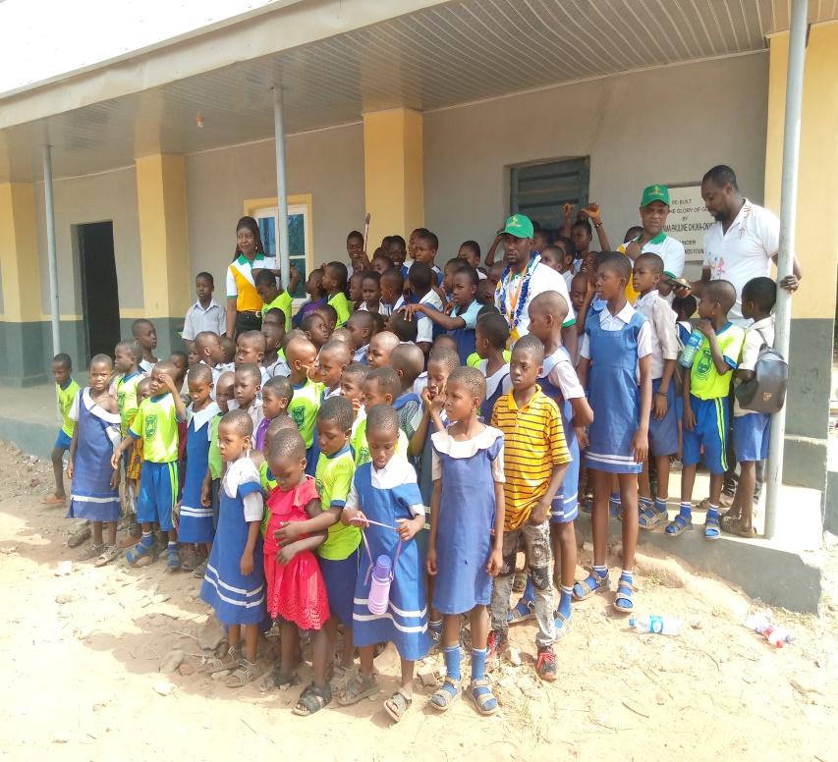
THE JHF TEAM AND FEW OF THE PUPILS DURING THE COMMISIONING.

