PARKVIEW ORPHANS ACHIEVERS SHELTER PROJECT(POAS)
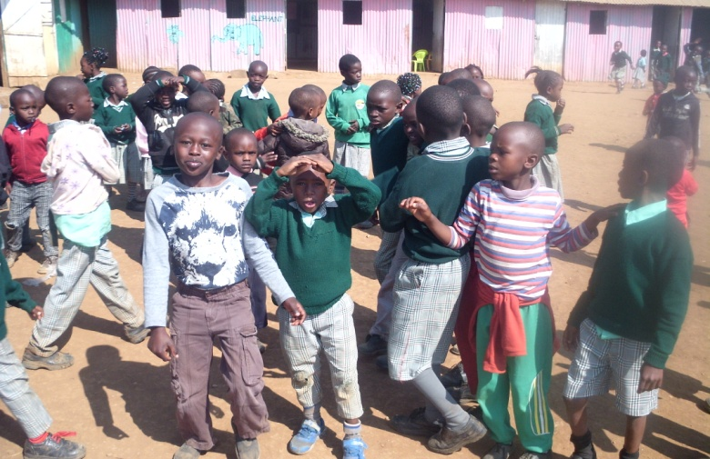
MOTTO
TOGETHER LET’S ERADICATE MARGINALISATION
Parkview orphans achievers shelter is located in Tuala township,Kajiado county.The school has 250 pupils, most of them are orphans, Hiv positive therefore we offer counseling and psychosocial for HIV and AIDS orphans.
We also offer formal and informal education for the orphans and also equipping them with basic necessities so that they can enjoy their life like the ordinary children.
We partner with the community and well-wishers who would wish to join us in providing a better life for those innocent souls guided by the love of God, we are obliged to offer those orphans a better life in accordance with the International Children’s Rights for eradication of poverty in the community.
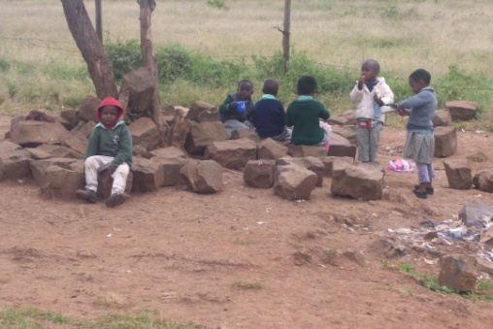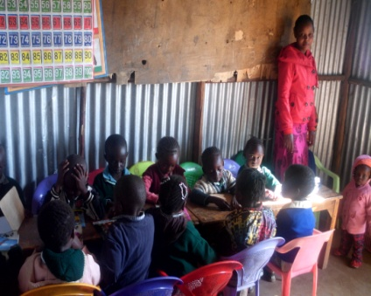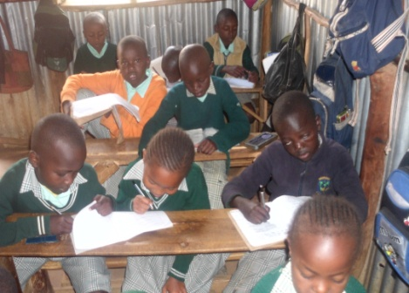

OBJECTIVES
- To promote access to education and basic necessities to orphans and vulnerable children
- To equip the children with suitable learning materials
- To train and nurture children providing them with suitable skills to be self-reliant in future
MISSION
Restore, encourage, give life and hope, mentor and transform the broken heart of neglected abandoned and rejected children in the society.
VISION
To build a huge global children’s shelter program, rescue and life transforming and restoration center

APPEAL
We are appealing to any person, organization or company to join hands with us to help these unfortunate children to enjoy ordinary life like the normal child in the society.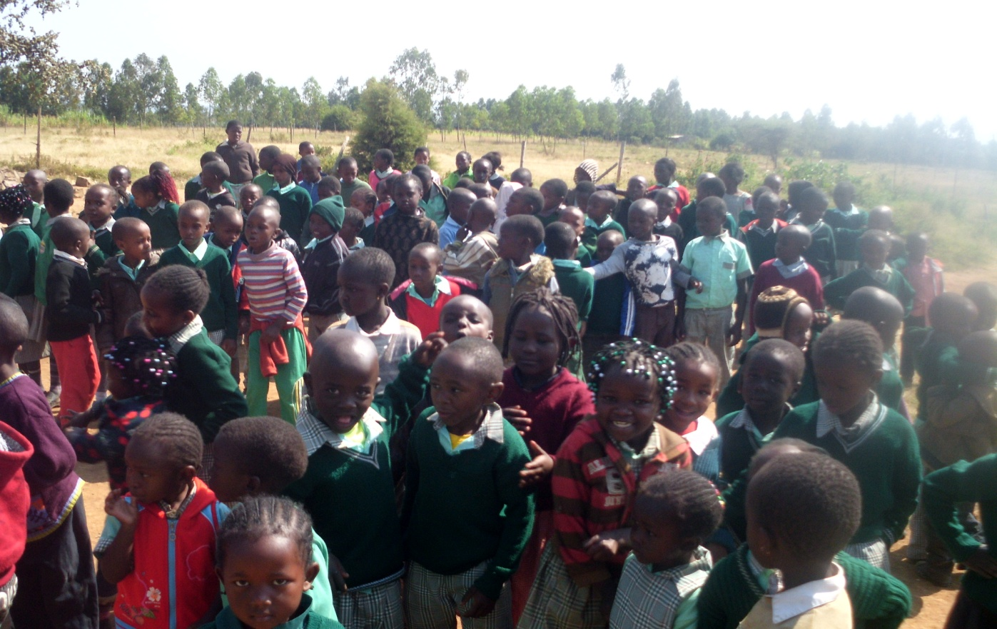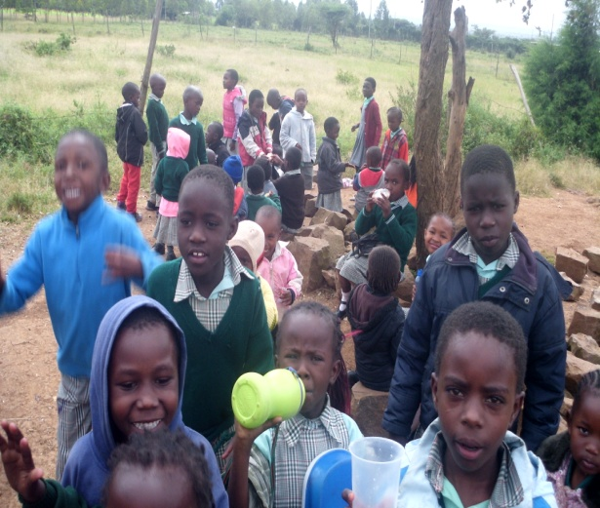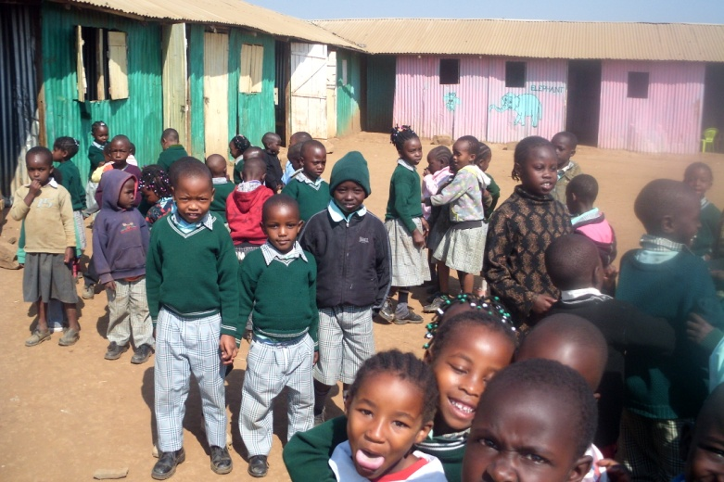
SUPPORT US TODAY
Banking account details:
Co-operative Bank of Kenya
Account No: 01128504192800

Parkview Orphans Achievers Shelter(POAS)
Oloosirkon-Kajiado County
P.O BOX 1135-00511
Ongata Rongai-Kenya

MOBILE: 0725733814/0734460513
EMAIL:parkviewachieversschools@gmail.com

