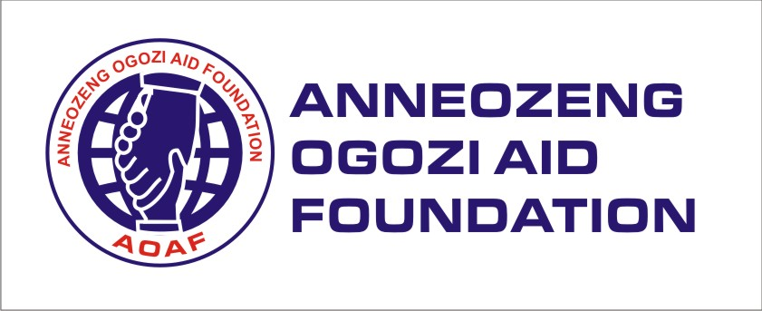
PROPOSAL SUMMARY
The Anneozeng Ogozi Aid Foundation (AOAF) aims to promote in-house education of 400 pupils and students of Kahida community area at Gwagwalada Area Council of Abuja, by offering critical literacy support services through capacity building for hired home-service teachers using the local community volunteers for sustainable, effective teaching and learning; provision of education materials and sensitization on POST COVID-19 health safety precautions as well as conduct child education advocacy.
INTRODUCTION/OVERVIEW
The AOA Foundation is a non-profit organization that is focused to help, giving hope to the hopeless, the less privileged by providing them with jobs, good education, good health care facilities and most importantly in their life’s once again. The organization was born out of passion to mitigate hopeless among people in Nigeria and across the world. Our services cuts across, enhancing quality of education, creating health awareness, advocating for women and children right, providing humanitarian services, providing care for the physically challenge and empowering women, youth children, and mitigating among the less privileged. The organization was formed in 2016 and operated as unregistered organization reaching out to the needy in every part of the country, however in 2018 the organization expended its operations as a registered organization and worked with increase team members to reach out to more individuals in the areas of their of their care competence.
VISION
To give hope to the hopeless by making them feel important in life.
MISSION
AOAF exist to provide a suitable and sustainable world in which everyone enjoys the right to a good life, filled with dignity and freedom from poverty and all forms of oppression.
NEEDS OF ASSESSMENT
According to a recent report published by unicef, Nigeria currently has 13.2 million out of school children, making it the highest rate anywhere on earth. Northern states in particular have one of the highest out of school rates in Nigeria. States in the north-east and north-west have female primary net attendance rates of 47.7 percent and 47.3 percent, respectively, meaning that more than half of the girls are not in school. The education deprivation in northern Nigeria is driven by various factors, including economic barriers and socio-cultural norms and practices that discourage attendance in formal education, especially for girls. Kaida community in Gwagwalada area council, located in the north cetral state of Abuja has a population of over 1500 inhabitants and about 750 of the population being of schooling age. While the community faces increasing poverty rates which have led to poor living conditions, particularly affecting the provision of standard educational facilities. Kaida community has seen hundreds of children face education concerns including; lack of good infrastructure in schools inadequate teaching aids, lack of finance for tuition fees and teachers with inefficient training. However, during a needs assessment that was carried out within the community by our team, it was noticed that despite the poor school facilities and dwindling educational materials, children remain keen on attending classes and continue to walk for miles under most times, uncanny weather conditions, just to have an opportunity to attend class. For most of these children, going to school has become an escape from the reality of living in such poor conditions.
With the unexpected coming of the global pandemic, Coronavirus, the Federal Governement of Nigeria, on the 19th of March 2020, announced that all schools and institutions across Nigeria be shut down. Three months later, standard learning institutions have moved away from physical structures to digital learning for their students. While COVID-19 pandemic is revolutionizing digital and online education globally, children in rural and impovrished communities such as Kaida community are being left behind in their education as they are not equipped to adapt or transition to the new methods of learning. This has become a major concern as vulnerable children in Kaida currently cannot keep up with their peers because of inaccessibility to digital tools. Unless a change is done, these children may never catch up and may continue to feel the effect of this gap long after the pandemic is over.
This inadvertently may result in a severely diminishing pool of young adults who have not garnered the necessary skills to stay ahead in the future. With Nigeria already behind in preparing its young people for the workplace of the future, the effects of the pandemic further exacerbate this issue. In
AOA Foundation since its inception (2018) has supported fourteen (15) schools across Nigeria with over sixty five thousand (65,000) educational materials and over ninety (90) scholarships to the less privilege pupils.
In order to bridge the education gap that is widening by the day, AOA Foundation will need complimentary support financially in providing critical literacy support services, basic educational materials , capacity building training for teachers and community volunteers from the local community, community sensitization on the COVID-19 pandemic and local safety precautions the community can adapt as well as general awareness for child and girl child education.
OBJECTIVES
This project aims to contribute immensely to closing the growing gap in education caused by the Covid-19 pandemic, for children living in hard-to-reach areas such as Kaida community by providing the community with critical literacy support services that will allow children in Kaida to continue their learning while adhering to World Health Organisation’s health standards such as maintaining social distancing in class, sanitizing their hands before and after class and the compulsory use of nose masks that will all be provided by the project. This project also aims to provide educational materials and capacity building training for all teachers and community volunteers.

SUSTAINABILITY
Sustainability can not be over emphasised in this project. Kaida community already has volunteer teachers, however their knowledge on teaching needs to be upgraded to easily adjust them to contemorary teaching methods. To ensure the work we intend to do in Kaida community continues long after we are through with the project, AOA Foundation will build the capacity of teachers from the community and ten community volunteers. This will ensure longevity and social inclusiveness and empowerement for the engaged community members.

PARTNERS
The Project will work closely with Kaida community leadership, Mothers Rescue and Empowerement Initiative who will assist in the capacity building trainings.

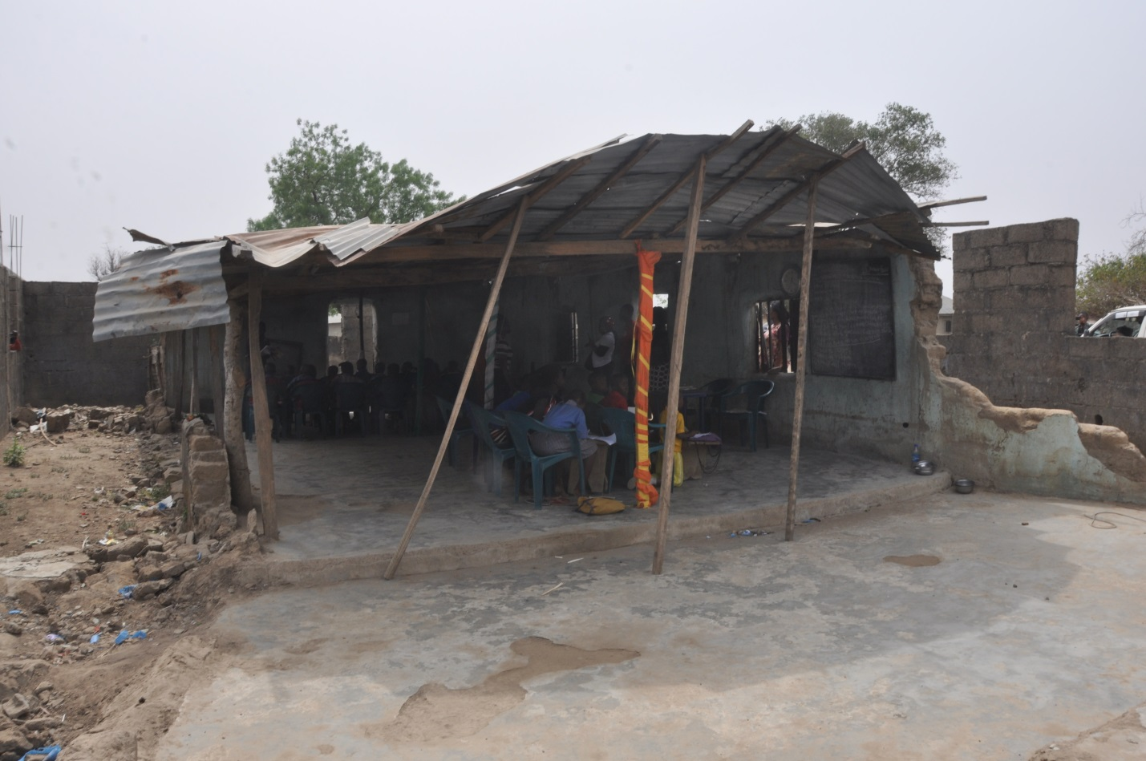
Cross section of a learning center in Kaida Community on 23rd/Janurary/ 2020
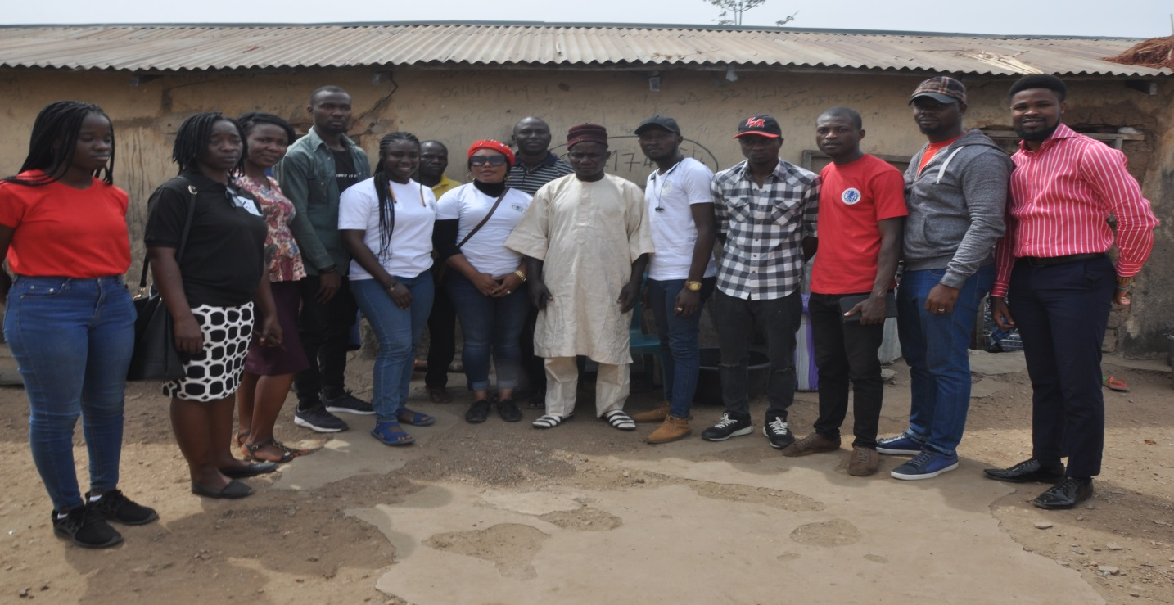
AOA Foundation with Kaida community head. (23rd January 2020)
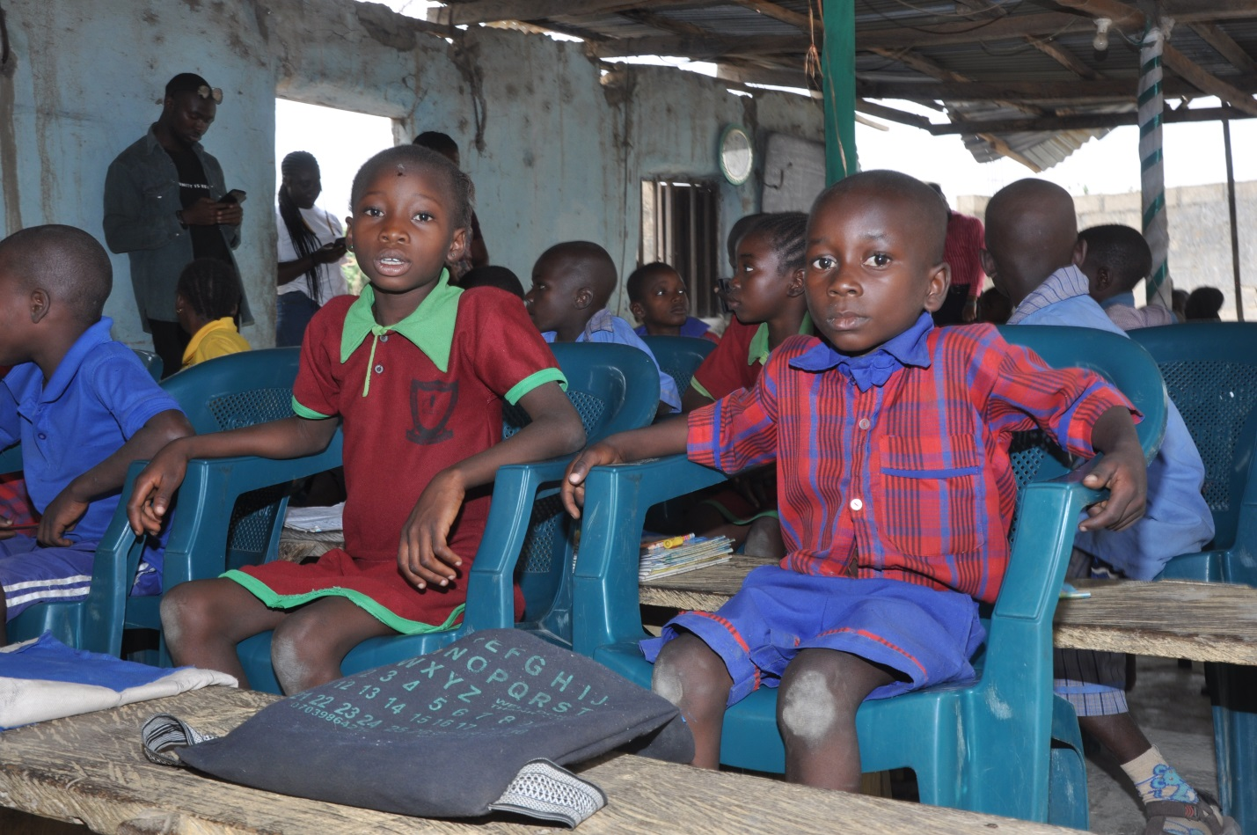
Some students from the educational center in Kaida Community

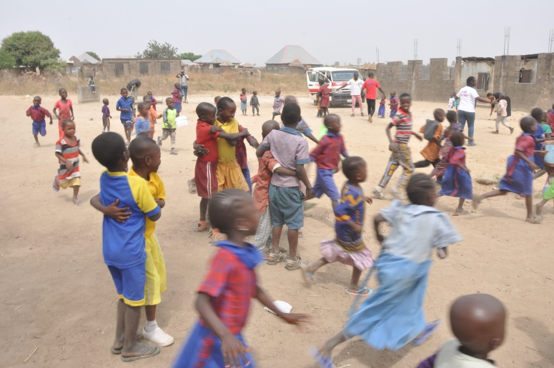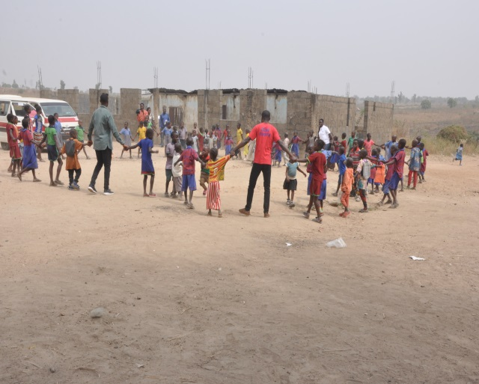
AOAF staff taking children in Life skills practical game on 23rd/Janurary/ 2020

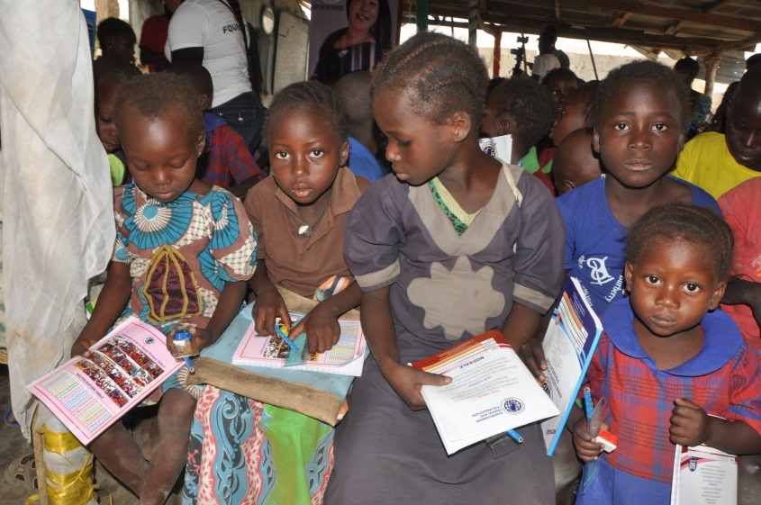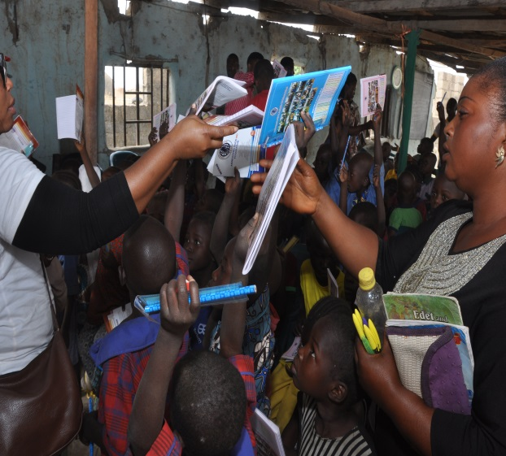
Educational materials shared amongst children in Kaida on the 23rd/Janurary/ 2020
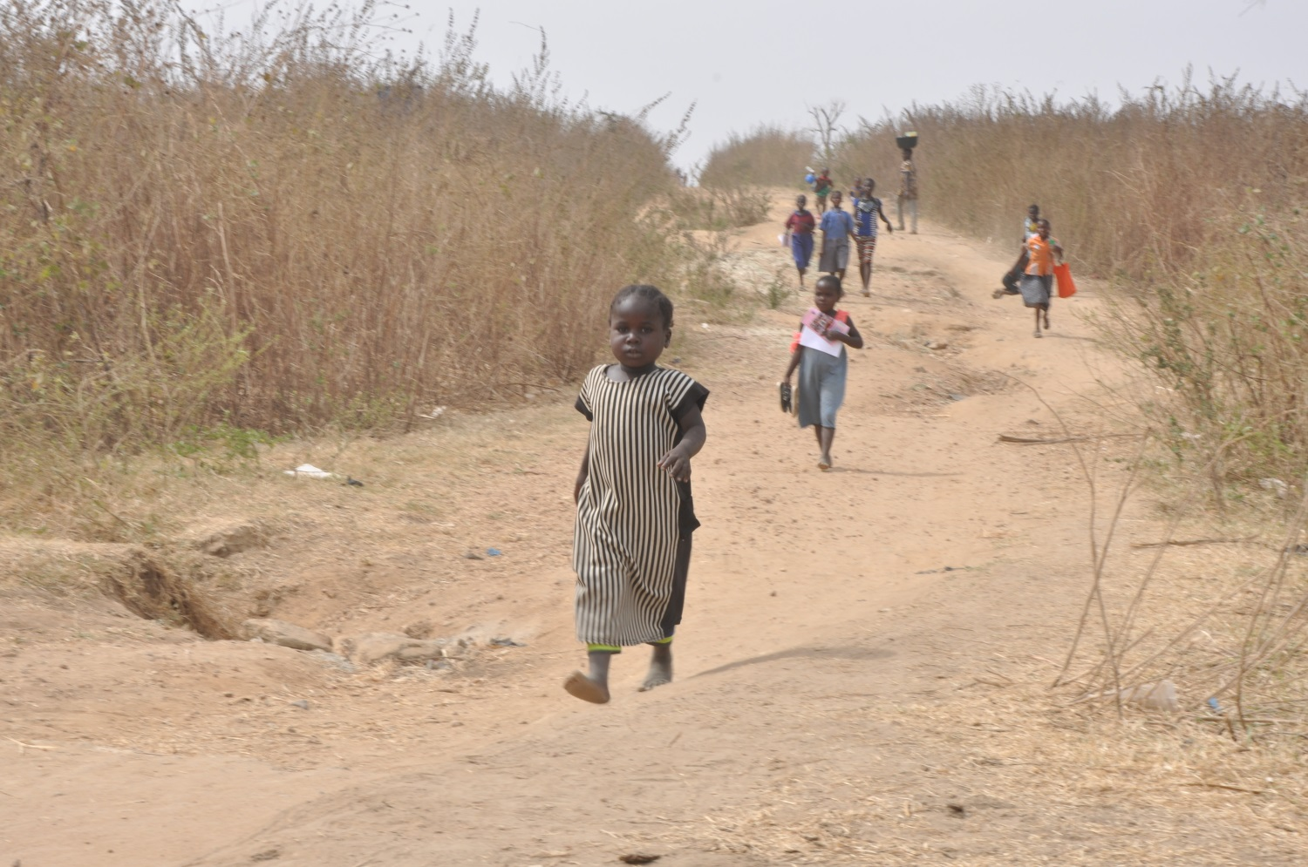
Barefoot but keen on learning! Students walking from learning center with AOAF educational materials in Kaida Community.

