

**ACTIVITY REPORT FOR EDUCATE A VULNERABLE CHILD PROGRAM**

**Locations :** Internally Displaced Persons camp in Durumi AMAC L.G.A Abuja, Nigeria

**Date :** 3rd to 11th of August, 2020

**Implementing Organization:** Anneozeng Ogozi Aid Foundation.

**FUNDING PARTNERS:** Global Giving and Anneozeng Ogozi Aid Foundation.

**Introduction**

Nigeria, topping the list of the three countries in Africa with the highest population of insurgency survivors caused by the Boko Haram Islamic extremist group has also seen close to 14.8 million people in the northeastern part of the country affected or displaced.

Since the advent of Covid-19, educational institutions have been closed down for over three months. While Online education became a welcomed idea to ensure children keep learning, it also served as a disadvantage for millions of vulnerable children living in underserved communities across Nigeria who have no access to online facilities. Before the Coronavirus pandemic, according to UNICEF, approximately 20% of the total global out-of-school population is from Nigeria. Today close to 46 million students have been affected by the shutting down of schools.

In light of this, Anneozeng Ogozi Aid Foundation (AOAF) understanding the growing digital gap being created by a select few having access to education and the majority being cast aside, would have severe consequences such as a future labor market where the majority of youth have no educational qualifications to apply for better paying jobs. This would inadvertently cause the rate of unemployment to spike in the country.

To curb this growing gap, AOAF carried out an assessment in Durumi IDP camp that targeted children between the ages of 8 to 12 years.

**ACTIVITIES**

After receiving consent from Camp Coordinators, AOAF implemented hygiene, life skills and sex education sessions. In addition to promoting safe education, AOAF ensured the following:

A minimum of 20 students were taught at a time and sitting arrangements limited to 2 on a bench with a distance of 1 meter between students Each student was provided with face masks and it was made compulsory for children to bring them to class each day.

* Washing of hands with hand wash and sanitizing was done before each class commenced
* Activities were designed to ensure no contact was made during sessions.

Facilitators who carried out these activities were all staff of AOAF and volunteers who worked closely with the M & E officer to ensure the smooth running of the activities.

Toolkits Used:

* Learn on- AOAF health and Life skills Manual
* My Body, My Own- AOAF Sex Education Manual

**Response:**

* The children responded in their numbers and the classes throughout the week were made interactive by the teachers, and due to the interaction, several questions were raise among the children
* Children were able at the end of classes to identify how to keep themselves clean and the importance of maintaining hygiene protocols particularly during Covid-19. Children particularly had many questions on Covid-19 as many of these children are of the belief that it is a hoax and cannot be real. Facilitators took time to explain what the various is and the importance of adhering to the health regulations stated by the government.

**DATA REVIEW**

1. It was noticed that there is a higher population of girls are more interested in learning and schooling generally, however most of the children that attended (especially the girls) would come late for classes because their parents rather have them use their free time to hawk. On several occasions, when on route to the venue for classes, facilitators would have to talk to children to attend classes before resuming to hawk. When AOAF facilitators tried talking to parents, most of them reiterated the lack of other means to survive and that hawking was the only option for their children to bring more money to the family.
2. It was also noticed that majority of the beneficiaries were from Borno State, however, most of the children have been living so far away from their states of origin that they vaguely recall how their homes.
3. Durumi Camp is densely populated with People adhering to the Muslim faith as compared to other camps AOAF has worked in.
4. As compared to other camps, beneficiaries in Durmi camp were not as fluent in English language and the need for translators was needed.

**Challenges**

* Over estimated number of children had to be catered for because a lot of them couldn’t stay back and watch their mates attend the classes due to the period of time they have been out of school, but the organization/team members were able organize the children so as to practice social distance.
* The raining season caused a major delay during some of the classes, but the AOAF team was able to get there in good time to carry out activities proper lessons for the children.
* In Durumi Camp, it was noticed that majority of the children could not understand english and therefore the need for interpretators was needed. This was howver fixed as few staff and volunteers are able to speak the local dialect.
* No sitting

**Observations:** Proper identification of learning areas needs to be done by the M&E prior to the coming of the team to carry out activities. This will avoid wasting the childrens time and having to do the classes in bad locations.

|  |  |  |  |
| --- | --- | --- | --- |
| S/N | **CATEGORY** | **IDP CAMP LOCATION** | **TOTAL** |
| 1. | BOYS | 22 | **60** |
| 2. | GIRLS | 38 |
| 3. | Beneficiaries who are CHRISTIANS | 4 |
| 4. | Beneficiaries who are MUSLIMS | 55 |
| 5. | Beneficiaries from BORNO | 58 |
| 6. | Beneficiaries from BAUCHI | 1 |
| 7. | Beneficiaries from KADUNA | 0 |
| 8. | Beneficiaries from CAMEROON | 0 |
| 9. | Beneficiaries able to speak english fluently | 10 |

|  |  |  |  |  |
| --- | --- | --- | --- | --- |
| **S/N** | **ITEM** | **QUANTITY** | **COST PER UNIT** | **TOTAL** |
| 1. | BISCUITS | 4 CARTONS | N3,600 | N14,400 |
| 2. | CHI EXOTIC FRUIT JUICE | 4  CARTONS | N 1,400 | N5,600 |
| 3. | LOLIPOP SWEETS | 5 PACKETS | N480 | N2,400 |
| 4. | NYLON FOR PACKING SNACKS | 7 PACKETS | N50 | N 350 |
| 5. | TRANSPORTATION | 6 days for 2 cars | N 1,000 per day | N 6,000 |
| 6. | FACE MASK | 60 | N 100 | N 6,000 |
| 7. | HAND WASH | 3 Bottles | N1,500 | N4,500 |
| 8. | HAND SANITIZER | 3 BOTTLES | N1,000 | N3,000 |
| 9. | PVC Educational Kit. | **60 sets Education Materials-**  Pencils  Exercise books Erasers sharperners  per child | N20  N250  N10  N20 | N1,200  N15,000  N600  N1,200 |
|  | **GRAND TOTAL** |  |  | **N54,250**  **($142,38)** |

**BUDGET**

**Total Amount from Global Giving:$87**

**Conclusion**

The activities were a success and the aim to provide safe education during the Corona Virus Pandemic for vulnerable children in Internally Displced Camps in FCT Abuja was achieved with positive response from the children, parents and their coordinator. Appreciation goes to Global Giving for their support in helping to raise funds for this activity to be carried out. The AOAF team also deserves appreciation for their cooperation and dedication towards child education and humanitarian services.

**Gallery**

**C:\Users\USER\Pictures\EVC DURUMI DAY 4\_MG_8885.tif**

**Child Rights session at Durumi IDP Camp/08/2020**

**C:\Users\USER\Pictures\EVC DURUMI DAY 4\IMG_8876.tif**

**Non-contact games during session 08/2020**

**C:\Users\USER\Pictures\EVC DURUMI DAY 4\IMG_8897.tif**

Social distancing practical with children in Durumi IDP Camp 08/2020

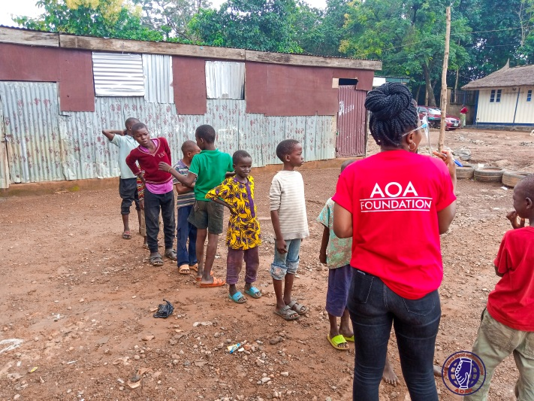

Registration for beneficiaries 8/2020

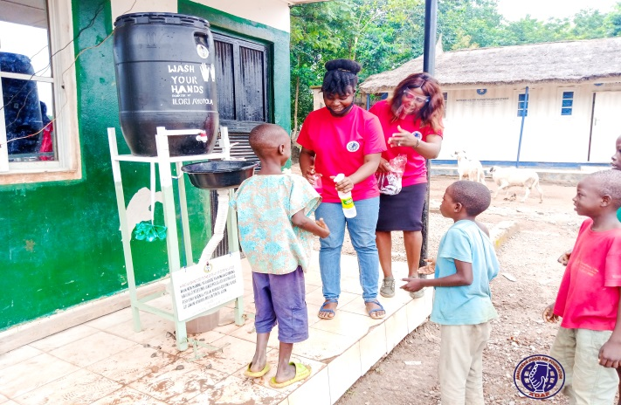

Handwashing before classes for all beneficiaries

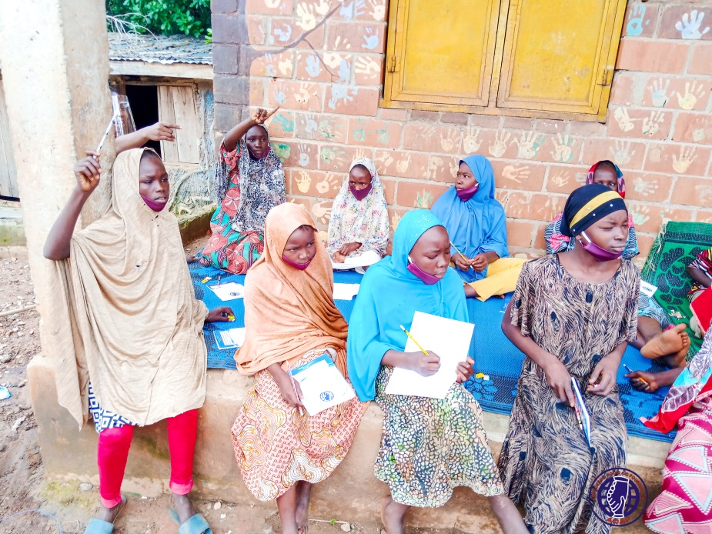

Beneficiaries taking notes during class.

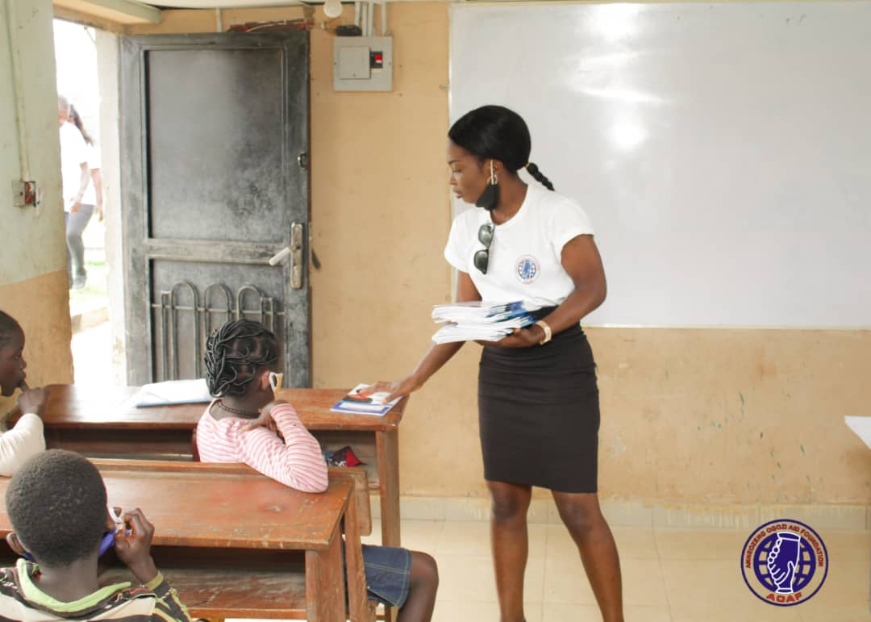

Beneficiaries receiving educational materials.