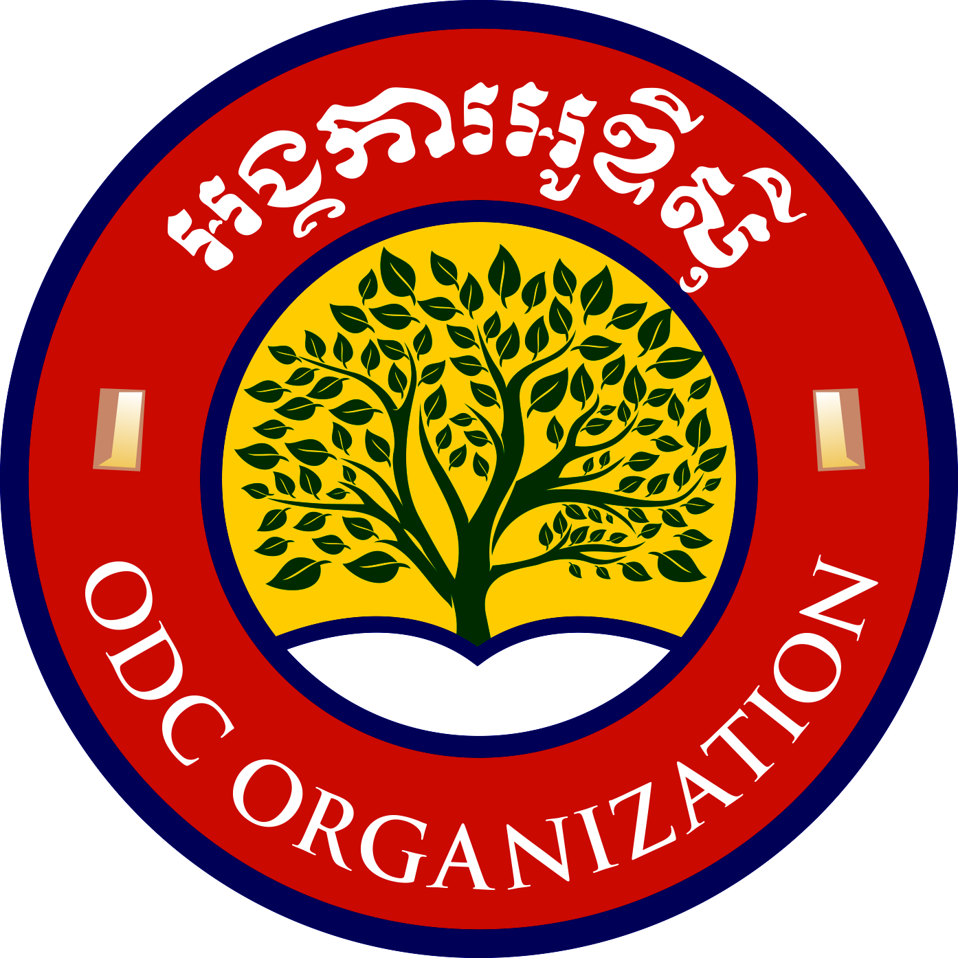
អង្គការ អូឌីស៊ី
Opening Doors Cambodia

Address: L’ak Village, Kandaek Commune, Prasat Bakong District, Siem Reap Province, Cambodia
Contact person: Mr Chhaiya Im (Founder and Executive Committee Chairperson)
Tel: +85569 926 543 / +85577 579 729
Email: chhaiyalove@gmail.com
Website: www.openingdoorscambodia.com
Facebook: https://www.facebook.com/odcenglishschool/
Registration ID with Ministry of Interior, Royal Kingdom of Cambodia: 6293BrK

English education for under-privileged children and youth in Cambodia
An investment in the future of Cambodia
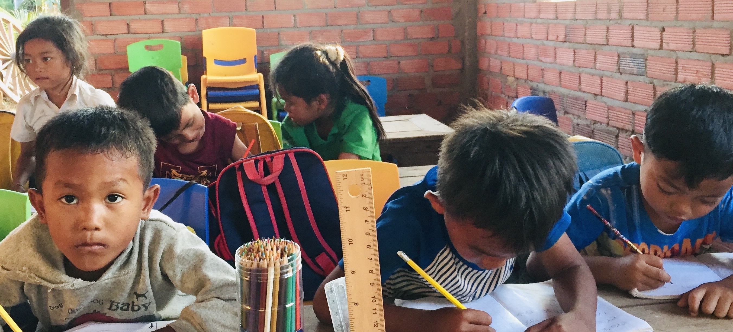
With our quality and values-based education, we will transform lives!

Opening Doors Cambodia
Our Mission

To provide quality values-based English education to under-privileged children and youth in rural areas of Cambodia and equip them with the skills to access opportunities for employment
Our Vision
To use English education as a bridge to build a community of shared values in Cambodia, where people work together, to improve their family's economic conditions and enable them to make contributions back to society as a whole. Our dream is to transform lives of the youth in Cambodia so that they can play a part in making this world a better place for future generations of Cambodians and people of the world.
Our Objectives
1. To provide quality English education that focuses on the four macro skills
2. To instil values in our children and youth so they develop ethics to build a strong society in Cambodia
3. To equip the youth with the skills to access opportunities for employment and as a result lift their families out of poverty.
Our history: the dream of one man …
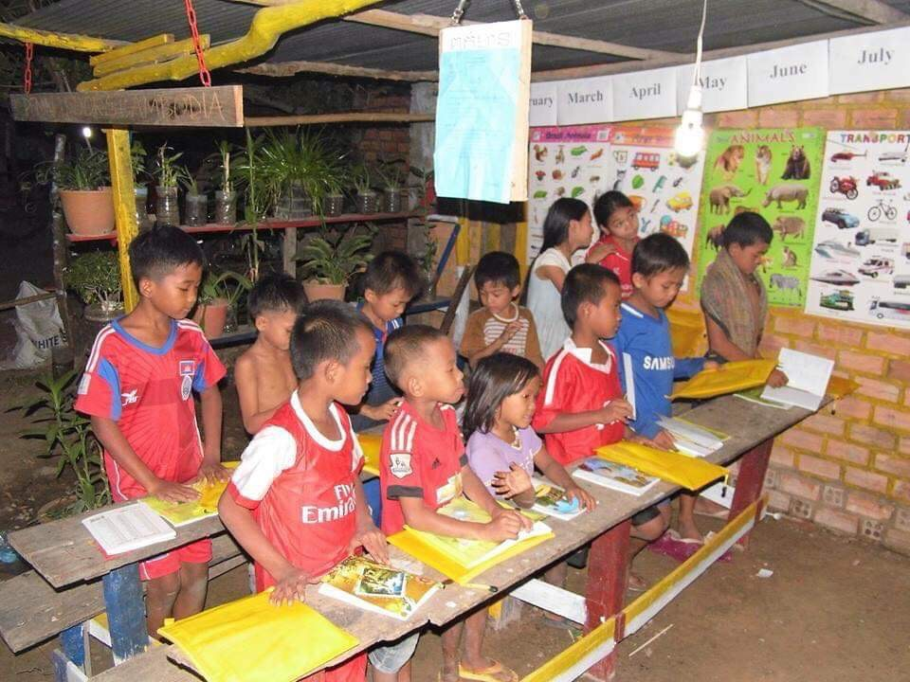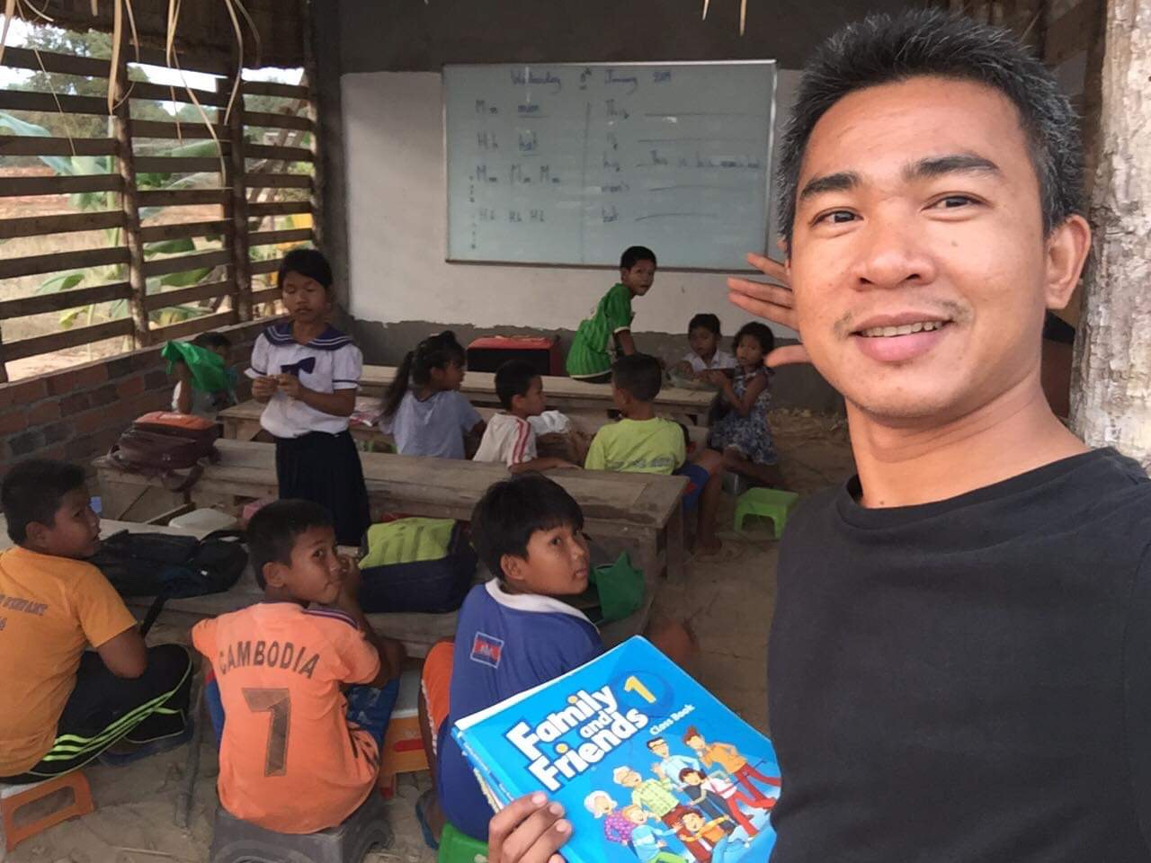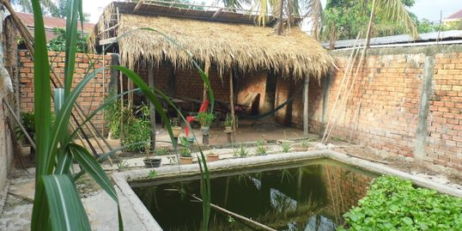

Chhaiya came from a very poor Khmer family and suffered much hardship as his parents tried to make ends meet. As he grew up he was determined to make a better future for himself. He worked a number of jobs to pay for his education and graduated with a Bachelor Degree in Finance and Marketing. He also studied English and became an English teacher.
Chhaiya is kind and generous and is passionate about helping his own people and believes that education is the only way to lift his people out of poverty. His dream was to start an English school for under-privileged children from rural areas. In 2015, he started a school at his parents’ home with just 12 students. In 2017 he bought a plot of land at La’ork Village, about 7km from Siem Reap. In 2018, with support from the local community and friends overseas, he opened Opening Doors Cambodia English School with 18 students.

Opening Doors Cambodia Today

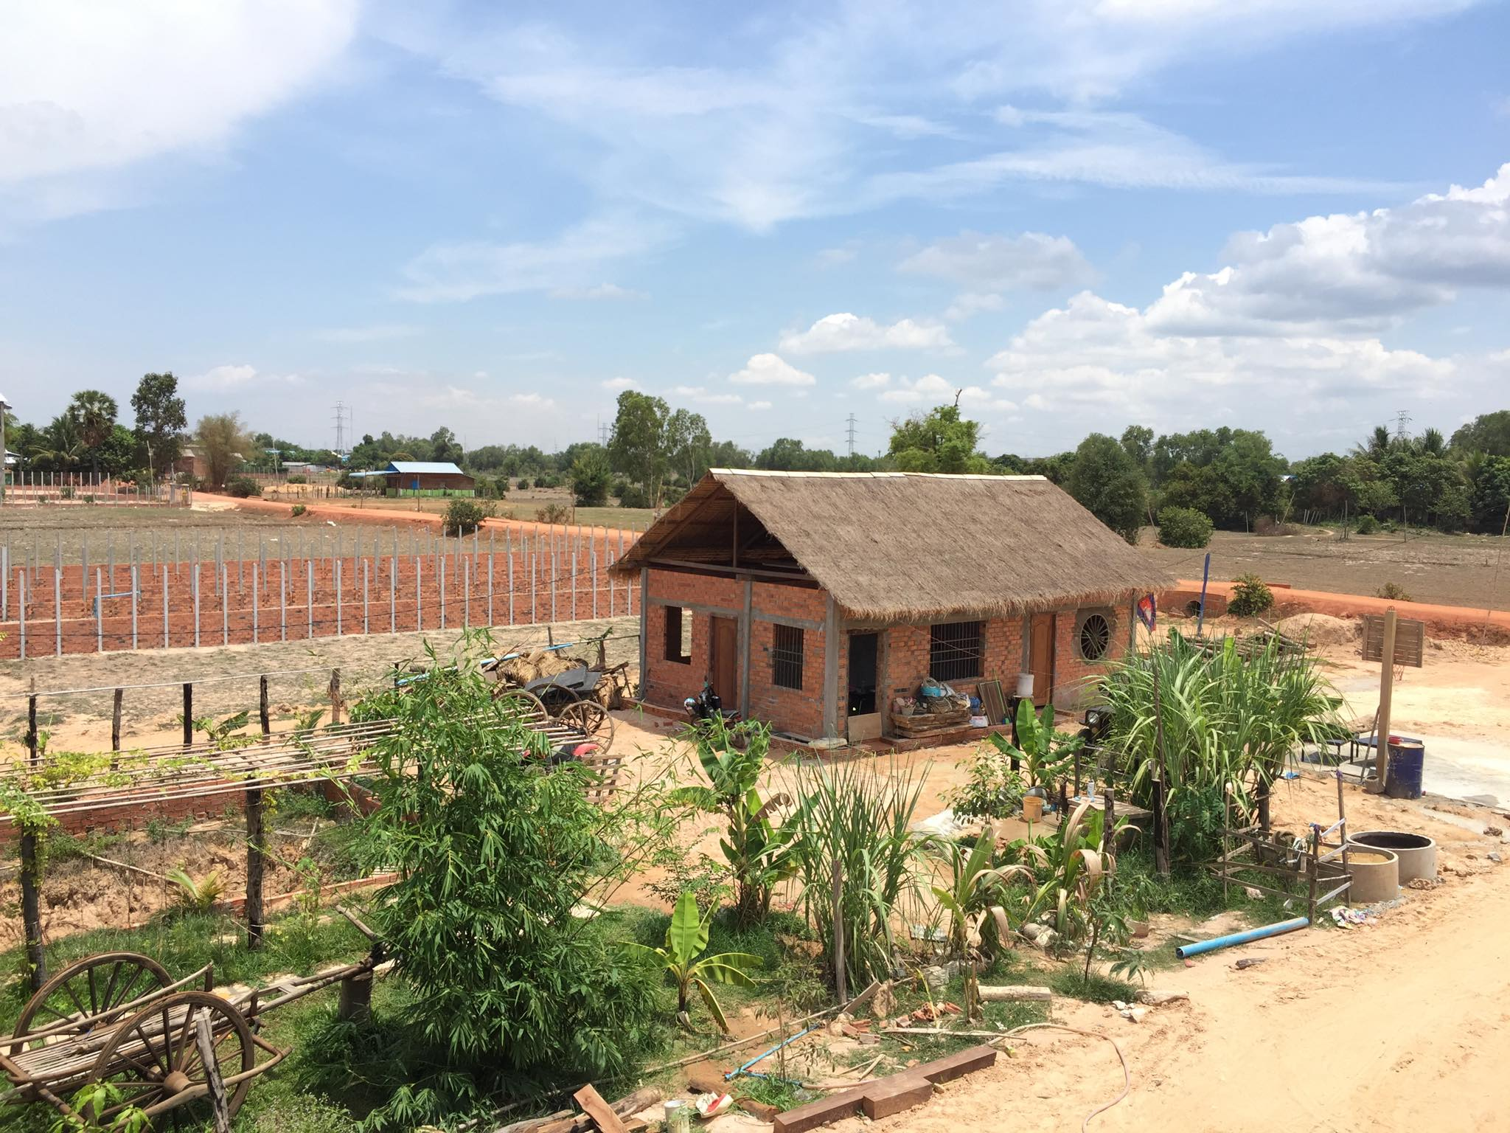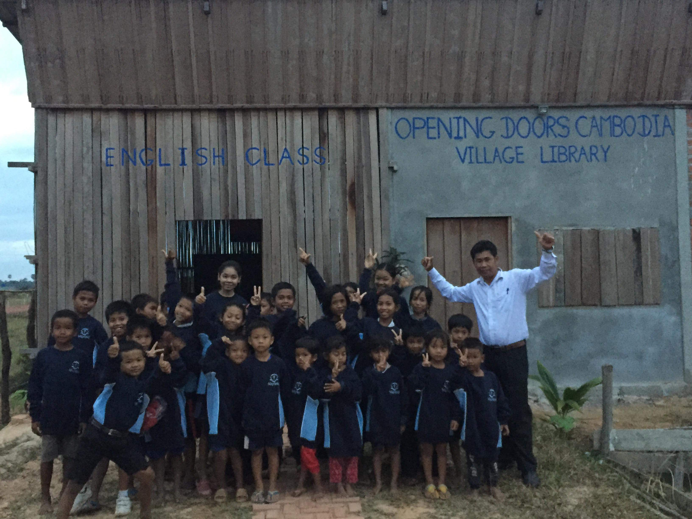
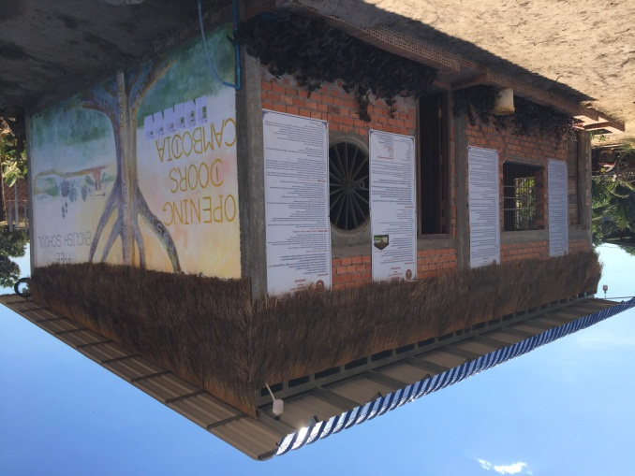
In March 2019, ODC gained major financial support from the Hedley-Urban Trust. This allowed ODC to be registered as an NGO in Cambodia. It was able to employ qualified local teachers and expand the number of classes. By the end of 2019, over 80 students from the ages of 5 - 17 were studying at ODC English School. There are six English classes; K – Grade 5 that run in three sessions from 4.30pm – 7pm. All students attend compulsory Khmer school before they attend ODC. Students are graded according to their ability determined by an Entrance Test and are placed in appropriate classes.
The school premises consist of three classrooms, a library and a staff room in two school huts.
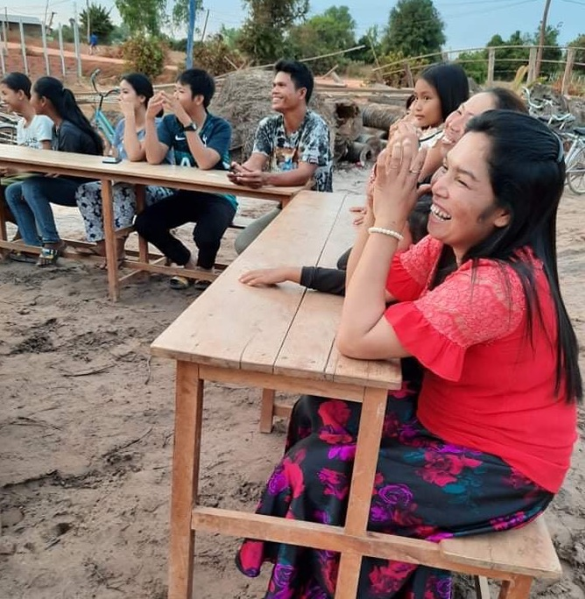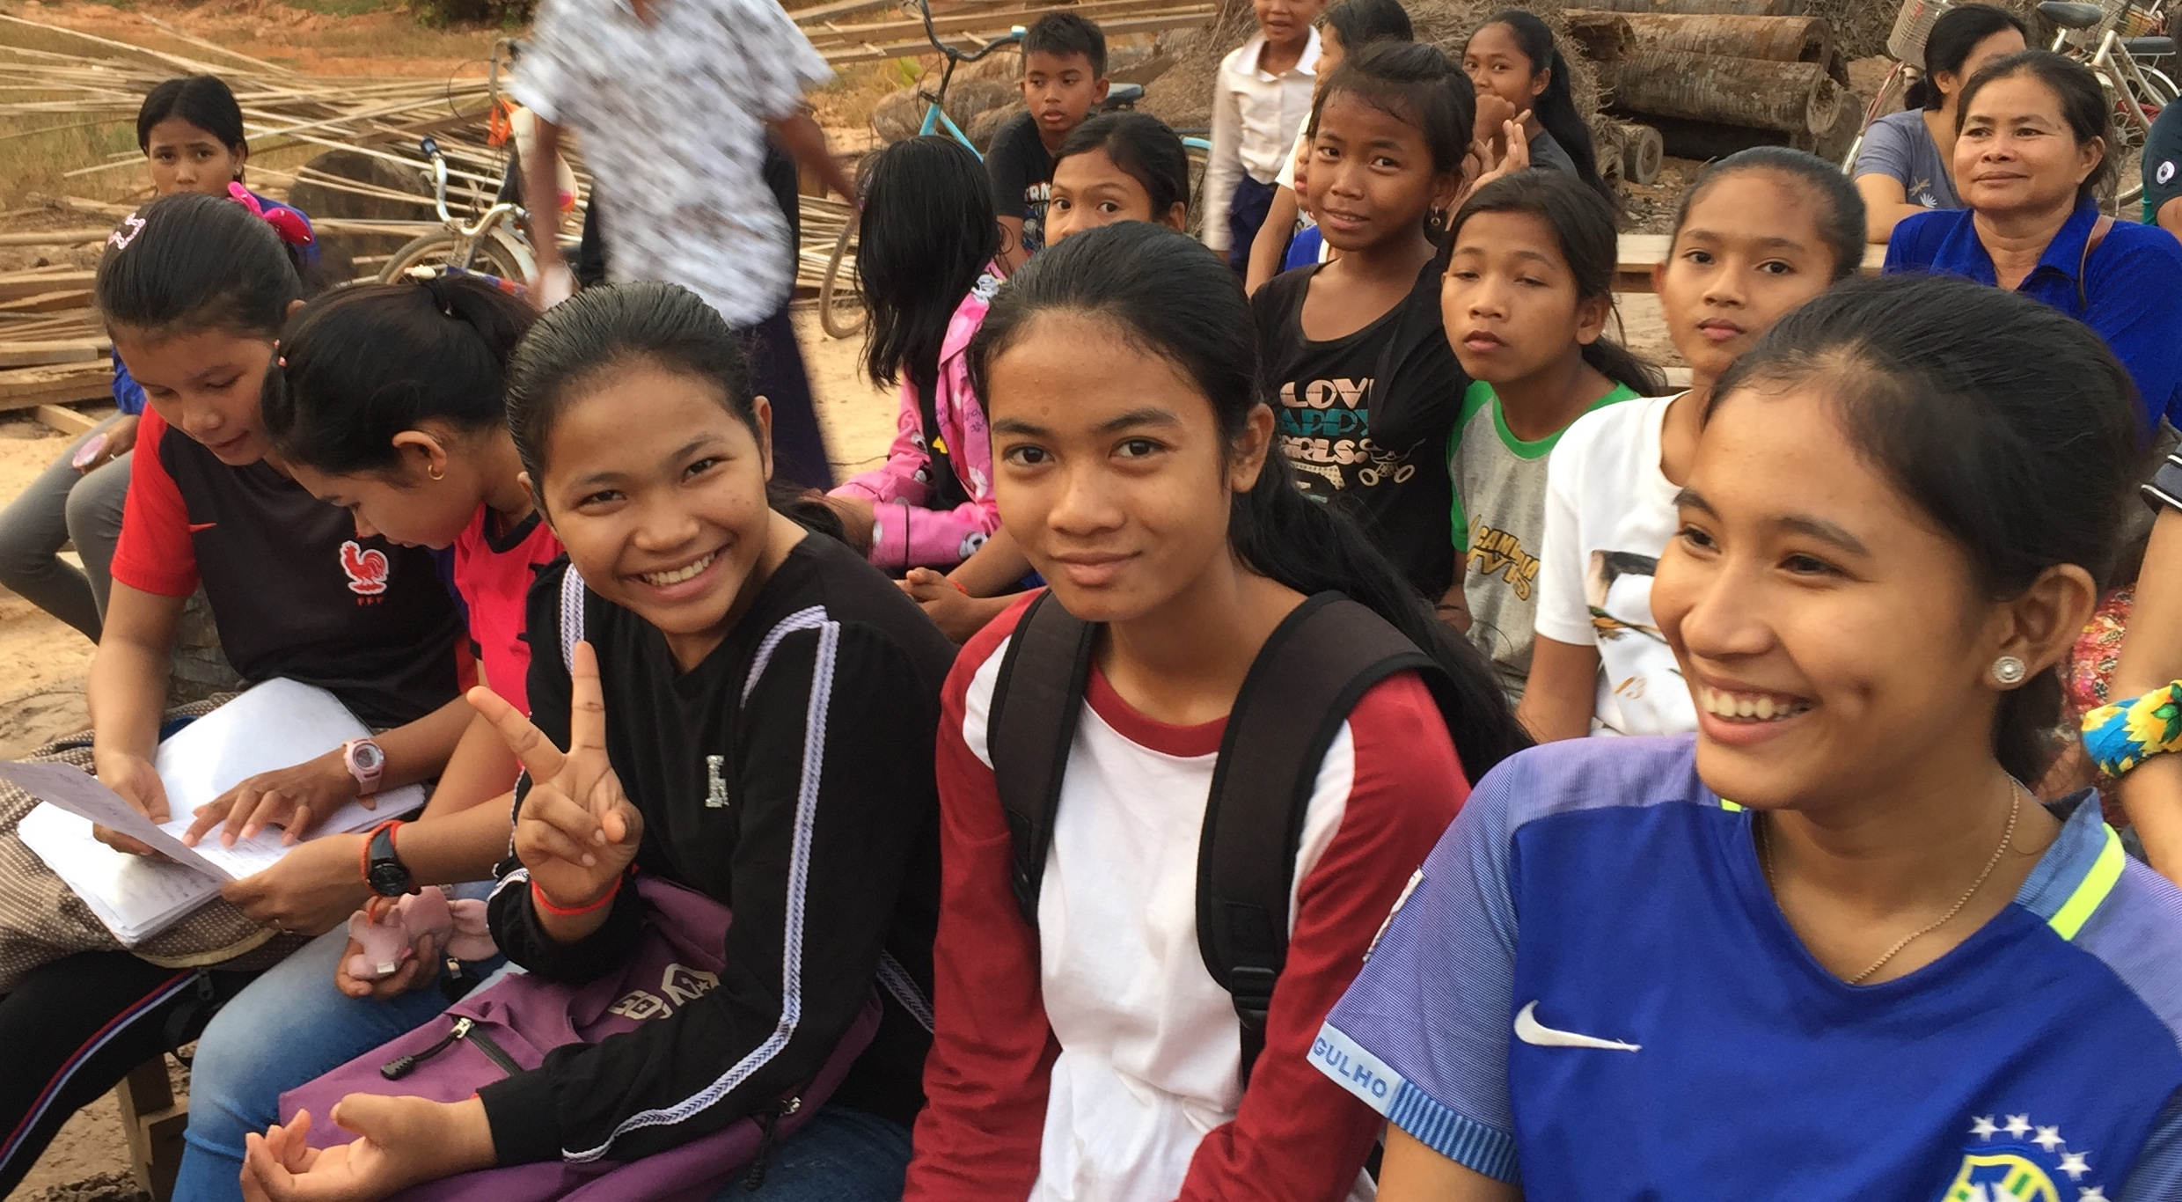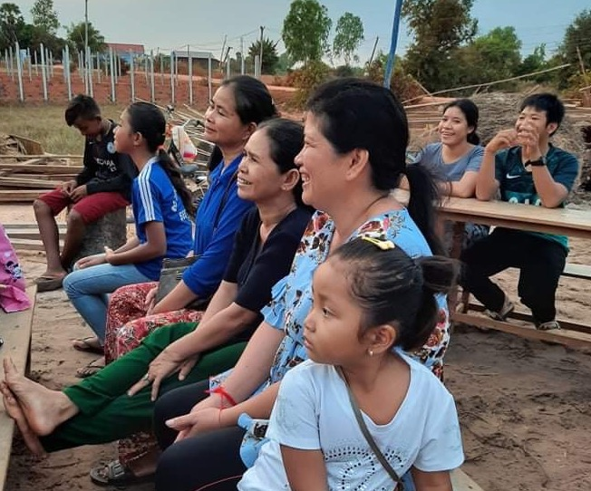
Students and parents at the 2019 End of Year Awards Presentation

Our staff and our curriculum
Opening Doors Cambodia employs local qualified, passionate and motivated teachers who offer high quality and creative teaching/learning experiences through a specially designed curriculum that focuses on the macro skills: Writing, Reading, Listening and Speaking. Traditional teaching strategies are used in conjunction with stimulating internet-based educational materials. Additional support is also given to a couple of classes through remote learning with volunteer teachers in Australia. Computer lessons are also offered at weekends.
ODC Staff are given regular professional training to continually improve and use creative and engaging ways of interacting with students. Training is conducted by a highly experienced teacher who is on the ODC Board.
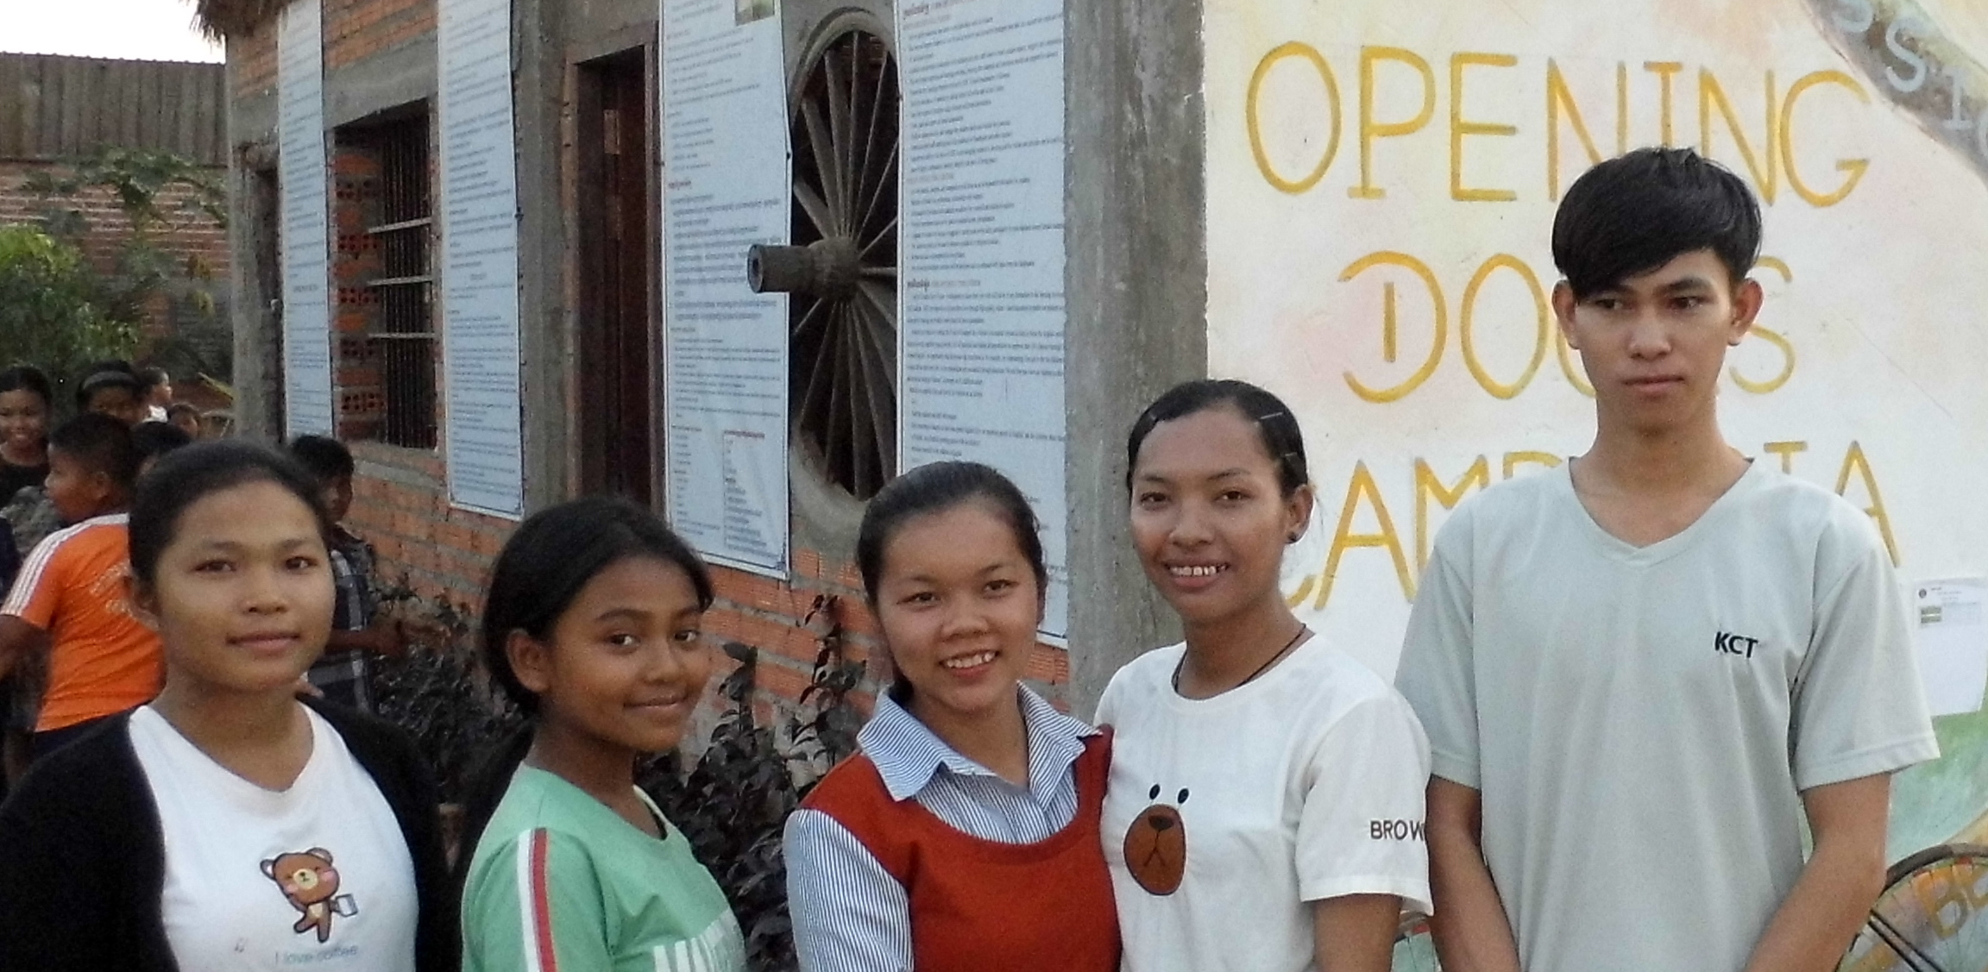

Our values
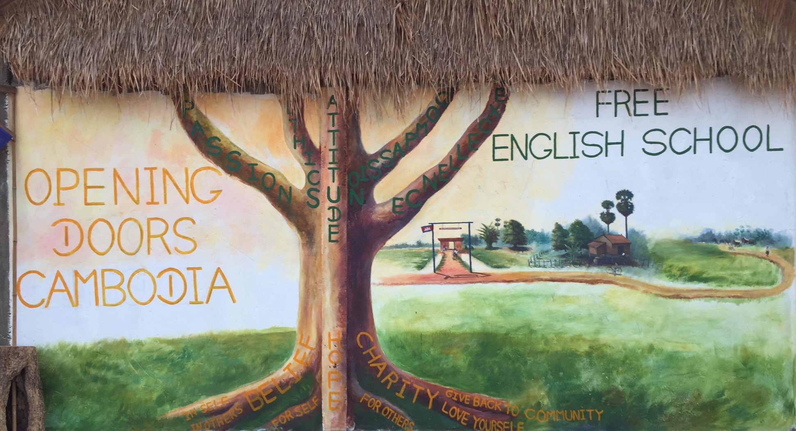
- Belief in self and others
- Hope, to make the world a better place
- Charity, to help others and give back to society
Our staff emulate these values and encourage our children to be passionate and compassionate, act with honesty and integrity and always strive for excellence.

Safeguarding our children and staff
The purpose of this policy is:
- To protect children and young people who receive ODC Organiszation’s services from harm.
- To provide staff and volunteers with the overarching principles that guide our approach to child protection

This policy applies to anyone working on behalf of ODC Organization, including senior managers and the board members, paid staff, volunteers and students.

We believe that:
- Children and young people should never experience abuse of any kind
- We have a responsibility to promote the welfare of all children and young people, to keep them safe and to practise in a way that protects them.

We recognise that:
- The welfare of children is paramount in all the work we do and in all the decisions we take
- All children, regardless of age, disability, race, religion or belief, sex or sexual orientation have an equal right to protection from all types of harm or abuse
- Working in partnership with children, young people, their parents or guardians is essential in promoting young people’s welfare.

We will seek to keep children and young people safe by:
- Valuing, listening to and respecting them
- Adopting child protection and safeguarding best practice through our policies, procedures and code of conduct for staff and volunteers
- Providing effective management for staff and volunteers through supervision, support and training so that all staff and volunteers know about and follow our policies, procedures and behaviour codes confidently and competently
- Recruiting and selecting staff and volunteers safely, ensuring all necessary checks are made
- Making sure that children, young people and their families know where to go for help if they have a concern
- Using our procedures to manage any allegations against staff and volunteers appropriately
- Creating and maintaining an anti-bullying environment and ensuring that we have a policy and procedure to help us deal effectively with any bullying that occurs
- Ensuring that we provide a safe physical environment for our children, young people, staff and volunteers
- Building a safeguarding culture where staff and volunteers, children, young people and their families, treat each other with respect and are comfortable about sharing their concerns.

Our Community Project
Helping children at a remote village; a potential site for a second school
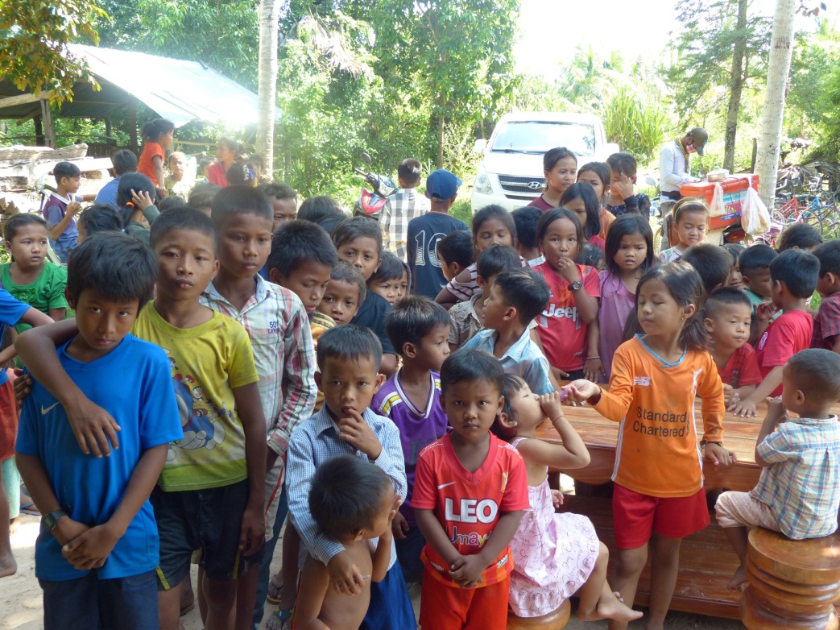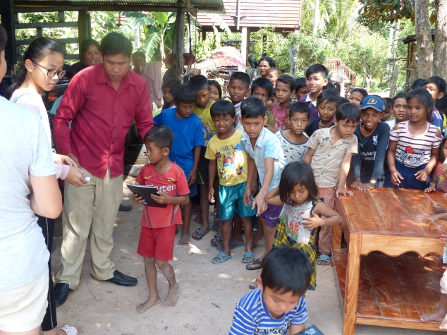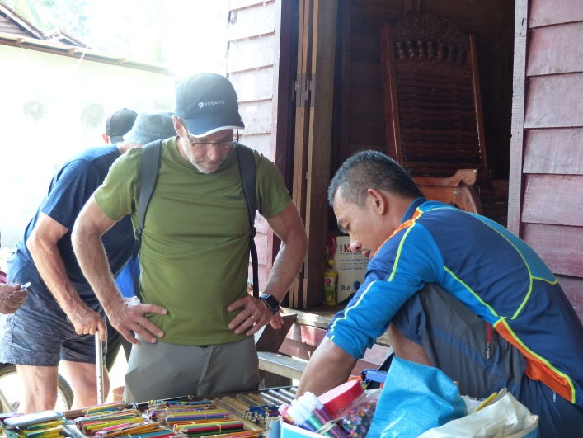

Our 2020 Goals and Objectives
Our Students and Educational Programs:
- Develop and deliver the 4 macro skills (writing, reading, listening and speaking) in English with specific age appropriate performance/progression measures
- Provide >6 classes per week for two terms of ~160 days each
- Maintain the operational capacity to fill and staff >6 evening classes per night
- Maintain a student to teacher ratio of no more than 16:1 pupils/teacher
- Establish and confirm a less than 95% attendance, excluding medical exceptions or ODC approved absentees
- Follow the ODC guidelines for conduct and traditions
- Deliver end-of-term exams in each 4 macro skills as compared to entry and end-of-year
Our Teachers:
- Ensure that teachers fulfil their full professional and contractual requirements with negligible absenteeism
- Perform ODC orientation, regular training
- Perform mid-year and end-of-year performance reviews with all teachers
- Ensure all ODC teachers are trained and prepared in emergency skills
- Begin an apprenticeship program for teacher assistants
Our School Facility:
- Fix roof of the second school hut
- Ensure all ODC facilities are safe and compliant
- Complete the construction of a new lawn and playground area
- Rent a photocopier
- Offer new computer(s), video and internet-based educational materials
- Expand the pilot use of “distance teaching” via online teacher support
- Explore a “shared facility” model with other schools (and their teachers)
Our Community:
- Hold a Parent-Teacher Day at the beginning and the end of each school term
- Foster inclusion of parents into ODC’s mission and expand the use of ODC’s facilities by the community
- Begin to develop a network of employers for eventual ODC graduates and interns
Our Sustainability:
- Join and graduate from Global Giving Accelerator January 2020 Cohort (i.e. >$5K and 40 donors)
- Finalize ODC certification review with CAF in the USA
Our Future:
- Establish a five-year operating plan with detailed expense/revenue forecasts and key-performance-indicators/metrics
- Execute a compelling fund raising and stewardship plan mapped to 5-year plan
- Begin to establish and maintain an ODC alumni network of students and their families

