KATALEMWA CHESHIRE HOME FOR REHABILITATION SERVICES
REPORT ABOUT THE RENOVATION OF THE KATALEMWA PHYSIOTHERAPY SECTION
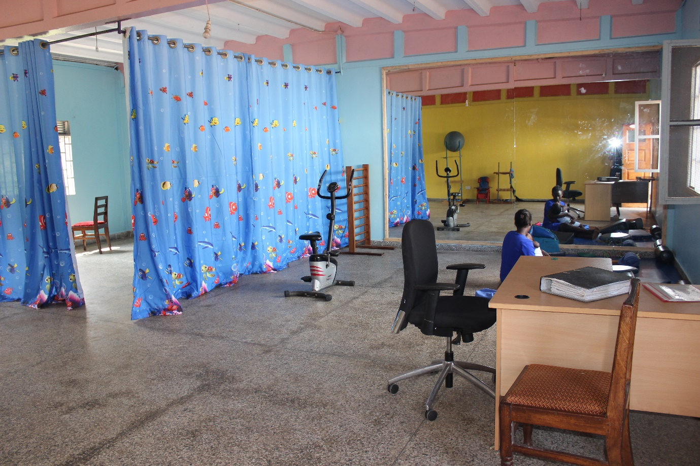
Due to the increased number of children with disabilities in need of physiotherapy services, the management decided that one of the vacant dormitories should be transformed into a physiotherapy section. The aim of this resolution was to create more space to accommodate a bigger number of children with disabilities that can participate in both group and private therapy plus physiotherapy equipment.
Below are some of the activities that were done;
Painting: The proposed physiotherapy room was designed and painted with child friendly colors to motivate them during therapy session; yellow, orange and sky blue were painted
Purchase of furniture: An office table, chair and Cubin were procured for the physiotherapist to be used during assessment, conduct office work and also store client’s files in the cubins
Purchase physiotherapy equipment: A tens machine and stationed bike were procured to assist in providing exercise and relieve pain for injured clients.
A physiotherapy mirror; We also procured a bigger physiotherapy mirror to motivate children in performing exercises/therapy.
Child friendly Curtains; These were procured to create a private area for some children that require some privacy during therapy.
Before pictures
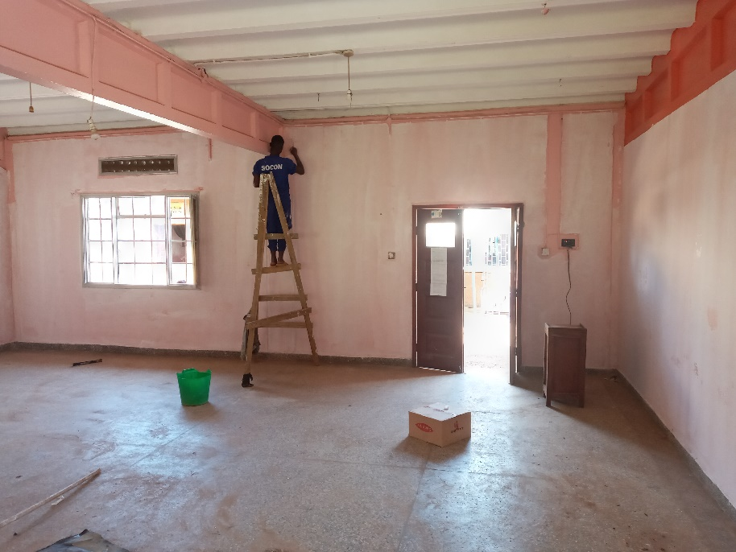
After the painting
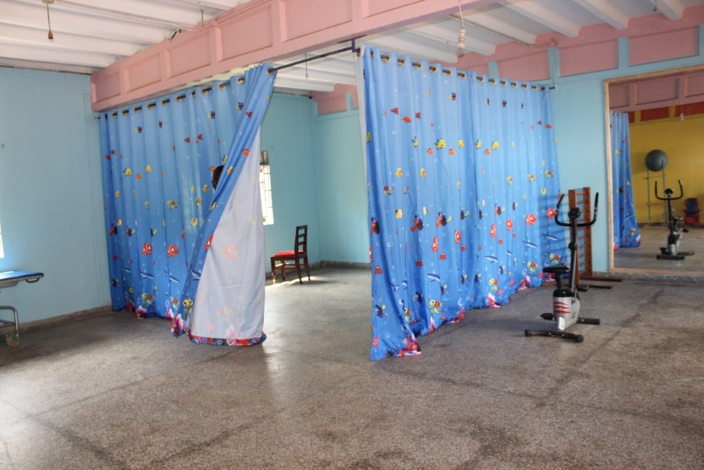
Achievements
- All the proposed items were purchased and fixed in the new physiotherapy section.
- The children with disabilities are excited and motivated to attend physiotherapy sessions.
Challenges
- The Project was delayed due to some major renovations that were on going at the center therefore this particular dormitory (proposed physiotherapy section) was utilized to store organization items.
Inconclusion, we appreciate our donors for this support and we anticipate that this renovated facility will respond to the increasing demand of physiotherapy services thus improving our service delivery. However, there are sections that need some uplift like the nursing and occupational therapy department, therefore I argue donors to donate towards this noble cause.

Compiled by
Basule Barbara
Project Leader

