KATALEMWA CHESHIRE HOME FOR REHABILITATION SERVICES
SOME OF THE CASE STORIES OF BENEFICIARIES FROM ASSISTIVE DEVICES
Arnold (not real names) is a 16-year-old boy with scoliosis secondary to muscular dystrophy that was identified during an outreach clinic. Due to this condition, he had challenges with mobility, feeding and toileting independently. The family couldn’t afford the cost of rehabilitation therefore just looked on as the condition of their child was deteriorating. The therapists referred him to Katalemwa Cheshire Home to enable him learn some exercises to strengthen his muscles, acquire a corset and a modified wheelchair with toileting and ambulation. During his stay at Katalemwa, the caretaker was taught some exercises that can be performed to avoid further deformities and he received a modified wheel chair.
Arnold is grateful for this support because he no longer feels embarrassed being carried all the time by his peers and wants to go back to school. The arm rest on the wheelchair helps him to feed independently and the family is happy about this support.
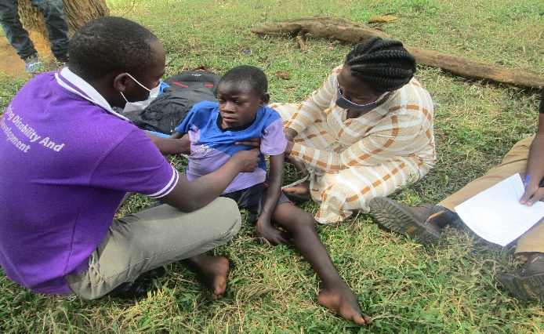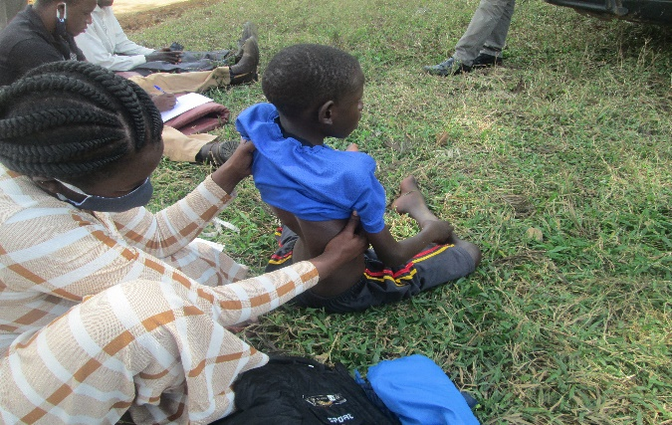
Before and During Assessment By Kch Staff
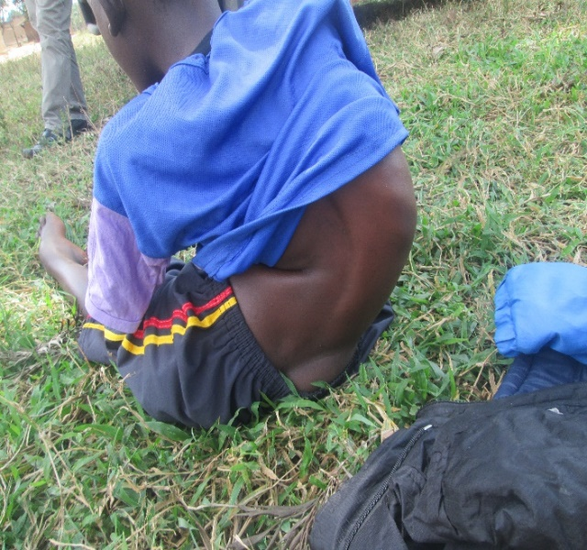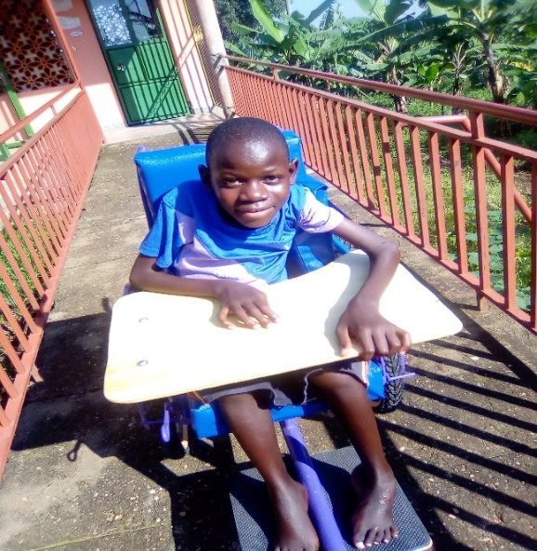
AFTER-GOZANGA IN A MODIFIED 3-WHEELER
Dan (not real name) is a 15year old boy with Cerebral Palsy that was brought to Katalemwa at an older age. The family all along thought that Dan’s condition couldn’t be rehabilitated medically, they sought for spiritual support from traditional herbalists but there was no improvement on the child’s condition. It’s a friend that referred her to Katalemwa and after assessment a wheel chair was recommended for the child and some therapies. The mother underwent some psychosocial support sessions and health education about the condition of the child. After this intensive rehabilitation, the mother appreciates the importance of medical rehabilitation and was able to perform daily exercises on the child. The mother is also grateful about the support of the wheel chair as it will help her move with her child with minimal straining and learnt the therapies that she will continue performing on her child.
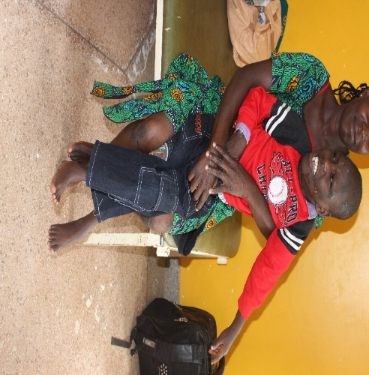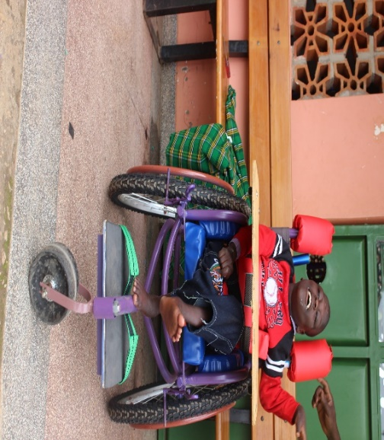
Before After Receiving A 3wheeler
Compiled by
Basule Barbara
Project Leader

