**KATALEMWA CHESHIRE HOME FOR REHABILITATION SERVICES**

**REPORT ABOUT RADIO AWARENESS PROGRAMMES CONDUCTED IN JINJA AND KAMULI DISTRICTS.**

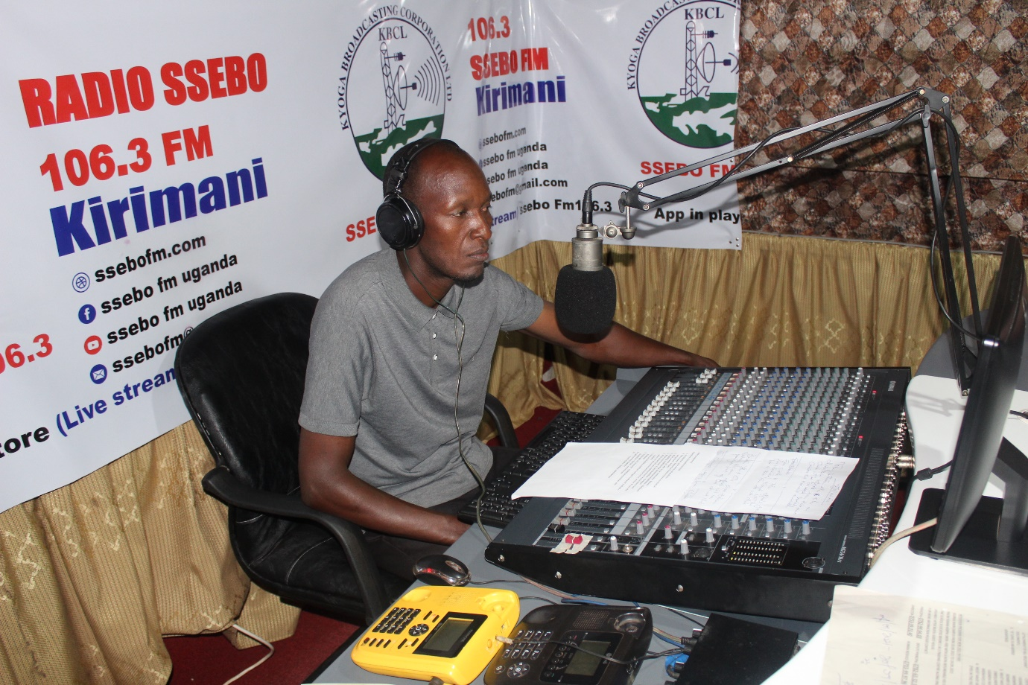

**INTRODUCTION**

Katalemwa Cheshire Home is implementing a community based inclusive development project in the Busoga sub region covering districts like Namayingo, iganga, Mayuge and Kamuli. Through our medical rehabilitation interventions, we realized that most people have limited information about disability (causes, management and prevention) and continuously attach it to a curse or witch craft. Therefore caregivers/parents with these perceptions become resistant to allowing their children access medical rehabilitation services and some don’t adhere to the treatment plan. The KCH team decided to conduct radio programmes due to the COVID 19 restrictions that limit communal gatherings to conduct awareness campaigns on disability. Two radio programmes were conducted at a Kamuli based radio station Ssebo FM 106.3 and NBS FM 89.4 a Jinja based radio that has a wide coverage in the Busoga subregion.

Aim

1. To create awareness about disability majoring on different conditions their causes, management and preventions.
2. To disseminate information about the BMZ project (areas of focus) and encourage community participation.

**Radio Script**

The radio programme was attended by a team from Katalemwa Cheshire Home and this included the project officer and occupational therapist and a radio panelist and below are some the questions that were asked during the programme.

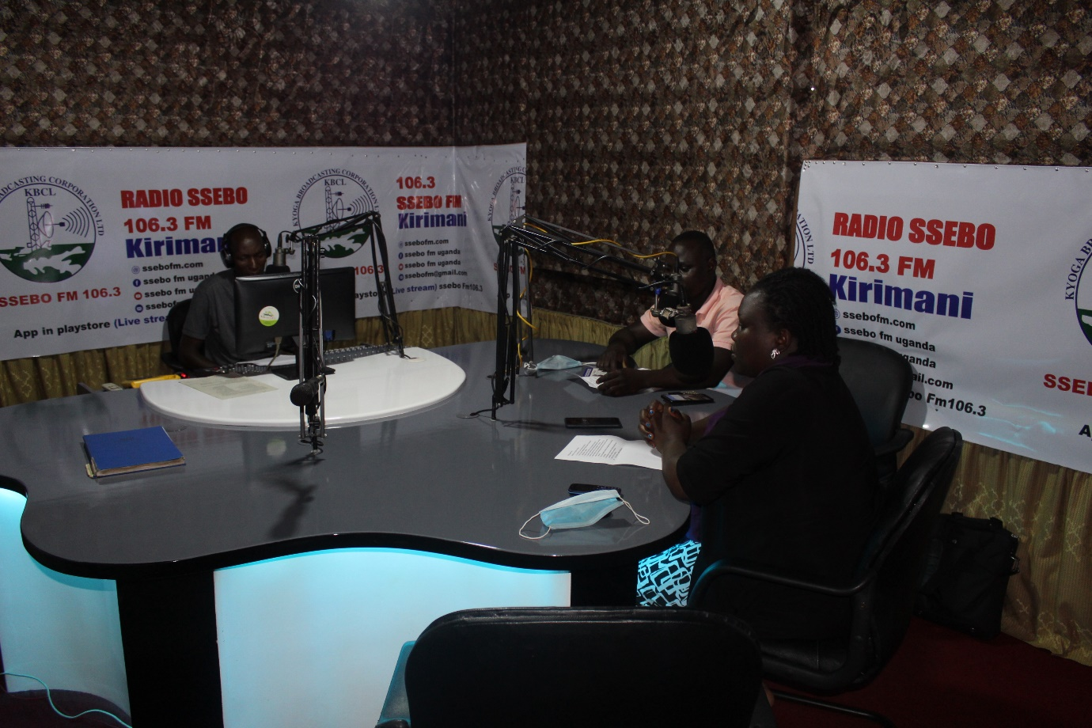

1. Introduction, your names and positions
2. Tell us about Katalemwa Cheshire Home, its historical background – Barbara
3. What services do you offer in the community – Barbara
4. Disability conditions that Katalemwa rehabilitates – Kimbowa
5. What causes some of these disabilities – Kimbowa
6. What project are you implementing in Kamuli district and where are you working and what kind of services do you offer - Barbara
7. How are disability conditions managed locally and medically - Kimbowa
8. Challenges you encounter rehabilitating children with disabilities – Barbara and Kimbowa
9. Final remarks – Barbara and Kimbowa

**Calls from the listeners included**

1. What services does Katalemwa Cheshire Home provide to adults?
2. Can children with cerebral palsy heal completely?
3. Where is Katalemwa Cheshire Home located?
4. Are children with visual impairment treated by Katalemwa

**Inconclusion,** the listeners were receptive about KCH services and appreciated KCH for considering to extend its services closer to vulnerable children with disabilities in the Busoga subregion. However, there is need for more programmes at different times to cover a wider audience.

**Compiled by**

**Namudope Barbara**

**Project officer.**