Edonyida Foundation Founder welcoming the audience at the presentation
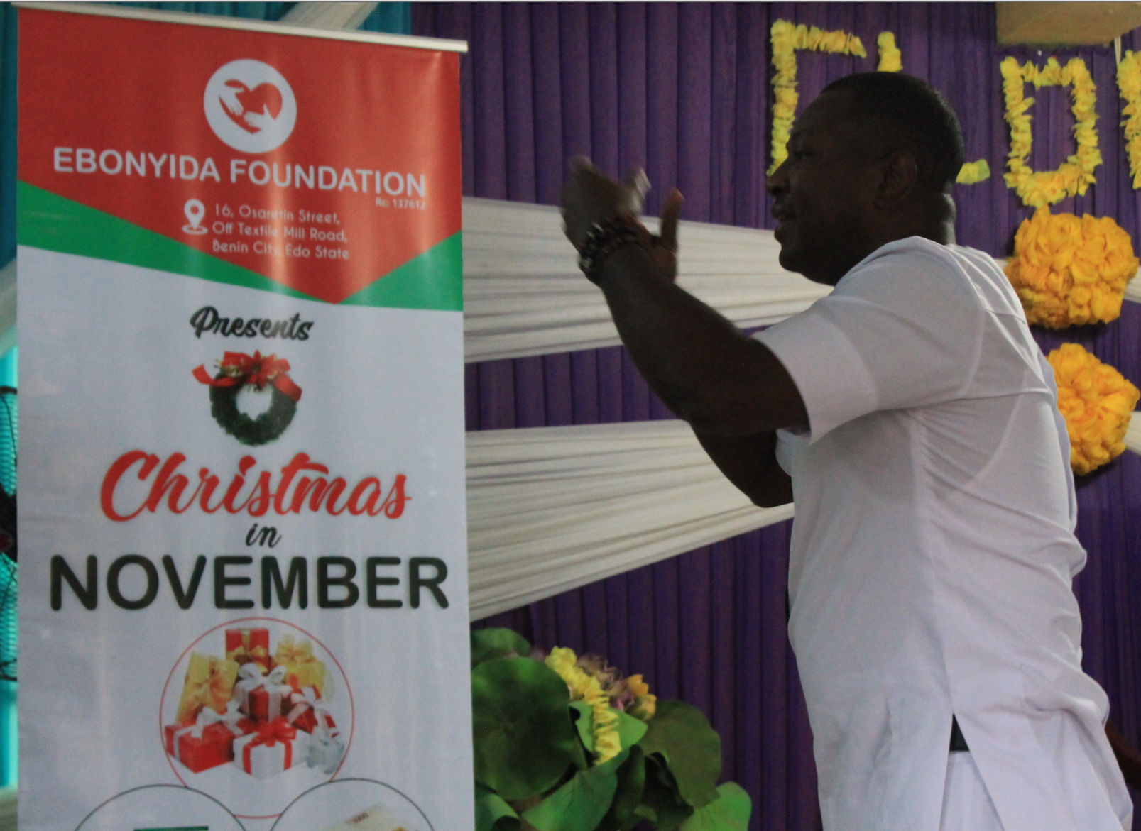
Presenting the Children with 100,000 thousand naira for three families for Christmas in 2019
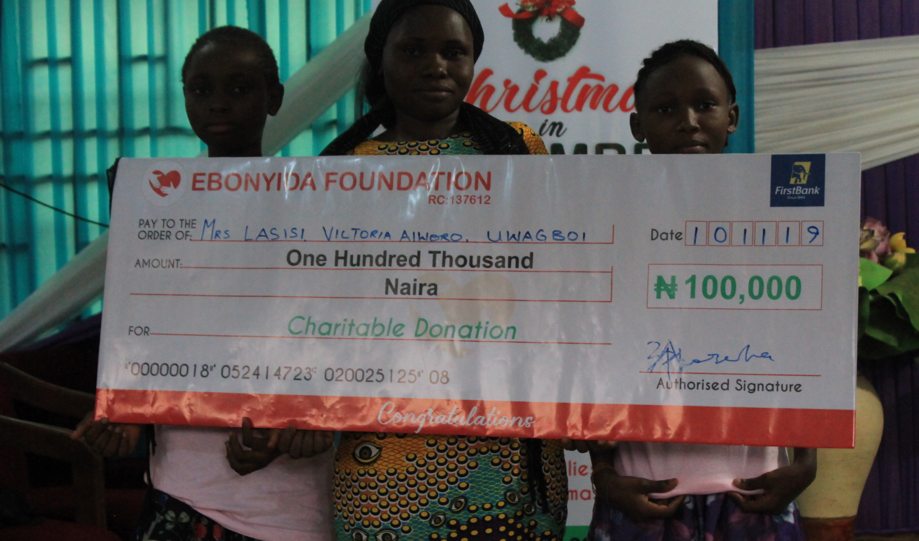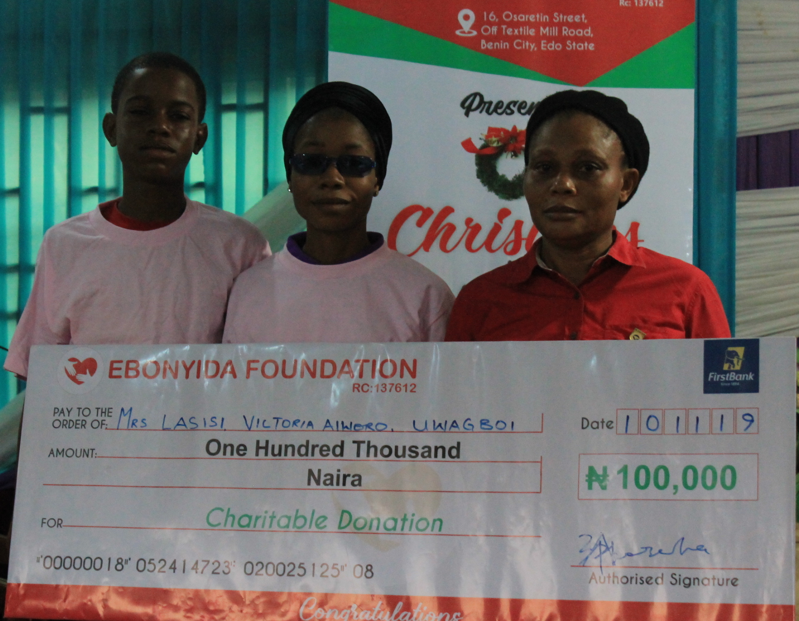

The Chair and Committee Board Members
