CHARITY REGISTERED BY THE CHARITY COMMISSIONERS OF ENGLAND AND WALES Charity number 1195213
www.rotaryhealthprofessionals.org

REPORT TO GLOBALGIVING (GG)
PROJECT 44370 CLASSROOMS AND FARMING HELP TANZANIAN SCHOOL KIDS
PROJECT SUMMARY: ‘5 years ago, we - a group of Rotarians from the United Kingdom - started a project on the island of Ukerewe in Lake Victoria (Tanzania) to help schools grow crops to feed their pupils. 7 schools (7,000 pupils) participated. Now we have raised enough funds to extend it to 1 new school. Thank you for those who responded to the appeal. We want to do more to help these kids - we want to make their classrooms safe by repairing some damaged ones and reduce classroom overcrowding by building new ones.’ https://www.globalgiving.org/dy/v2/pe/project-edit/edit-page-1.html?project.projId=44370
FUNDING TARGET AND FUNDS RECEIVED
Our target was to raise $12,588 – we nearly achieved this goal – so far through GlobalGiving we received 91 donations totalling $11,388.
We continue to be in contact with our friends in Ukerewe offering them friendship and support as they face the challenges of the Pandemic.
DISBURSEMENTS FROM GLOBAL GIVING FOR TANZANIA PROJECT
TOTAL IN USD 10,704 CONVERTED INTO GBP 8471
Disbursement Id | Date Paid | Cover Donations Thru | Memo | TANZ USD | TANZ GBP
375244 | Aug 23, 2021 | Jul 31, 2021 | Jul-21 | 874.00 | 630.22
352525 | Apr 26, 2021 | Mar 31, 2021 | Mar-21 | 766.80 | 547.40
341524 | Feb 25, 2021 | Jan 31, 2021 | Jan-21 | 31.64 | 22.41
293689 | May 22, 2020 | Apr 30, 2020 | Apr-20 | 973.09 | 793.19
288752 | Apr 24, 2020 | Mar 31, 2020 | Mar-20 | 8,059.20 | 6,477.94
 |  |  |  | 10,704.73 | 8,471.17

In addition to GG, we received other donations including Rotary grants, Club donations and personal donations via Newbury Rotary Club Benevolent Fund - GBP 5,794.00
Total available GBP 14,265.00
This has enabled us to achieve more than what we set out to achieve
BACKGROUND
Ukerewe is the largest inhabited island in Lake Victoria accessed by 3.5-hour ferry journey from the nearest Tanzania town of Mwanza.
Its remote location has perhaps contributed to its under development. The infrastructure of schools, hospital and health centres are precarious and the facilities minimal.
There are 123 primary schools in Ukerewe each with about 1000 pupils, classes with over 200 pupils. Many children walk long distances to get to school, often with nothing to eat or drink. Many schools have no access to water, toilet, books, learning materials or sports.
A whole generation of young people have been caught up in this cycle of poverty and deprivation – it is not their fault. They deserve support.
With generous support from Rotary and others we have improved water supply to some schools, built toilets, equipped science lab, library and have introduced IT studies as well as supporting children with Albinism.
NUTRITIOUS FOOD FOR PRIMARY SCHOOL PUPILS AND IMPROVED EDUCATION
In 2015, we also started a sustainable farming project in 7 schools.
Funds raised through GG and other donations have heled us to extend the programme to 4 new schools. The four new schools are:
Bulamba primary school – total number of pupils 755
Nebuye primary school total number of pupils 750
Bugolora primary school1 total number of pupils 1,378
Bugombe primary school total number of pupils 798

The total number of schools that have benefitted from this programme now is 11. The programme is managed by the Foundation for Farmers’ Services (FFS), Box 222, Opposite DC Office, Nansio – Ukerewe, Mwanza – Tanzania.
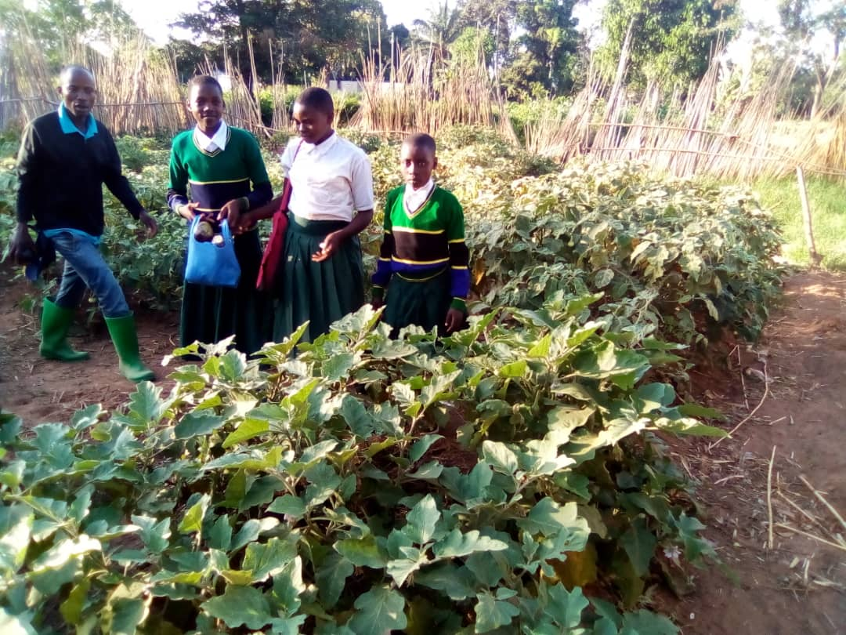
An MOU and budget were agreed with FFS before the programme. The MOU outlined the requirement for regular feedback reports including measurable objectives such as school attendance. Local coordinator Reuben Richard was meticulous in submitting follow up reports on regular basis.
All reports are available for inspection.
The schools were chosen by the representatives of the Foundation for Farmers Services (FFS) in Ukerewe taking into account staff commitment, community involvement and availability of land and water.
The Memorandum of Understanding with the FFS described the objectives as:
- To facilitate the formation of environmental clubs and committees in schools and to train members on organizational development.
- To enhance the capacity of school children and teachers to adopt sustainable land use management practices resulting in the development of ‘model farms’. The purpose of such farms is to grow seasonal crops to provide pupils nutritious and balanced food items cooked in school premises, as frequently as possible.
- Contribute to environmental protection by planting new fruit and timber trees, reducing waste, recycling especially plastics and to promote these concepts to the wider community.
- To promote to the wider community farming methods which are sustainable and help increase productivity.
A team of Rotarians from UK visited the Community before the pandemic and were satisfied that the programme was progressing satisfactorily. Subsequent reports confirmed that all objectives have been met.
CLASSROOM DESKS
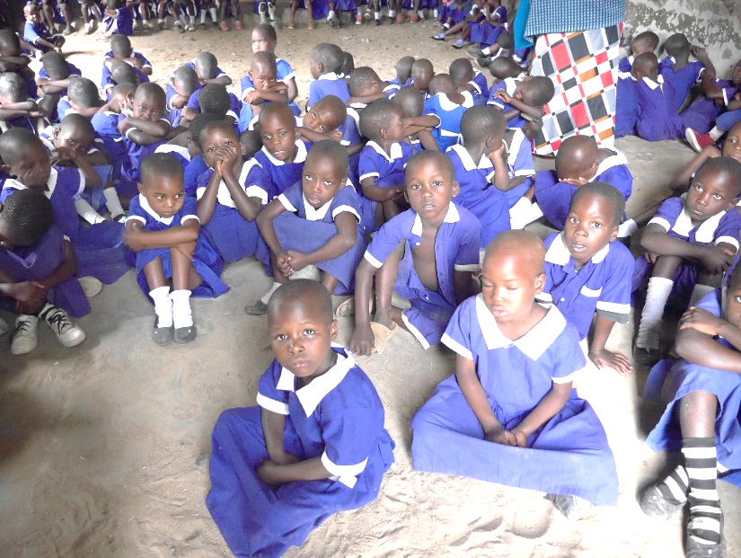
Following an appeal from the Educational Authorities in Ukerewe we made a decision to provide primary schools with locally made benches and desks. These were made by local carpenters under the supervision of Vocational Training School thus providing trainees an opportunity to improve their skills. made an appeal for help.
Drawings and specifications were obtained from a major Tanzanian supplier of school furniture and a budget agreed with FFS and the Vocational Training School including a time frame in a separate MOU.

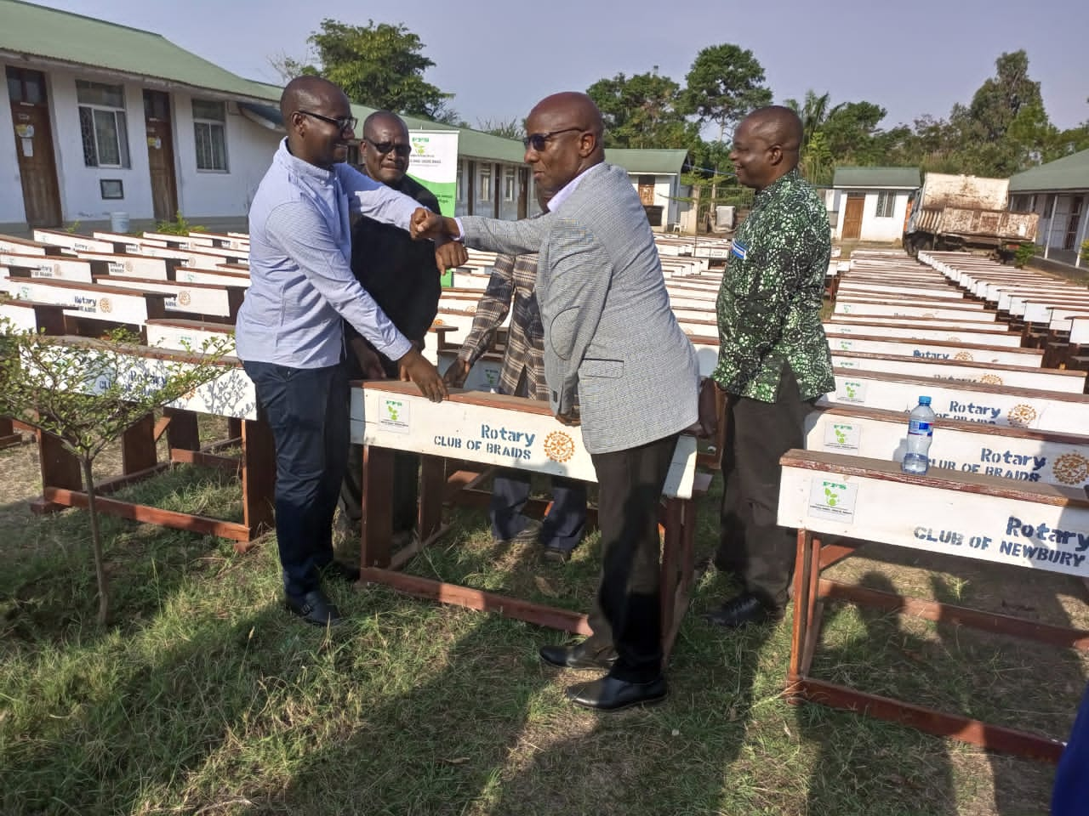

BUDGET RECONCILIATION
The following table shows the amount spent on the two programmes.
 | Number commissioned | Unit cost | Total cost
Desks | 528 | £16.00 | £8,448.00
Farming |  |  | £5,817.00
TOTAL |  |  | £14,265.00

The following table shows the amount of funds transferred to FFS.
26/11/2020 | FFS | £3,308.50 | Receipt
14/04/2021 | FFS | £3,258.50 | Receipt
08/11/2021 | FFS | £3,249.50 | Receipt
30/11/2021 | FFS | £4,448.50 | Receipt
 |  | £14,265.00

Bank transfer receipts on page 5

Thank you for caring for the people of Ukerewe. If you need more information, I’ll be pleased to hear from you.

Dr John Philip
Chairman, International Rotary Fellowship of Healthcare Professionals
Past Rotary District Governor (D1040), The Rotary Foundation Cadre
District Foundation Chair (D1090)
United Kingdom
+44 (0) 7889 388038
www.rotaryhealthprofessionals.org

