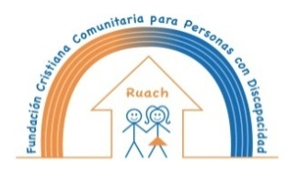
La Fundación Cristiana Comunitaria para
Personas con Discapacidad Ruach les desea

We wish you an inspired Christmas and a very worthwhile 2021!

Inspite of the restrictions caused by the corona virus we have enjoyed a good 2020. We might progress in our mission to promote the rights of people with an intellectual disability in Juigalpa and to work towards a better world for all! You have helped us achieving this through a donation, a fund-raising campaign or by promoting our work. A big thank you for your support to our work!

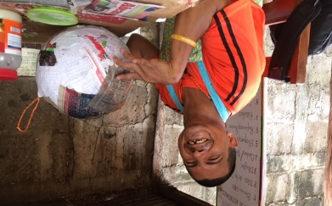
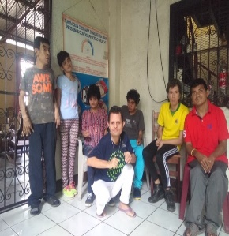
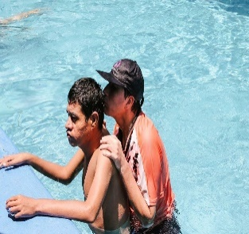

We’ve shown this year that together we are stronger!
Can we count on your support in 2021?

