Raise Support/Awareness
It is never easy for everybody to travel to a distant place like Africa, however much they would wish to. As a team, we revised ways of how we could avail everybody an opportunity to participate in this cause, and one of this was to simply allow one Raise support/Awareness of this great need from wherever they are located/situated. You could simply raise awareness in your schools, church, market place, workplace about the need to support and reach out to the most vulnerable people in the hurting communities of Uganda through supporting Diiro Child Care Foundation activities.
For more information or tips on how you could raise awareness and support, simply write to us at diiroj@yahoo.com

Keep a vulnerable child in school
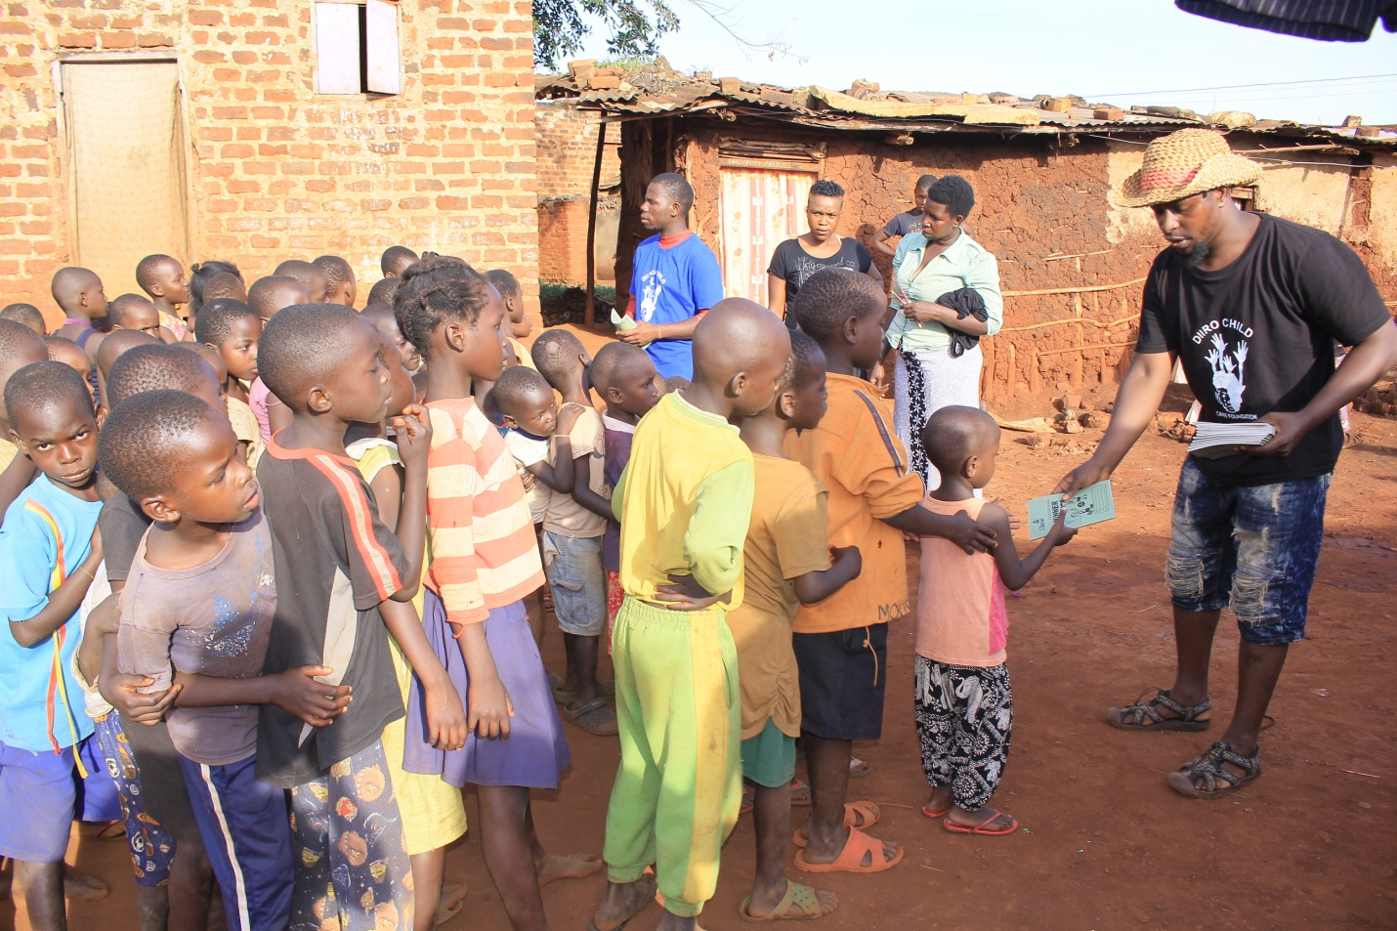

EDUCATION FOR ALL IN VULNARABLE COMMUNITIES
Child sponsorship is very possible and with such and more we are in position to create lasting impact for a vulnerable child in the community to stay at school, we are in position to provide education and scholastic materials, basic necessities like food, medication, clothing, school uniform, school bag, shoes, pen, pencils,books ,lunch travel and holiday sessions for the child.
Keep a vulnarable child in school
With your support we can take a child to school within our program under a campaign termed As “Keep vulnerable child in School“. Under our program, a child is catered for from their respective communities, this campaign mainly looks after total and single orphans and street cihldren whose parent, relative or community Samaritans are no longer in position to take care of the child, Among the necessities we provide are; education in form of school fees, scholastic materials, clothes and food.
BUDGET SHOWING COST PER CHILD
No. | Item | 1st Term  Per Child | 2nd Term  Per Child | 3rd Term  Per Child | TOTAL | 150 children/year
1 | School fees | 100,000 | 100,000 | 100,000 | 300,000 | 45,000,000/$11,842
2 | Uniform | 45,000 | - | - | 45,000 | 6,750,000/$1776
3 | Books | 10,000 | 10,000 | 10,000 | 30,000 | 4,500,000/$1,184
4 | Pens | 6,000 | 6,000 | 6,000 | 18,000 | 2,700,000/$711
5 | Pencils | 1,200 | 1,200 | 1,200 | 3,600 | 540,000/$142
6 | Shoes | 35,000 | - | - | 35,000 | 5,250,000/$1,382
7 | Socks | 5,000 | 5,000 | 5,000 | 15,000 | 2,250,000/$592
8 | Bag | 30,000 | - | - | 30,000 | 4,500,000/$1,184
9 | Lunch | 75,000 | 75,000 | 75,000 | 225,000 | 33,750,000/$8,882
10 | Set | 5,000 | - | - | 5,000 | 750,000/$197
11 | Other Requirements | 30,000 | 30,000 | 30,000 | 90,000 | 13,500,000/$3,553
12 | Medical | 30,000 | 30,000 | 30,000 | 90,000 | 13,500,000/$3,553
 | Total (UGX) | 372,200 | 257,200 | 257,200 | 886,600 | 132,990,000
 | Total (USD) | $98 | $68 | $68 | $234 | $34,998

d.

For more information regarding our campaign, Keep A vulnarable child In School“. Email us on diiroj@yahoo.com
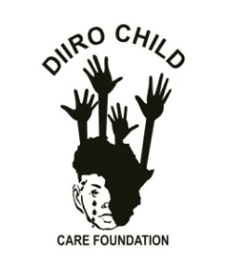
Diiro Child Care Foundation is a Community based organization operating in Uganda,jinja.( DCCF)

Our Contacts
P.O.Box 390 Jinja (U) Available 24/7
+256752417920 | +256780846961
diiroj@yahoo.com

