**The periodic report of the project from February to April 2021:**

**Addressing malnutrition for children under five years of age, lactating and pregnant women among the displaced community and the host community in the Ablas region - Hamadan - Sana'a**

**Funded by Global Giving**

**2021**

**Report prepared by: Muhammad Abu Hayder**

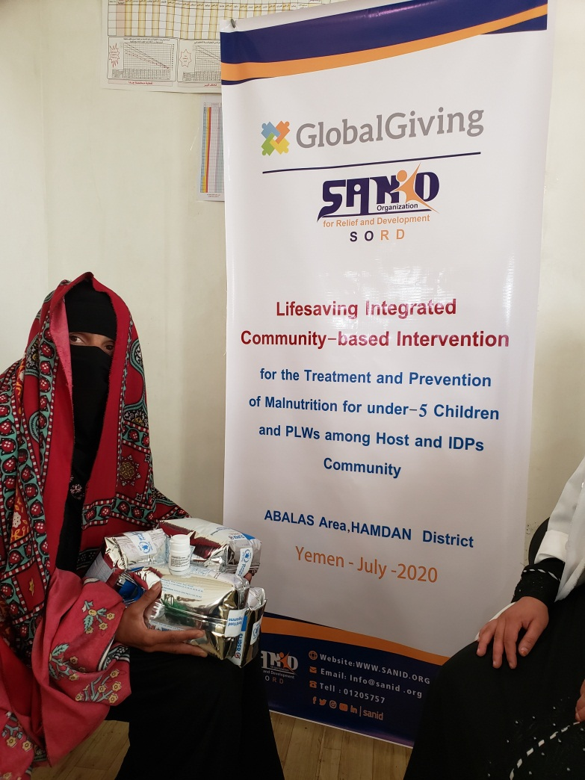

The project Location

Ablas area in Hamadan district - Sana'a governorate

The name of the organization applying for the grant Sanid Organization for Relief and Development (SORD)

Report period 3 months

starting date January 2021 **End date March 2021**

The total cost of the project is in US dollars

Organization address Algeria Street, next to the European Commission

phone number *0096701205757*

Report prepared Mohammad Abu –Hayder

Current Position Project Manager

Email Programs.officer@sanid.org

Mobil number *00967 775907606*

The organization's website www.sanid.org

Project Name Protection 1469 Yemeni children from malnutrition.

Content

Introduction  : 4

Project Summary: : 4

The nutritional program focuses on the Ablas unit:: 4

the main nutritional intervention for SORD:: 4

Implementation: 5

Implementation of the nutrition program activities at the health unit and community level: 5

Achievements : 9

## Introduction:

We envision a world where every child has the opportunity to live life to its fullest. Good nutrition is a fundamental basis for health and development, yet malnutrition remains the most serious health problem in the world and the largest contribute child mortality, so Sanid Organization for Relief and Development (SORD) has made treating malnutrition a top priority.

Our goal in the nutrition sector in SORD is to ensure that mothers and children receive good nutrition and end malnutrition in the target area.

## Project Summary:

Given the current coverage of the Targeted Supplementary Feeding Program (TSFP) and the coverage of the Basic Nutrition Services Package (BNSP), Sanid Organization for Relief and Development (SORD) - in cooperation with the Ministry of Public Health and Population (MoPHP) is planning to reach 781 children under the age of five and 339 pregnant and lactating women through the TSFP program. The detection of active cases was emphasized by measuring MUACs through the community awareness component. Priority activities were (a) Strengthening the provision of CMAM - MAM services in order to increase service access to the target area with a high malnutrition rate; (B) Promote community services through trained community nutrition workers and volunteers. Thus BNSP ensures the provision of a minimum preventive service that includes health education, promotion of IYCF infant and young child feeding, micronutrient supplementation, and deworming to ensure that the nutrition is eaten holistically rather than in a purely therapeutic perspective. Women who are illiterate or who suffer from lack of education and women married at an early age are more vulnerable to under nutrition. Therefore, women and mothers of childbearing age have been targeted in the proposed courses to increase community awareness of a total of 242 women. In order to ensure the progress of the project, continuous evaluation, supervision visits and monitoring of program performance indicators were carried out regularly, and for the sake of transparency and to ensure the achievement of the project and to ensure the satisfaction of the beneficiaries, the complaints mechanism was activated.

**The nutrition program at the Ablas unit focuses on:**

• Children suffering from severe acute malnutrition can access therapeutic feeding for patients in the health unit with fully trained staff to reduce the prevalence of acute malnutrition among children under five and pregnant and lactating women.

• Children and pregnant and lactating women with acute and moderate malnutrition have access to a targeted supplementary feeding program and appropriate infant and young child feeding sessions.

• Health workers and community volunteers are trained to screen for acute malnutrition, effectively detect cases, and follow up on the beneficiaries of the program.

• Strengthening preventive nutrition services among vulnerable population groups.

**The main nutritional intervention to SORD:**

Provision of medicines and nutritional supplements. •

• Providing preventive services.

• Conducting educational sessions on infant and young child feeding, health and hygiene for caregivers of children suffering from malnutrition.

## Implementation:

### Implementation of the nutritional program activities at the health unit and community level:

Responsible HWs and CHVs have provided all CMAM services to children 6-59 months old with SAM in the health unit and at community and family level, such as nutrition screening, admission to TSFP and OTP, vitamin A supplementation, Fe / Fo supplementation for pregnant and lactating women, Deworming and zinc supplementation for diarrhea cases, hygiene promotion and other key primary health services.

In schedule No. () statistics for the number of children> 6 to 59 months at the health center level:

Monthly summary of the number of children > 6 to 59 months according to  
the schedule at the level of the health center

Number of  
children Classification by nutritional status of the child by all the criteria in the screening record Action taken

Sever acute  
malnutrition   
(SAM) Average  
malnutrition  
MAM Normal Awareness Referral

421 17 204 200 195 0

schedule (No.) Statistics of the number of children> 6 to 59 months at the community level (volunteers)

Monthly summary of the number of children > 6 to 59 months according to

the schedule at the level of the community level (volunteers)

Number of  
children Classification by nutritional status of the child by all the criteria in the screening record Action taken

Sever acute  
malnutrition   
(SAM) Average  
malnutrition  
MAM Normal Awareness Referral

417 9 110 398 152 47

Schedule (No.) Statistics of the number of children> 6 to 59 months at the community level (volunteers)

Monthly summary for screening of PLWs at the health facility level

NO Average (< 23 cm) Action done

Pregnants Lactating Awareness Referral

107 49 58 89 2

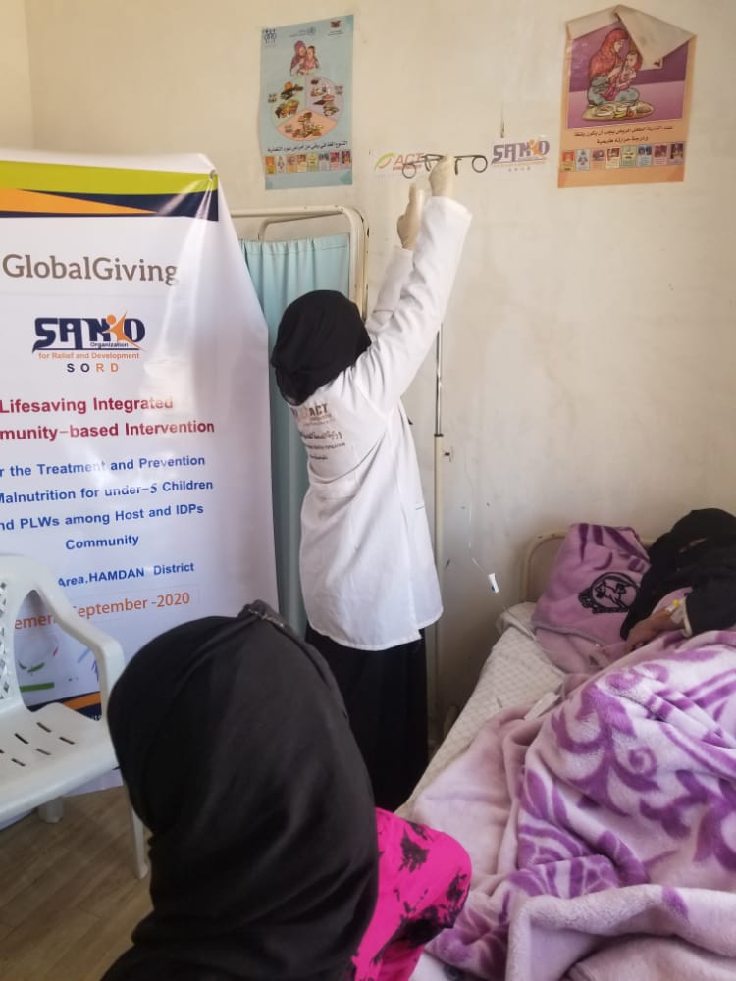**Monthly summary for screening of PLWs at the health facility level**

(volunteers) Monthly summary for screening of PLWs at the community level

NO Average (< 23 cm) Action done

Pregnants Lactating Awareness Referral

215 34 27 35 4

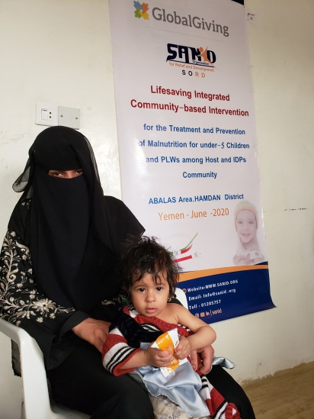 **(volunteers) Monthly summary for screening of PLWs at the community level**

**Achievements :**

The achievements of the treatment and preventive program SAM and MAM in the health unit in the area of ​​Laplace from May until November 2020, as shown in Table (No.).

Table No. () Achievements of Activities:

Activities Number

# Acceptance of SAM  26

# Acceptance of MAM  314

The number of pregnant and lactating women has reached to the awareness session on infant and young child feeding 168

Number of pregnant and lactating women received iron and folic acid tablets  122

# Children 6 to 59 months old who are screened and referred for acute malnutrition  17

# Children 6 to 59 months old who are screened and referred for acute malnutrition at the community level  7

Number of children 6-24 months of age tested and referred for acute malnutrition  26

# Children 6 to 24 months of age who were tested and referred for acute malnutrition at the community level 5

Plumpy Nut carton number has been distributed  48

# Pregnant and lactating women  258

# An advisory session

The number of worms tablets distributed  35

Micronutrients(Powder) 76