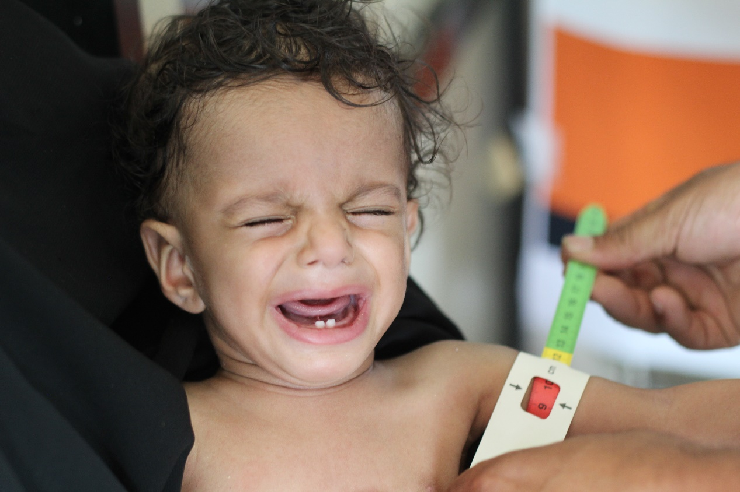

**Report on protecting 1,469 Yemeni children from malnutrition**

**June - August 2023 AD**

**An overview of the tragic situation in Yemen**

# It has been so inspiring to see the work that globalgiving does and the humanitarian community , the SANIDITM organization . It expresses its profound gratitude to all supporters in the humanitarian field who are doing their utmost to help the Yemeni community and alleviate its suffering. In the midst of an escalating global food insecurity crisis, hope is fading for millions who already suffer from extreme hunger Globalgiving was It is the hope to save him from the specter of famine that has reached him

Yemen is one of the countries with a high prevalence of acute malnutrition

. They are needed for this project l Vital nutrition services are provided to the most vulnerable communities.

Clinical feeding centers .

Which lacks sufficient support to cover the needs of malnourished people, whether nutritional supplements, the most important of which is therapeutic milk.

It is also in dire need of rehabilitation, furnishing, equipment and supplies .   
According to analysis and studies , most Yemen spokesman The most vulnerable and poor , where food insecurity and acute malnutrition converge to very high levels . .   
For severe malnutrition, the WHZ score ranges in these areas The measure of wasting for children under five years of age increases , from 17% to 26%, well above the emergency threshold For those interested , it amounts to 15%, while for acute food insecurity, these Yemeni regions have the highest prevalence rates with more than 65 percent of the population in the third stage of the classification of the official authorities and follow-up of the situation for food insecurity and above at the present time . A large number of   
targeted areas are also expected to move to higher IPC stages, with significantly reduced levels of humanitarian food assistance.

**In turn**, SORD submitted its project entitled: “Protection 1469 Yemeni children suffer from malnutrition . The proposed project aims to contribute to reducing deaths and diseases associated with acute malnutrition for children under the age of five in targeted areas with high rates of acute malnutrition. During the third quarter of 2023, children under the age of five were provided Those suffering from severe acute malnutrition should receive appropriate complementary feeding. Community awareness has been raised among pregnant women, nursing mothers, and girls of childbearing age regarding the prevalence of malnutrition, both for the child and the mother, the importance of good nutrition for mental and physical health, and how to use available resources in order to overcome or reduce malnutrition.

More details about the project's achievements can be found on our side, and based on the available capabilities, we have made remarkable progress compared to the percentage of cases recorded by the team in the field. During the second quarter of the year 2023 AD.

|  |  |
| --- | --- |
|  |  |

**Activities that were carried out during the month of June to August :**

SANED has worked to implement the activities according to its available capabilities and in accordance with the support and donations it received from Global.

**The total number of beneficiaries during the third quarter from June to August: 924 children and women distributed over the services Which is implemented by Sand distributed as follows :**

• Coordination was made with the health center to receive 198 cases of malnourished children (new). They were presented to the specialized doctors within the malnutrition program at the health center in Aslam district.

Where approximately 272 cases of malnourished children were recorded, and as we mentioned that due to the lack of resources, Sanad could not help this number of injured people. It was able to provide aid (examination, examinations and disbursement of therapeutic supplements to 198 children under the age of 5 years who suffer from toxic and poor malnutrition .

167 children under the age of five were immunized with vaccines against infectious and deadly diseases.

• A number of 117 children under the age of five who were helped were received during the period from June to August, and their cases continue to be followed up until recovery. Their cases were followed up through examination and obtaining nutritional supplements.

• After coordination with the health center, the Motherhood and Childhood Department received 160 cases of malnourished mothers, pregnant and breastfeeding women (new), and they were presented to specialist doctors within the motherhood and childhood program in the health centers in the targeted areas.

Approximately 222 pregnant and breastfeeding women suffering from malnutrition were registered. As we mentioned, due to the lack of capabilities, Sanad was unable to help this number of pregnant and breastfeeding women in need of health care and follow-up. Sanid was able to provide aid (inspection, examinations, and dispensing therapeutic supplements) to 186 women (pregnant and breastfeeding women). .

Immunization procedures for 96 pregnant women against tetanus .

• , whose cases have become difficult and require intensive care, have been referred to some hospitals in the governorate, which have special capabilities and care, where they were assisted with the costs of transportation, accommodation, supplementary feeding, and intensive care room fees in private hospitals.

• 12 cases of pregnant and breastfeeding women suffering from chronic diseases and needing special care were referred to hospitals in the provincial center .

• Implementation of 19 awareness sessions on aspects of reproductive health, measures to prevent malnutrition, hygiene methods, and proper healthy nutrition. 190 pregnant and lactating women were targeted by volunteer midwives.

As 18 cases of malnourished children transitioned to the recovery stage, including 8 females and 10 males .

**Challenges :**

•The deterioration of the health situation in the health centers in the targeted areas.

•Non-availability of salaries by the government for workers in health centers.

•Poor capabilities to cover the visitors to health centers.

•Lack of support and donations.

•The high number of malnourished people.

**Recommendations :**

• Redoubling efforts to provide support and assistance to save the largest number of children and women who are on the brink of death.