 | 

Monthly Progress Report: Child Protection in Yemen
Reporting Period: January 1 – April 20, 2026

1. Project Overview
- Project Title: Protecting Children in Yemen from Violence Amidst Conflicts and Crises.
- Implementing Partner: Sanid Organization for Relief and Development (SORD).
- Location: Yemen.
- Report Preparer: Shaif Ahmed Ali Ezz El-Din
      - Phone number 0096701231744
      - Current job Project Manager
      - e-mail Programs.officer@sanid.org
      - Mobile number 00967778515109

2. Humanitarian Context
Children in Yemen have faced severe hardships since 2015 due to ongoing conflict. The current situation includes critical challenges:
- Protection Risks: High vulnerability to violence, exploitation, and forced recruitment.
- Displacement: Ongoing forced displacement, with many children living in inadequate camp conditions and lacking basic services.
- Health & Nutrition: High rates of acute malnutrition and limited access to healthcare, clean water, and sanitation.
- Education & Psychosocial Needs: Severe disruption to the education system and widespread psychological trauma among children.

3. Strategic Objectives
The project aims to provide safety and resilience through:
- Essential Protection: Establishing Safe Spaces and providing psychosocial support (PSS).
- Awareness & Advocacy: Educating parents and communities on child rights and the harmful effects of exploitation.
- Capacity Building: Training staff and volunteers in professional child protection standards.
- Protection Networks: Strengthening local and national networks to ensure a coordinated response.

4. Key Achievements (Jan - Apr 2026)
Despite limited funding, SORD has focused on high-impact protection activities:
- Safe Space Operations: Sustained a Child-Friendly Space (CFS) providing a secure environment for displaced and conflict-affected children until July 2026.
- Psychosocial & Educational Support:
  - Conducted 30 awareness sessions led by female specialists.
  - Provided psychosocial support sessions for 50 children.
  - Engaged 80+ children in ongoing literacy and art activities (reading, writing, and drawing).
- Material Assistance:
  - Distributed winter clothing to 50 children during the cold season.
  - Provided general clothing to 30 additional children.
  - Supplied 80 children with light nutritional meals during CFS activities.
- Health & Nutrition Awareness: Facilitated access to primary healthcare and vaccinations while promoting healthy nutrition programs to combat malnutrition.

5. Visual Documentation
- Winterization: Distribution of winter clothing to vulnerable children.
- Recreational Activities: Children participating in physical and intelligence-building games at the CFS.
- Educational Support: Group awareness sessions and literacy/drawing workshops.
- Nutrition: Provision of light meals during project activities.

6. Contact Information
- Address: Al-Habari, Shu'ub District, Amanat Al-Asimah, Yemen.
- Phone: 00967 01231744
- Email: Programs.officer@sanid.org.
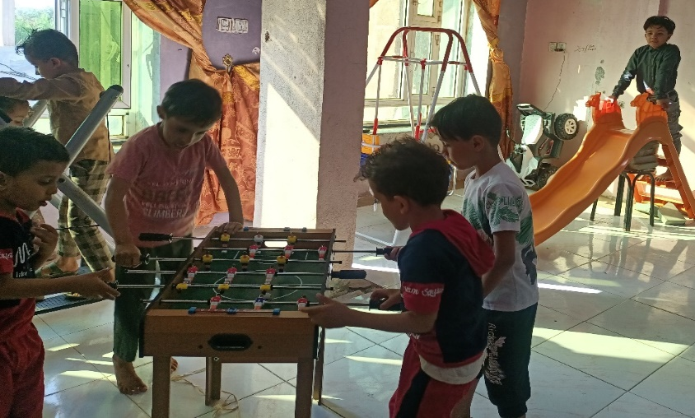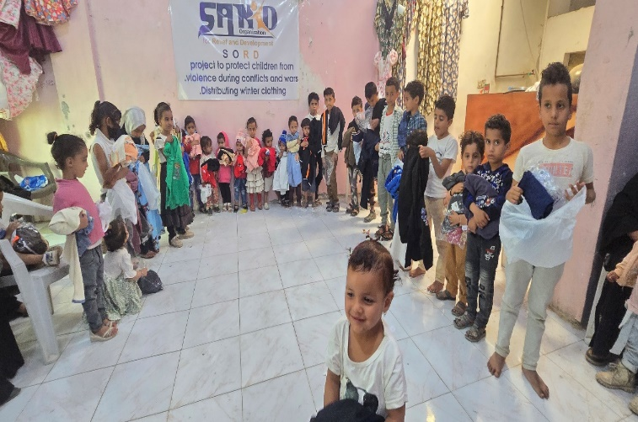
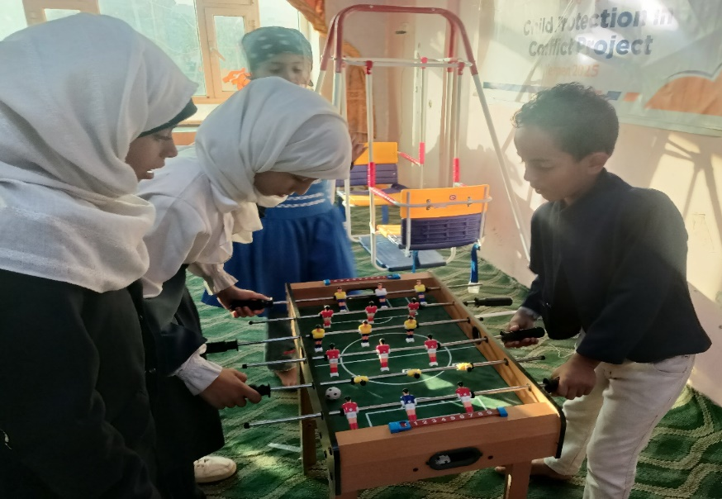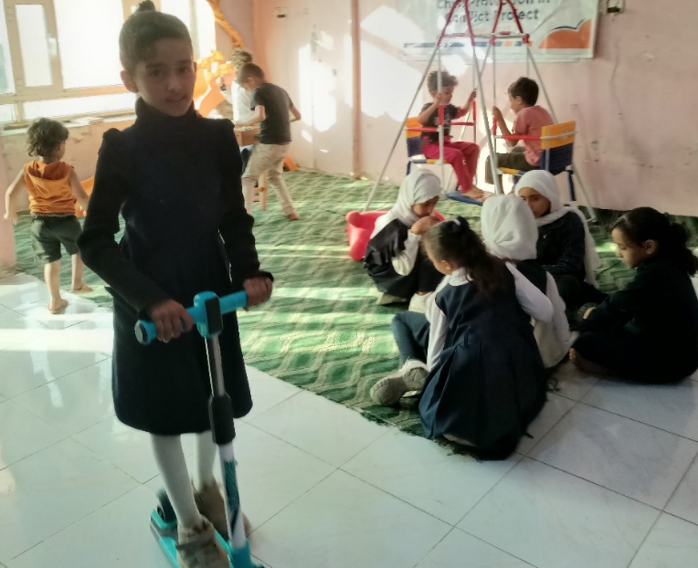

SANID ORGANIZATION FOR RELIEF AND DEVELOPMENT (SORD)
Sana'a - Al-Hasba - Shu'ub District - Al-Hasba Al-Jamahiriya Street -Alhabari Round-behind Aljedri Station
 https://sanid.org  www.facebook.com/sanid.org  https://twitter.com/sanid_org
 https://www.instagram.com/sanidorganization
Tel : +9671231744 Mob:+967775433335 Email : info.sord@sanid.org

