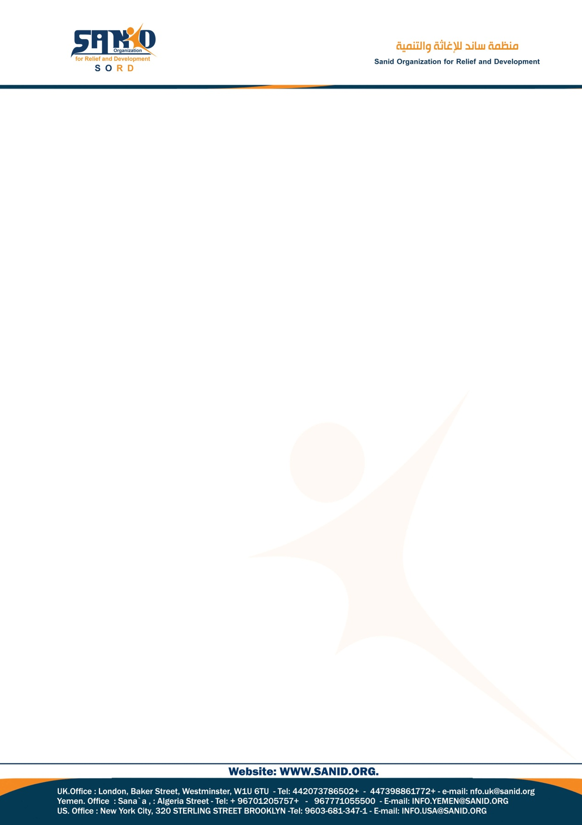

Monthly Performance Report – Local Partner (SORD)
Project Report: Protecting Children in Yemen from Violence in Conflict and Crisis Situations
Reporting Period: August 2026
Report Prepared by: Shaif Ezzedine
Project Information
Field | Details
Project Title | Protecting Children in Yemen from Violence in Conflict and Crisis Situations
Project Location | Yemen
Grantee Organization | Sanid Organization for Relief and Development (SORD)
Reporting Period | Quarterly
Project Start Date | 1 May 2026
Project End Date | 1 August 2026
Organization Address | Amanat Al-Asimah – Shu’ub District – Al-Habari
Report Prepared by | Shaif Ezzedine
Position | Project Manager
Email | Programs.officer@sanid.org
Website | www.sanid.org
1. Overview of the Situation of Children in Yemen
The “Protecting Children in Yemen from Violence in Conflict and Crisis Situations” project is an initiative aimed at promoting the protection and safety of Yemeni children who are at risk of violence and exploitation as a result of armed conflict and the ongoing humanitarian crisis in the country.
The project includes a range of activities and initiatives designed to promote children's rights and enhance their psychosocial and social well-being. Key areas of intervention include:
Provision of Basic Protection:
The project supports the establishment and continuation of safe spaces for children affected by conflict, provides care and psychosocial support, and promotes a safe and protective environment for children.
Awareness-Raising and Community Education:
The project conducts awareness and educational sessions targeting children, parents, and community members on different forms of violence and exploitation, their negative impact on children, and the importance of protecting and promoting children's rights.
Capacity Building of Child Protection Personnel:
The project provides training and support to child protection personnel and relevant volunteers to strengthen their knowledge, skills, and capacity to provide appropriate assistance and care to affected children.
Strengthening Protection Networks:
The project seeks to establish and strengthen local and national child protection networks and promote coordination with relevant local and international institutions to improve collective protection mechanisms for children.
Overall, the initiative aims to mitigate the negative impact of conflict and humanitarian crises on children in Yemen and contribute to a safer and more supportive environment for their growth and development.
2. Key Protection and Humanitarian Needs
Children in Yemen continue to face severe challenges and urgent humanitarian needs as a result of the protracted conflict. The key areas of concern identified in the report include:
- Child Protection: Children are exposed to violence, exploitation, recruitment, and other protection risks.
- Health: The spread of diseases continues to have a significant impact on children's health and well-being.
- Education: The education system has been severely affected by the conflict, undermining children's access to education.
- Nutrition: Many children continue to experience acute and chronic malnutrition.
- Mental Health and Psychosocial Well-being: Children are experiencing psychological distress and trauma associated with prolonged conflict and violence.
- Displacement: Many children experience prolonged displacement and live in displacement camps or inadequate hosting conditions, with limited access to adequate shelter, healthcare, and education.
- Protection and Basic Services: Displaced and vulnerable children face multiple forms of violence and risks, including forced migration and trafficking, as well as limited access to safe water, sanitation, and quality health services.
3. Activities Implemented
During 2026, Sanid Organization for Relief and Development focused its interventions primarily on child protection, awareness-raising, and psychosocial support, while humanitarian assistance activities remained limited due to constrained organizational resources and insufficient funding and donations available to support vulnerable children.
From May to August 2026, the following activities were implemented:
- Access to Basic Health Services
Supported children's access to basic healthcare services, vaccinations, and emergency and secondary healthcare services.
- Operation of a Child-Friendly Safe Space
Continued operating a safe space at one of the centers and enrolled both boys and girls to help protect them from various forms of violence and protection risks associated with displacement, ongoing conflict, war, and humanitarian crises.
- Recreational and Educational Activities
Children participated in a range of recreational, educational, awareness-raising, health, and nutrition-related activities.
- Child-Friendly Recreational Materials
The safe space provided a variety of games and recreational materials that supported children's physical well-being, cognitive development, thinking skills, and psychosocial well-being.
- Awareness-Raising Sessions
A total of 22 awareness-raising sessions were conducted for children enrolled in the safe space, facilitated by female specialists in awareness and education.
- Psychosocial Support (PSS)
34 children received psychosocial support sessions delivered by qualified psychosocial specialists.
- Literacy and Creative Activities
More than 50 children regularly participated in reading, writing, and drawing activities.
- Food Support
50 boys and girls received light snacks during activities conducted at the safe space.

