KATALEMWA CHESHIRE HOME FOR REHABILITATION SERVICES
Training on Physical accessibility for Head teachers in Makindye Division
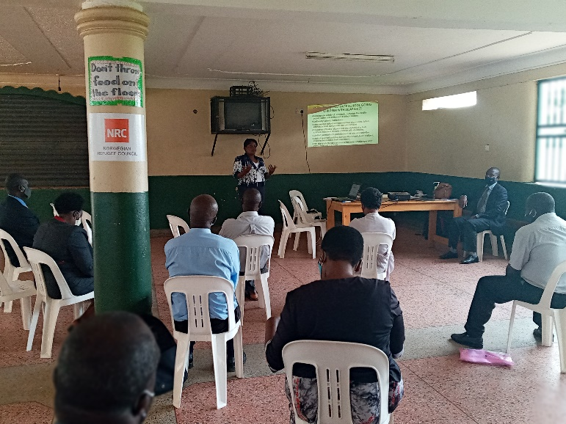
As Katalemwa advocates for Inclusive Education through our Child empowerment programme, inaccessible school environment is one of the biggest challenges to learners with disabilities. Therefore, we organized a training about accessibility for 17 head teachers (6 female and 11 male) in Makindye Division because it’s one of the sub counties in Kampala district whose schools are inaccessible for learners. The aim of this training was to equip these headteachers with knowledge about accessibility and its relevance to learners with disabilities.
This training was conducted in partnership with the Kampala Capital City Authority (Directorate of Education and social services) & the KCCA Makindye Division - Education department, and it targeted Government aided primary schools.
This was a very participatory training where headteachers shared some of the challenges they face improving their school environment i.e. Inadequate knowledge about accessibility standards, limited funding from Government towards inclusive infrastructural development in schools, school terrain and old facilities that are expensive to modify.
At the end of the training, Headteachers committed to sensitizing their managements about the relevance of accessibility, integrate accessibility in their development plans, use temporary modifications that are cost effective, start budgeting for special needs activities in their schools and work closely with Katalemwa to provide technical support in accessibility development.
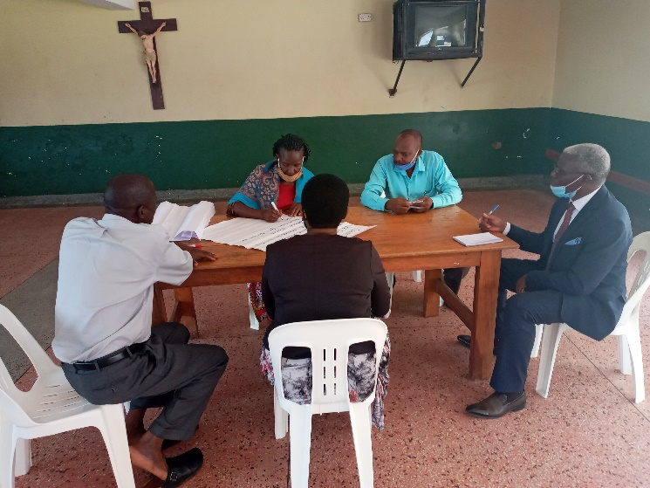
Some of the participants doing group work
Inconclusion, Training Government aided primary school headteachers is a good initiative as we promote inclusive education. However, there are more private schools in this division that require this capacity building. Therefore, Katalemwa requires more funding towards this nature of training to continue promoting inclusive education for all learners.
Compiled by

Basule Barbara
Advocacy and Networking officer

