KATALEMWA CHESHIRE HOME FOR REHABILITATION SERVICES
A BRIEF REPORT ABOUT 4 HOME BASED CARE VISITS CONDUCTED IN NAMAYINGO, KAMULI, MAYUGE AND IGANGA DISTRICTS, JUNE 2021
INTRODUCTION
Katalemwa Cheshire Home has a programme that extends rehabilitation services to vulnerable children with disabilities in communities through Home Based care visits. We conducted Home visits with an aim of reaching out to vulnerable children that are unable to access rehabilitation services and review children that have previously been rehabilitated.
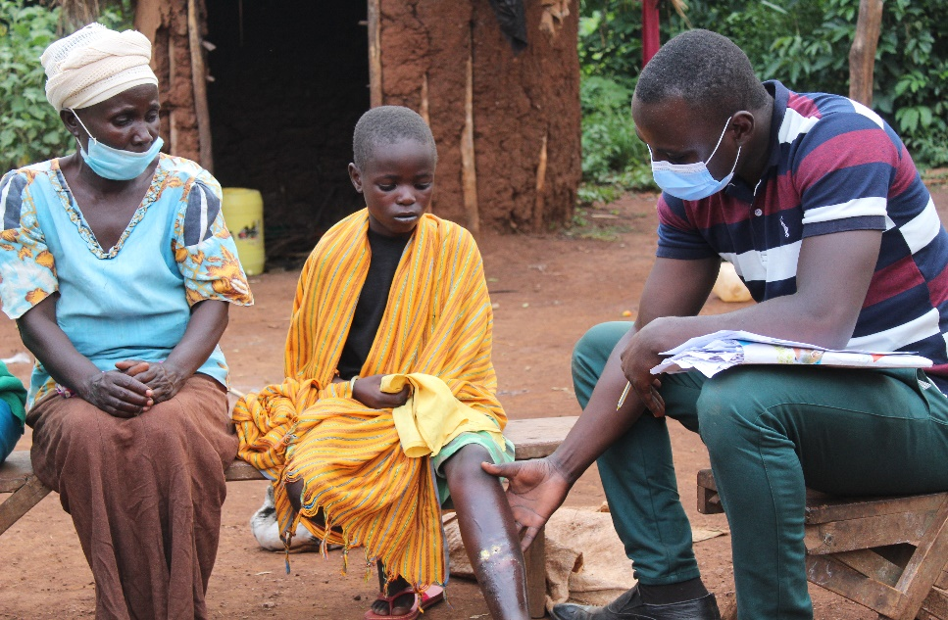
An occupational therapist assessing a child in Namayingo district with osteomyelitis
A field team from KCH comprising of an occupational therapist and social worker visited 29 children with disabilities in the 4 districts of Busoga ( Namayingo, Mayuge, Iganga and Kamuli) and assessed children with hydrocephalus, spina bifida, cerebral palsy, osteomyelitis, epilepsy, visual and hearing impairment.
The Katalemwa Team provided services like reviewing therapy, measuring assistive devices, counseling caregivers, provision of medication and making appropriate referrals to nearby health center and Katalemwa Cheshire Home for further management of their cases.
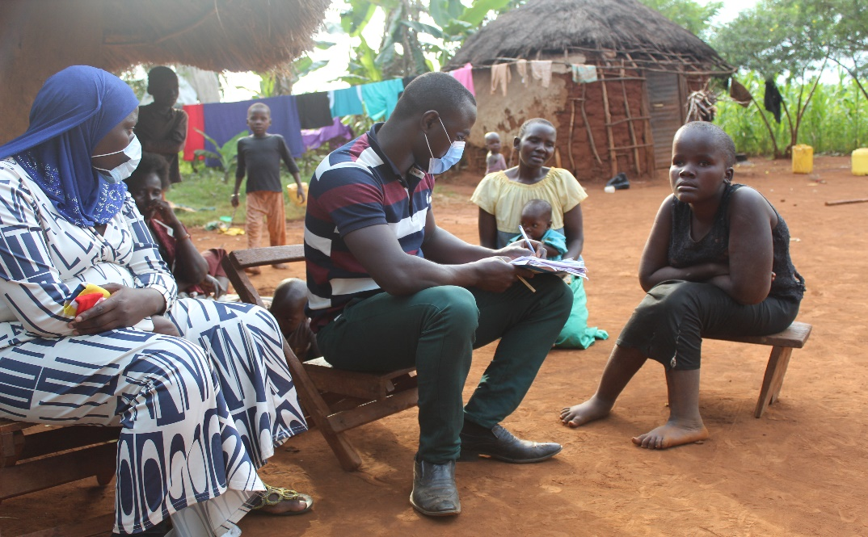
KCH Occupational therapist and social working visiting a family with two children with epilepsy, Namayingo district
Finding from these Home Visits;
- Most of the children with disabilities visited, their caretakers had neglected cases and were living with single parents.
- Children with cerebral palsy were malnourished because parents had minimal information about feeding culture of these children.
- Poor medicine adherence, most children with epilepsy had stopped using their drugs due to the reluctancy of their caretakers.
Inconclusion, the children with disabilities in need of home-based care visits are many however Katalemwa has limited resources to reach out to every child with disability. Most children retard at homes therefore need regular visits to monitor progress. KCH encourages donors to support its programs and enhance its outreach activities for vulnerable children with disabilities in the community
Compiled by
Barbara Basule
Project leader

