KATALEMWA CHESHIRE HOME FOR REHABILITATION SERVICES
REPORT ABOUT ASSISTIVE/APPLIANCE PRODUCTION FOR 100 CHILDREN WITH DISABILITIES
Introduction
Last year in December, Katalemwa Cheshire Home participated in a global giving campaign to fundraise for funds to support the fabrication and production of assistive devices to benefit 100 children with disabilities that are undergoing intensive rehabilitation at the center and school going CWDs. KCH received a half of the targeted amount and we are waiting for additional funds; therefore, we argue all donors to continue donating to this cause so that we can support this vulnerable group of people.
Activity
Katalemwa through its orthopaedic workshop (Metal section) fabricated 10 wheel chairs (3wheeler) that have been delayed to be picked-up by beneficiaries because of the current travel restrictions that have engulfed the country due to the fight against Corona virus. We shall be sharing stories and pictures of the beneficiaries in the subsequent reports after pick up is done.
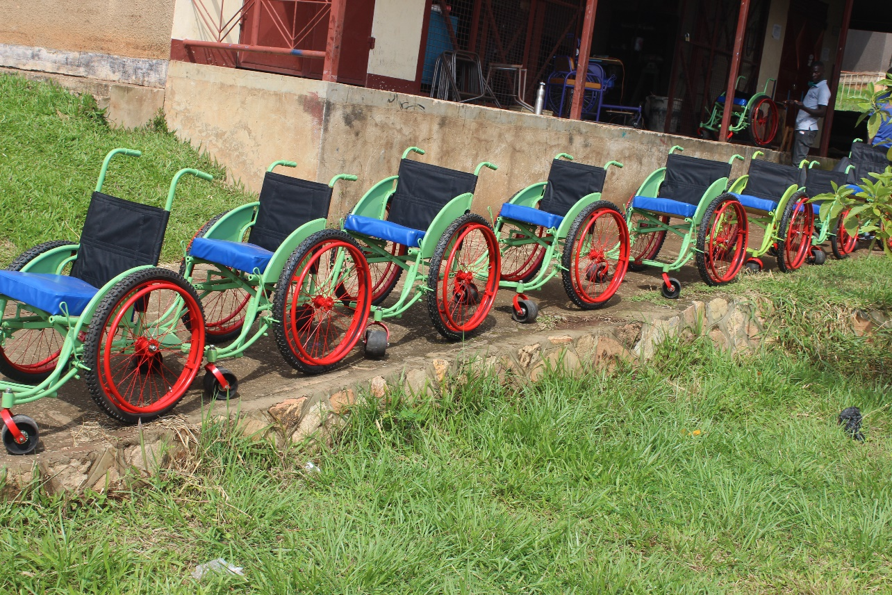
Some of the wheelchairs ready for pick-up
Conclusion, we are waiting for the situation to stabilize so that children with disabilities can be able to come for fitting as well as training in usage of these wheel chairs and this will be done by our orthopaedic technologists.

Thanks
Basule Barbara
Project Leader

