KATALEMWA CHESHIRE HOME FOR REHABILITATION SERVICES
REPORT ABOUT CHILDREN WITH DISABILITIES SUPPORTED TO ACQUIRE ASSISTIVE DEVICES
Katalemwa was supported by donors on the global giving website to enable children with disabilities acquire assistive devices. Our target was to support 100 school going children with disabilities and those with parents that are unable to purchase assistive devices due to their financial status. We utilized these donations to purchase materials that fabricated assistives for the children with disabilities below;
Carol is 7 years old and was born without a one leg. While at katalemwa an artificial limb was fabricated and fitted on her to easy movement. She was previously using crutches; she is excited to walk independently and conveniently with her artificial limb.
Before After
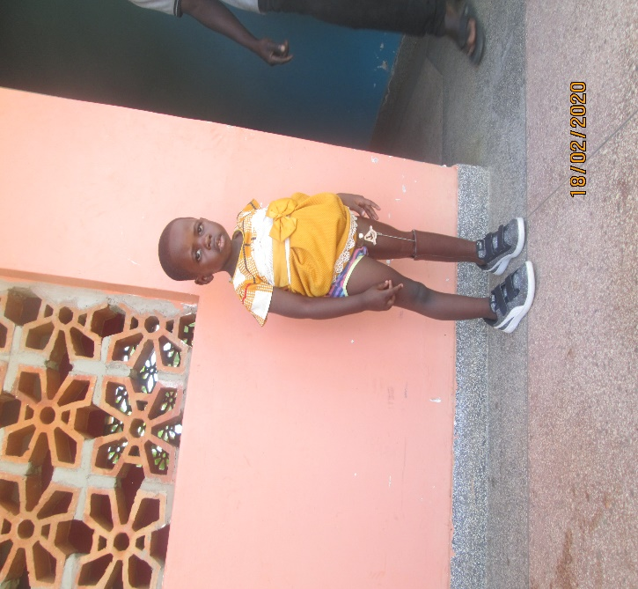
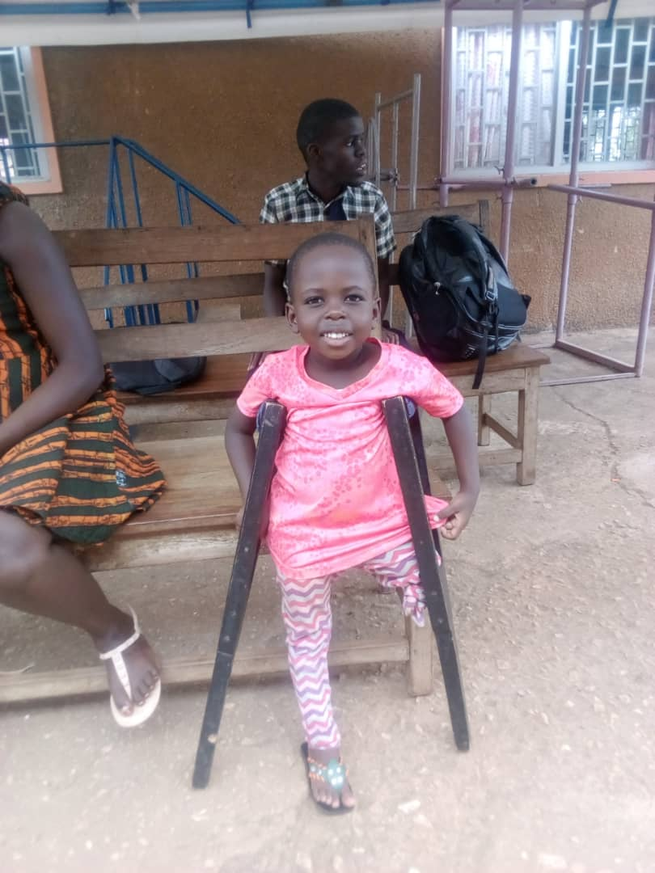

Andrew is 12 years old and has hydrocephalus, he found difficulties moving independently therefore a wheel chair was given to him to aid his mobility. He is grateful about this donation.
Picture of Andrew in a wheel chair
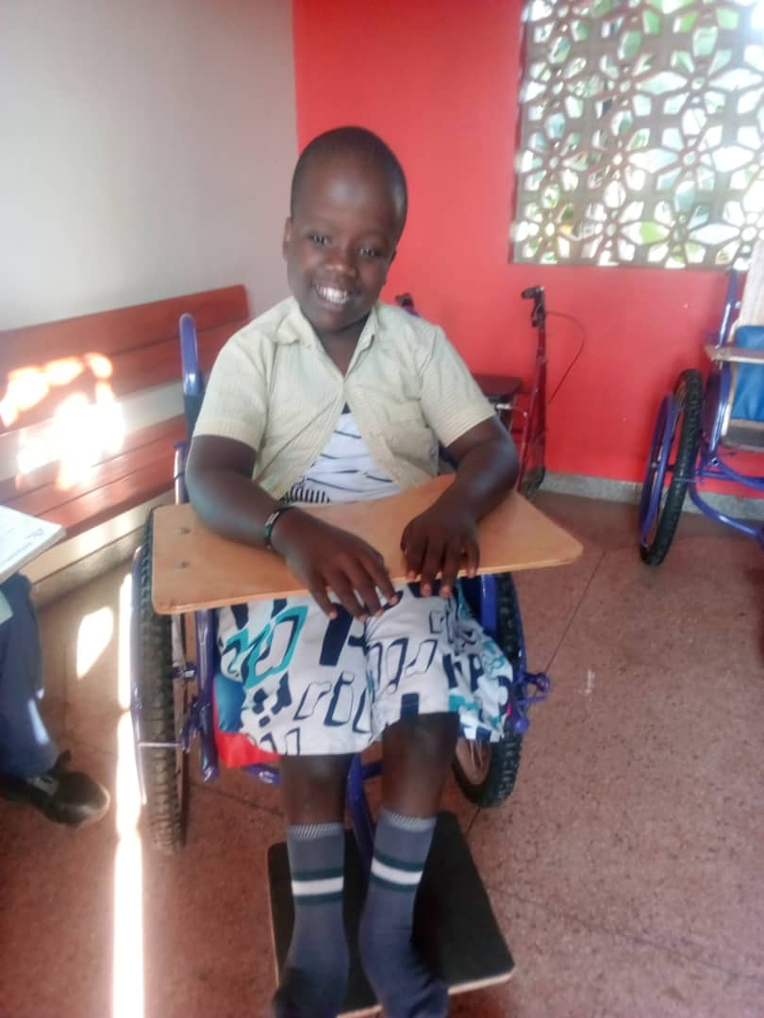
James aged 10 was born without one arm and had low esteem because of his condition. However he was given an artificial arm , this will improve his esteem, confidence and participation in society.
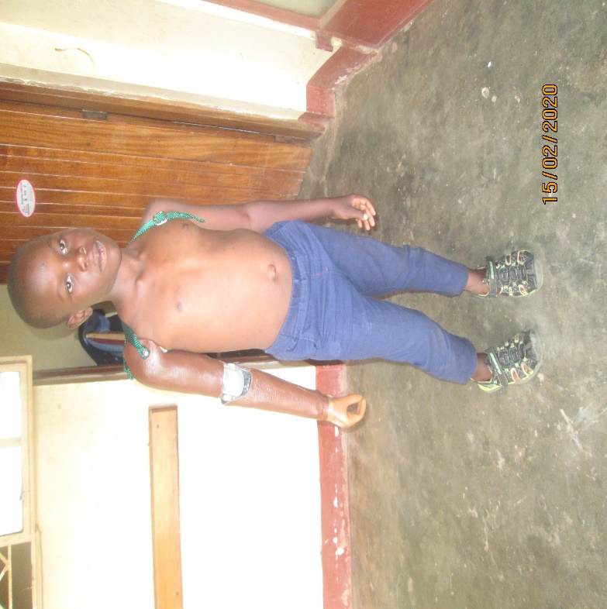
Esther is a school going girl of 15 years old that was amputated due to illness, therefore she used crutched to aid her mobility. She was given an artificial limb with the donations from Global giving. And she is back school, moves independently and she is very excited about the support
Below are the pictures
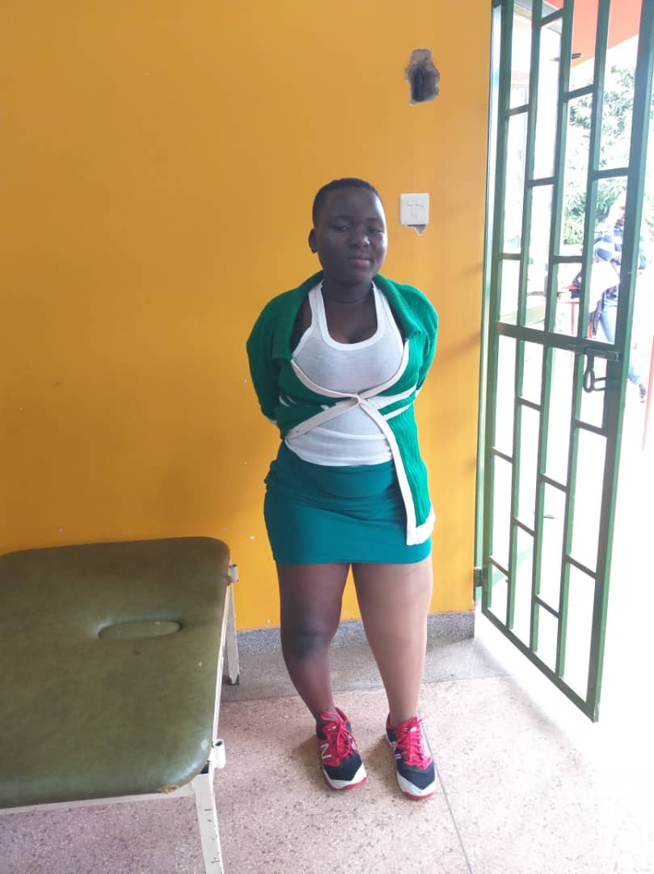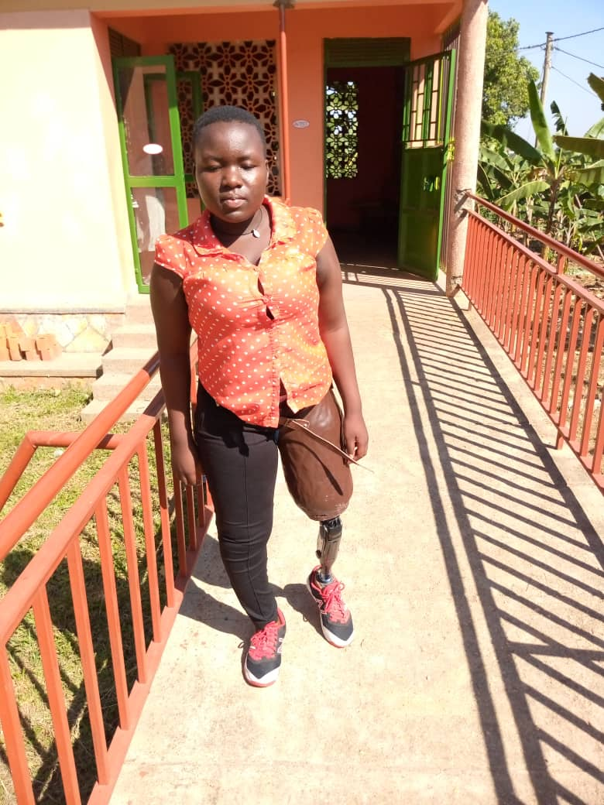
Adam is 2 years old with spina bifida and this caused curving of his feet therefore needed AFOs to regain normal positioning of his feet and these were fabricated for him at katalemwa.
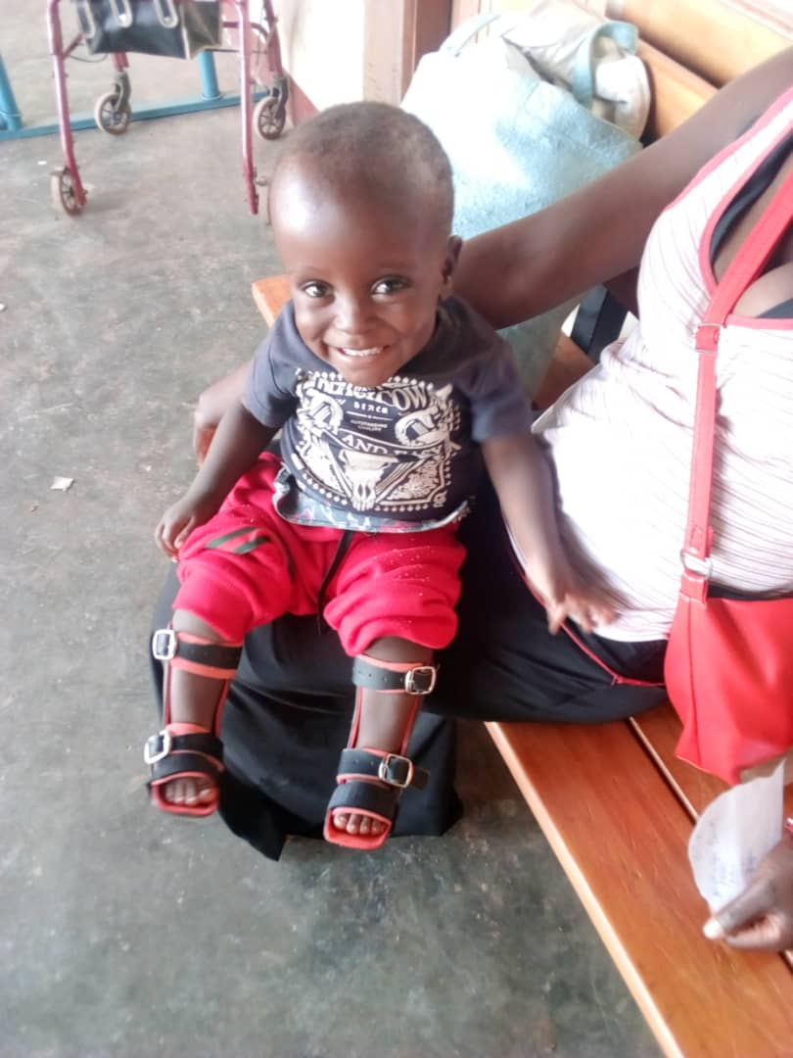

John is 8 years old and moves with crutches, he came to Katalemwa when his crutches were old and worn out therefore, he was given new crutches to support his mobility.
Before after
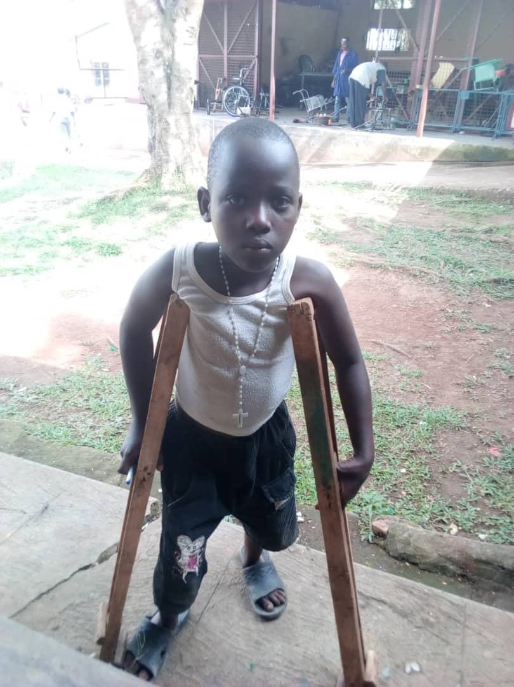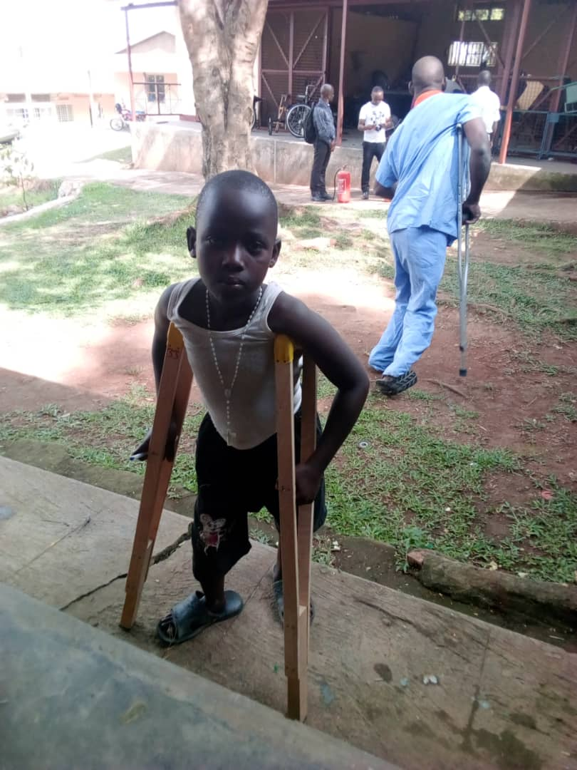
Acilewo is a 4 years old boy with cerebral palsy that affected his mobility, therefore he was given a wheelchair to relieve the caretaker from carrying him and to also assist him to train in sitting.
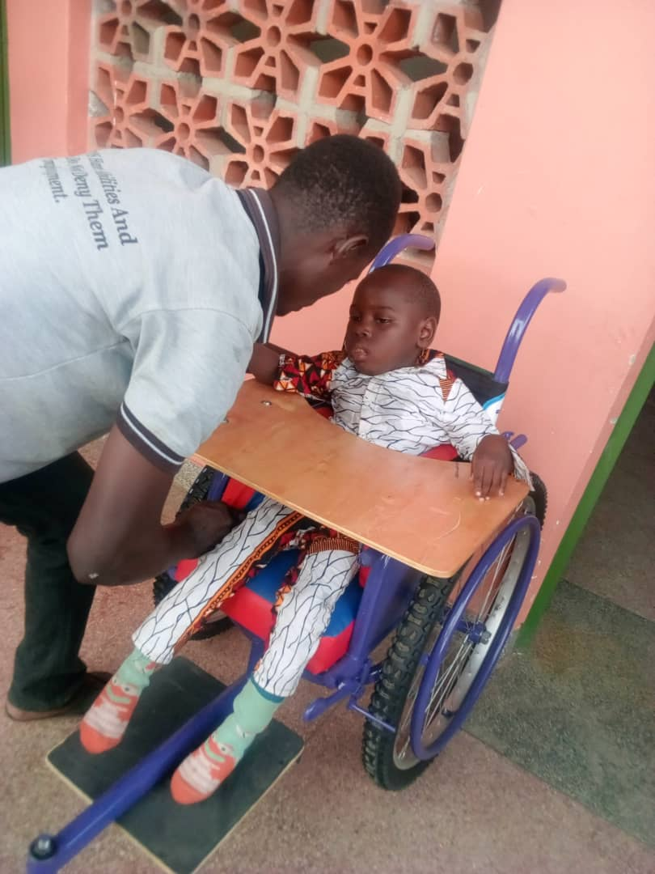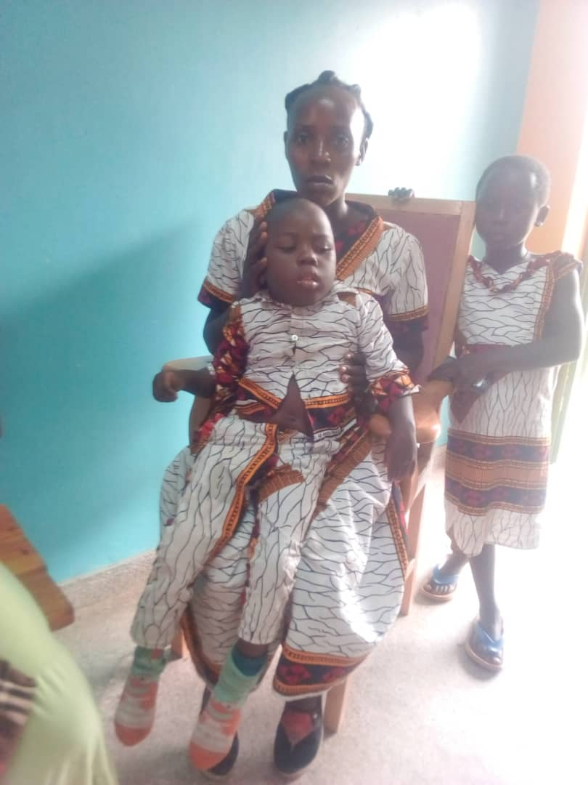
After pictures
Lydia 9-year-old, sustained burn contractures that left her feet deformed, without toes and she couldn’t use normal shoes. While at Katalemwa orthopedic shoes and crutches were provided to aid her mobility
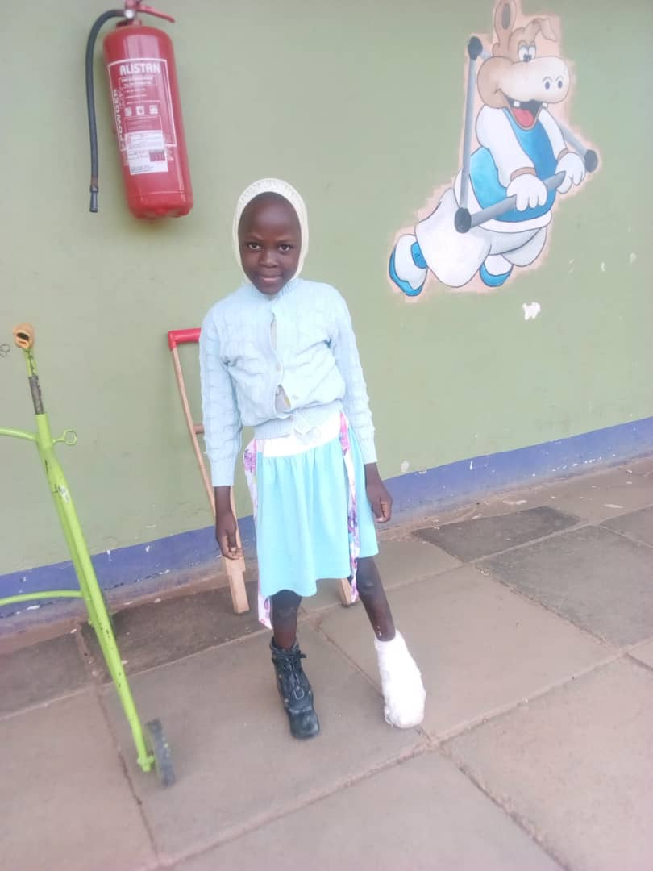
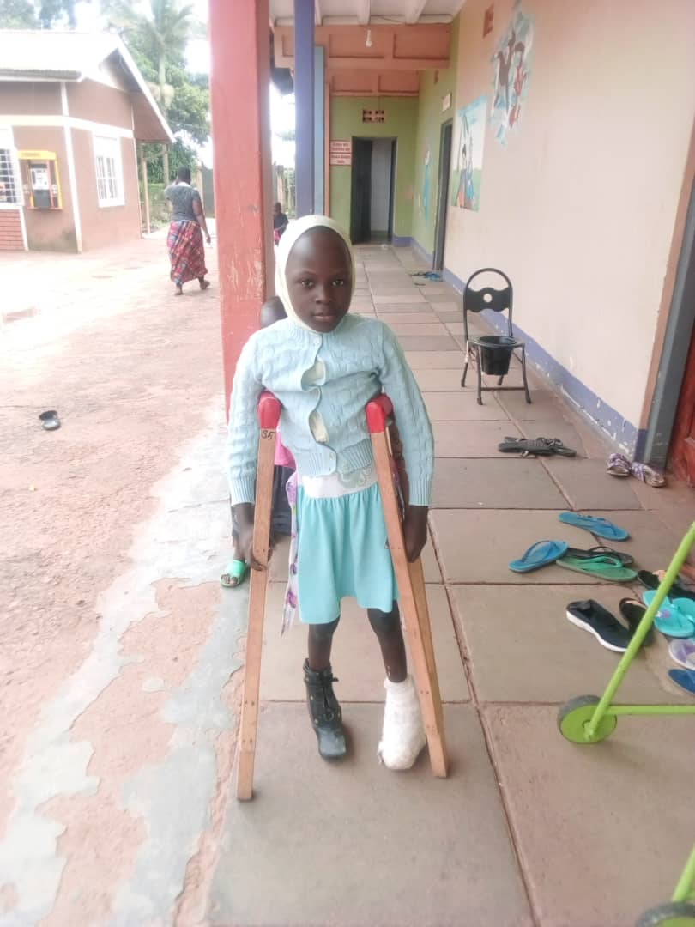
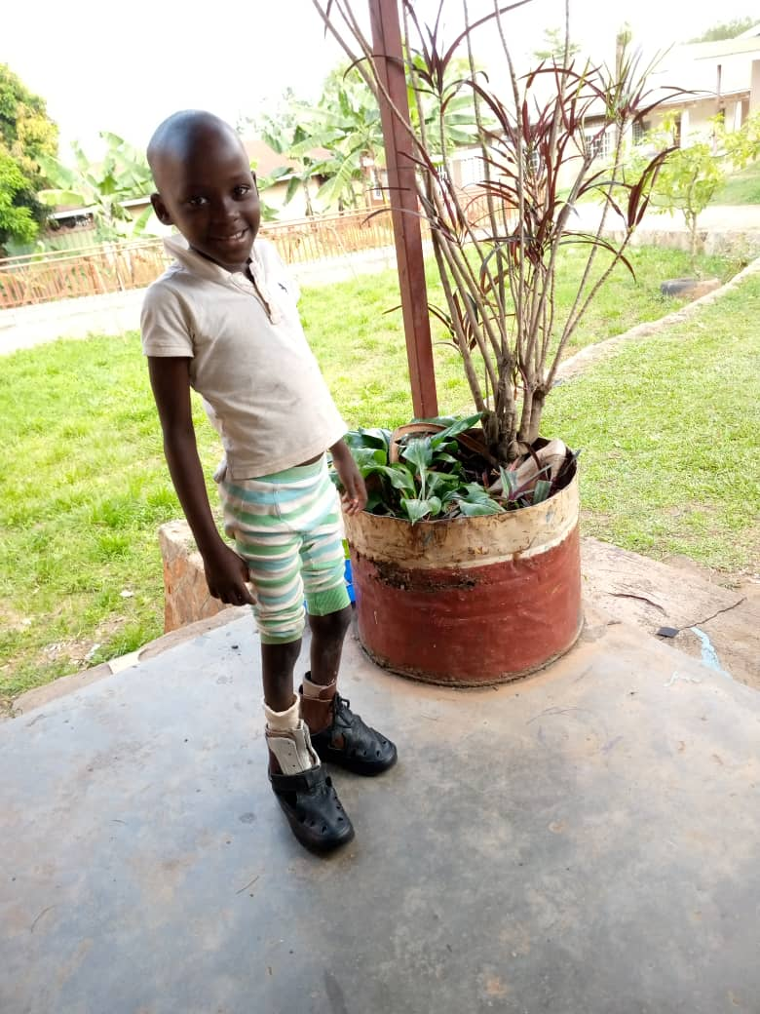
Kato has cerebral palsy that affected his mobility; therefore, he was given a wheelchair to ease movement and also improve on his sitting posture
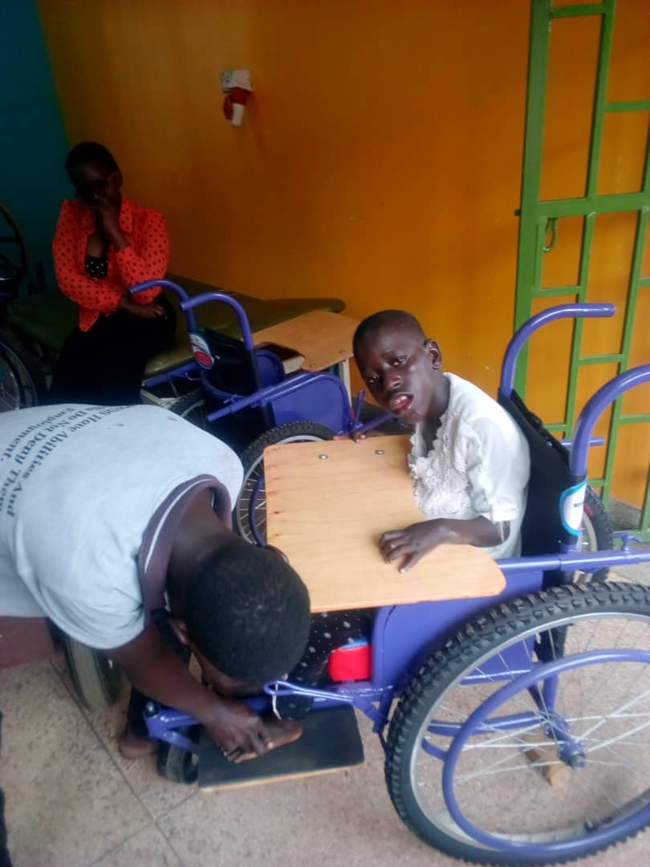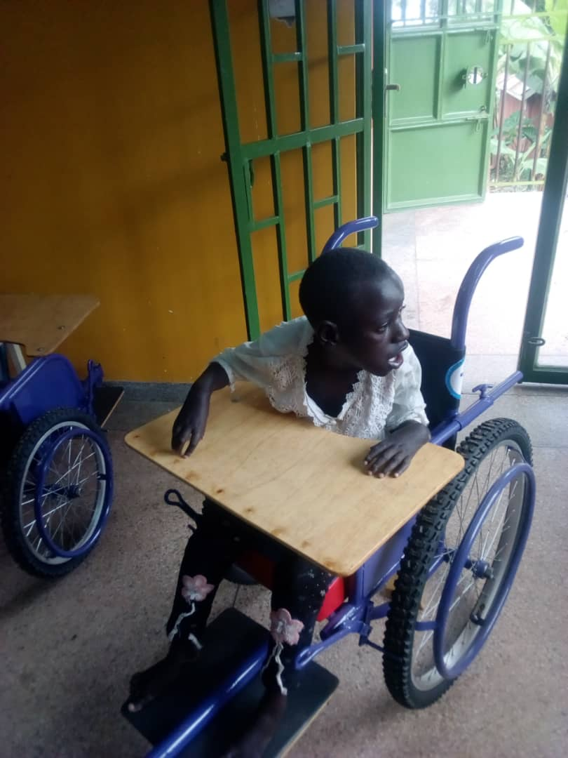
Kato during fitting
Conclusion
We would like to appreciate all our donors for your kind support, you donations have brought smiles to children with disabilities that are rehabilitated by Katalemwa Cheshire Home.
Compiled by
Namudope Barbara
Advocacy and Networking officer

