KATALEMWA CHESHIRE HOME FOR REHABILITATION SERVICES
REPORT ABOUT THE VERIFICATION OF POTENTIAL BENEFICARIES FOR THE VSLA GROUPS FORMED IN BULOPA SUBCOUNTY, KAMULI DISTRICT FROM THE 5th – 7th July 2022
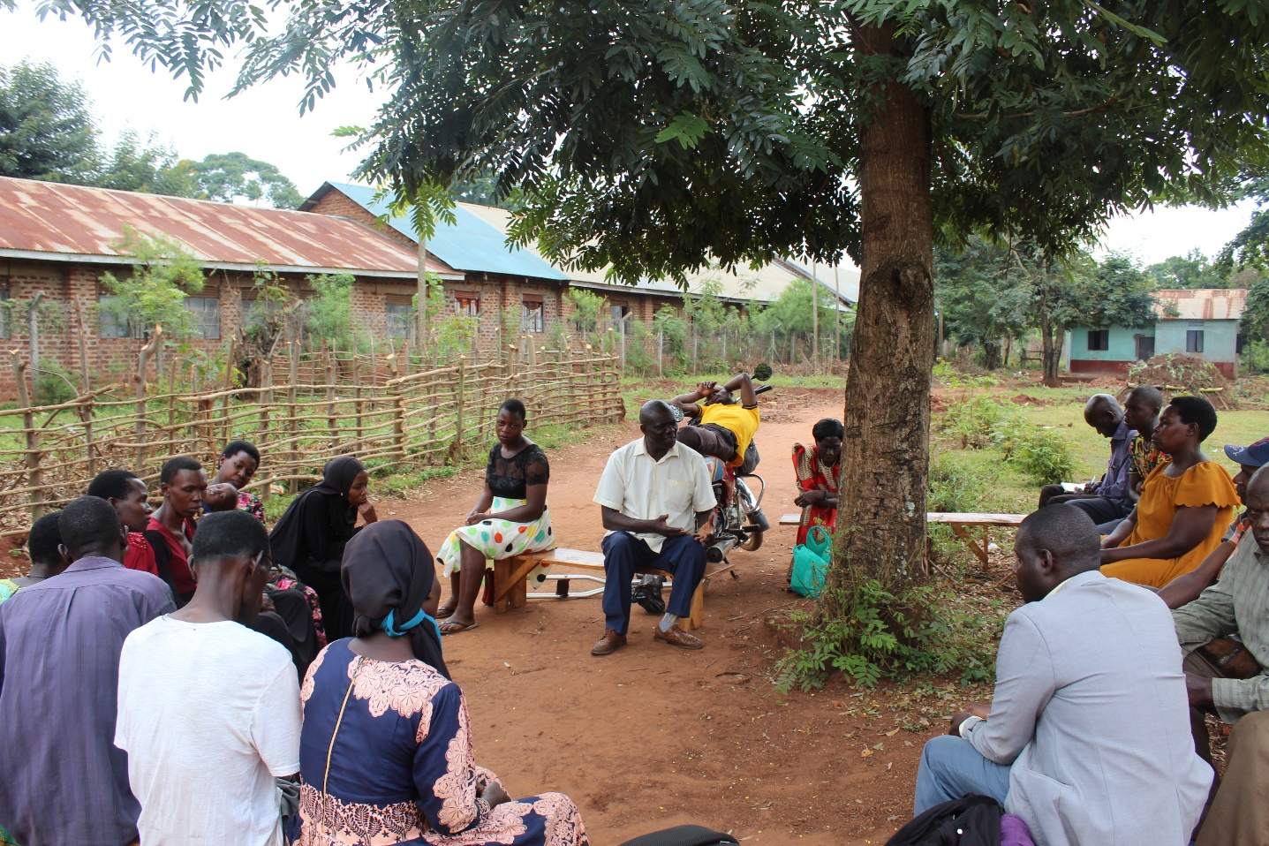
Introduction
Katalemwa Cheshire Home is implementing a CBID project in the Busoga region with support from BMZ/CBM. A mobilization exercise was done to disseminate information about the VSLA Isave model to encourage communities to form VSLA groups in Kamuli District focusing in Bulopa sub county. Therefore, communities voluntarily identified potential beneficiaries amongst themselves and requested the KCH team to verify their prospective groups.
A verification exercise was conducted in Bulopa sub county, Kamuli district from the 5th to 7th July 2022 on the prospective members that expressed interest to start up VSLA Isave model groups. The verification exercise was done in collaboration with the chairperson of the Kamuli District Union for persons with disabilities.
Objective
- To assess the suitability of propestive members to VSLA Isave groups formed.
- To ensure that the prosposective VSLA groups match with the Isave model standards/criteria.
Activities
Verifcation exercise
This involved potential group members providing personal details like names, age, condition/disability and the catergory they would prefer to belong too in the group. Persons with disabilities were assessed by the representative from the District union to ensure that they quality under that catergory
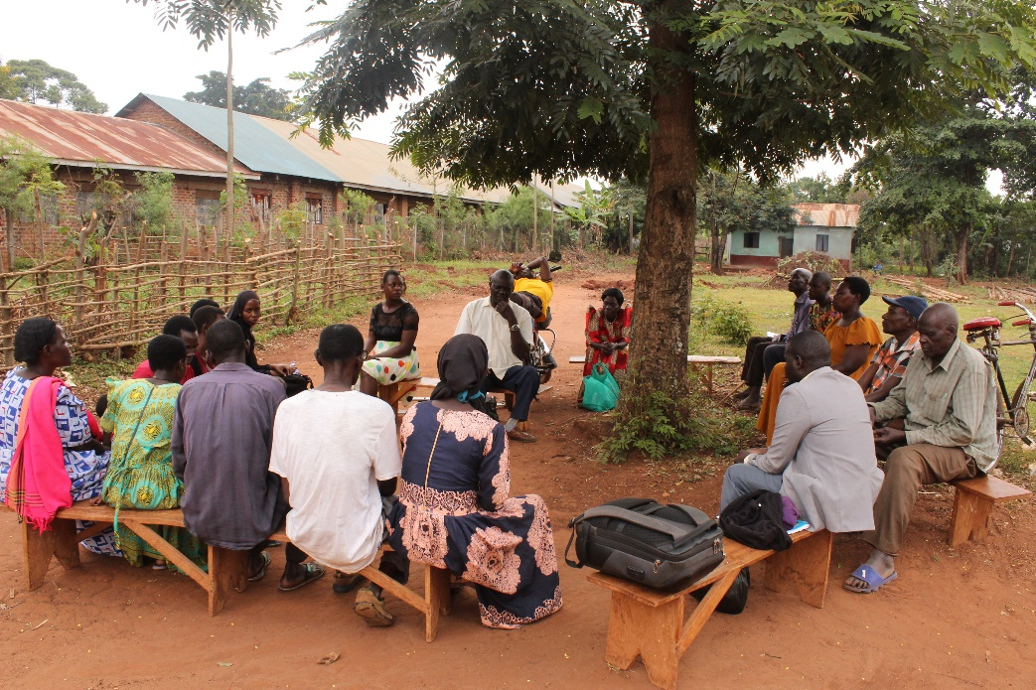
Potential VSLA group members attending the verification exercis, Bulopa subcounty Kamuli district
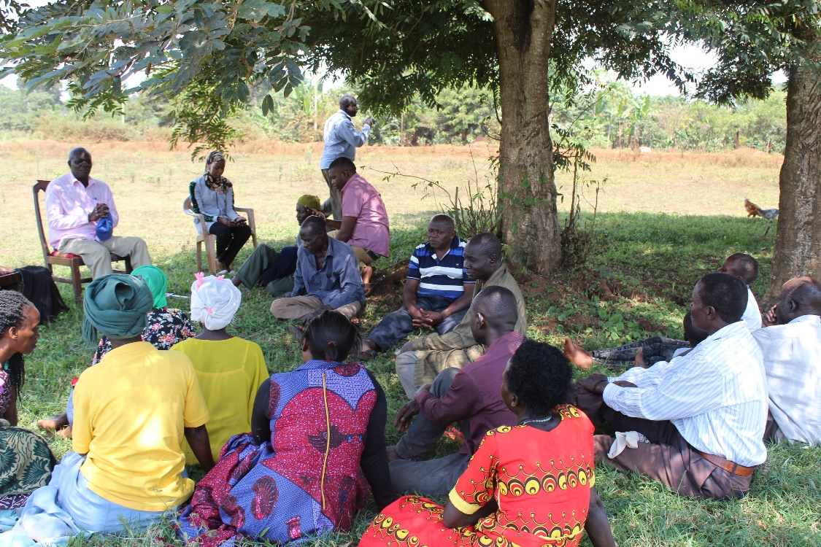
Potential VSLA group members attending the verification exercise, Bulopa subcounty Kamuli district
From this exercise, 3 groups were verified with 75 members from the Bulopa town council and these met the selection criteria for the VSLA Isave model groups of 60% PWDs, 25% caregivers of children with disabilities as well as 15% well-wishers.
These 3 verified groups will be engaged in trainings on leadership, election, savings, social fund, share purchases, credit policies, development of association constitution after which they will commence savings in the 5th week of the cycle.
Presentation about the VSLA Isave model
The field team shared more information about the Isave model operations like saving criteria, consistitution development, success stories of the isave groups and Katalemwa’s start up contribution towards these groups. And the prospective members asked questions and these were responded too accordingly.
Achievements
3 VSLA groups were verified and await for more training and support before the saving phase starts.

Challenges
- Misinformation about the starting time of the verifcation meeting affected the starting time of the exercise, therefore the field team waited for members to gather hence consuming time.
- Community ceremonies also affected the meetings as people were rushing to attend a burial ceremony.
Conclusion
The 3 groups that were verified in Bulopa subcounty will be supported by the KCH social worker and be linked to the NUDIPU field officer that is implementing the same project in other subcounties in Kamuli district. And these will be supported to form stable and long lasting groups.

Compiled by

Namudope Barbara
Project Officer

