KATALEMWA CHESHIRE HOME FOR REHABILITATION SERVICES
CASE STORIES OF CHILDREN WITH DISABILITIES SUPPORTED WITH WHEEL CHAIRS
Katalemwa Cheshire Home has an orthopedic workshop but often times parents of children with disabilities are unable to meet the cost of purchasing these appliances. Therefore, your donations contributed towards the purchase of materials to fabricate assistive devices for the needy children that required wheelchairs and below are the case stories
Sarah (Not real names) is a 8 years old girl with Hydrocephalus, this condition was detected at birth and she sought for Medical attention at Cure Hospital Mbale, here she received surgery. However, the family didn’t continue with rehabilitation because of some financial challenges therefore the child acquired some deformities/contractures. She was identified during a Home-based care conducted by our field staff that referred her to Katalemwa for further management of her condition. During her stay at KCH, she received a wheel chair and has been undergoing numerous exercises to improve her functionality. Apparently, Sarah has improved, she is able to make a few movements, interacts with people and the family is happy about this support. The mother appreciates all the support rendered to her child and she is confident that her child will be able to perform some activities independently with time like feeding. She feels relieved of the burden to carry her all the time because of the new wheel chair she received.
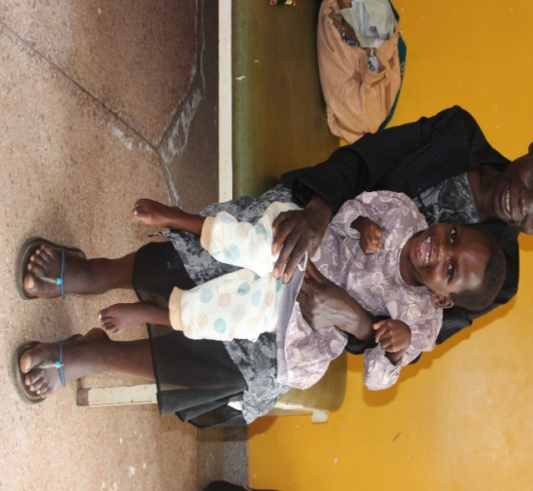
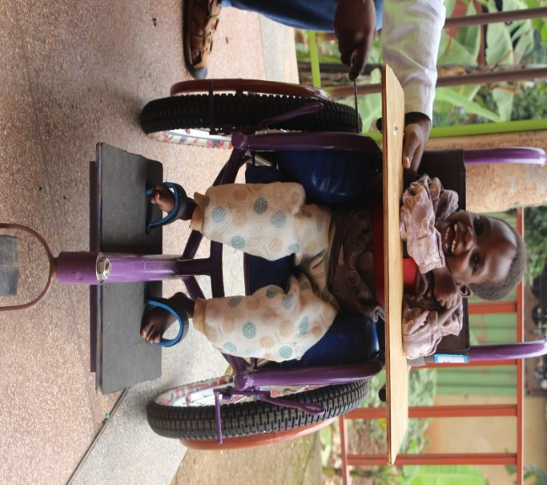
Before After
Annet (Not real names) is 8years old with Cerebral Palsy living with her grandmother in Kiboga District. She was identified during an outreach clinic that was conducted by our medical team in that area. She was abandoned by her parents after discovering that she had a disability and needed extra care. Cecilia was malnourished and the grandmother wasn’t aware of rehabilitation services. At the Outreach clinic, she was referred to Katalemwa for intensive rehabilitation, while at Katalemwa, she was enrolled on nutritional therapy, occupational therapy and the grandmother was taught some exercises that she needs to perform on Cecila. She was also given a wheel chair to aid the movement of the child. With the exercises conducted, Annet can move her hands and limbs, interacts with people. The Grandmother is happy about the support rendered to Cecilia, feels relieved of the burden of carrying the child all the time and hopes to continue performing exercises she has learnt to avoid further deformities.
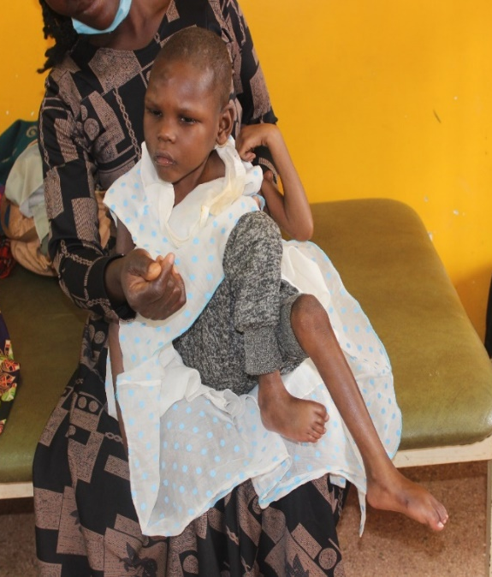 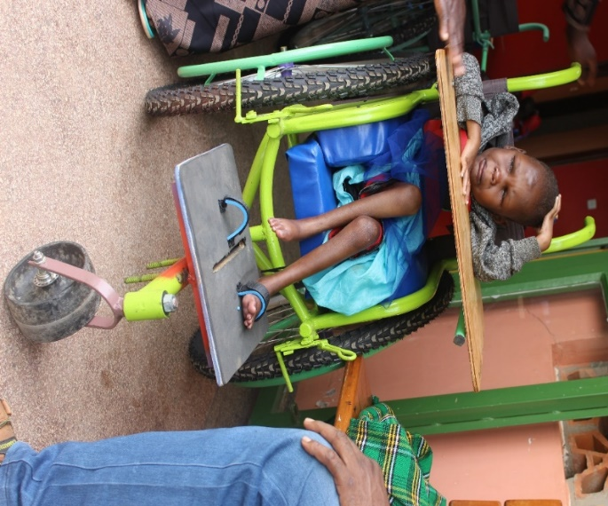 before after
Conclusion; We encourage our donors to continue supporting more children with disabilities to access assistive devices to improve their functionality, mobility, participation and independency.
Complied by Basule Barbara
Program Leader

