KATALEMWA CHESHIRE HOME FOR REHABILITATION SERVICES
REPORT ABOUT A RADIO AWARENESS RAISING ACTIVITY CONDUCTED AT EASTERN VOICE FM 102.2 ON THE 25TH MARCH 2022.
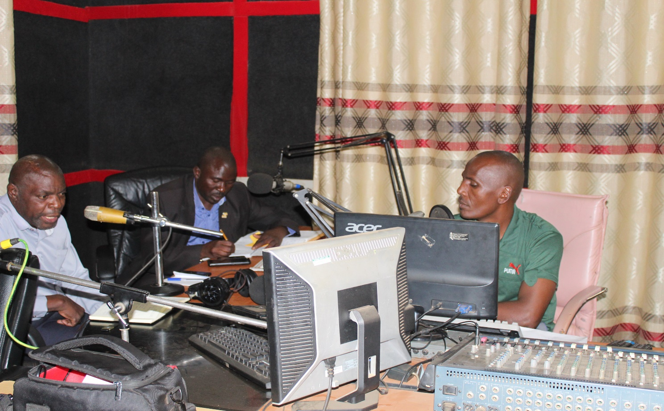
INTRODUCTION
Katalemwa Cheshire Home is implementing a community based inclusive development project in the Busoga sub region covering districts like Namayingo, iganga, Mayuge and Kamuli. Awareness raising on media is one of the activities under the BMZ project. Therefore, KCH staff together with the Namayingo district councilor for PWDs and the Iganga District Community Development Officer conducted an awareness raising on Eastern Voice FM 102.2 in Bugiri District for one hour. During the programme, the KCH staff shared about services offered by KCH and the BMZ activities in the 4 districts. The other two panelists shared extensively about the parish development model were Government support will be extended to parishes to promote agricultural value addition, collective marketing and boast agriculture produce. They also highlighted on the other grants at the district that PWDs can benefit from like the Disability grant, UWEP (Uganda Women Entrepreneurship Programme) and the Youth livelihood support. The panelists encouraged persons with disabilities and their caretakers to subscribe to the Parish Development model arrangement at parishes in order to improve on their incomes.
Aim
- The aim of this activity was to create awareness about the Parish Development Model which is an approach by Government to improve household incomes.
- To disseminate more information about the BMZ project activities and services in the community.
Radio Script
The radio programme was attended by the Katalemwa project officer, a councilor representing persons with disabilities at Namayingo district and the Iganga district community development officer.
Below is the radio programme
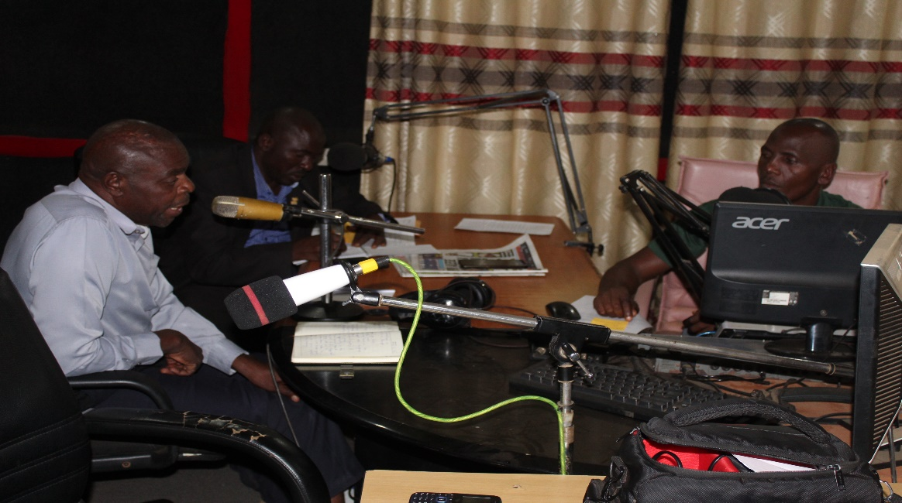
Guide questions
- Self-introductions of the panelists
- Brief background of Katalemwa Cheshire Home (Highlighting services and programmes for CWDs) – Barbara
- Tell us briefly about the BMZ project that is being implemented in the Busoga sub region – Barbara
- What programmes does Iganga district local government have for persons with disabilities – Mr. Batuuka.
- How can persons with disabilities benefit from the parish Development model – Mr. Batuuka
- Are persons with disabilities benefiting from some of these government programmes in Namayingo district – Mr. Bwire
- Where and how can persons with disabilities access funds of the parish development model. Mr. Bwire
Call in from the Audience
Below are some of the questions that were asked by the audience and they were responded too accordingly by the panelists.
      - Will other Government programmes that have been running at the district stop with the introduction of the Parish development Model?
      - What is the difference between Emyoga and the Parish Development Model
      - Will the Parish Development Model also involve group savings?
Conclusion from the panelists
The Panelists encouraged persons with disabilities to engage in the parish development model which is an economic boast from Government and the parish administrations to support persons with disabilities in acquiring this support.
Compiled by Namudope Barbara
Project Officer

