KATALEMWA CHESHIRE HOME FOR REHABILITATION SERVICES (KCH)
PROJECT PROGRESS REPORT

PROJECT DETAILS
Project Number | 44124
Project Title | Supporting 100 Children with disabilities access assistive Devices
City/ Country/ Region | Central Uganda Districts.
Reporting Period | January -June 2023
Report submitted to | GLOBAL GIVING PROGRAM TEAM
Report Submitted by | Amasse Jackline Ogalai
Designation | Program Officer -Advocacy
Email Address | jmercita0@gmail.com
Date of Submission | 22nd June 2023

- INTRODUCTION
Katalemwa Cheshire Home (KCH) is a development-oriented non-governmental organization (NGO) with more than 50 years of working for children with disabilities and their families. KCH is motivated by a deep commitment to providing holistic rehabilitation services to children with disabilities and their families.
KCH’s programs promote access to rehabilitation services for children with disabilities including Medical and social rehabilitation, psychosocial support, fabrication and production of assistive devices, Education and Skills Development, and Livelihood support. KCH’s work also focuses on community empowerment, capacity building of partners, partnership, advocacy and networking, Research & documentation.

This narrative report gives an overview of the activities that were implemented by KCH under the Community-Based Rehabilitation Program (CBR) to promote access to assistive devices by children with disabilities in Central and Eastern Uganda. The report also highlights the key achievements of the program, challenges faced during the implementation in the reported period, lessons learned, and recommendations

- OVERVIEW OF THE KCH COMMUNITY-BASED REHABILITATION (CBR) PROGRAM
KCH employs Community based rehabilitation (CBR) approach to sustain its services in the communities and demystify the negative attitudes and beliefs associated with disability in these communities.
With the limited number of disability rehabilitation facilities in Uganda especially in hard-to-reach areas, coupled with the high costs of accessing these services, a very small number of children with disabilities are able to access and utilize rehabilitation services including access to assistive devices. KCH bridges this gap by taking free services closer to its beneficiaries in these hard-to-reach communities. These community-based services included; community awareness and sensitization events, capacity-building training in disability-related issues, Advocacy Dialogue meetings, Community Health camps, and home-based care services. Annually KCH reaches approximately 1,200 children with disabilities through its community interventions
Through this approach, KCH also enhances the capacities of households of persons with disabilities, and other community structures including Health facilities, community DPOS, Local NGOs, and local council structures, to manage disability-related issues. Additionally, the program advocates for disability mainstreaming in community mainstream programs. Building the capacity of community members and structures has decreased rehabilitation care and support costs in the long run for people with severe to moderate disabilities. Thus, improving health, well-being, and quality of life outcomes for persons with disabilities and their caregivers.
  - OVERVIEW OF THE COMMUNITY-BASED REHABILITATION ACTIVITIES IMPLEMENTED IN THIS REPORTING PERIOD
In this reporting period, KCH engaged the communities of Central and Eastern Uganda through the following activities;
    - COMMUNITY HEALTH CAMPS
To increase access and utilization of disability assistive devices by Children with disabilities in the selected districts of East and Central Uganda, KCH organized 6 community Health camps in 6 districts of these two regions. A total of 343 (177 male; 166 female) children with disabilities were assessed and provided with appropriate services including taking measurements, fitting, and training on the use of assistive devices.
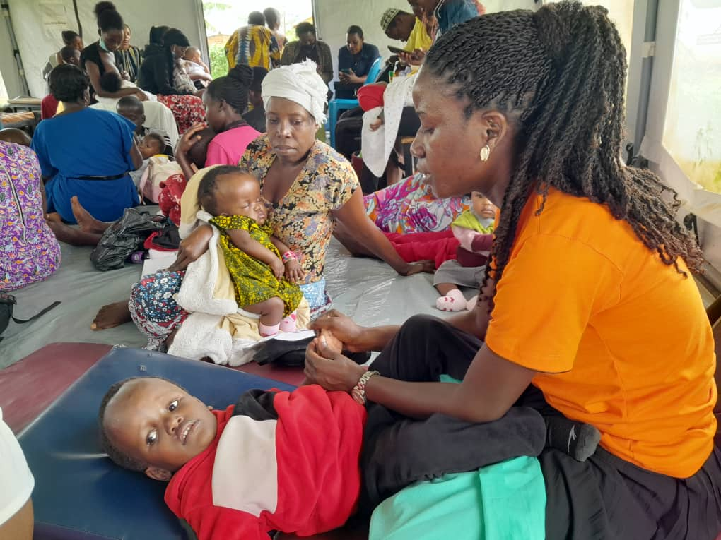
KCH senior OT performing therapy on a child in a health camp organized in Mubende district

Objectives of Organizing the Health Camp
- To increase community awareness of childhood disability including disability management
- To assess the rehabilitation needs of children with disabilities in the selected community including the need for assistive devices and provide appropriate services
- To follow up on Children with disabilities from the respective districts who received assistive devices from KCH
- To Build the capacities of community health workers to assess Children with disabilities, provide appropriate rehabilitation services and make appropriate referrals
- To build the capacities of caregivers on disability management using locally available materials

Activities Carried Out in the Health Camp

- Disability Health education: Parents/caregivers of children with disabilities and other community members were educated on childhood disability. Information was provided on types of disabilities, their causes, prevention, and management. The importance of early identification and interventions was emphasized. Information on institutions that manage different disability conditions was also shared with the community, KCH being one of the institutions.

- Assessments for assistive devices and other medical rehabilitation needs: All children with disabilities were assessed to ascertain their medical rehabilitation needs and based on the need they received a range of services including;
- Measurement of children for assistive devices, fitting and training on assistive devices usage, repairs of previously issued assistive devices
- Provision of therapeutic service (occupational therapy, physiotherapy, counseling.
- Provision of drugs especially anti-epileptic drugs to epileptic children
- Training caregivers on how to perform therapies
- 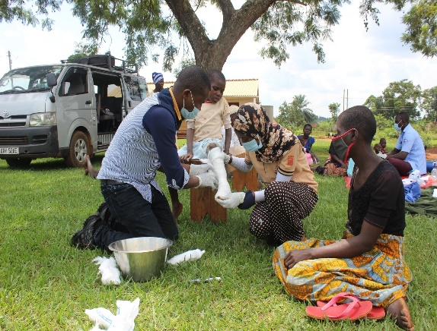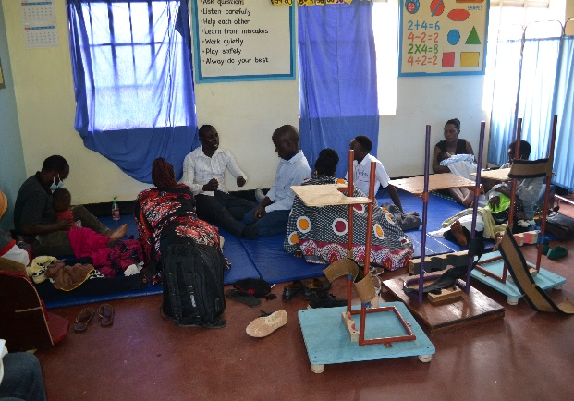
Health camp activities in Iganga and Mubende districts
Referrals: children with disabilities that came with conditions that needed further management or specialized services like ENT services, surgeries, and assistive devices were referred to different facilities for appropriate management. Referrals were made to KCH for appliances, to CORSU for surgeries, and to other health facilities for other medical medications

Table showing the number of children with disabilities reached through the Health Camps in six Districts of East and Central Uganda
District | Children seen |  | Total No. seen per District
 | Boys | Girls
Mubende | 21 | 20 | 41
Iganga | 26 | 46 | 72
Mayuge | 47 | 43 | 90
Mukono | 28 | 17 | 45
Nakasongola | 31 | 22 | 53
Mityana | 24 | 18 | 42
Total | 177 | 166 | 343
Out of 343 Children and youth with disabilities seen in these Health camps, 62% (213); 110 males and 103 females required at least one type of assistive device.

  - HOME-BASED CARE
The monthly target of KCH is to visit at least 20 children with disabilities, especially those under the care of grandparents and those from financially disadvantaged families, to provide rehabilitation care and support. In this reporting period, KCH was able to visit at least 73 (43 male: 30 female) children with disabilities from their homes. During Home visits, a number of activities were carried out including assessment of the home environment and providing necessary adaptations, repair of assistive devices, provision of drugs especially antiepileptic drugs, provision of therapeutic service, counseling and training of caregivers in rehabilitation care, sensitization of household and community members to improve their participation in the rehabilitation.

Objectives of Home-based care
The objectives of Home-based care are quite similar to those of the health camp, the only difference is that in Home-based care, a single household is reached as compared to the entire community in reached during the Health camp.
The objectives included;
- To follow up on children that received treatment and appliances from KCH and provide appropriate services including repairs and adjustments of assistive devices.
- To increase access to rehabilitation care by reducing costs associated with transport
- To increase the participation of households of children with disabilities in the rehabilitation processes of their children.
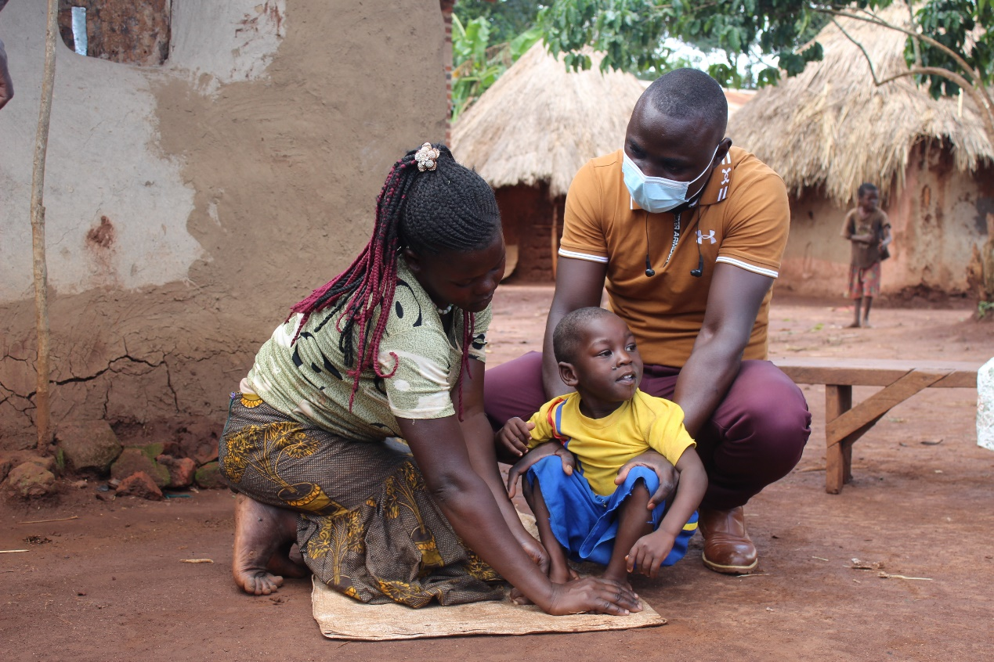
A mother is shown how to perform therapy on her child during one of the home visit sactivity in Iganga District

Table showing the number of children with disabilities reached through Home-based care in nine Districts of East and Central Uganda
District | Children Seen
 | Girls | Boys | Total No. of children seen
Mubende | 2 | 2 | 41
Iganga | 3 | 9 | 12
Mayuge | 5 | 8 | 13
Masaka | 5 | 2 | 7
Kampala | 4 | 6 | 10
Wakiso | 2 | 6 | 8
Kayunga | 4 | 2 | 6
Jinja | 2 | 5 | 7
Nakasongola | 3 | 3 | 6
Total | 30 | 43 | 73

  - Community empowerment through training, meetings, and Dialogues
KCH engages Community members, and decision-makers continuously through training and meetings to increase their knowledge of the existing disability problems and their roles in defending the rights of children with disabilities. In this reporting period, KCH organized 3 community dialogue and awareness creation meetings in 3 districts of Eastern Uganda: that is Mayuge, Iganga, and Kamuli districts, reaching a total of 240 community members including community leaders.
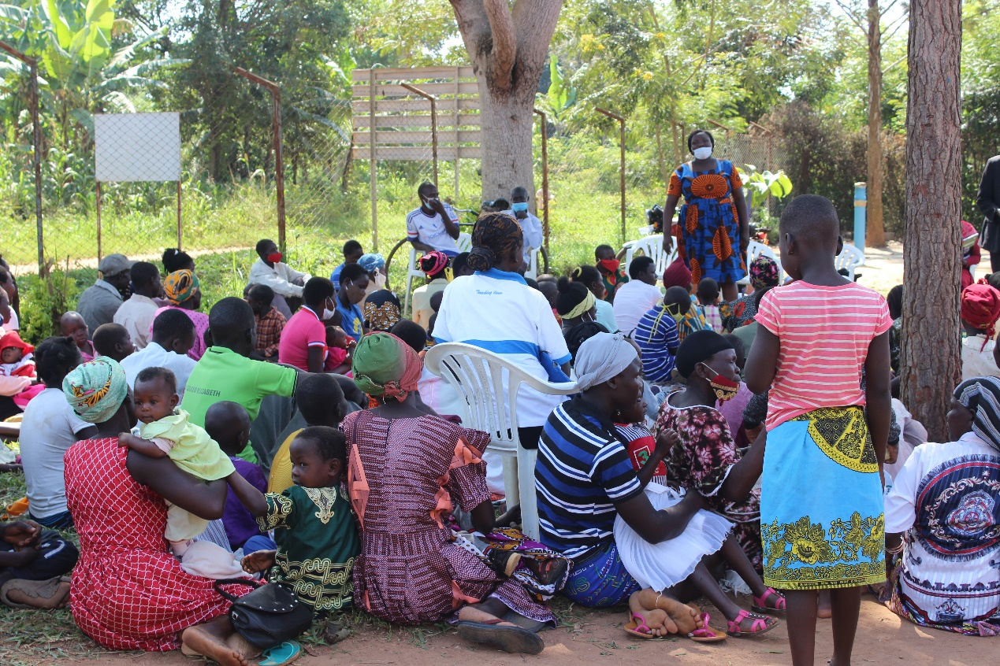
Community Sensitization on childhood disability in Mayuge District in Eastern Uganda

ACHIEVEMENTS IN THE REPORTING PERIOD
- Increased community awareness of childhood disability in the districts of intervention.
- Increased number of children with disabilities referred to KCH for rehabilitation services from the selected districts after the activities
- Increased participation of community leaders in disability rehabilitation; this is witnessed through the number of referrals made by community leaders of the intervention areas

CHALLENGES FACED IN IMPLEMENTATION IN REPORTING PERIOD

- Even with the subsidized costs of assistive devices produced by KCH, most parents still can’t afford to contribute towards the recommended assistive devices
- Some CWDs failed to turn up at the health camp due to a lack of transport to reach the venue despite the fact that the activity was organized in their proximity.
- The disability condition of some children received at the health camps had become complex due to late interventions
- Negative attitudes and beliefs against people with disabilities that still exist in these communities significantly hamper turn-up for these community activities
- Limited funding that confines the scope of the program

LESSONS LEARNED:

- Working with village health workers empowers them to respond to disability-related issues and increase community awareness, thus improving community attitudes.
- Community leaders and organizations are very receptive and willing to promote disability inclusion, the challenge however is that they lack knowledge on how to streamline disability in their programs.

GENERAL RECOMMENDATIONS

- Continue with resource mobilization to facilitate a considerable percentage of Children with disabilities from very Vulnerable households to have access to free disability rehabilitation services including assistive devices.
- Increase the coverage of community health camps and home-based care to extend rehabilitation services closer to Children with disabilities in other districts.
- Conduct more awareness-raising events in the communities to increase knowledge on childhood disability, especially on prevention and the need for early interventions.
- Build capacities of more community resource persons to follow -up on children seen in these community activities

CONCLUSION
The gap between the number of children in rural communities accessing rehabilitation care services and those in urban settings is still big; as earlier noted this is caused by limited rehabilitation facilities in the communities and other associated costs of accessing these services. KCH’s Community-based rehabilitation program has the potential of reaching more children with disabilities in these rural communities with extra financial support.

