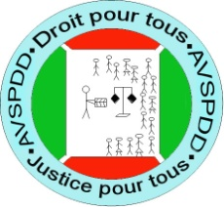
ASSOCIATION OF VOLUNTEERS FOR AWARENESS, PROMOTING RIGHTS AND SUSTAIBLE DEVELOPMENT, AVAPRSD
Ord. Min. :530/ 1123 Du 25 Juillet 2017

NARRATIF REPORT OF DRINKING WATER SUPPLY PROJECT AT RUGERO I FUNDMENTAL SCHOOL

FROM DECEMBER 2019 TO FEBRUARY 2020

Name of the Partner Organisation: | Association of Volunteers for Awareness, Promoting Rights and Sustainable Development (AVAPRSD in English)  Association des Volontaires pour la Sensibilisation, Promotion de droit et de Développement Durable, AVSPDD (in French)
Country : | Burundi
Activity’s periods : | December to February 2020
Name, Mail, and phone of the Responsible of the Report | Name : NSHIMIRIMANA Jean Paul  Email : jeanpaulnshimi@gmail.com  Tél : +25771569415

February 2020

- REMERCIEMENTS
Many Geetings from AVAPRSD
We have been getting your valuable generous support through GlobalGiving and we are thankful to you from the core of our heart and we wish you happy New Year 2020.
We are glad to share the Great news! We are very proud to have been recognized as a Permanent Partner of GlobalGiving Foundation and been vetted in 2020 once again on GlobalGiving. Thank you Team GlobalGiving for your Guidance and valuable support over this first semester of the year 2020.
Huge thanks to all of our Supporters, Donors, Friends and Friends of Friends who made this possible. We couldn’t accomplish any of this without your support. The achievement has a significant share of the Honorable Donors because their support enables us to work fast, efficiently and effectively for the drinking water supply at Rugero Basic School. Hence, we give many and many thanks to GlobalGiving Foundation and the Respected Donors.
We also congratulate the team of AVAPRSD or AVSPDD, together it is possible! We assure you the organization will be contributing its best for the drinking water supply at Rugero Basic School and the access to rights and justice for Vulnerable Persons program, and also in all of its projects and programs.
Thanking each one of you and your kind cooperation and financial support regularly for many years and those who are newer supporters and have provided substantial sums to make this possible. Without your generous donations, it is very difficult for us to realize the drinking water supply at Rugero Basic School and the access of rights and justice of vulnerable persons in Burundi
Many thanks again for your support. We will continue to keep you updated about our work and events of the followings months. We still on your disposal for your comments.
Thank you Donors for your continued, Faithful Support.

Jean Paul NSHIMIRIMANA
CEO AVAPRSD

II. CONTEXT AND JUSTIFICATION
Helping the Rugero I Basic School and the inhabitants of Rugero I, in Kirundo commune and province in Burundi, to have clean water is to cover the lives of students, teachers and the surrounding community who are in danger and raise development obstacles, particularly in rural areas. The municipality of Kirundo has a very low access rate to drinking water. It is estimated that about 10% of Burundian population in rural areas have access to drinking water.
The 13540 inhabitants of the hill with more than 1200 students of the Fundamental School of Rugero I have difficulty access to drinking water The rural population in Kirundo draws mainly drinking water from backwaters, shallow and unsecured traditional wells, or from lakes with all the negative consequences for hygiene and health. The quality of the water is obviously very poor. Many of the school infrastructures suffer from the from the lack of drinking water, which hampers the running of studies.
- ACTIVITIES CARRIED OUT

Two visits of the Association of Volunteers for Awareness, Promotion of Law and Sustainable Development, AVSPDD was made dated 20/12/2019 and 20/01/2020 to the Basic School of Rugero I in Commune and Kirundo Province for a meeting with the parents of the students, the surrounding population, the school administration and the local administration for an interview on the proper management of this project.
- THE PRODUCTS OF THE ACTIVITIES MADE
- A monitoring and monitoring committee of the implementation composed of two parents of the students, two members of the school's management, a member of the local administration, and a representative of the students was created;
- A discussion on hygiene and role distribution has been strengthened;
- Awareness on human rights in general and in particular the rights of women, girls, children and people with disabilities took place;
- the creation of "right for all, justice for all" clubs
- THE MORE BIG SUCCES OF THIS ACTIVITY

The greatest success of our activities is that the beneficiaries have discussed and welcomed this project to provide drinking water to this school as it will protect the lives of students, teachers and the surrounding population from hand disease.
- PROBLEMS ENCOUNTERED

In general, the financial resources remain a major problem to execute and sustain these products that the project has already achieved and to make new initiatives such as the start of the project.
- MEASURES TAKEN TO ADDRESS THESE PROBLEMS

With the Coaching and Monitoring Committee set up, a fund to support better school health at the school has been set up. In addition, we continue to ask our donors to continue to support this project and become recurring or monthly donors to better impact the community through this project.
- THE LESSONS LEARNED
As lessons learned from all these activities, participants in these meetings expressed their intentions for the regular organization of these meetings to closely monitor the progress and implementation of this project.

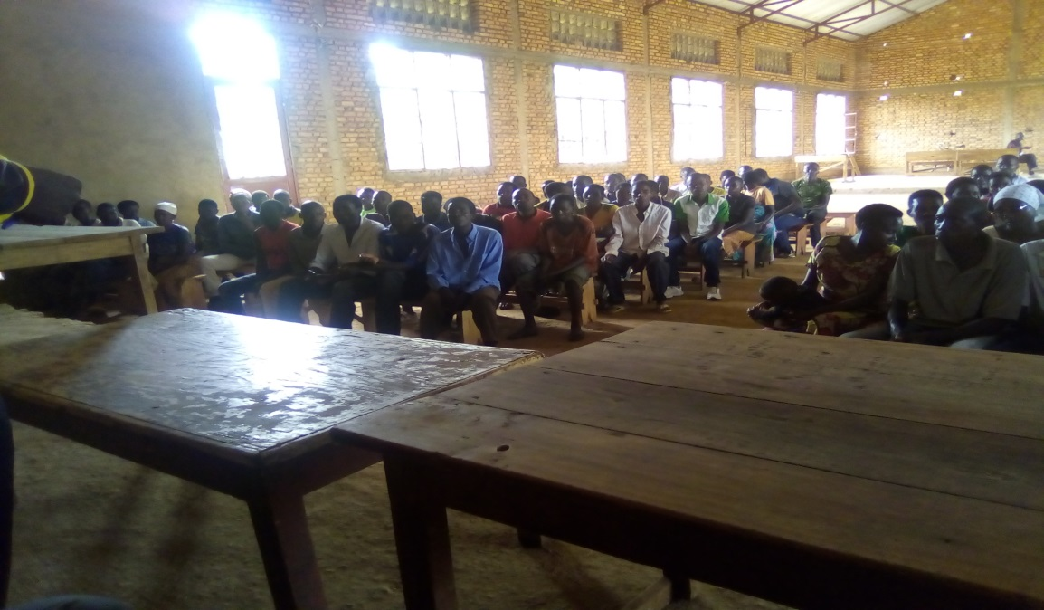
View Participants's meeting of parents, school principals and local administration

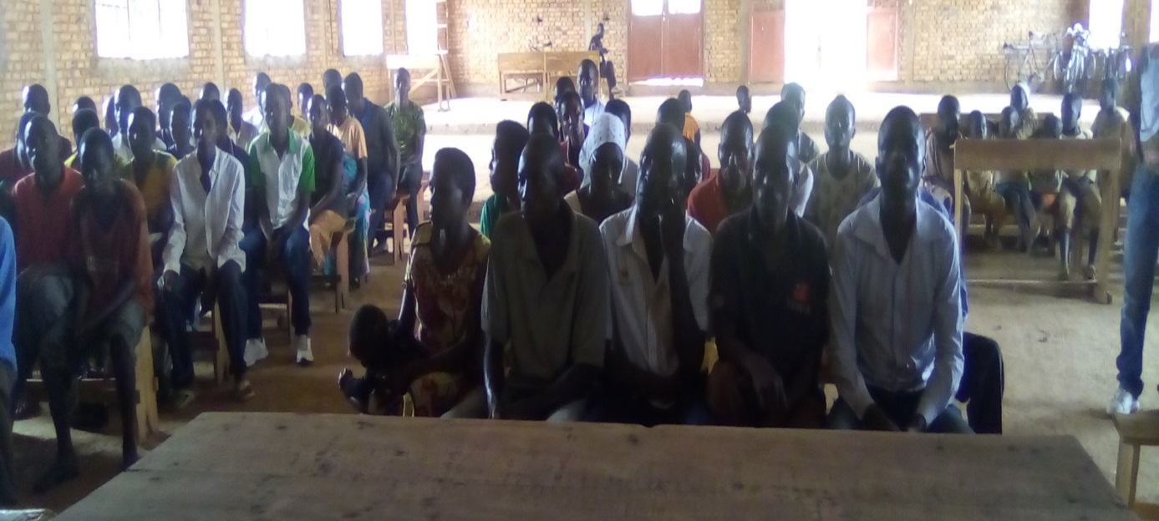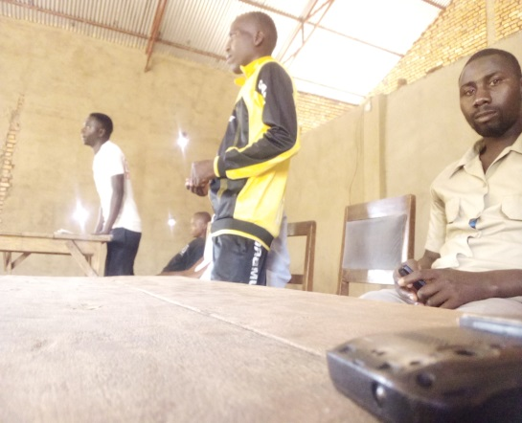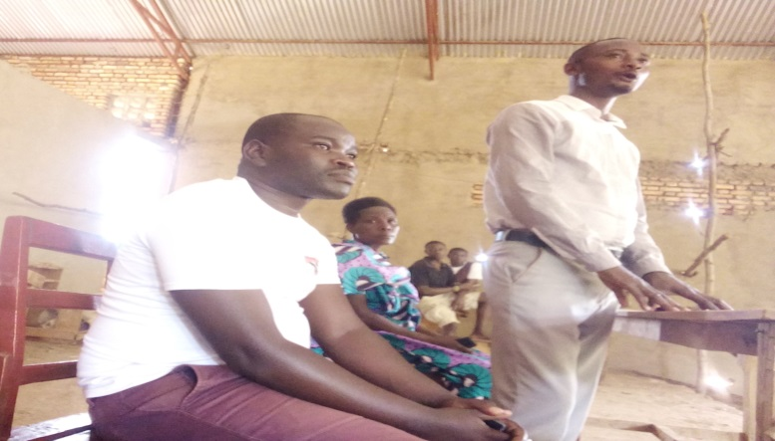
View of the school management and the local administration of Rugero I Hill where this Rugero I Fundamental School is erected

