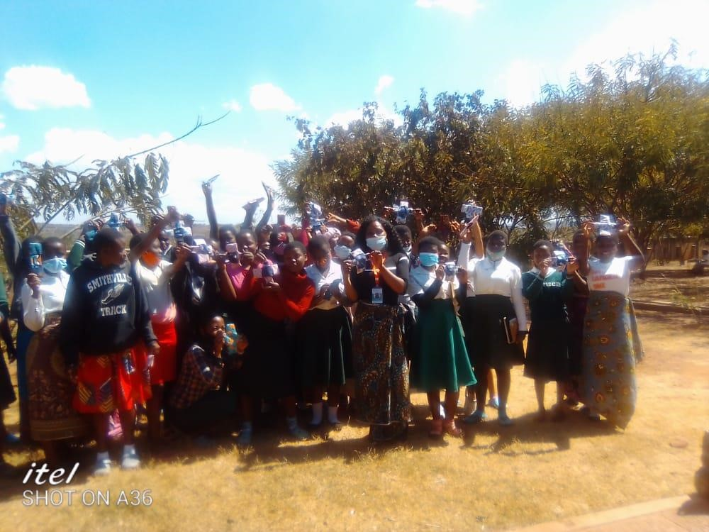
Girls at Mseche excited after receiving the reusable sanitary pads
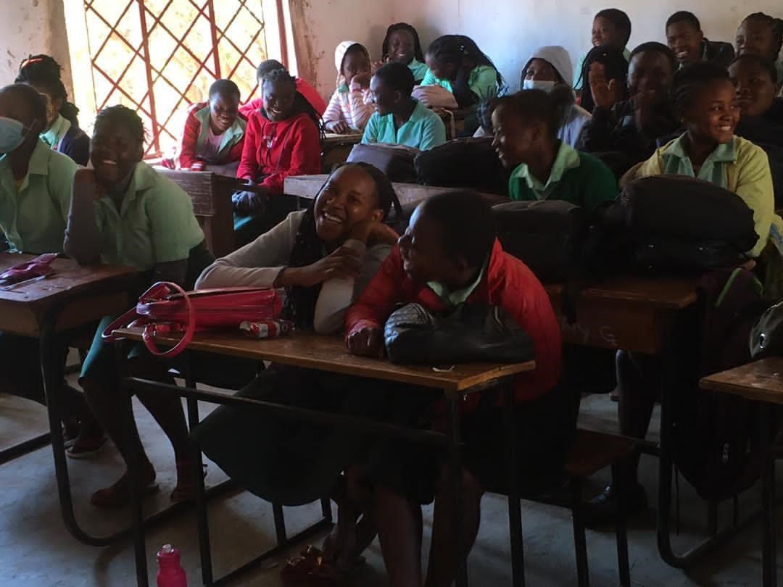
During girl talk session at Kaps school

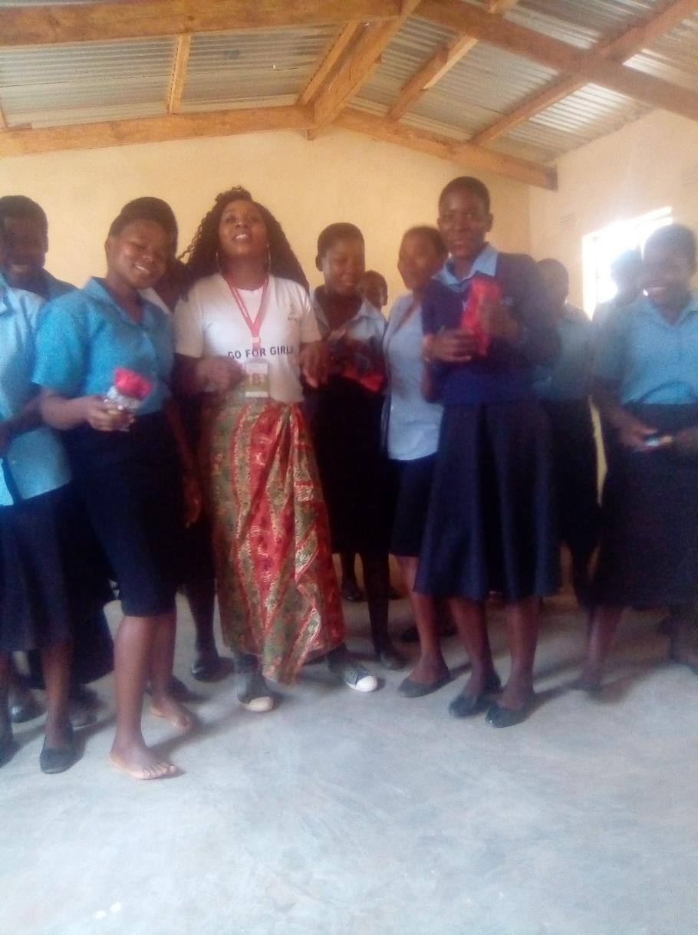

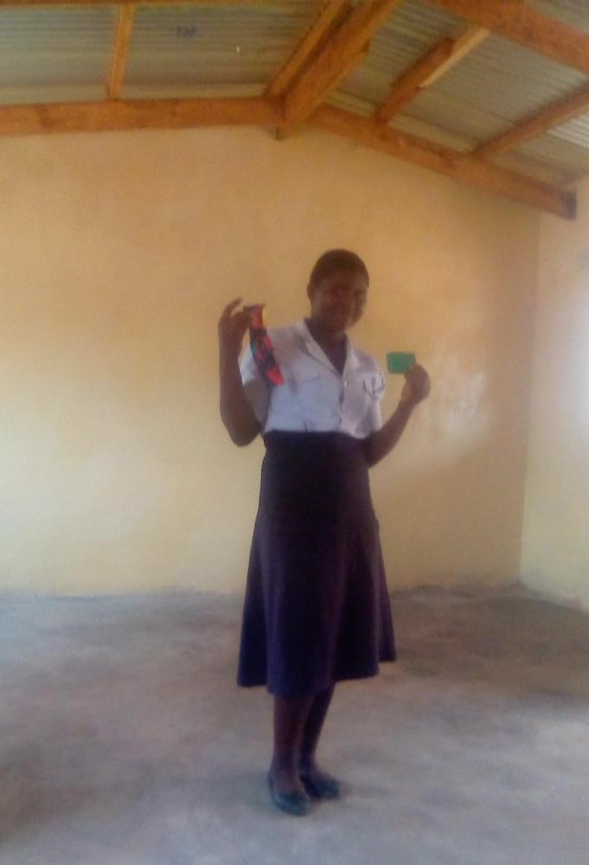
‘I will no longer be missing classes because now I have received these items’. Says Ivy Laston a form 4 student at Chiwamba. Girls were very excited after receiving these items.

