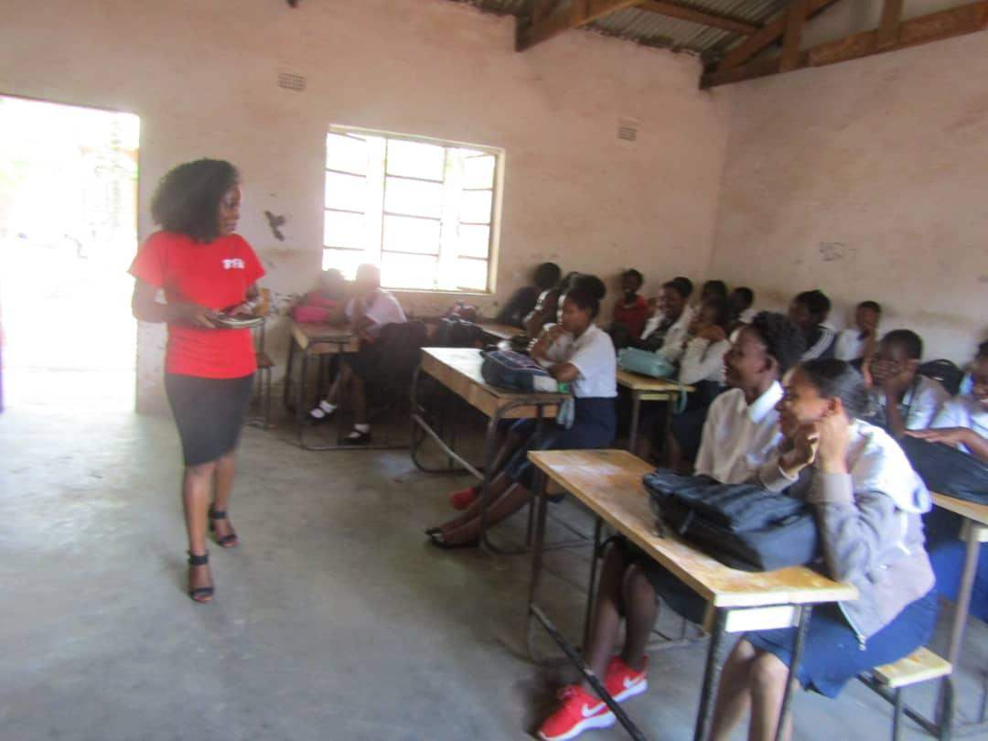A girl talk session at Falls Secondary School, Lilongwe
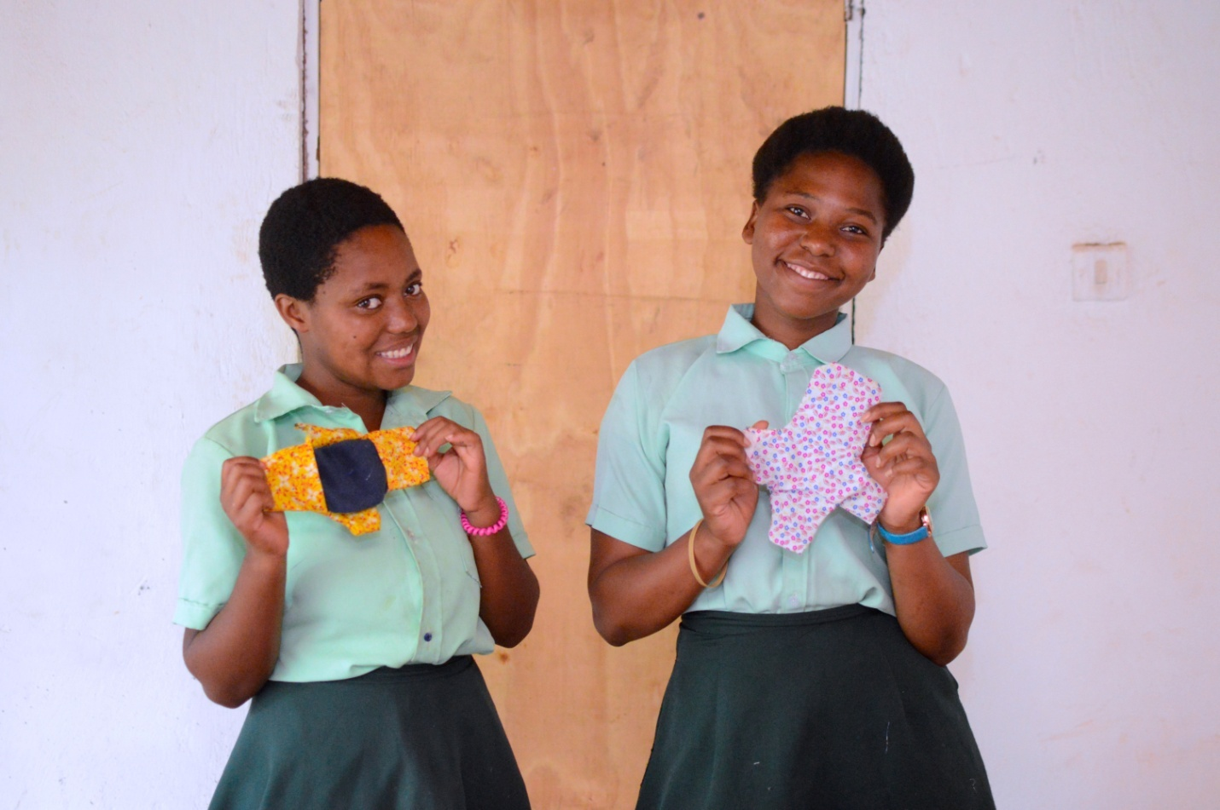
The reusable sanitary pads

