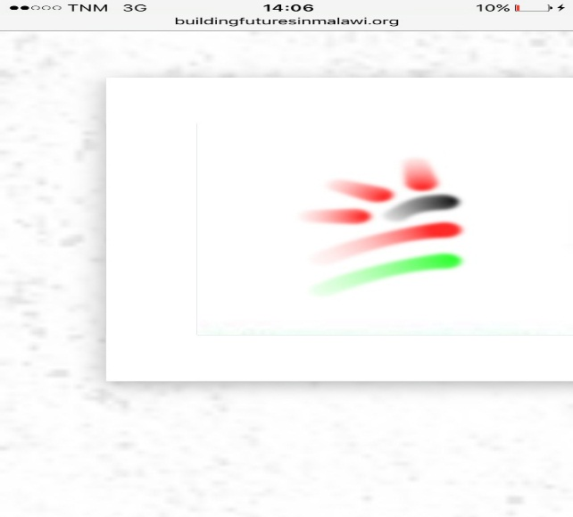

**Building Futures in Malawi**

P.O. Box X191, Lilongwe, Malawi

Phone: +265 886 040 262/ 991 165 437

[**info@buildingfutures.inmalawi@ymail.com or,terryterrymas@gmail.com**](mailto:info@buildingfutures.inmalawi@ymail.com%20or,terryterrymas@gmail.com)

**Date: 30th May, 2022**

From : Go for Girls Officer

To : Global Giving

Subject : March - May Report

During this quarter, Go for Girls visited different schools and interacted with girls through the girl talk program as well as training session on hand sewing of reusable sanitary pads.

**Girl Talk Program**

Young girls are victims when it comes to issues of early marriages and sexual abuse. Go for girls reach out to these girls through its program of girl talk- to empower and advise them to open up on issues that may endanger their wellbeing, carrier talk, health and other general concerns. During this quarter we had a session with schoolgirls from Standard 6-8 at Kaps Model School. 24 girls were in attendance (learners were busy writing exams hence the low attendance)

*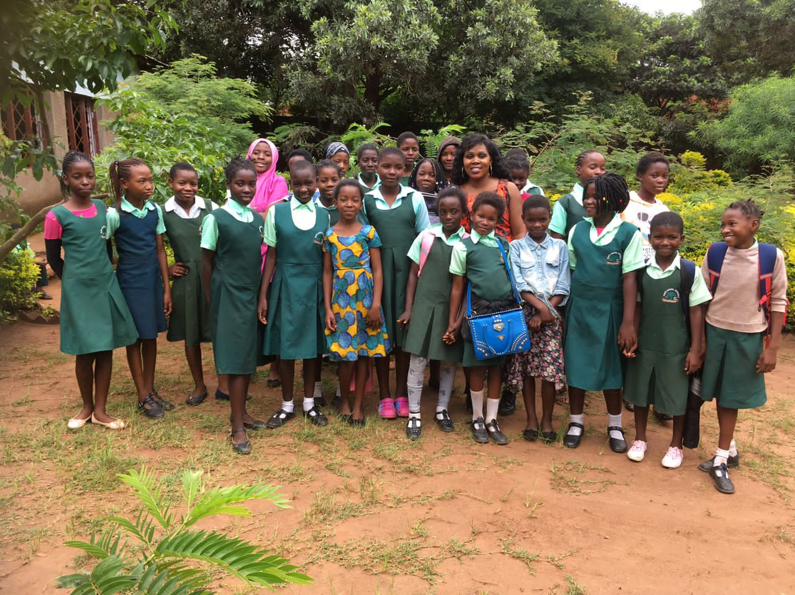 Girl talk at Kaps primary school*

**Girl Guides Association of Malawi visit to Kaps School**

In the month of May, we had a chance to be visited by a team of volunteers from Girl Guides Association of Malawi- a voluntary, non-political, non-religious and self-governing association whose aim is to enable girls and young women to develop socially, emotionally, physically, mentally and promote education among girls. Their visit was to talk to girls and encourage them to work hard in school and also provide menstrual hygiene practices.

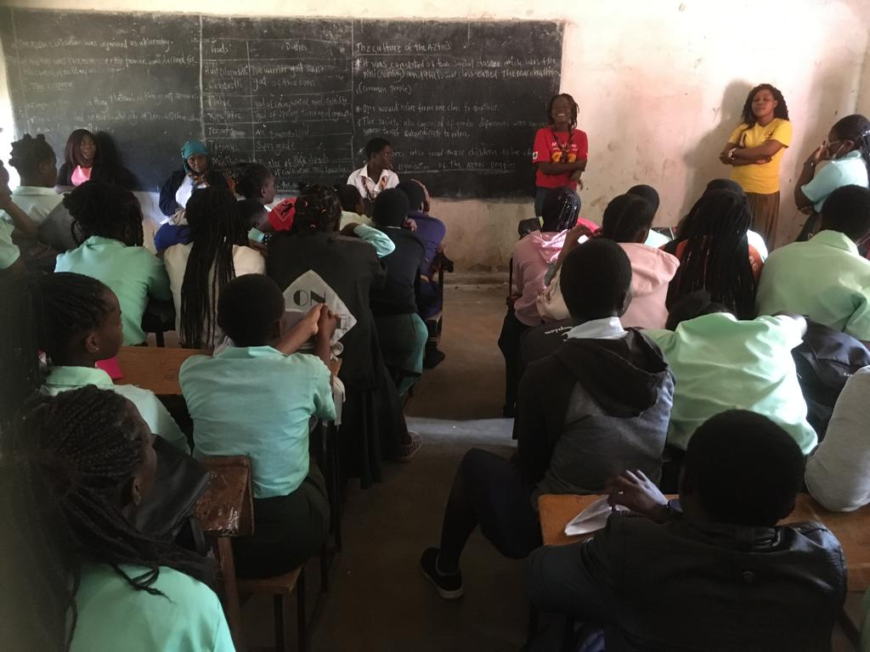

*Girl talk with team from girl guide*

**Assisting school girls at Kaps with Sanitary pads**

We assist school girls at Kaps Schools with Sanitary pads as others do come to school not well prepared, therefore every time a school girl ask for assistance, we do provide them with sanitary pads so that they do not go home but attend classes which is one of the main goal of the project- attaining girls in school.

2

**Training Session at Kaps**

During the month of May, Go for girls through its project officer planned an activity of teaching form one girls on how to sew reusable sanitary pads. After the training, girls acquired sewing skills and were advised to sew own reusable pads at home at their own free time. The pads that were sewn during the training were a take home for the girls who attended the training.

10 girls were trained on how to sew reusable sanitary pads.

The head teacher of the school commends the project very well and in his statement he said that the absenteeism rate amongst girls has decreased from 70% as of last year to 80% by far

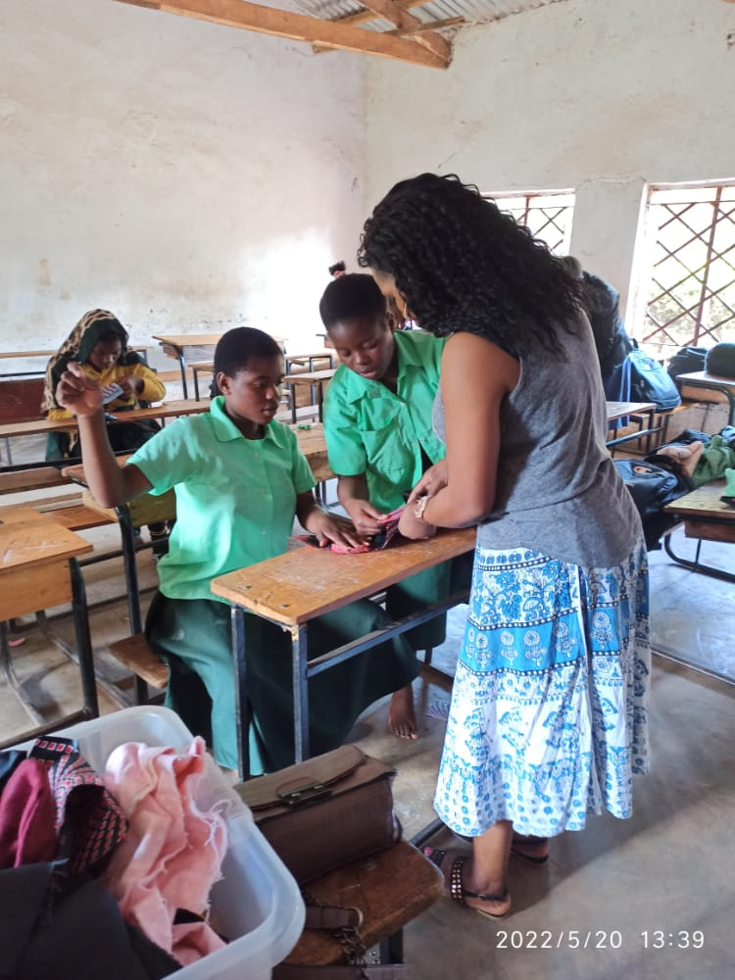

**3**

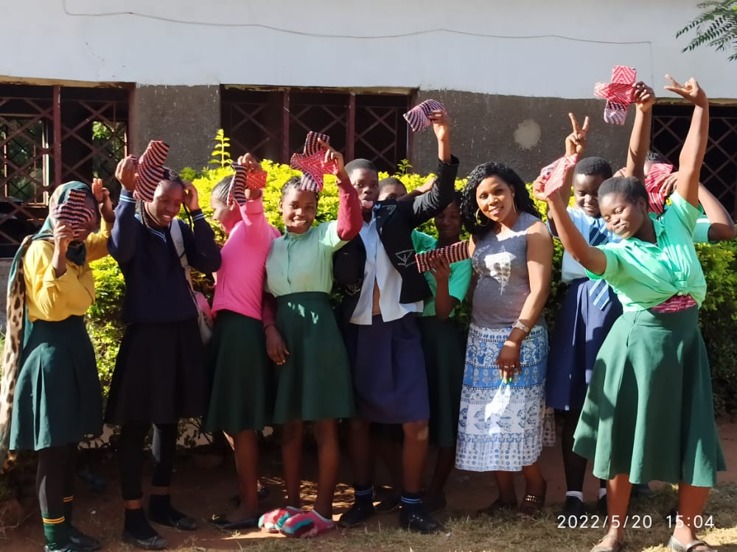

***Girls trained on how to sew reusable sanitary pads***

**Janet house**

Janet house is an orphanage that Building futures in Malawi supports. At this orphanage there are 3 boys and 8 girls. Age ranges of girls that are at this orphanage is from 9-16. These girls do not have a main activity that they do at their free time, so Building futures saw it appropriate that these girls should learn how to sew reusable sanitary pads as well as learn some sewing skills that will help them sew own clothes and also develop a keen interest in becoming professional tailors .

4

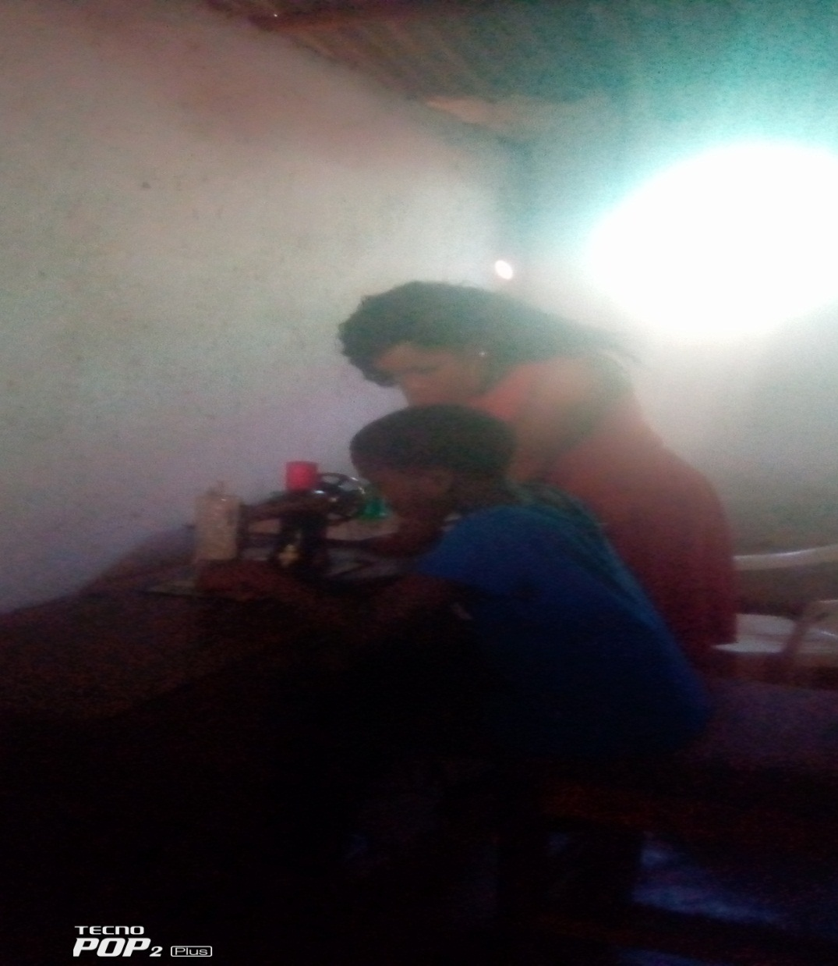

*Teaching girls at Janet house how to sew*

**Immediate Assistance**

Girls at Kaps are privileged as the do the support and assistance from the Building futures in Malawi which is situated in the Campus. Girls do not go home to access the sanitary pads, instead they visit BFM office and they are assisted with the sanitary pads, the purpose for the assistance is for girls to stay in school and not miss their classes.

This approach has proved to be very positive as we see the decrease in absenteeism rate amongst girls as well as boosting their confidence when they are going through these phases.

During our visits in schools through girl talk programs, girls also requests that we supply them with sanitary pads in their schools so that they should not go home and miss classes when they start their menses.

5

**Menstrual Hygiene day**

In commemoration of Worlds menstrual hygiene day which fall on 28th May. Go for girls had the privilege to attend an event which was organised by a Member of Parliament in Lilongwe. The project officer, Communications Officer (4) girls from Minga secondary school, (4) girls from Kaps and (2) girls from Biwi secondary school and two matrons were in attendance. This trip was organised by the project officer so that these girls can attend this event and learn from their peers and also commemorate this day together with their fellow girls. We organised a short play on menstrual hygiene that was displayed at the event and the girls pulled it out very well.

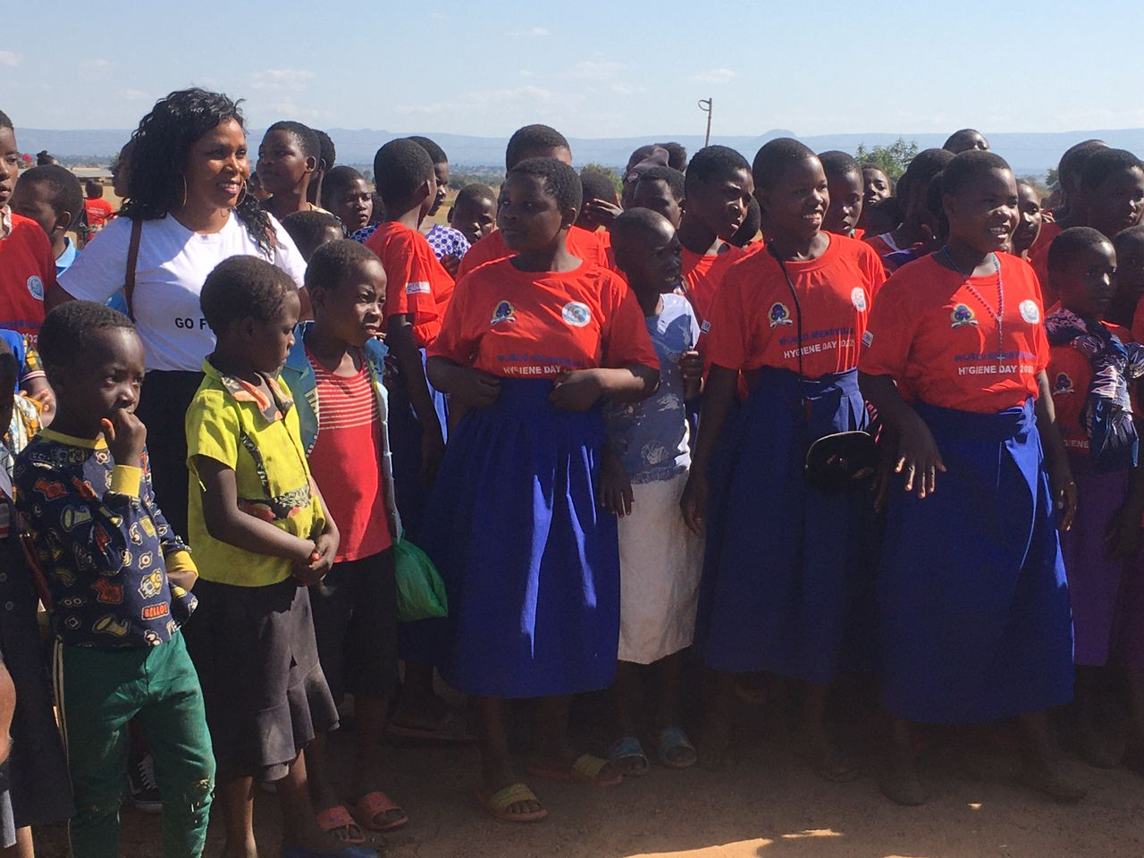

6

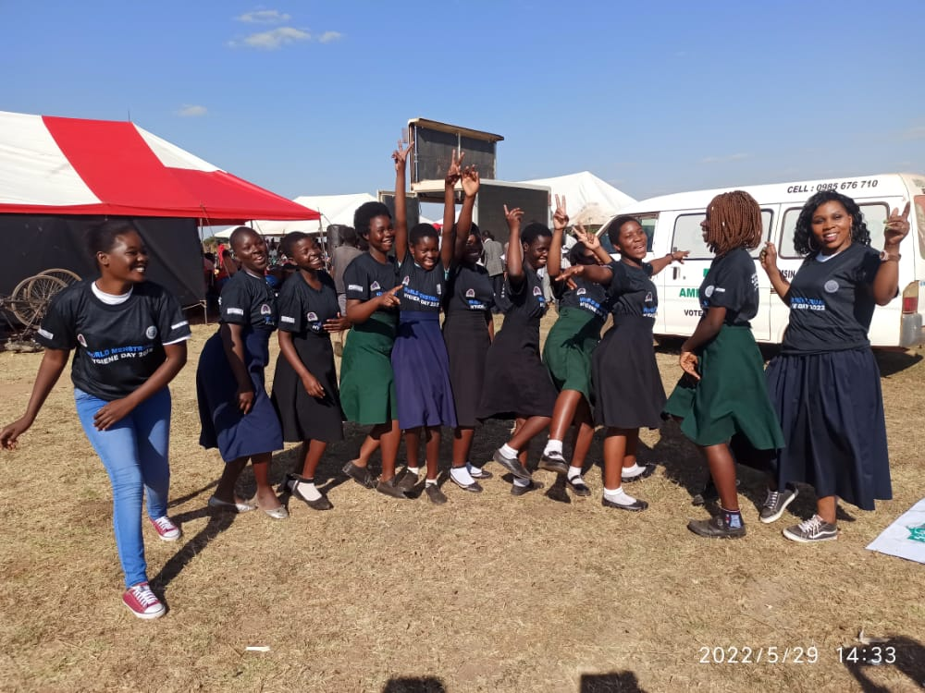

*Mitundu- commemorating menstrual hygiene day*

**Challenges**

* There is a need to buy sewing machines and locate them in all the schools we work with so that girls can be sewing own reusable sanitary pads.
* Schools request for sanitary pads to be available in schools for immediate assistance and this requires more funds

**Conclusion**

Go for girls project is providing a diverse assistance to many school girls and the result is very positive. Supporting this project is very commended as it is a direct approach in promoting education amongst girls in Malawi

We look forward to deliver more of many life changing activities to these young girls in the remaining months of 2022.