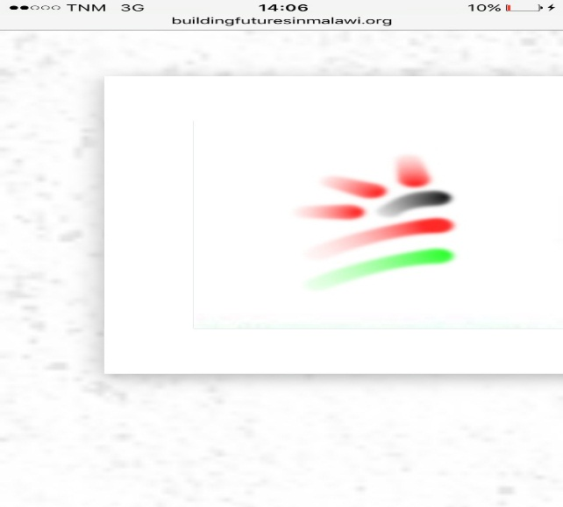

**Building Futures in Malawi**

P.O. Box X191, Lilongwe, Malawi

Phone: +265 886 040 262/ 991 165 437

[**info@buildingfuturesinmalawi.org,terryterrymas@gmail.com**](mailto:info@buildingfuturesinmalawi.org,terryterrymas@gmail.com)

**Date: 30th October, 2022**

From : Go For Girls Officer

To : Global Giving

Subject : August-December Report

The program of retaining girls in school by providing them with hygienic sanitary pads and moral support is going on well. During this quarter, many girls have been encouraged and supported through activities that the project implement.

**Girl Talk**

This is one of the activities that has received a positive support from the beneficiaries- (girls as the target group). Everywhere we conduct these talks, girls do enjoy and cooperate. This is much observed from the comments they make, questions they ask and the participation/a good turn up in number.

Girl talk involves a focus group discussion with female students. During these discussions we tackle different issues such as HIV related issues, menstrual hygiene, relationships, carrier guidance and early marriage issues that is on the rise in our country as well as other general concerns. Through girl talk, 264 girls were reached during this quarter

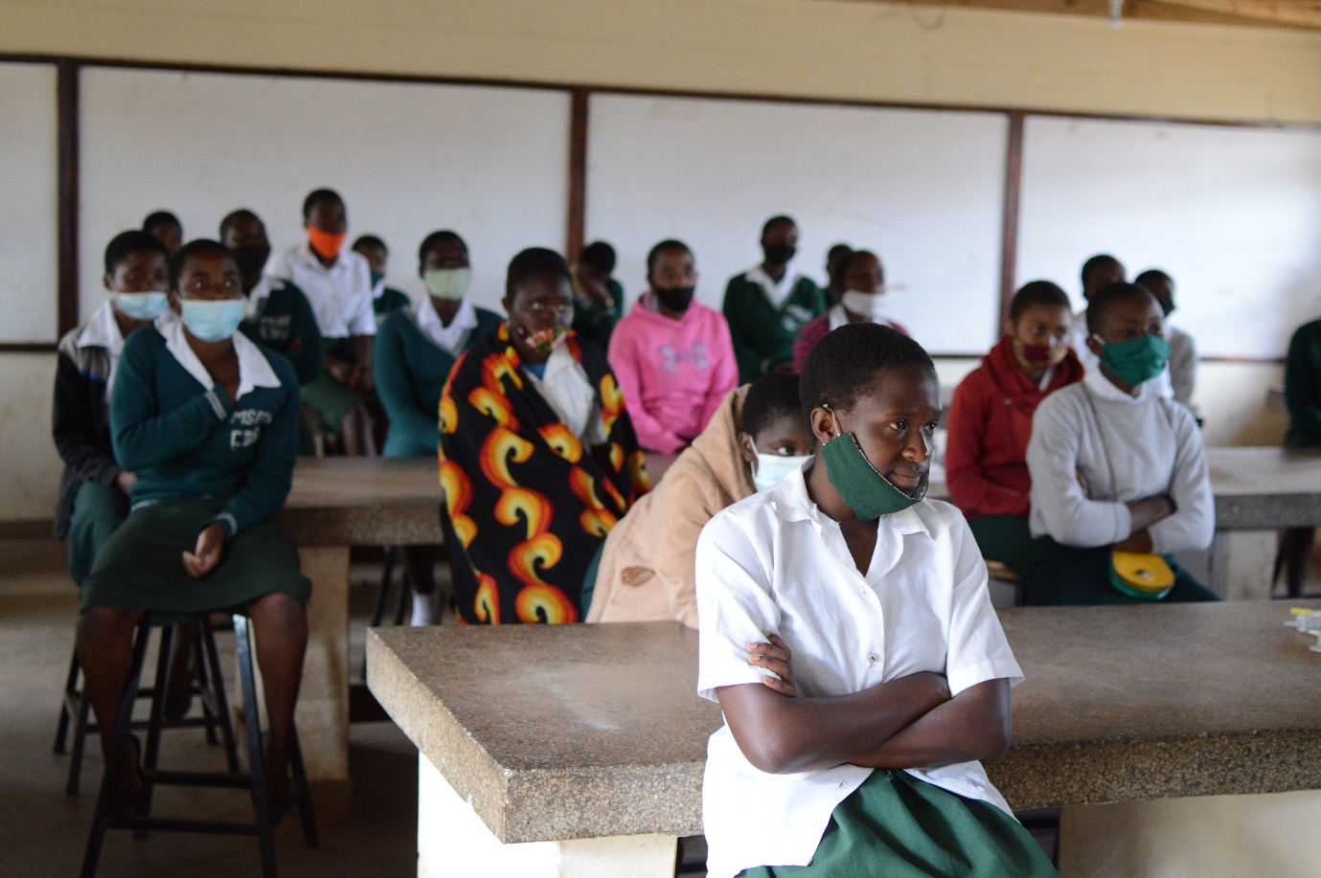

***A girl talk session at Mseche Community Day Secondary School***

**Future plans**: As stated earlier, this program is assisting many girls especially in the schools that we work with, it is my wish that the program should expand nationwide to as many schools as possible for a great impact that these talks have on a girl child.

Cases of youths committing suicide in our country due to mental health issues centering on relationships and Peer influence has risen drastically. This is another concern that will be addressed to these young girls and boys on mental health areas.

**Assisting schoolgirls at KAps with Sanitary pads**

Go for girls’ project assist schoolgirls at KAps Schools with hygienic Sanitary pads as others do come to school not well prepared for their menses and others unexpectedly start their menses whilst at school. Hence our office provides immediate assistance to these girls with sanitary pads and let them continue to attend classes, this is One of the main goals of the project- school girls not to miss classes.

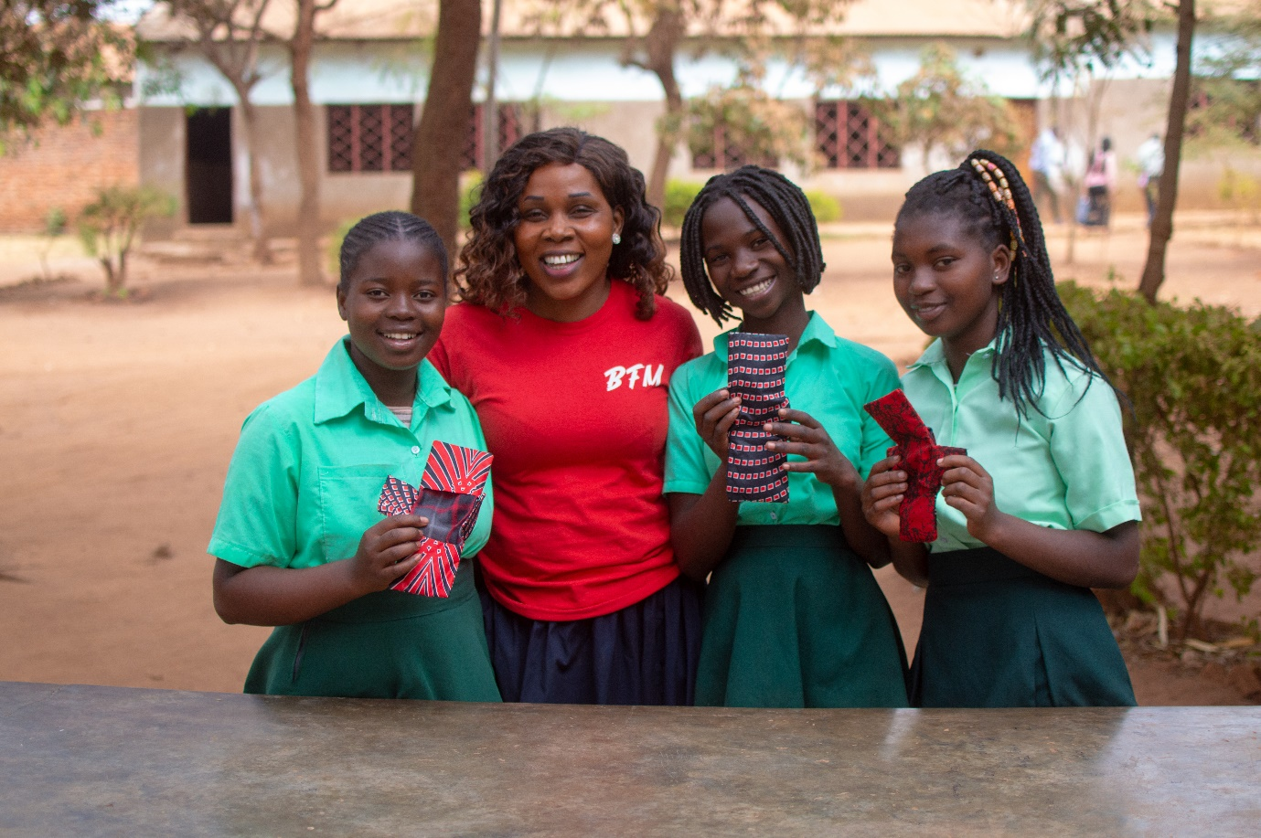

**CHALLENGES**

-Lack of funding: Our plan is to extend to other districts and reach as many girls as possible nationwide as we do operate in few schools of central region only.

-We only have one manual sewing machine which is very challenging to reach out to all the 8 schools in a very effective and timely manner. A sewing machine in each school would be very helpful because each school can be producing their own reusable sanitary pads.

-Transportation: We target schools in rural areas and visiting them frequently has never been possible due to lack of resources to carter for that.

**CONCLUSION**

Go for Girls project would like to thank you so much for the endless support to Building Futures in Malawi. Your support has fostered implementation of the project. You have changed lives of many Malawian girls and we hope to see them successful in future. Go for girls’ project will continue with its activities and we hope to reach as many girls as possible.