BUILDING FUTURES IN MALAWI
P.O Box X191, Lilongwe, Malawi
Phone: 265 991 165 437
Email: buildingfutures.inmalawi@ymail.com
lameck9223@gmail.com

REPORT FOR EMPOWERING 600 SCHOOL GIRLS HYGIENE IN LILONGWE
FOR THE PERIOD OF JANUARY – FEBRUARY 2020
Dear Friends
In the month of January, we had an orientation of the project at one of the schools in the rural area called Minga Community Day Secondary school(MCDSS). The total number of girls at this school is 214. The school dropout rate amongst girls at this institution is 30% per academic year and absenteeism is also high amongst girls. From the survey that was conducted at the school, lack of hygienic sanitary materials required for girls to use during their menses is main cause why this absenteeism rate is this high amongst girls and sometimes it leads to school dropout.

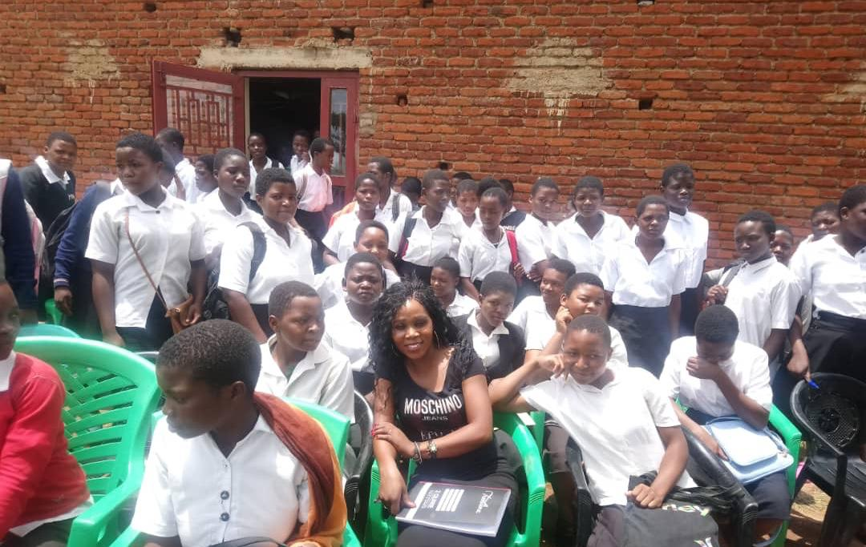Orientation at Minga Secondary school
Kaps School
This is one of the schools that acted as a pilot location for the project. There are many girls at this institution about 220+ and also 36 Primary girls. We conduct sessions every Thursdays at this school.

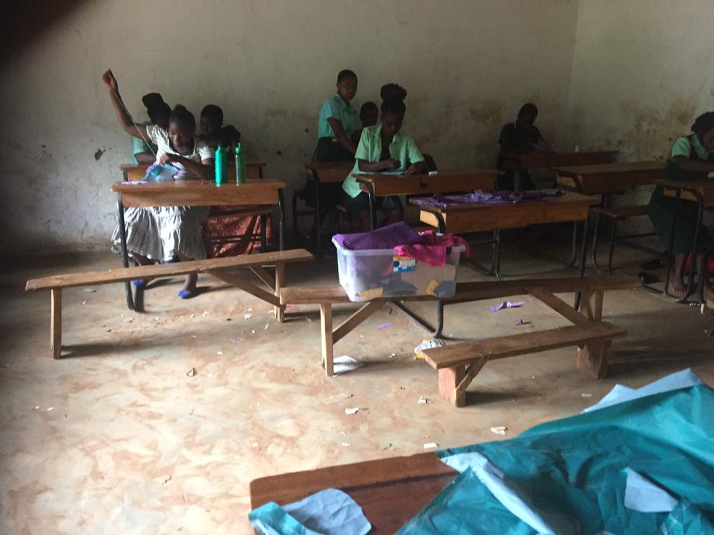
Training session in progress at Kaps Model Schools

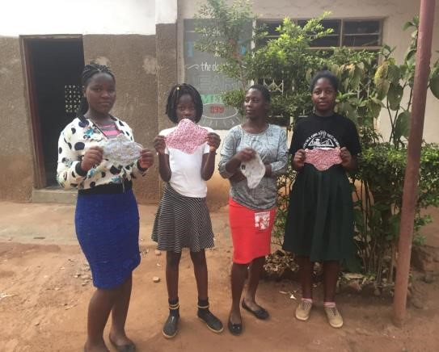
Girls who completed the pads at Kaps Model schools

February
The month of February was a very busy one, we conduct training and girls talk sessions with every Thursdays at Kaps and Fridays at Minga CDSS. We also visited different schools in the rural areas where there are problems of no washing facilities as well as high % rate of absenteeism in girls. Chiwamba CDSS is one of the schools that will be added to the program.

Another school has been Identified known as Mseche Secondary School, it is also a school in a rural area. This school is 50 kilometers away from where our offices are. The total number of girls at this school is 190+ girls. A survey was conducted at this place and there was an organization which promised to implement the same project 3 years ago, but they did not put their words in actions, the girls at this school are ready for the project and I believe the results will be tremendous. The dropout rate percentage at this school is 16%/year. Absenteeism as a result of lack of hygienic materials during the cycle, is also very high amongst girls.

A pack of disposable pads goes at a price of MK650 and many girls came forward to say they do not have access to the hygienic materials because their parents cannot afford to buy for them, instead they use unhygienic cloths that have negative impacts on their health.

We are planning to purchase 6 sewing machines in March to be distributed in the school that we will be working with. The girls will be taught how to sew using the machines.

Achievements
- Orientation was conducted at the Schools explaining the need for this project and the benefits it will bring to the schools and the girls.
- 26 Girls trained on how to sew reusable pads
- Girls are now knowledgeable on how to use the re-usable pads
- Absenteeism rate dropping by 53%
- Girl empowerment
- Sewing skills acquired
- Girls interacting and participating in different activities that helps them to improve hygiene in and outside the school area

Challenges
- The schools do have their own Activities, and this interrupts our training sessions
- Girls start the sessions very eagerly and they become lazy to finish the kit, that we have to do a strict follow up on them
- Sewing Lessons are not offered in schools and this becomes a challenge during the sessions because we only have one person who teaches the girls how to make the pads.
- The school that we have added to the program are very far from where our offices are situated; hence mobility becomes an issue as our office do not have a motor vehicle and this affects managing the time as the only option is to use public transport.
- Currently the pads are hand sewn so this is time consuming
- For the program to be very efficient and effective, we need to have sewing machines.
- Through the surveys that have been conducted there is need for more support to reach as many girls as possible.

CONCLUSION
The program has started off well this year. Many girls were not aware of the many menstrual hygiene practices that are available, through the girls talk sessions we had, the girls opened up as to how they have been in the dark about other factors concerning their health. I believe that this program will change a lot of girl’s futures and also girls will be able to acquire long term skills and retention of girls in schools will increase as they will be able to overcome challenges they experience each and every month of failure to attend classes.

Thank you for the support that you give to this project.

Teresa Masale
Project officer

