

Building Futures In Malawi

P.O Box X191, Lilongwe, Malawi

Phone: +265 886 040 262 /991 165 437

[info@buildingfuturesinmalawi.orgterryterrymasgmail.com](mailto:info@buildingfuturesinmalawi.orgterryterrymasgmail.com)

Date : 31st March, 2024.

From : Go for Girls Officer

To : Global Giving

Subject : March, 2024Report

This is the second term in the 2023-2024 academic year. It has been one of the busiest quarter as we managed to visit different schools to train girls on how to sew reusable sanitary pads, introduce sewing clubs and also conduct girl talk sessions. This term we visited five schools namely; Chipasula secondary, Minga secondary, Kaps secondary, New Insight and Mseche secondary school.

**Training of reusable sanitary pads**

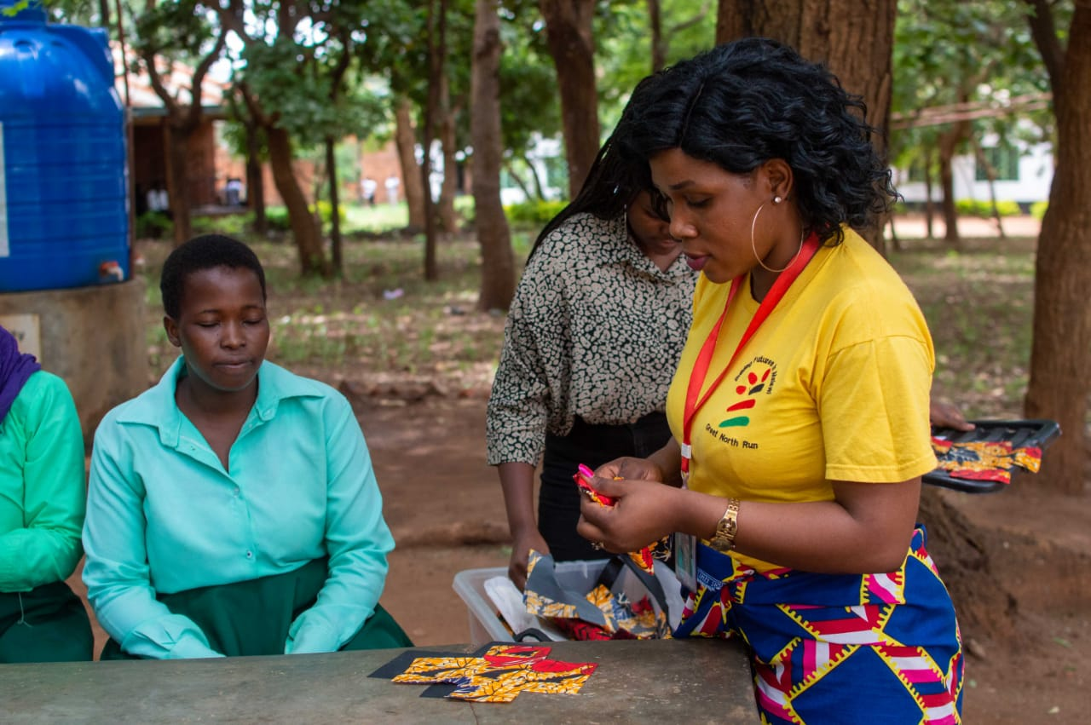

During this quarter, Go for Girls project trained 131 girls on how to sew reusable sanitary pads. The valuable skills that these girls have acquired in making own reusable sanitary pads will benefit them long term-whilst there are in school but also when they finish their secondary level as they have been economically empowered. We also encourage these girls to train their siblings as well as other community members.

**Advantages of reusable sanitary pads**

* They are durable
* They are not expensive (not bought every month)
* They are organic, since no chemicals are involved when making the sanitary pads
* They are comfy.
* They are environmental friendly
* It is another way of empowering girls economically whilst they are in school

As the project officer I, encourage these girls to build up the skills acquired as they have the capability of combating problems regarding menstruation that exist amongst many girls in the country.

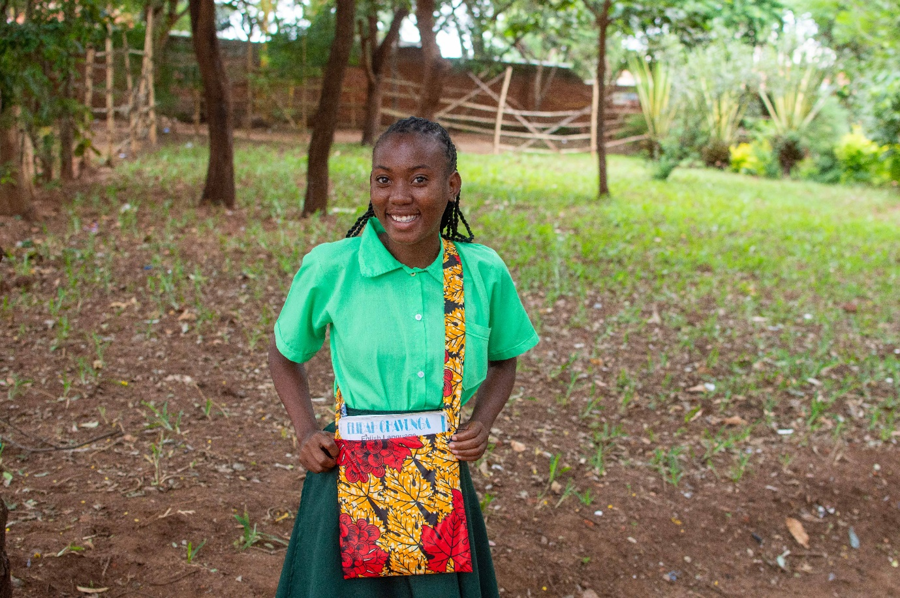

*Sample of a min bag*

Sewing clubs has been introduced in all the 5 schools that we visited. The clubs are open to all students even those with no experience with the aim of teaching girls sew different patterns whilst they are in school. Through the sessions we have seen girls enjoying the creative process, improved concentration, and they have learnt how to work with their hands. As a result, these skills will help them become more independent and self-motivated.

**Girl Talk**

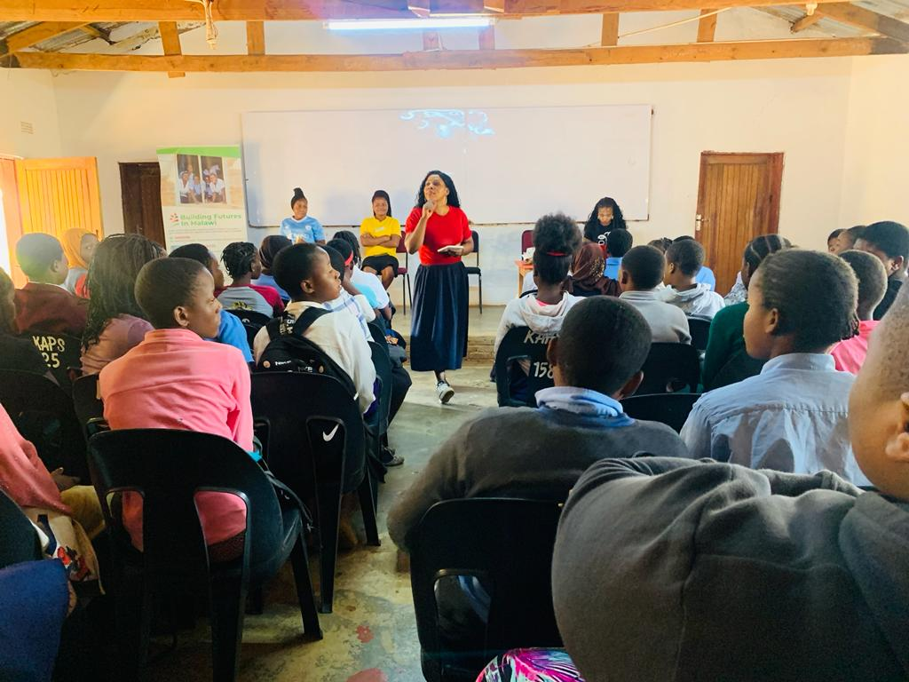

A very commended platform that go for girls created to engage/interact with the girls and which is highly praised by the girls themselves in all the schools that we visit.

We cover topics from menstrual hygiene, carrier development, mental health and Aids, Early marriages and other general concerns. During these sessions we create an atmosphere where girls do open up to us by asking questions/comments from the topics covered as well as questions from their own encounters.

It is a platform which by far has transformed many girls, lives when it comes to opening up on sensitive issues, considering that our cultures somehow limits children to be very close/open up to their parents as respect towards parents is much observed. Go for girls bridges that gap by advising girls to open up to us as social workers and also build relationships with their parents so that they can easily share what they are going through.

During this quarter we managed to reach to 252 girls and plan to visit as many schools as possible as funds may be available. Head teachers, teachers and girls commend this program as it encourages, motivates and provides a healthy social wellbeing to girls whilst they are studying

As one way of encouraging girls to focus on their future and set goals in life, girls were able to make own vision boards that serves as a constant reminder of the goals that are to be achieved by investing their full focus on their studies.

**Achievements**

* Introduction of sewing clubs(girls sewing bags)
* Boosted confidence in girls( opening up and asking of general questions)
* Girls interacting
* Menstrual hygiene
* Sewing skills acquired
* Girls become career focused

**Challenges**

* Sewing clubs that have been introduced requires sewing machines so that the program may run effectively and efficiently. Materials to be available at all these schools for the progress of the clubs
* Visiting the schools regularly to monitor the progress of the project becomes a challenge due to lack of funds for transportation.

**Future Plans**

* The project to expand to other regions in the country.
* To introduce counselling programmes in areas of mental health, relationships and HIV/Aids.

***Immediate Assistance***

During this quarter we have maintained the program of assisting girls from Kaps secondary with sanitary pads so that they stay in school whenever they are in their menses. This mechanism has also proved to be a contributing factor to low absenteeism amongst girls.

We would have loved to be providing girls from all the schools we work with, with sanitary pads .This programme can only be possible if enough funds are available.

**Panned activities**

* Teaching fundamental sewing skills
* Teaching how to cut and mark pattern pieces
* Sewing different patterns and other basics.
* Teaching how to sew min (different patterns)

**Conclusion**

Go for girls is one of the projects that is promoting education and building girls’ futures through its different impactful programs here in Malawi. We are reaching to girls/schools where our programs are highly valued as they bring change to a community through these girls.

As a project officer, personally extend my gratitude as I directly can confirm that your support brings a change in a girls, life.

We continue to THANK YOU for the support that you are tirelessly rendering to our organisation.