Support beekeepers with Modern bee hives and equipment in Rwaniro of Huye District - Rwanda
Project Summary
Agro Action Rwanda plans to support poor beekeepers with poverty ranking level one (1) in acquiring modern bee hives, smokers , hive tools, nucleus top-bar hives, top-bars, clean clothes, combs and full protective gears enabling as many 180 beekeepers in Rwaniro Village escape from poverty and hunger.
The project provides 1) Rwaniro Beekeepers with sustainable income generating facility by moving from traditional to modern beekeeping 2) Increase in Yields of honey harvesting from 1 kilo to 10 kilos per hive 3) Training in modern beekeeping techniques and technologies 4) Access to honey market and 5) Creation and registration of a beekeepers’ cooperative.
Requested funding amount
30,310 USD

Donation Options
- $10 Will provide 2 hive combs
- $15 pays 1 nucleus top-bar hive or hive tools or will train 5 beekeepers in beekeeping techniques and technologies
- $20 pays clean cloth to cover hive in honey harvesting
- $25 Will pay 1 smoker for beekeepers
- $50 will provide 1 modern bee hive
- $85 will pay full protective gears for beekeepers

The social challenge:

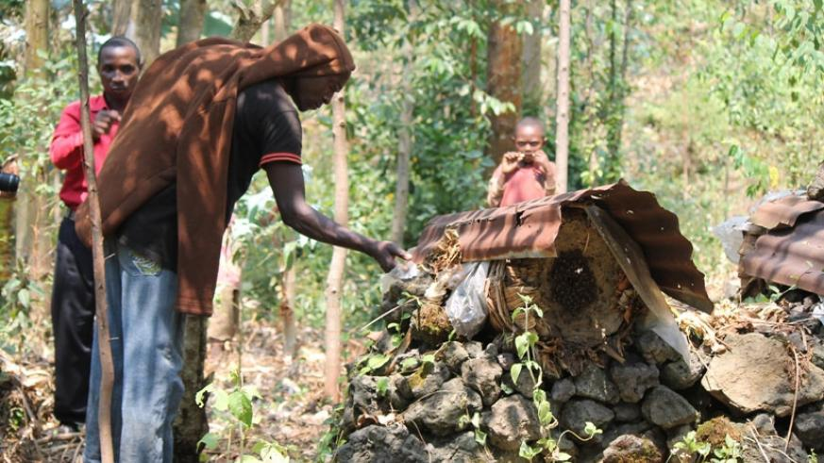
Rwaniro village in general, yet there is no people producing sufficient honey quantities for the market. Rwaniro beekeepers are poor people who are mostly ranked level one, which means no other source of income. About 180 beekeepers are using traditional beekeeping techniques to survive. In the area, there many forests planted, to protect environment, bee keepers who live nears the planted forests need to be empowered to have means and protect the environment in Rwaniro. Agro Action Rwanda plans this project because there is a ready market for honey in Rwanda. This project will be piloting one to plan for its extension in others sectors and villages in Huye District by the aim of teaching and coaching to protect forests and environment as a whole.

Potential Long-Term Impact

The project will train 180 beekeepers in modern Beekeeping techniques and technologies and will support in creation and registration of Beekeeping cooperative in Rwaniro Village of Huye District of Rwanda. The estimated bee hive production will be 120 Kgs per year as the project will be using modern bee keeping technologies.

By producing honey for market, bee keepers farmers will earn money. As the government has adopted to protect environment by forests plantations, fauna and flora protections, the surrounding villagers will be able to cope with the planted trees as bees need to develop with various flowers of plants. Hence, the farmers will be motivated in their bee farming as it will be the main source of income. In addition, the economic development of the country will increase as well as Sub-Saharan environment.

