Evaluation Report 2019
CasaSito Association
Youth Development Program

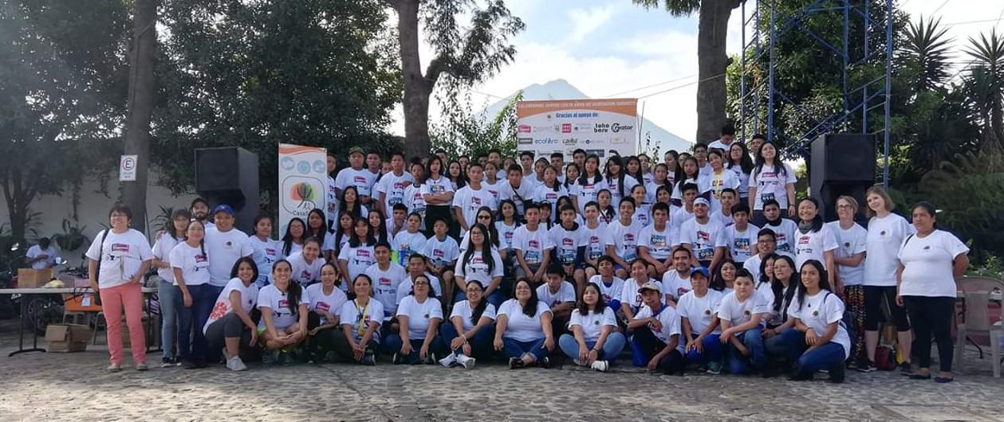
- POPULATION DEMOGRAPHICS

Scholars: 102 (50 female, 52 male) Location by District:
32 middle school 54 Alta Verapaz
54 high school 12 Quiché
16 university 36 Sacatepéquez

- IMPLEMENTATION AND IMPACT:

- Project objectives

- HIGH ACADEMIC SUCCESS RATE: Among the 102 scholars, the academic success rate is 95%; 99 scholars successfully completed their school year.

- HIGH GRADUATION RATE: In 2019, 16 students (100%) successfully graduated from high school.

- LOW DESERTION RATE: In 2019, the dropout rate of scholars was 3%; only 3 students left the program without finishing the academic year.

- LOW PREGNANCY RATE: The pregnancy rate in 2019 was 1%; only one case of pregnancy was recorded in the rural area.

- How do the achievements improve the living conditions of the beneficiaries?
Guatemala is a country that lacks opportunities for young people who do not have academic education and professional skills. Through our program, the living conditions of our scholars and their families were improved as follows:
1. Education: Upon completion of their studies, scholars will be able to graduate and thus have the possibility of finding a job with better salary and working conditions.
2. Family economy: By being a professional and finding a job, scholars will have the opportunity to financially support their families and thus their living conditions.
3. Personal and professional growth: Scholars have the opportunity to improve their skills in English and mathematics, self expression, creative writing, emotional intelligence and art. This allows scholars to feel more secure and manage difficulties in life more independently.
4. Family strengthening: Families who attend orientation workshops and psychology service, are often able to break harmful and pathological parenting patterns and to improve mental health within their family.

The following activities have been successfully implemented in 2019:

 | Alta Verapaz, Cobán y Quiché |  | Sacatepéquez |  | Total
Indicator | Scholars | Parents | Scholars | Parents | Scholars | Parents
Workshops | 7 | 7 | 15 | 7 | 22 | 14
Number of patients who received psychological support | 18 | 8 | 14 | 6 | 32 | 14
Hours invested in psychological support | 264 | 24 | 294 | 126 | 558 | 150
Hours invested in volunteer work by scholars | 975 |  | 896 |  | 1871
Hours invested in monthly monitoring | 338 |  | 190 |  | 528

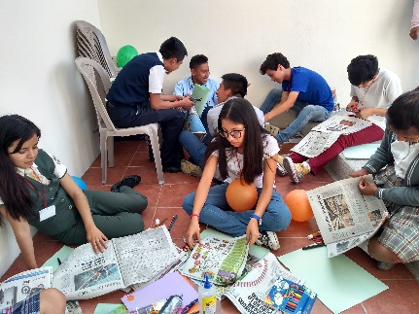
Examples of workshops offered in 2019:
- Wake up and reach your dreams: The workshop aimed to foster a critical, creative and purposeful attitude in the scholar, so that each scholar is aware of their reality and participates in their own search for their goals and strives to achieve them.

- Leadership and Personal Development: The objective of the workshop was to provide tools for young people in order to develop or strengthen their leadership skills, which will allow them to improve their performance and, above all, develop themselves.

Who has benefited from these achievements? CasaSito through its programs has benefited young scholars, their families, communities and educational centers. This year, 102 young people, around 85 families, from 38 communities in three departments, benefited from the association’s program.

- What has been the reaction of the target public to the project?
The different programs offered by CasaSito have been of great support. Parents and scholars have expressed deep gratitude for all the opportunities provided by the association.
Workshops: Parents expressed that the workshops have been of great support for the family in general. Olga Gualim: “During the last workshop I learned how to make candies. Now I am planning to make my own sweets and tamales and sell them together with my daughter. The profit will we use to cover expenses of the house”.
Psychological service: Scholars expressed that the psychological support has been of benefit to them, as it allows them to solve personal situations and to better get to know themselves. "From the time I received psychological therapy, I learned to be more positive and not let pessimism direct my life", said Mildred Vicente.
Economic scholarship: The monthly scholarship has allowed them to cover their school expenses. “Without the financial support of CasaSito, I surely couldn't have continued studying and would have stayed in third grade,” said Joseline de Paz.
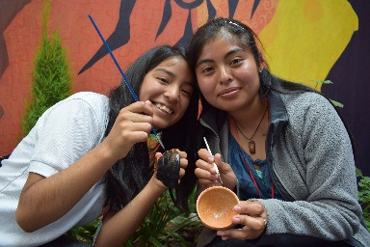
- Multiplier effect

This year, CasaSito has established cooperative relationships with the University of San Carlos and the Rafael Landívar University. Both universities provide the association with professional psychological support. In addition, good relationship has been established with the municipal authorities, which allowed CasaSito to hold sports and cultural events open for the community.

This year an alliance was established with the Japan International Cooperation Agency (JICA) which sends Japanese expert volunteers to help develop programs within the association for a short or long term. CasaSito will be able to offer Japanese classes to their scholars and the general public during holidays.
In 2020, the association will start a pilot program for teachers from public and private schools that aims at providing training to teachers in the technique of debate. Debate is an activity that allows to develop different capacities such as critical thinking, research skills, expression, security among others, and will help participating teachers to improve their teaching techniques in their classrooms.

- BUDGET AND FINANCING:
Here is our 2109 Program actual expenses through September 30. Full-year expenses will be about 20% higher. The program is majority-funded already, the Global Giving request is make up our shortfall and hopefully provide some extras to our student participants.
Details | Amount in Quetzals | Amount in Dollars
Financial Aid | Q 261,205 | $ 34,369
Workshops | Q 13,218 | $ 1,739
Clubs | Q 39,016 | $ 5,134
Support Service | Q 33,154 | $ 4,362
Staff-Operations | Q 276,181 | $ 36,340
Staff-Administration | Q 87,999 | $ 11,579
Total | Q 710,773 | $ 93,523

(Exchange rate $1 to Q7.60)

