WHO WE ARE?
We are A Ray of Hope for Cancer Victims.
A warm welcome to this new year 2021, we started the year well though amidst the pandemic. We are thankful to God for keeping us safe so we keep on reaching out to our community needs.
Patient Relief Mission aspires to improve cancer care and management for female patients and their care-givers by providing hostel accommodation and feeding to those who come from rural areas in order to receive their treatment from the Uganda Cancer Institute who otherwise would have nowhere to stay in the city while undergoing treatment. Patient Relief Mission was founded in 2015 with the aim of ending the needless suffering for cancer patients in Kampala, Uganda.

SUMMARY
No./Items |  | June | July
1. | New patients received | 00 | 00
2. | Old patients who returned | 16 | 10
3. | Discharged/done with treatment | 00 | 00
4. | Caretakers | 13 | 09
Total |  | 29 | 19

SUCCESS STORIES/MILESTONES
Our programme is growing in Uganda, where there is only one treatment hospital for cancer that is Uganda Cancer Institute, situated in Kampala. With the COVID-19 pandemic impacting everyday life in the country, we are very grateful for the continued support from all our donors and partners which has enabled us to continue caring for our patients. We had our different local partners visit and offer us food relief during this pandemic, this has enabled us continue our work.
Patient Relief Mission (PRM) is able to accommodate/host 48 cancer patients with their caretakers at the hostel located in Nsambya for the period from June to July 2021. During their stay at PRM, we provide them with 3 meals each day, and accommodation because they do not have anywhere else to stay within Kampala where the cancer Institute during that period as they undergo treatment, and we do offer Psycho-social support as a supplement to their treatment. While at the hostel, patients have a quite environment that allows them to have enough rest as needed, meals are provided on time by the caterer, they have clean and specious rooms to avoid covid and any related infections. On top of the above, we are blessed with a retired nurse and social worker who make sure they are smiles on the patient’s faces after their one-on-one sections. This allows patients to be encouraged to continue with treatment, to have hope and know they have a reason to face tomorrow.
Other activities done at Hostel
While at the hostel, there are also opportunities for one-on-one talks between the patients and the retired nurse/hostel manager as mentioned above, the nurse always listens to them and gives them encouragement and advise as needed. Some of the patients are having troubles with their families so that state affects their wellbeing even when they get treatment. When they get such counselling, they gain strength and hope which contributes to the healing process.
They also get a chance to do other skills like knitting, making of briquets which helps them be busy instead of taking time thinking about the illness. These activities help our patients to stay stable and active as they undergo treatment.
Some of the caretakers undergoing a training on briquettes making
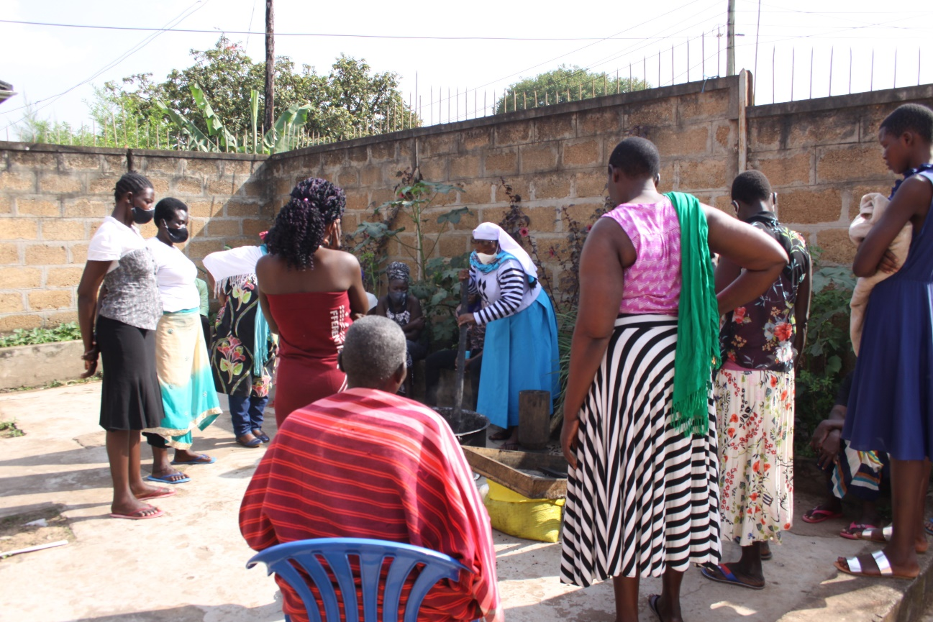

THE CHALLENGES
The COVID-19 pandemic negatively impacted the operations of Patient Relief Mission and the life of our Cancer patients. Patient Relief Mission is facing the following challenges; increased costs for food, and the utility bills. As we adapt to these alterations, we will continue to serve our community better in order to achieve our goals and objectives in an effective manner.

PRAYER REQUESTS
We invite you to join us in praying for;
- Our patients to recover so they can move on with their families and settle in their families smoothly. Most of these patients have children home so they are needed back home.
- That we enlarge and have enough space that can take on more patients who need our support. Like we now have full board, all the beds are full yet we have many women in need of our help.

CONCLUSION
As COVID-19 continues to spread, the future is so unpredictable. These are challenging times for the country and world at large, however, this will not stop us from making a difference in our community. We are doing everything possible to sustain the daily operations. While there’s a lot of uncertainty, we know that our community needs us more so we have to adapt fast to the changing reality and we need you to keep us at your hearts.
We thank you for your continued support that is enabling us to make a difference to the vulnerable patients under our care. It is our wish that you and your community will stay safe, healthy and peaceful.
Kindly follow this link to donate and help PRM care for the vulnerable cancer patients:
https://www.globalgiving.org/dy/v2/pe/project-edit/edit-page-1.html?project.projId=48143.

https://www.globalgiving.org/projects/help-provide-shelter-to-28800-women-with-cancer.

