**



**BIO-BRIQUETTING** 4

**EDUCATION, ECONOMIC EMPOWERMENT & CLIMATE ACTION**

**DATE: 20 November 2019**

**BUSINESS**

**CONTACT**

**Raphael** Otakwa

**PO Box** 28097 – 00200 Nairobi

**Email**: ask@africanpridecentre.org

**Tel.:** +254 202 670 380 **Cel:** 0727 457 333

**fb:** African PRIDE Centre **twt:** @apcentre

**www.**africanpridecentre.org

**CONCEPT**

**2019**

1. **INTRODUCTION** 
   1. **The Wood Energy Sub-Sector: A Complex System with Constraining Realities**

The wood-based energy sub-sector is evolving rapidly in technology-driven ways but has sustainability-related questions (Szulecka, 2019). In Kenya, 80% urban and 90% rural folk rely on biomass, in the form of firewood and charcoal, for heating and cooking (Ndegwa, et al., 2011). 64.6% of the country’s 8.7 million households depend entirely on firewood for cooking - each estimated to be consuming between 10 Kg and 20 Kg of firewood daily (CapitalNews, 2015). This consumption is equivalent to between 3 to 6 fast-growing trees and, is resulting in the shrinking of the country’s tree-cover and forests, and is annihilating sustainable supply of wood-fuel in the country. Poor households’ budgets are straining under this constrained supply that is aggravated by the ever-rising costs of fuel.

Constrained by these realities, most poor households in the country are reverting to agro-waste use for their cooking and heating. Burning of agro-wastes releases large amounts of particulate matter in the atmosphere. Concentrations of fine particulate matter (PM2.5) cause elevated susceptibility to respiratory diseases, pulmonary and systemic oxidative stress, and diabetes mellitus, among other ailments (Tao, et al., 2018).

Reliance on wood-fuel for heating and cooking also exacerbates deforestation (Liyama, et al., 2014), which destroys forests that are key carbon sinks. It thus adds to the burden of global warming and climate change. The poor, particularly women and children, bear the bulkiest impact of climate change. Poverty, pressures of population growth, and inadequate innovations in the clean-cooking energy sub-sector have made deforestation a major catastrophie (Lele, et al., 2013). Solutions to firewood/charcoal-use that are informed by the existing state of poverty, pressures of population growth, and research-inspired innovations are hence urgently required.

* 1. **Evolution of APC’s Idea for Dealing with the Cooking Energy Challenge in Kenya**

1.2.1. Education

Since 2007, APC has been implementing an *Education & Skilling Programme* targettting Early Childhood Education (ECD), primary, and secondary learners. The Programme’s goal has been to increase access to good quality education and relevant lifeskills for children and young people, particularly those from poor/disadvantaged family backgrounds.

(a) Early Childhood Education

Support for ECD is a major component of the *APC Education & Skilling Programme*.[1] Children from poor/disadvantaged households are our prime target. ECD-based direct support was provided by APC when ECD was generally emphasised only at policy level in Kenya. This state of affairs changed with the promulgation of the Constitution of Kenya 2010, following which ECD was mainstreamed as part of the basic education agenda, and is now one of the functions devolved to County Governments. Accordingly, APC adjusted its approach to ECD from promoting the establishment of community ECD centres to supporting poorer and disadvantaged families and communities get the best out of existing public sector ECD opportunities. This has been done through targeted efforts to address causes of toxic stress and protection of children from its consequences; infrastructure support; support in the acquicition of uniforms, learning materials, and feeding programmes; and monitoring for quality.[2]

The science of early brain development informs APC’s investments in ECD. This science comprises of 5 basic concepts established over decades of neuroscience and behavioural research. The concepts help illustrate why child development, particularly from birth to five years, is a critical foundation for a prosperous and sustainable society. The concepts are (Center on Developing Child, 2007):

* Cognitive, emotional, and social capacities are inextricably intertwined throughout the course of life;
* Toxic stress damages the architecture of a developing brain, which could lead to lifelong problems in learning, behaviour, and physical and mental health;
* Brains are built over time, from the bottom up;
* The interactive influences of genes and experience shape the developing brain; and
* The brain’s capacity for change decreases with age.

**KEY ISSUES**

1. **Cognitive, emotional, and social capacities are inextricably intertwined throughout the course of life**

The brain is a highly inter-related organ. Its multiple functions operate in a richly coordinated fashion. Emotional well-being and social competence provide strong foundations for emerging cognitive abilities and, together, they are the bricks and mortar that make the foundation of human development. The emotional and physical health, social skills, and cognitive-linguistic capabilities that emerge in the early years of an individual’s life are all important prerequisites for success in school and later in the workplace and community.

1. **Toxic stress damages the architecture of a developing brain, which could lead to lifelong problems in learning, behaviour, and physical and mental health**

Scientists now know that chronic, unrelenting stress in early childhood, caused by extreme poverty, repeated abuse, or severe maternal depression, for example, could be toxic to the developing brain. While positive stresss in the form of moderate, short-lived physiological responses to uncomfortable experiences is an important and necessary aspect of healthy development, toxic stress is the strong, unrelieved activation of the body’s stress management system. In the absence of the buffering protection of adult support, toxic stress becomes built into the body by processes that shape the architecture of the developing brain. Figure 2 illustrates how toxic/persistent stress changes brain architecture.

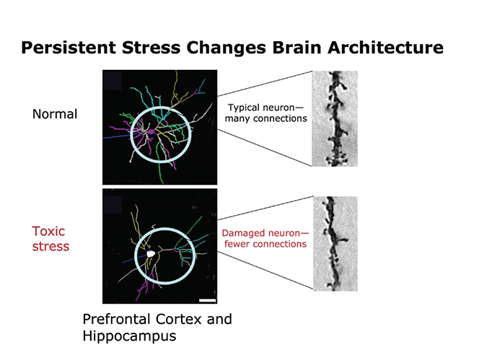

1. The basic principles of neuroscience indicate that early prevention interventions will be more efficient and, produce more favourable outcomes than remediation later in life.
2. A balanced approach to emotional, social, cognitive, and language development will best prepare all children for success in school, and later in the workplace and community.
3. Supportive relationships and positive learning experiences begin at home, but could also be provided through a range of services with proven effectiveness factors. Children’s brains require stable, caring, and interactive relationships with adults. Any way or any place these could be provided will benefit the healthy brain development in children.
4. Science clearly demonstrates that, in situations where toxic stress is likely, intervening as early as possible is critical to achieving the best outcomes. For children that are experiencing toxic stress, specialized early interventions are needed to target the cause of the stress and protect the children from its consequences. APC has identified extreme poverty as the main cause of stress in the communities that it targets. Interventions targeting parents/guardians and older siblings of targeted ECD children seek to protect the children from effects of such extreme poverty.

**Figure 2**: How persistent or toxic stress changes the brain architecture (Radley, et al., 2004).

Brains subjected to toxic stress usually have underdeveloped neural connections in areas of the brain that are most important for successful learning and behaviour in school and in the workplace, (Bock, et al., 2005).

2.1.2 Primary and Secondary Education

**Primary:** While the free primary education (FPE) program in Kenya has increased access to primary education, especially for children from poorer households, ancillary costs of primary education like school uniforms continue to hinder the educational attainment of many of these children. Provision of quality education also remains a challenge, as was underlined in a study by Uwezo (2010). The study established that disappointing levels of learning among primary school children exist in Kenya. Public schools, where most children from poor households increasingly enrol, were found to perform poorly compared to private schools where children from families that are better off financially enrol. The dorminance of private schools in the Kenya Certificate of Primary Education (KCPE) implies that children from rich families end up being admitted to the best secondary schools and, later, have high chances of joining universities and doing courses that place them on sure pathways to success.

Evidence from randomised evaluation suggests a number of key cost-effective interventions that could be introduced to address the inequalities in access and achievement in primary school, including programs that provide remedial education to students that are falling behind (Glennerster, et al., 2011). Programs that allow teachers to tailor their lessons to better suit the level of preparation of their students are effective at boosting students’ academic performance. Existing evidence also shows that merit scholarship programs could raise achievement. As primary school fees have been abolished in Kenya, providing merit scholarships for students who gain admission to secondary school has been cited as a possibility that warrants further exploration (Glennerster, et al., 2011). Additional programs that provide teachers or head-teachers with incentives to raise the levels of learning in their students have also been touted as possible interventions toward enhanced performance.

Educational attainment could also be boosted by life skills training. As children grow up into adolescents, they increasingly face deficits in personal, cognitive, and social skills, which could push them into drug abuse, bullying, violence, sexually transmitted infections (STIs), human immune-deficiency virus (HIV), acquired immune-deficiency syndrome (AIDS), malnutrition, and other socio-economic and environmental challenges that affect their educational performance and steps to future success. Specific emotional, cognitive, behavioural, and resilience skills play a vital part toward ensuring an adolescent’s personal and social success, (Langford, et al., 2015). Likewise, psychosocial skills allow individuals to recognise, interact, influence, and relate to others in different environments. Indeed, children and adolescents with psychosocial skills have been reported to exhibit positive mental health and well being (WHO, 1993). Life skills trainings are therefore very important toward effective empowerment of children and adolescents from poverty-related backgrounds. They empower them with attributes that determine valued behaviour. They comprise of reflective skills like problem-solving and critical thinking, personal skills like self-awareness, as well as interpersonal skills. When children and adolescents practice these life skills, qualities like self-esteem, sociability, tolerance, competencies to take action and generate change, capability to have the freedom to decide what to do and who to be stand out.

APC understands that children and adolescents in extreme poverty need these skills to make the most out of life. The skills bring confidence in their life, motivate them, and bring positivity and happiness in their lives. The organization has, based on this, been organising mentorship encounters for children and adolescents during school holidays during which they are helped to encounter challenges or meet daily tasks that shape their approach to life. The encounters prioritise the skills required for the children’s and adolescent’s well-being. The encounters help the children and adolescents to develop into active and productive members of their families and communities.

APC’s education and skilling interventions for children and adolescents at primary school level therefore comprise of the following:

* Support to acquire school uniforms and other educational requirements;
* Remedial programs and need-based merit scholarships;
* Life skills training; and
* School infrastructure improvement.

**KEY ISSUES**

**1. Support to acquire uniforms and other educational requirements**

In Kenya, with the abolition of general school fees, the cost of uniform is the highest monetary outlay for primary school (Evans, et al., 2009). Anecdotal evidence suggests that students are less likely to be sent away from school for failure to wear a uniform after 2002 than previously, but that students often feel stigmatised due to their failure to wear uniform, and may be reprimanded by teachers (Evans, et al., 2009). Existing evidence evokes that reducing the cost of schooling by providing uniforms, among other inputs, increases school participation (Evans, et al., 2009). Evans, et al (2009) also established that distributing uniforms results in a 44% reduction in student absenteeism. For children who did not already have uniform, distributing uniform was reported to reduce absenteeism by 62% (Evans, et al., 2009). Evans, et al (2009) also reported the existence of positive impacts of distributing uniforms on student performance. The cost of primary school uniforms in Kenya in early 2000 varied between 325 and 550 Kenya Shillings (US$4.33 to US$7.33) for girls, and between 405 and 550 (US$5.40 to US$7.33) for boys (Kremer, et al., 2002). The variation in prices is because uniforms for each school and gender require different materials and designs.

**2. Remedial programs**

Commercialisation of education is a global phenomenon now. Tough competition among learners is therefore a norm. In such scenarios, only those students with good grades get admitted to good secondary schools and, pursue the course of study of their choice. This translates into better prospects of employment for them. Academic accomplishments therefore become the benchmark of self-worth and success. Given this reality, educators, trainers, and researchers have for long strived to identify educational facets that efficiently promote learning. Factors that contribute to academic backwardness and are threat to academic growth require to be identified. This helps to implement appropariate remedial measures/intervention programmes. The programmes can be introduced at the school, familial, or societal level. Factors responsible for poor academic progress could be emotional, environmenmtal, and medical (Nasreenbanu & Yashoda, 2017).

These factors usually affect the academics of adolescents. Indeed, in students, emotional disorders like anxiety, obsessive-compulsive disorders, mood disorders, depression, and psychosomatic disorders are widespread. These require concerted remedial programs that take cognizance of environment and relational factors. Environmental factors for poor school grades include circumstances at home, at school, and in the neighbourhood. Relations with friends also influence academic performance – children from broken homes, those having alcoholic parents, and those subjected to physical and verbal abuse display poor academic performance. Remedial programs can boost the learning proficiencies in such children.

**3. Need-based merit scholarships**

Poverty decreases a child’s readiness for school via aspects of health, home life, schooling dynamics, and neighbourhood realities. Six poverty-related factors are known to impact child development and school readiness. They are, the incidence of poverty, the depth of poverty, the duration of poverty, the timing of poverty (e.g., age of the child), community characteristics (e.g., concentration of poverty and crime in the neighbourhood, and school characteristics), and the impact that poverty has on the child’s social networks (parents, relatives, and neighbours) (Ferguson, et al., 2007). A child’s home has a particularly strong impact on readiness for school. Children from poor families often do not receive the stimulation, and do not learn the social skills, required to prepare them for school. The typical problems that they encounter include, parental inconsistency (with regard to daily routines and parenting), frequent changes of primary caregivers, lack of supervision, and poor role modelling. Very often, the parents of these children also lack needed support

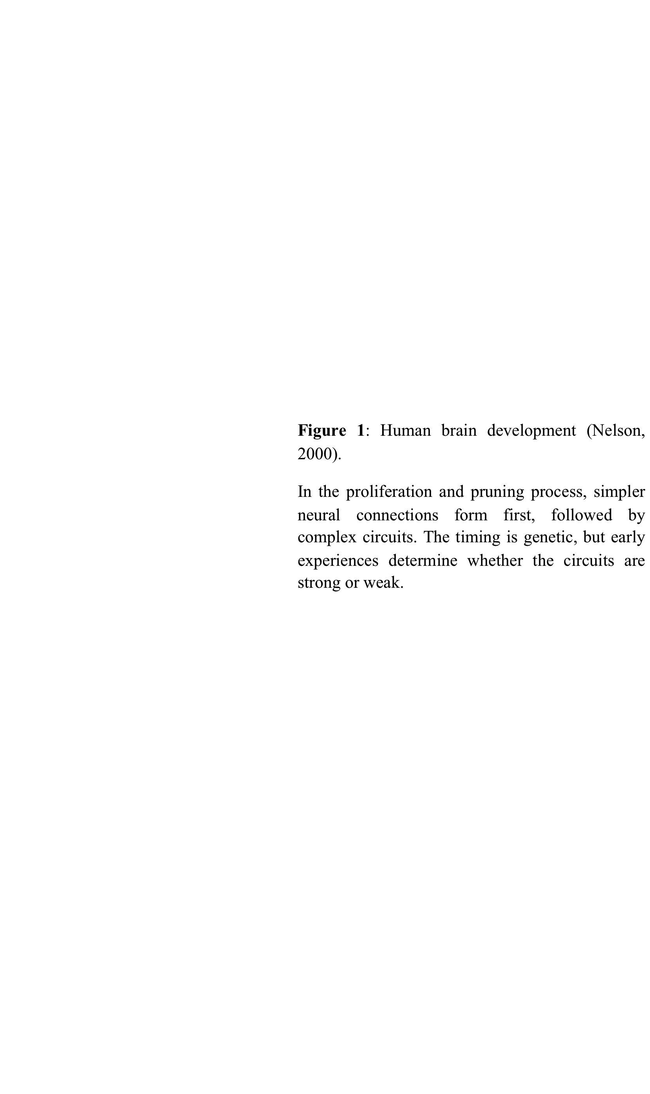



A report by Thomas (2007) concluded that children from poorer households score significantly lower on measures of vocabulary and communication skills, knowledge of numbers, copying and symbol use, ability to concentrate, and cooperative play with other children than those from wealthier households. Janus, et al. (2007) reported that schools with the largest proportion of children with low school readiness were from neighbourhoods of high social risk, including poverty. Willms (2007) reported that children from households of lower socioeconomic status (SES) scored lower on a receptive vocabulary test than those from higher SES. Evidence is therefore strong and unanimous that poor children arrive at school at a cognitive and behavioural disadvantage. Schools are obviously not in a position to equalize this gap, hence, the importance of interventions by other stakeholders in the development agenda relating to children from poor backgrounds.

While children from poor backgrounds are likely to get fewer opportunities to excel, they should be encouraged to work hard. A dual system where the base rate for scholarship is determined, not just from income status, but adjustments are made based on students’ academic performance has been encouraged (Cassie, 2015). This is because it would be wasteful to squander aid on high-achieving, high-income students with an above-average academic record, even if they might not have the perfect transcript of a high-income student who has been receiving high-quality tutoring since they started schooling. Putting the merit aspect into the needy children’s issue, therefore, strikes the appropriate balance in the quest to determine who to benefit from scholarships. (David, 2018).

**4. Life skills training**

In an ever-growing technology- and data-driven world, much of the focus in education has, understandably, taken a shift toward science, technology, engineering, and mathematics (STEM)-based initiatives that prepare learners for the coursework and careers of the future. Even so, life skills – how well equipped learners are to make good decisions and solve problems in their academic and professional careers, as well as their personal lives, should also play a critical role in a well-rounded and comprehensive education. Life skills are building blocks or frameworks that allow learners to apply the knowledge that they acquire in school to real world problems and situations. Life skills enhance one’s ability to think abstractly and approach problems from multiple angles, so as to find practical solutions.

Life skills trainings also enhance childrens’ abilities to communicate clearly and effectively. Building life skills in children also helps them to develop sound judgment and good habits for long-term stability, wellness, and success. Reaching children through life skills programs, both within and outside of the education system, is a unique opportunity to develop in them leadership abilities, provide vocational aptitudes, and integrate elements of empowerment for girls and young women. These programs help shift cultural norms, as well as create social change for the next generation of children (UN Women, 2013).

**5. School infrastructure improvement**

Education infrastructure is a crucial element of learning environments in schools. There is strong evidence that high-quality infrastructure facilitates better instruction, improves student outcomes, and reduces dropout rates, among other benefits (Teixeira, et al., 2017). Schools in marginalised areas face the biggest investment needs in Kenya. This means that learners attending these schools are doubly disadvantaged – they mainly come from low-income and rural families, to attend poorly equipped schools. Some of the attributes of adequate infrastructure are:

* Sufficient space per child (usually guided by standards set by a country’s Ministry of Education);
* Sufficient space for 30-40 children per classroom (to permit efficient use of teachers);
* Construction methods that ensure the safety of children in school, and are suited to the natural hazards of the area;
* Adequate separate sanitary facilities for boys and girls, as well as for staff; and
* Increasingly, electricity and Internet connectivity.



Infrastructural facilities may be inadequate in many ways, including being over-crowded or dangerous, inadequate sanitary facilities, and lack of water for hygiene. The health implications of inadequate toilets and sanitation are very severe - girls, in particular, are pushed out of school if facilities are inadequate. Older primary-age girls often miss significant amounts of school or are unlikely to continue at school after they begin menstration if sanitary facilities are poor or non-existent.

Effective approaches toward improvement of school infrastructure would include (Educate a Child, Undated):

* Rehabilitating schools that are in disrepair;
* Expanding learning space in overcrowded schools; and
* Improving water, sanitation, and hygiene (WASH) facilities in schools (UNICEF, 2012).

**Secondary:** UNESCO Institute for Statistics and the Global Education Monitoring (GEM) have reported that 420 million people could be lifted out of poverty with a secondary education, thus reducing the number of poor people worldwide by more than half, and by almost two-thirds in sub-Saharan Africa and South Asia.

While UNESCO underlines that education must reach the poorest in order to maximise its benefits and reduce income inequality, according to the 2016 GEM Report, children from the poorest 20% of families are 8 times as likely to be out of school as children from the richest 20% in lower-middle-income countries (GEM, 2016).

APC has, over time, come to a well-founded appreciation of the barriers to secondary education that learners from poor families, and communities at the margins of society, continually grapple with, and has been designing and implementing interventions to counter these barriers in various communities. The interventions have encompassed targeting secondary school learners, their siblings, their peers, their parents, and the communities through:

* Provision of conditional cash transfers, stipends, or scholarships;
* Life skills training (incuding seeking for, and placing the children in, voluntary service or free jobs during holidays);
* Targeting boys and men to be part of the discussions about cultural and societal practices;
* Working with communities and other actors to end child/early marriage;
* Working with communities and other actors to address violence against girls and women; and
* Designing and implementing targeted interventions to combat poverty among parents/guardians of targeted children/learners, which are fundamentally grounded in Brac’s Ultra-Poor Graduation Approach.

**KEY ISSUES**

**1. Girls are more likely not to proceed to secondary education**

Girls are particularly more likely not to proceed to secondary education. This calls for concerted efforts to foil the trend. Girls’ education goes beyond getting girls into school. It is also about ensuring that girls learn and feel safe while in school, complete all levels of education, develop skills to make them effectively compete in the labour market, learn the socio-emotional and life skills necessary to navigate and adapt to a changing world, make decisions about their own lives, and contribute to their communities and the world. Girls’ education is therefore a strategic development priority. Indeed, better educated women tend to be healthier, participate more in the formal labour market, earn higher incomes, have fewer children, marry at a later age, and enable better healthcare and education for their children should they choose to become mothers. When these happen, they help lift households, communities, and nations out of poverty.

**2. Poverty is a major barrier to girls’ access to secondary education**

Poverty is a chief determinant of whether a girl accesses education or not. Studies indicate that girls that face multiple disadvantages, e.g., low family income, living in remote/underserved areas, are living with disabilities, or are of minority ethno-linguistic groups, are farthest behind in terms of access to and completion of education (Tanner & Antonowicz, 2013). Prioritising access to education for girls from poor households and communities is therefore a strategic choice.

**3. Violence negatively impacts access to education**

Violence adversely impacts access to education. It also disrupts safe environments for learning. Violence includes gender-based violence (GBV), which comprises child marriage and female genital mutilation (FGM). Child brides are much more likely to drop out of school and complete fewer years of education than their peers who marry later.

This affects the education and health of their children, as well as their ability to earn a living. It has been reported that more than 41,000 girls under the age of 18 marry every day (Coby, 2017). Putting an end to the practice will increase women’s educational attainment and, with it, their potential earnings. Estimates show that ending child marriage could generate more than $500 billion in benefits annually.

**4. Conditional cash transfers, stipents, or scholarships**

Studies have shown that providing conditional cash transfers, i.e., payments made to households that are conditional on their children’s school attendance, as well as stipents or scholarships, can effectively reduce dropouts (Mo, et al., 2013). For children from poor backgrounds, these significantly encourage transition from primary to secondary education, given that the opportunity cost of the students’ time in school are usually higher because they are physically bigger and seen more as capable workers and/or wives, hence their parents or families would prefer them starting to help out in meeting household budgets and/or getting married to attract dowry.

While it is fundamental not to discriminate against boys when designing interventions to foster access to education, positive discrimination in favour of girls is often inevitable given their complex circumstances. The onset of puberty could have baffling impacts on girls. For example, the onset of menstruation could affect their enrolment for both biological and cultural reasons, and parents may worry about their safety both when travelling to school and when in the school. At the time of adolescence, the option of early marriage and demands for care of siblings and other household chores impact the opportunity cost of sending female children to school. Differences may also exist in perceived returns on educating girls versus boys.

Furthermore, while most parents may have been to primary school, fewer have attended secondary and post-secondary school, and so, they are less farmiliar with post-primary education. Consequently, their information may be fragmentary and in some cases, very inaccurate. This is likely to increase the chances of them making poor decisions with respect to their girls’ post-primary education.





**5. Brac ultra-poor graduation program**

People living in ultra-poverty are confronted by many interconnected and cyclical problems. They have little or no land or productive assets and, simultaneously struggle to cope with food shortages, poor health, social stigma, and lack of basic services like clean water and sanitation. They are also mostly excluded from social services and healthcare, generally live in remote areas disconnected from markets, and are often unable to work due to prolonged illnesses or disability in the family. These realities surely weigh on the education of their children, especially girls. Unfortunately, conventional development programs have not been able to cope with these complex and interrelated needs. To address this, the Brac Graduation Approach (BGA), which is a globally recognized model for innovative and holistic solution to ultra-poverty, was pioneered.

BGA is a comprehensive, time-bound, integrated, and sequenced set of interventions that seek to enable extreme and ultra-poor households achieve livelihoods and socioeconomic resilience, in order to progress along an informed pathway out of extreme poverty. The approach entails livelihoods promotion, social protection, financial inclusion, and social empowerment.

1.2.2 Economic Empowerment

Children often value and seek to excel in education upon seeing how education has helped their parents/guardians and older siblings. A study by Aga Khan University on the education dividend among young people in Kenya established that 78% had attained post-primary education, 39% had post-secondary education, and only 22% had primary education as the highest level of education (Aga Khan University, 2016).

With young people constituting 80% of Kenya’s population, the findings on the country’s education dividend means that the country has the best-educated generation. Yet, unemployment remains Kenya’s leading economic policy challenge, with unemployment among young people estimated to be double the 12.7% national level unemployment. When parents/guardians and older siblings who pursued education and excelled are unemployed or economically unproductive, it triggers autocatalytic cycles that discourage hard work by children in school. This could be cured through ruthless support for youth entrepreneurship.

Aga Khan University (2016) established that Kenyan youths are entreprenueral: the majority would like to start their own business, rather than pursue careers in law, teaching, medicine, or engineering. Few (11%) want to become farmers, implying that the country’s urbanization is likely to continue apace – escalating demand and competition for farm employment.

**KEY ISSUE**

**Employment:** Aga Khan University (2016) established that, overall, unemployment among youth in Kenya to be 55%. It was highest among women (62%), and even higher among rural women (68%). Employment rates were lowest among those without post-secondary education (15%). By comparison, 32% of those with post-secondary education were unemployed. 1 in 2 graduates were unemployed and, only 1 in 5 youth with university degrees were in self-employment. Youth aged between 18 and 25 were twice more likely to be unemployed compared to their counterparts aged 26 to 35 years.

A recent analysis by The World Bank (2016) established that almost all youth aspire for entrepreneurship, but lack access to start up financing; managerial and entreneurial skills; exposure and networks for starting and growing business; access to apprenticeships; etc.



1.2.3 Community-Based Climate Action

The Intergovernmental Panel on Climate Change’s latest report states clearly that climate change is already having discernable impacts that are disproportionately affecting poor communities – especially those in poor countries (Saleemul & Hannah, 2007). These impacts are set to intensify; yet poor communities are unable to cope with current climate (and other) shocks, let alone any future risks related to climate change. It is therefore important that these communities are helped to adapt as well as effectively participate in climate change mitigation efforts through community-based climate actions.

Community-based climate action is an approach to climate change that aims to bring to the fore people that are vulnerable to climate change in the design and implementation of climate change mitigation and adaptation measures. The most obvious forms of community-based climate action include simple, but accessible, technologies like substituting firewood and charcoal with bio-briquettes for cooking and heating purposes, storing freshwater during flooding, afforestation, raising the level of houses that are near water masses, etc. It can also include more comple forms of social and economic resilience, such as increasing access to a wider range of livelihoods or reducing the vulnerability of social groups that are exposed to climate risks. Community-based climate action offers useful lessons for broader transformation to socially inclusive forms of climate change policy and organization, rather than in infrastructure and technology alone.

**KEY ISSUES**

**Vulnerability of poor communities:** Poor communities in poor countries are the most vulnerable to climate change and are already feeling its impacts, but have contributed least to the problem.

**Poor communities to adapt and mitigate:** Helping poor communities adapt to, and participate in mitigation efforts against, climate change is vital, but identifying steps to take and ensuring that this is a major challenge.

**Community-based climate action:** Community-based climate action is an approach for helping communities adapt to, and participate in mitigation efforts against, climate change.

**Outsiders:** To do any good, community outsiders must first gain the trust of the communities they want to help. Normally, this would mean spending some adequate time with the community. But if trusted local intermediaries like NGOs, community groups, etc. are available, it is best to start dialogue with them before moving to the communities themselves.

**Esoteric and Confusing:** Climate change is an esoteric and initially confusing concept to many. Communication about it must use a community’s own language and terms they can understand. This means not only translating scientific texts into local languages, but also giving up on the written word altogether and using traditional means of communication, such as art and theatre, or modern methods like videos.



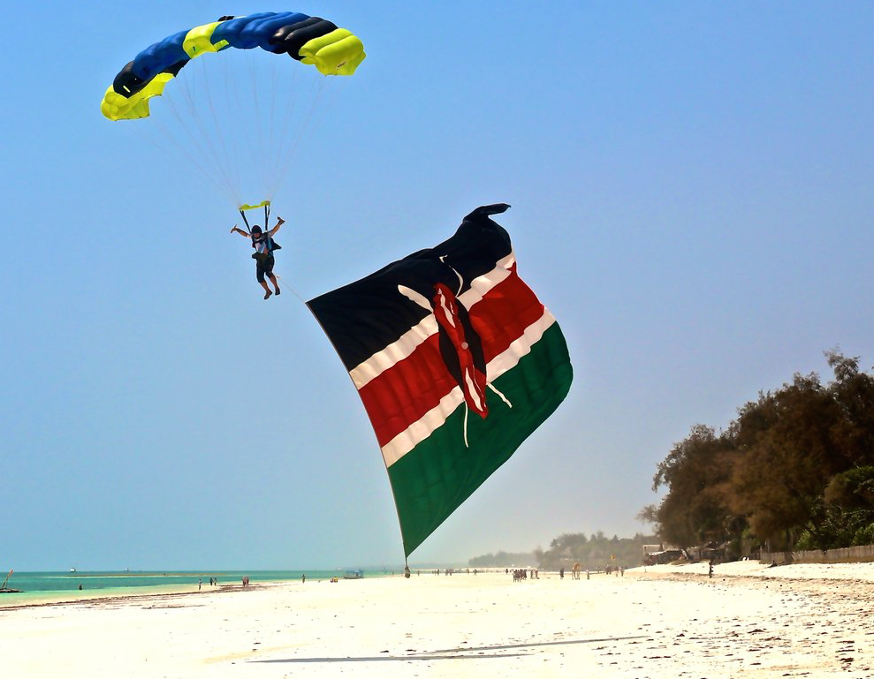

**THE POINT**

Poverty stands out as a major barrier to the sustainable development of many African communities. In conformity with its vision “*African communities better able to innovate and implement robust solutions to hunger, poverty, and disease and, are critically conscious of environmental health,*” APC has made a strategic decision to ruthlessly focus on **education**, economic **empowerment**, and community **climate action** so as to enhance its impact for the communities in which the organisation works. This targeting of investment in fewer thematic areas is expected to lead to greater impact.

APC has also made a strategic decision to take full advantage of the entrepreneurial opportunities in the wood sector, particularly bio-briquetting enterprise and value chains, to ensure that they autocatalytically leverage delivery of action and outcomes in the core areas/pillars of **education, economic empowerment, and community climate action**.

The organisational will therefore seek to:

* Contribute to ensuring invlusive and equitable quality ECD, primary, and secondary education for Kenyans;
* Contribute to ensuring full and productive employment and decent work for young Kenyans; and
* Contribute to ensuring environmental stewardship through informed climate action.

The design and implementation of supporting strategic thrusts will be underpinned by the fact that the wood energy sub-sector is complex and has varied constraining realities. Adoption of Emergent Practice, as opposed to Good or Best Practice, derived from sensible processes of **probing, sensing, and responding** (see the section on Approach) will be fostered.

1. **APPROACH**

Given the complexity associated with the wood energy sub-sector in Kenya, Figure 1 illustrates key issues that underpin the design and implementation of strategic thursts under this project.

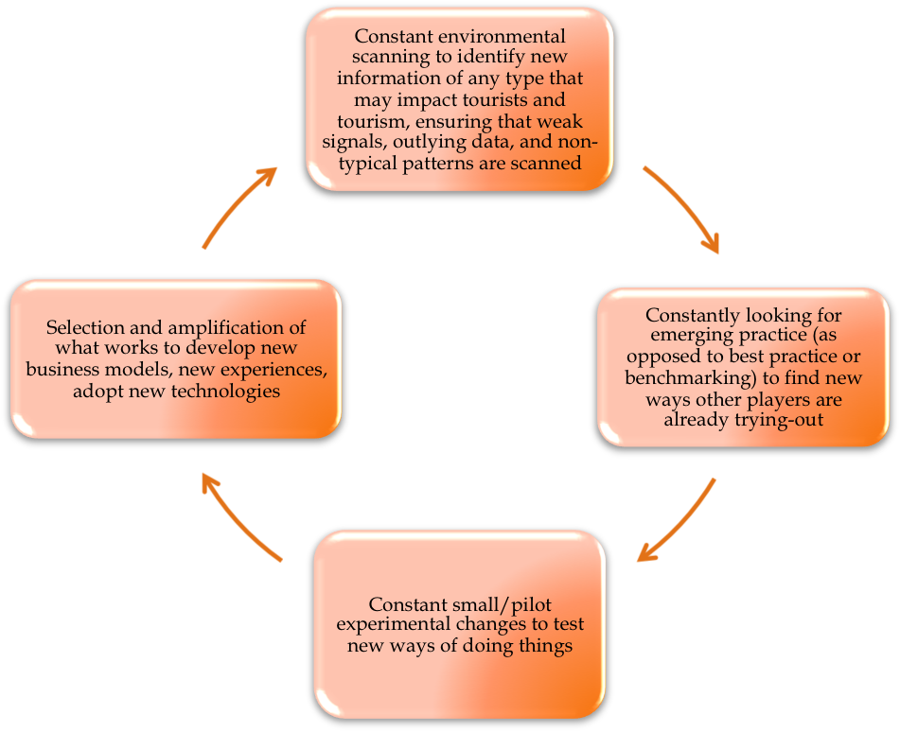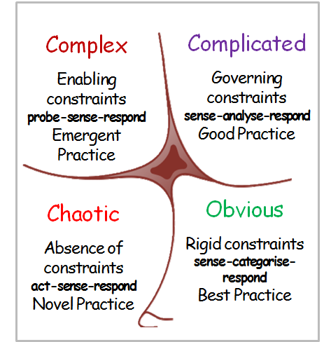

**Figure 1:** Framework for managing ‘complex’, ‘complicated’, ‘chaotic’, and ‘obvious’ environments (Government of Kenya, 2016).

**THE PROCESS**

The co-creation approach adopted during the design of this project will be followed through during its implementation as well as during monitoring and evaluation. This is because the approach encourages participation in and loyalty to the organisational brand by creating strong ownership. Through co-creation of interventions, APC has learned that stakeholders, especially targeted communities, are empowered to own both processes and results. This increases team morale and the delivery of intended deliverables.

The co-creation approaches employed during the design of this project sought to establish obe unique tactic for delivering education, empowerment, and climate action at grassroots levels. Contribution to securing viable substitutes to charcoal and firewood use was most prioritised. Consequently, APC worked together with researchers in Maseno University in Kenya to identify agro-wastes in various counties in the country that could be used in producing viable and culturally acceptable bio-briquettes for use in cooking and heating purposes in those communities.

Results from the study indicate that vast amounts of agro-wastes that could be used to produce bio-briquttes with high calorific values exist at grassroots levels in Kenya. These agro-wastes include banana peels, groundnut shells, maize cobs, cassava stalks, sugar cane bagasse, mango leaves, mango seeds, tobacco waste, cotton stalks, cassava peels, gram stalks, vegetable waste, and wheat straw. While these are viable feedstock for producing bio-briquettes with high calorific values, they are frequently burnt in open air, left to degenerate in the open, or are sometimes used by poor households in cooking and heating.

Given that these agro-wastes are easily accessible at grassroots level, including among households living in poverty, APC worked with LLAs in West Pokot, Vihiga, and Kitui Counties in Kenya to ventilate on the possibilities of turning the agro-wastes into enterprises that could earn communities at grassroots level, especially households living in poverty, income to help secure the education of their children. This idea is hinged on the understanding that bio-briquettes, mostly made out of agro-waste and other organic materials, provide not only a more eco-friendly alternative to fossil-fuel sources of cooking energy, but are manufactured from a readily available, low-cost, fuel source that is often disposed of as waste.

Bio-briquetting co-creative industries have immense potential to; increase the number of young women and men with technical and vocational skills for wealth creation; increase the number of ECD, primary, and secondary school children from poor households that are achieving literacy and numeracy; uplift educational facilities for inclusive and effective learning outcomes; and foster grassroots-inspired climate action.

Given the impressive results from interventions that sought to deal with ultra-poverty using the Brac’s Graduation Approach, APC will adopt the approach and integrate the bio-briquetting enterprise in it when targeting individuals (parents/guardians and children) for direct support and facilitating the individuals to form self-help grous (SHGs) [also referred to as Local Level Associations (LLAs) under APC’s lingo] through which enterprises for collective business venture (bio-briquetting in this case) will be promoted.

**THE PLAN**

**Strategic Purpose**:

To secure, through engagement in and promotion of bio-briquetting, inclusive and equitable education (ECD, primary, and secondary) for Kenyan children from disadvantaged backgrounds, the lifting of Kenyan youths out of povery, and grassroots-inspired climate action.

**Strategic Targets:**

1. At least 195 ultra-poor women and at least 105 ultra-poor men (ages 15-35) empowered with technical and vocational skills in the bio-briquetting value-chain, underpinned by the Brac’s Graduation Approach framework, for employment and/or enhanced income generation, by the end of 2021.
2. At least 195 girls and at least 105 boys from ultra-poor households supported based on the Brac’s Graduation Approach framework to achieve top-level literacy and numeracy, by the end of 2021.
3. By the end of 2021, the capacity to develop and/or scale up bio-briquetting enterprises and value chains by APC and 6 LLAs in West Pokot, Vihiga, and Kitui Counties in Kenya enhanced so as to enable them effectively participate in the upgrading of educational facilities attended by children targeted in Target 2 (with focus on hygienic latrines, electricity, safe water, and basic teaching tools) for inclusive and effective learning, as well as improved grassroots-inspired climate action.

**Strategic Thrusts:**

**Target 1**

* 1. Provision of productive assets;
  2. Training in entrepreneurship;
  3. Consumption support;
  4. Coaching/mentorship;
  5. Savings promotion; and
  6. Health empowerment.

***Target 2***

* 1. Provision of productive assets;
  2. Provision of lifeskills trainings;
  3. Consumption support (need-based merit scholraships, educational support, etc.);
  4. Savings promotion;
  5. Coaching/mentoriship; and
  6. Health empowerment.

***Target 3***

* 1. Provision of capital for enterprise development;
  2. Training in bio-briquetting enterprise and value chains and, in related skills;
  3. Coaching/mentorship;
  4. Savings promotion;
  5. Upgrade of educational facilities and community-based climate action; and
  6. Planning, digitalisation of processes (supply chains, etc.), monitoring, and support supervision.
  7. **Intervention Logic**

| Project Summary | Performance Indicators | Means of Verification | Key Risks & Assumptions |
| --- | --- | --- | --- |
| Purpose:  To secure, through engagement in and promotion of, bio-briquetting, inclusive and equitable education (ECD, primary, and secondary) for Kenyan children from disadvantaged backgrounds, the lifting of Kenyan youths out of poverty, and grassroots-inspired climate action. |  |  |  |
| Targets   1. At least 195 ultra-poor women and at least 105 ultra-poor men (ages 15-35) empowered with technical and vocational skills in the bio-briquetting value chain, underpinned by the Brac’s Graduation Approach framework, for employment and/or enhanced income generation, by the end of 2021. 2. At least 195 girls and at least 105 boys from ultra-poor households supported, based on the Brac’s Graduation Approach framework, to achieve top-level literacy and numeracy, by the end of 2021. 3. By the end of 2021, the capacity to develop and/or scale up bio-briquetting enterprises and value chains by APC and 6 LLAs in West Pokot, Vihiga, and Kitui Counties in Kenya enhanced so as to enable them effectively participate in the upgrading of educational facilities attended by children targeted in Target 2 (with focus on hygienic latrines, electricity, safe water, and basic teaching tools) for inclusive and effective learning, as well as improved grassroots-inspired climate action. | * Type of productive assets provided and their beneficiaries disaggregated by gender * Proportion of beneficiaries of entrepreneurship trainings venturing into active entrepreneurship, by gender * Type and extend of consumption support provided, and their beneficiaries by gender * Type and extend of coaching/mentoriship provided, and their beneficiaries by gender * Amount of individual savings made by project beneficiaries disaggregated by gender * Type and extend of health empowerment provided, and their beneficiaries by gender * Type of productive assets provided and their beneficiaries disaggregated by gender * Type and extend of lifeskills trainings provided to the children, disaggregated by gender. * Type and extend of consumption support provided, and beneficiaries. disaggregated by gender * Amount of individual savings made by project beneficiaries, by gender. * Type and extend of coaching/mentoriship provided to project beneficiaries, by gender. * Type and extend of health empowerment provided to beneficiaries, by gender. * Type of capital provided and the beneficiary entities and geographical locations * Type and extend of training in bio-briquetting, associated enterprises, value chains, and related skills. * Type and extend of coaching/mentoriship provided, and their beneficiaries by gender. * Amount of individual savings made by the targeted 6 LLAs * Type and extend of upgrades made to educational facilities (to foster child-, disability-, safety-, non-violelnce-, inclusive-, and effective-learning environments and, grassroots climate action. * Type and extend of planning, digitisation of processes (e.g., supply chains, etc.), monitoring, and support supervision. | * APC Financial Records * APC Programme Reports * Reports of the 6 targetted LLAs * Reports by supporters of the project | **Risks**   * Weak APC donor/investor base * Expectations from targeted villages following their involvement in enterprise prioritasation process that shaped this proposal * Members of targeted LLAs not taking anti-poverty efforts if the project fails to be realized * High initial investment costs * Lack of knowledge and skills in bio-briquetting enterprise * Lack of access to credit and markets * Transfers for purchase of productive assets likely to be spent on basic needs if appropriate safeguards are not put in place * Effects of market impacts like inflation * Proliferation of the informal sector * Time lag between investment in productive assets and generation of incomes * High illiteracy levels, especially among women and girls   **Assmptions**   * APC’s work with Maseno University will leverage its position in encouraging support for the project * APC will be able to get supporters that are keen on ensuring the innovative approach of dealing with barriers of poverty to education with action that simultaneously contributes to climate action by the poor, takes shape |
| Thrusts:   * 1. Productive assets - 195 women, 105 men   2. Entrepreneurship training - 195 women, 105 men   3. Consumption support - 195 women, 105 men   4. Coaching/mentorship - 195 women & 105 men   5. Savings promotion among 195 women, 105 men   6. Health empowerment – 195 women, 105 men   7. Adminstrative support, digitisation, monitoring, and support supervision   8. Productive assets – 195 girls, 105 boys   9. Lifeskills training – 195 girls, 105 boys   10. Consumption support – 195 girls, 105 boys   11. Savings promotion for 195 girls, 105 boys   12. Coaching/mentoriship to 195 girls, 105 boys   13. Health empowerment to 195 girls, 105 boys   14. Adminstrative support, digitisation, monitoring, and support supervision   15. Capital for enterprise – APC, 6 LLAs   16. Training in bio-briquetting – 6LLAs   17. Coaching/mentorship – 6 LLAs   18. Savings promotion – 6 LLAs   19. Upgrades to educational facilities   20. Community-based climate action   21. Adminstrative support, digitisation, monitoring, and support supervision | **Inputs:**  (See Separate Budget) |  |  |

**THE PRODUCT**

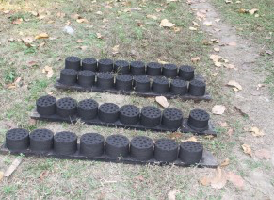

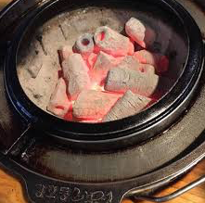

**REFERENCES**

Aga Khan University (2016). The Kenya Youth Survey 2016. *The East Africa Institute -* <https://www.aku.edu/eai/Pages/kenya.aspx> (Date of Use: 27 September 2019).

Bock, G., Zmud, R., Kim, Y., & Lee, J. (2005). Behavioural Intention Formation in Knowledge Sharing: Examining the Roles of Extrinsic Motivators, Social-Psuchological Forces, and Organizational Climate. *Management Information Systems (MIS) Quarterly* *, 29* (1).

CapitalNews. (2015, March 26). *Study: Kenya loses 5.6 million trees daily*. Retrieved April 15, 2018, from http://www.capitalfm.co.ke: http://www.capitalfm.co.ke/news/2015/03/study-kenya-loses-5-6-million-trees-daily/

Cassie, S. (2015, July 17). *Debate: Should Scholarships by Given on Merit or Need?* Retrieved June 29, 2019, from https://www.newtimes.co.rw: https://www.newtimes.co.rw/section/read/190686

Center on Developing Child. (2007). *The Science of Early Childhood Development (InBrief).* Retrieved June 27, 2019, from www.developingchild.harvard.edu: https://developingchild.harvard.edu/resources/inbrief-science-of-ecd/

Coby, J. (2017, July 12). *Every Day 41,000 Girls are Married Under the Age of 18 - A New World Bank Report Shows the Economic Impact of this Problem.* Retrieved June 30, 2019, from https://www.undispatch.com: https://www.undispatch.com/every-day-41000-girls-married-age-18-new-world-bank-report-shows-economic-impact-problem/

David, E. (2018, September 17). *The Power of a Label: Merit Scholarships vs Needs-Based Scholarships.* Retrieved June 29, 2019, from https://blogs.worldbank.org: https://blogs.worldbank.org/developmenttalk/power-label-merit-scholarships-vs-needs-based-scholarships

Ferguson, H., Bovairds, S., & Mueller, M. (2007). The Impact of Poverty on Educational Outcomes for Children. *Paediatrics Child Health* *, 12* (8), 701-706.

Glennerster, R., Kremer, M., Mbiti, I., & Takavarasha, K. (2011). *Access and Quality in the Kenyan Education System: A Review of the Progress, Challenges, and Potential Solutions.* Retrieved June 29, 2019, from https://www.povertyactionlab.org: https://www.povertyactionlab.org/sites/default/files/publications/Access%20and%20Quality%20in%20the%20Kenyan%20Education%20System%202011.06.22.pdf

Global Education Monitoring Report Team, UNESCO Director-General, Sachs. (2016). *Education for People and Planet: Creating Sustainable Futures for All, Global Education Monitoring Report, 2016.* UNESDOC Digital Library.

Janus, M., Walsh, C., Viverios, H., Duku, E., & Oxford, D. (2007, September 10). *School Readiness to Learn and Neighbourhood Characteristics.* Retrieved June 29, 2019, from http://offordcentre.com: http://offordcentre.com/readiness/files/PUB.2.2003_Janus-Walsh.pdf

Kremer, M., Sylvie, M., & Namunyu, R. (2002). *The Political Economy of School Finance in Kenya.* Retrieved June 29, 2019, from https://www.semanticscholar.org: https://www.semanticscholar.org/paper/The-Political-Economy-of-School-Finance-in-Kenya-Kremer-Moulin/f30fb838a025e4e17ae139582fd457974623c6e9

Langford, B., Badeaus, S., & Legters, L. (2015). *Investing to Improve the Well-Being of Vulnerable Youth Adults: Recommendations for Policy and Practice.* Retrieved June 29, 2019, from http://www.ytfg.org: http://www.ytfg.org/2015/12/wellbeing/. [Google Scholar]

Lele, U., Karsentry, A., Benson, C., Fétiveau, J., Agarwal, M., & Goswami, S. (2013). Changing Roles of Forests and their Cross-Sectional Linkages in the Course of Economic Development - Working Paper 2. *United Nations Forum on Forests.* https://www.un.org.

Liyama, M., Neufeldt, H., Dobie, P., Njenga, M., Ndegwa, G., & Jamnadass, R. (2014). The Potential of Agroforestry in the Provision of Sustainable Woodfuel in Sub-Saharan Africa. *Current Opinion in Environmental Sustainability* *, 6*, 138-147.

Mo, D., Zhang, L., Yi, H., Luo, R., Rozelle, S., & Brinton, C. (2013). School Dropouts and Conditional Cash Transfers: Evidence from a Randomized Controlled Trial in China's Junior High Schools. *The Journal of Development Studies* *, 49* (2), 190-207.

Nasreenbanu, A., & Yashoda, K. (2017). Remedial Learning Programme for the Academically Backward Children. *International Journal of Educational Science and Research* *, 7* (2), 69-82.

Ndegwa, G., Breker, T., & Hamhaber, J. (2011). Woodfuels in Kenya and Rwanda: Powering and Driving the Economy of the Rural Areas. *Rural21* *, 18*, 26-30.

Nelson, C. (2000). The Neurological Bases of Early Intervention. In J. S. (Eds.), *Handbook of Early Childhood Intervention (2nd ed.)* (pp. 204-228). Cambridge: MA: Cambridge University Press.

Radley, J., Sisti, H., Hao, J., Rochier, A., McCall, T., Hof, P., et al. (2004). Chronic Behavioural Stress Induces Apical Dendritic Reorganization in Pyramidal Neurons of the Medial Prefrontal Cortex. *Neuroscience* *, 125*, 1-6.

Saleemul, H., Hannah, R. (2007). A vital approach to the threat climate change poses to the poor. *International Institute for Environment and Development (IIED)*.

Szulecka, J. (2019). Towards Sustainable Wood-based Energy: Evaluation and Strategies for Mainstreaming Sustainability in the Sector. *Sustainability* *, 11* (493).

Tanner, S., & Antonowicz, L. (2013, February 05). *Thematic Study on Education and Gender Equality.* Retrieved June 30, 2019, from http://www.ungei.org: http://www.ungei.org/resource_norad_thematic_study.pdf

Teixeira, J., Amoroso, J., & Gresham, J. (2017, October 03). *Why Education Infrastructure Matters for Learning.* Retrieved June 30, 2019, from https://blogs.worldbank.org: https://blogs.worldbank.org/education/why-education-infrastructure-matters-learning

Termwiki. (2014). *http://www.termwiki.com/EN:plant_residue*. Retrieved October 22, 2014, from http://www.termwiki.com: http://www.termwiki.com/EN:plant_residue

Thomas, E. (2007, September 10). *Readiness to Learn at School among Five-Year-Old Children in Canada.* Retrieved June 29, 2019, from http://www.statcan.ca: http://www.statcan.ca/english/research/89-599-MIE/89-599-MIE2006004.pdf>

UN Women. (2013, December 13). *Life Skills Programmes for Children and Adolescents.* Retrieved June 29, 2019, from http://www.endvawnow.org: http://www.endvawnow.org/en/articles/1694-life-skills-programmes-for-children-and-adolescents.html

UNICEF. (2012). WASH in Schools Empower Girls' Education. *The Menstrual Hygiene Management in Schools Virtual Conference.*

Uwezo. (2010). *Kenya National Learning Assessment Report, 2010.* Nairobi, Kenya: Uwezo.

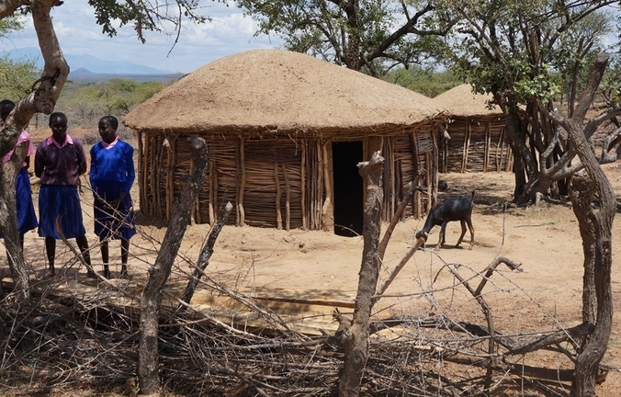Willms, J. (2007, September 10). *Ten Hypotheses about Socioeconomic Gradients and Community Differences in Children's Developmental Outcomes.* Retrieved June 29, 2019, from <http://www.hrsdc.gc.ca/en/cs/sp/sdc/pkrf/publications/research/2003#001272/page00.sht>

World Bank (2016). Project Appraisal Document: Youth Employment and Opportunities. *The World Bank*.

African PRIDE Centre Logo.jpg

**www.africanpridecentre.org**

**Innovations for Resilient Communities**

1. A large body of research has shown the import of the first 3 years of a child’s life (Yoshikawa, et al.). The experiences and interactions that children have in these early years heavily affect brain development and, help to establish the foundation for future learning (Center on Developing Child, 2007).
2.