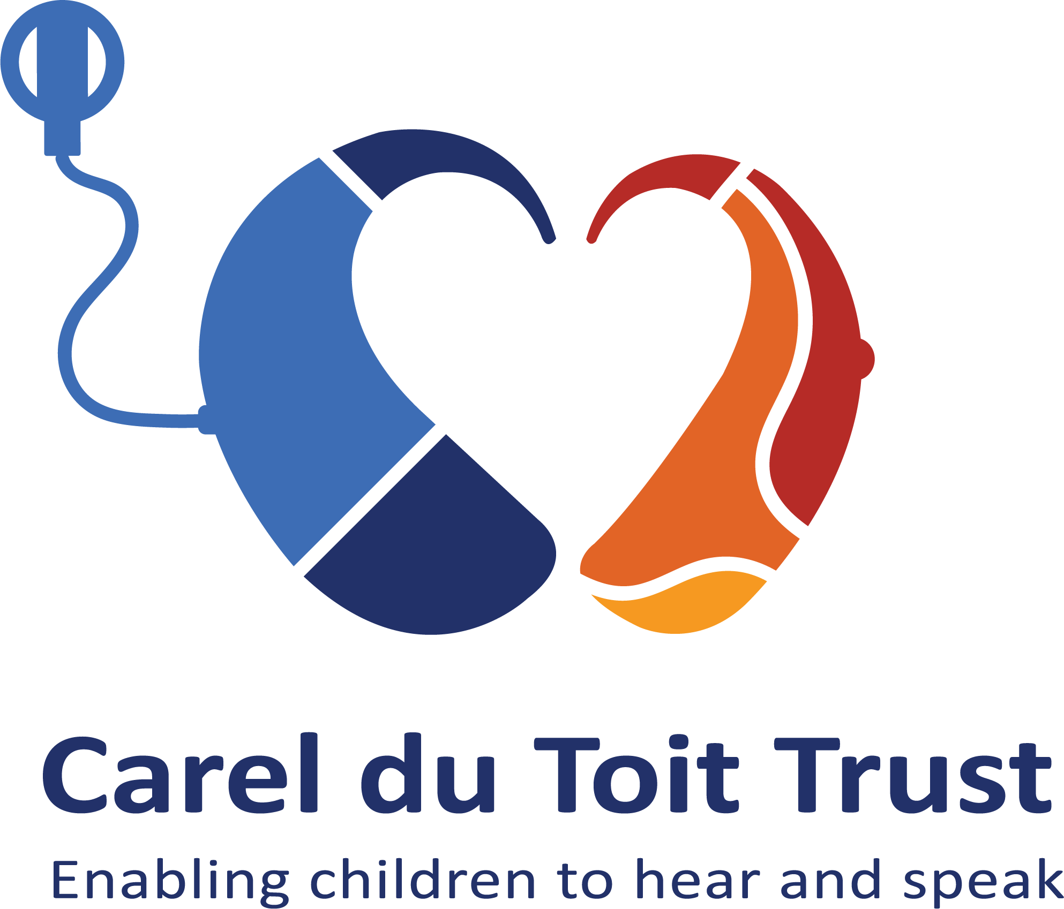

2019/08/21
Carel du Toit Centres where children with hearing impairments learn to hear and speak!
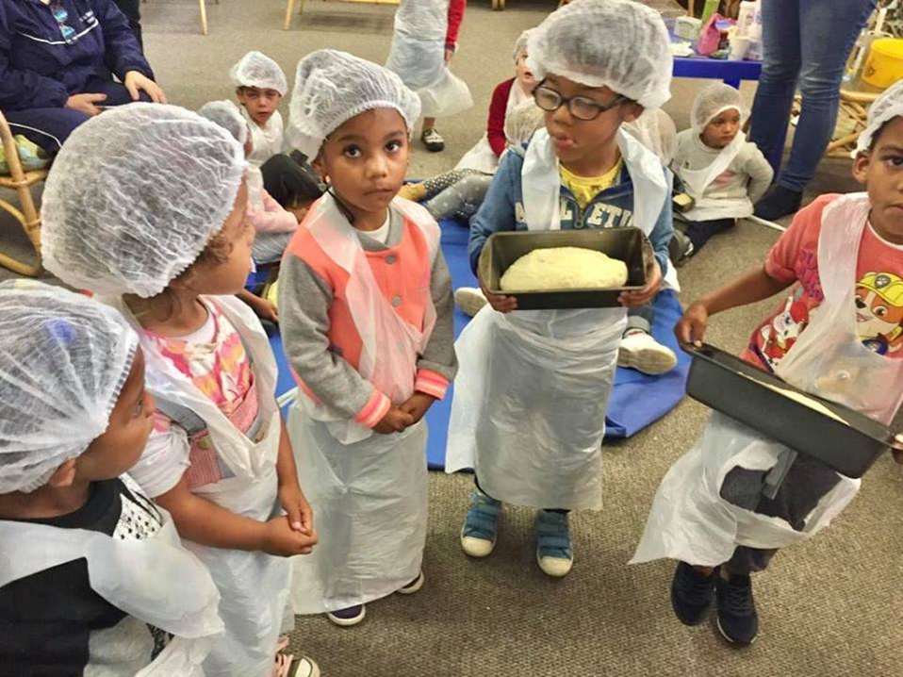Experiential learning is a hallmark of the teaching methodology at the Carel du Toit Centre. Here the ‘little bakers’ learn new words associated with their bread baking experience. Photo credit: Carel du Toit Centre.
The Carel du Toit ‘family’ represents a diverse group, highly skilled with strong links to the communities that we serve.
We play a vital advocacy role in support of equality and full inclusion for persons with disabilities, in particular children with hearing impairments who have the capacity to learn to speak.
Our fundraising, marketing and financial management team are skilled professionals with a strong passion for the cause, also representing “Carel du Toit’ with pride.
Within our broader team we have experts in the field of paediatric hearing loss, as well as specialist therapists and teachers, with 30% of our staff complement being parents of current or past learners of the Centre.
The staff who choose to serve at the Carel du Toit Centre/Trust are loving and kind, and this creates a happy team and a positive working environment, as well as a loving and safe place for the beneficiaries of our joint efforts - children who are deaf.

CAPE TOWN, SOUTH AFRICA - We take pleasure in introducing the Carel du Toit Trust – in support of the Carel du Toit Centres (CDTC) for children who are deaf to you with the sincere hope that you will consider funding our work. Our methodology is unique in that it enables children who are deaf (with as little as 3% hearing) to hear, to speak and to develop language to an extent where are fully integrated into a hearing world. Please see our budget attached. We request that you consider funding towards our operational expenses, but are happy to discuss individual projects and to expand the information if required.
Project information
Geographically the primary Carel du Toit Centre is located in the Western Cape of South Africa. Our footprint includes the Western Cape (Peninsula, Boland, West Coast, Drakenstein District); the Eastern Cape (East London and surrounds), Free State (Bloemfontein and surrounds).
CDTC, established in 1973 by Professor Carel du Toit, in an advanced stage of development, has helped many thousands of children who are deaf to acquire hearing, knowledge and functional spoken language (English, Afrikaans and IsiXhosa) and has programmes with proven results.
These are –
- Screening Unit to identify hearing impairments in new born babies at Tygerberg Hospital.
- 3E (ears and eyes for education) screening of young children in poor communities.
- CHAT (children hear and talk) family focused centre for 0-3 year olds and their parents/caregivers.
- Foundation Phase, Pre-Primary and Primary School up to Grade 3 (10 years of age)
- Audiological management and therapies i.e. occupational, speech and social.
Our vision is to teach children who are deaf to speak so that they can function optimally in a hearing world.
Once children who are deaf are fitted with hearing technology, they need to learn to hear and speak in order to gain functional language so that they can engage in a hearing world.
Children who are deaf are often underachievers at school because the education system doesn’t provide for their learning differences. We personalize learning for individual deaf students in the pre-school and foundation phase of schooling and we train and support our teachers.

What we do
The Carel du Toit Trust is the fundraising arm of the Carel du Toit Centre (CDTC); both are based on the grounds of the public Tygerberg Hospital in Parow, Cape Town. Our methodology encompasses early diagnosis and intervention (before three years of age), a family centred approach, best amplification and daylong listening, and experiential teaching and learning. We have a multidisciplinary team of audiologists, speech therapists, special needs educators, social workers and psychologists. Our students mostly come from low- or no-income households in poor communities, to include urban, peri-urban, rural, semi-rural informal settlements, townships and slums in the Western Cape. We maintain a small fleet of in-house and out-sourced vehicles to transport the children safely from home to the Centre where they receive, care, auditory support and tuition, after-school care, meal provision and in-house residence for those in need.
Babies and young children that are diagnosed with hearing loss are referred to our early intervention centre (CHAT centre) or to government facilities, where audiologists evaluate the hearing loss and fit the children with appropriate hearing technology. In CHAT the audiologists and social workers support the parents and guide them into caring for a deaf child. It is vital that the parents and caregivers of the child are involved in the education of the child as so much learning is done at home.
Through the 3E Project we have screened upward of 10,000 young children since inception two years ago in low income communities.
We are recognized globally as the best facility in Africa and recognized at government level as a specialist in the field and an advocate for children who are deaf. Our partners and donors include hearX, University of Stellenbosch, South Africa’s Department of Social Development, Department of Health, the Western Cape Education Department and trusts, foundations and individuals who support work with children, especially those with a disability i.e. hearing impairments, who come from low or no-income households.
Schooling
The children progress to the pre-primary and then the foundation phase classes at the CDTC. They follow a natural language acquisition learning approach through the maximum use of the auditory modality and the application of auditory verbal principles. The teachers follow the curriculum as prescribed by the Department of Basic Education but it is personalized for each student with small classes (up to 10 students), weekly themes, experiential learning with weekly outings, extra-mural activities, and weekly speech therapy. Intervention is based on individual needs. After Grade Three, the learners progress to mainstream or special needs schools depending on their requirements.
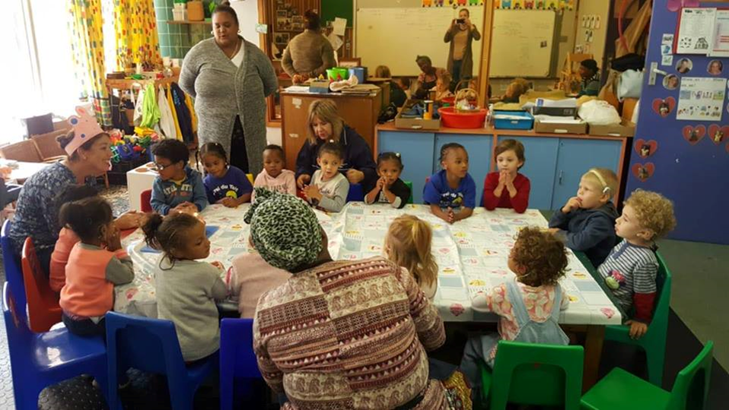
CHAT Centre
The CHAT centre provides family-centred early intervention for approximately 100 children who are deaf at any given time, who spend short or longer periods in the CHAT centre. Our capacity is limited purely by funding, which would enable us to expand to help more children and babies. Currently we employ 3 full-time audiologists and a team of subject-expert teachers and professional therapists. We also employ mothers of children at the school and train them to as assistants to teachers, translators into the Xhosa and other vernacular South African languages, where the teachers/trainers and audiologists are not fluent. The on-site professional support team offer support groups and workshops for the parents and caregivers as well as crèche and home visits. The CDTC pre-primary and primary school teaches approximately 220 children each year up to 10 years of age, and provides employment for 82 staff members. We provide in-house training to new staff members and volunteers using approved protocols and procedures to ensure that all staff are conversant with our audio-visual methodology.
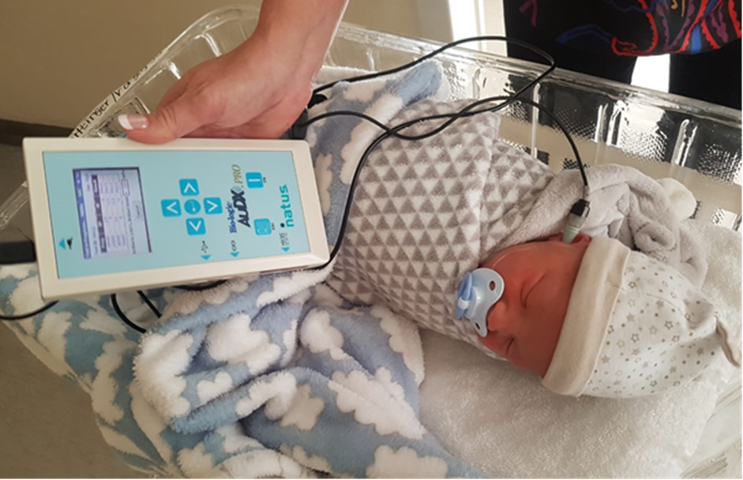
Aftercare at Carel du Toit Centre
The aftercare service at the Carel du Toit Centre is a caring environment where the children receive a lunch and have access to an outdoor play area with a jungle gym, while they wait to be transported back home – in a radius of up to 50kms from the Centre.

